**Cultivating sustainability: The revitalisation of UTAR Lake 5 as an aquaculture farm**

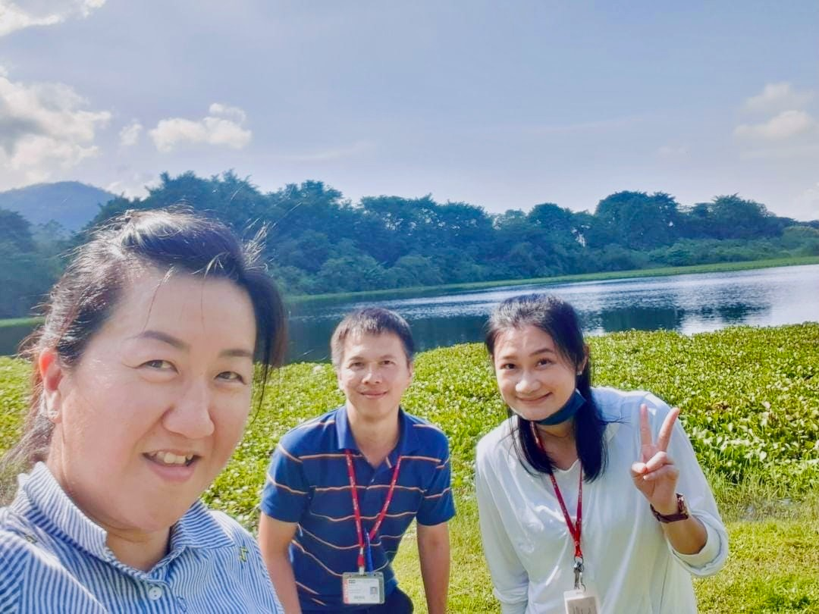

The team behind Lake 5’s revitalisation project (from left): Dr Ooi, Dr Wong, and Dr Teoh

In a long-term effort to support the Sustainable Development Goals (SDGs), UTAR’s commitment to sustainability remains one of the core principles to foster research and projects that strive to equip not only young talents but also the local communities with skills and knowledge to pave their ways for a future of sustainable food production and environmental conservation. As issues such as difficulties in land acquisition, rising production cost, water pollution, and the threat of diseases in the aquaculture sector slowly take their toll on food security and human health, stakeholders, including universities, must join hands to explore innovative solutions.

Achieving a balance in aquaculture often involves navigating a mix of complexities. However, utilising natural and unexploited water bodies has proven to be an effective method in pursuing sustainable development goals. In Kampar, Perak, the local geographical landscape offers an abundance of resources that align with these objectives. The town, once known for its tin-mining activities, now presents a different image. Although the tin-mining era in Malaysia has passed, its historical significance remains integral to Kampar’s identity. Over the years, old tin mines have transformed into lakes and ponds, shaped by the region’s frequent rainfalls. These water bodies now serve as a valuable resource for various applications, including aquaculture.

The idea of preventing not just one old mine, but a plethora of them from going to waste sparked the beginning of an up-and-coming sustainable fish farming project for the researchers of UTAR Faculty of Science (FSc) Assoc Prof Dr Wong Wey Lim, Ts Dr Teoh Chaiw Yee, and Dr Ooi Ai Lin, who are currently in the progress of revitalising abandoned ponds and lakes around Kampar.

Highlighting the risk posed to the environment, the leader of the aquaculture project Dr Wong said, “The abandoned ponds and lakes around Kampar are valuable resources for agriculture, especially for sustainable aquaculture that focuses on providing high-quality proteins. The natural ecosystem formed at the ponds would die over the years if they continued to be left untended. As invasive aquatic weeds and algal blooms progressively take over the ponds, muck and sediment will set in, resulting in a loss of depth and volume. Once the ponds dry up, it will not only affect local biodiversity and ecosystem, but also make agriculture activities in these ponds impossible, leaving us with lands that are no longer viable for cultivation.”

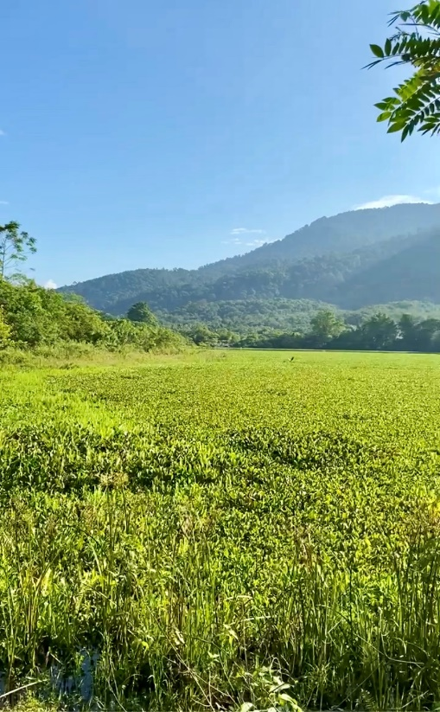

Lake 5, infested with water hyacinth before the project

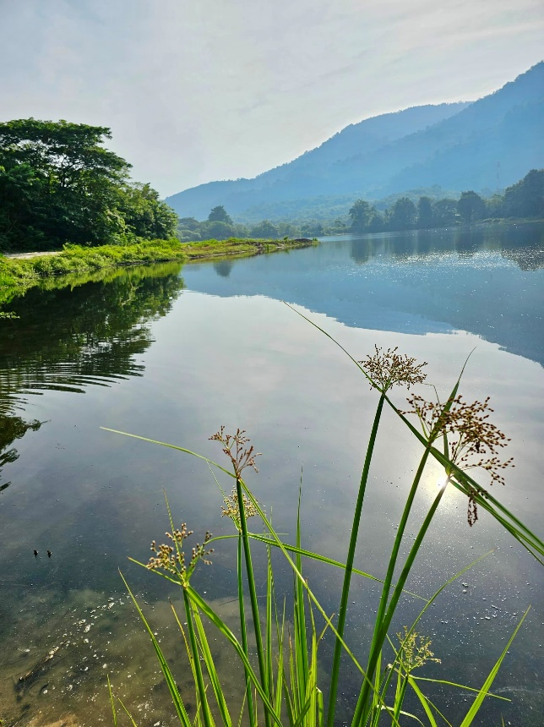

Lake 5, after clearing the water hyacinth

Continuing on their endeavour to transform abandoned lakes around Kampar into hubs of sustainable aquaculture, the team scored yet another milestone for sustainable aquaculture by successfully transforming Lake 5, located at UTAR Agriculture Park, Kampar Campus, into a sustainable fish farm.

The team’s previous progress entailed the successful transformation of Lake K11 at the UTAR Agriculture Park, Kampar into an educational site, which serves as the model lake for research advancement as well as a way to educate local communities on transforming abandoned ponds into a start-up commercialisation platform.

The transformation of Lake 5 represents the first UTAR ecological aquaculture project that involves deep collaboration with an industry partner. It essentially serves as a fish farm that not only promotes sustainable fish production and commercialisation, but also strengthens university-industry research collaboration.

Dr Wong said, “Our goal is to sustainably produce high-quality proteins to nourish society, while promoting fish production practices that minimise environmental impact.”

In this project, the team joined with PNT Gading Enterprise experts to cultivate high-quality fish based on sustainable methods. While the research team from UTAR monitors the conditions of the lake and provides scientific guidance, the enterprise provides its expertise in on-site operations and marketing.

“PNT Gading Enterprise is a key partner in this aquaculture project. En Mohamad Suki bin Abdullah, who is the current manager of the enterprise, mainly oversees the maintenance of the pond and the cultivation of fish. Meanwhile, the UTAR team monitors the aquaculture condition and water quality on a regular basis such as monitoring of algae community changes. As we monitor the lake’s condition, we will provide guidance based on our observation. Our partner will primarily manage the commercialisation process,” Dr Wong explained.

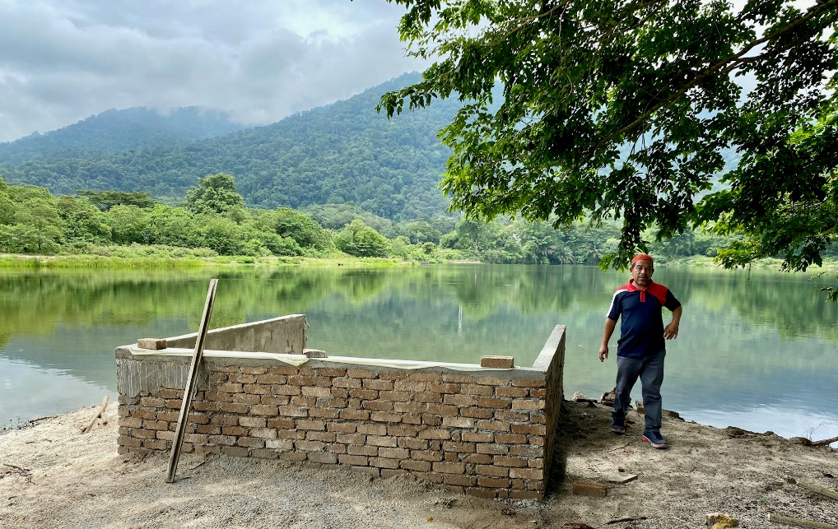

En Mohamad Suki bin Abdullah, Manager of PNT Gading Enterprise

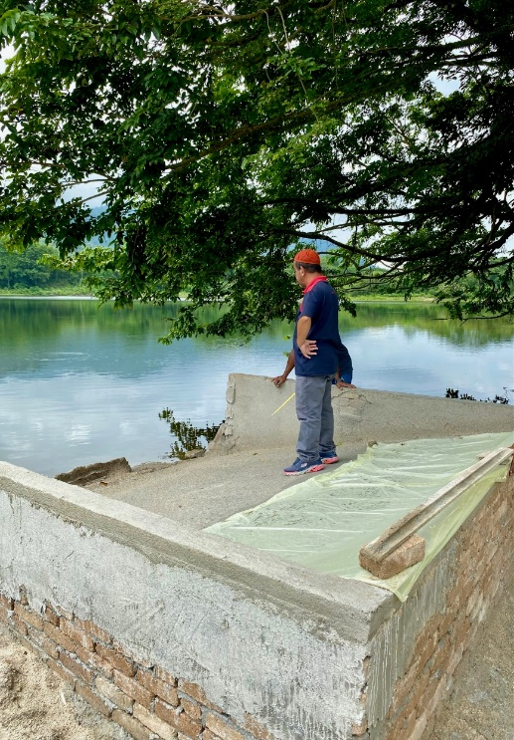

En Mohamad Suki overseeing the construction of the feeding site beside Lake 5

Lake 5 cultivates a variety of freshwater fish species, including Milkfish, Patin, and Carps. To ensure high-quality fish while preserving the lake’s ecosystem, Dr Wong’s team harnesses the lake’s natural resources, including its body of water, space, and ecological assets, focusing on biological integration and thus achieving the concept of self-sustainability.

Dr Wong said, “Our approach ensures that microorganisms such as plankton in the water not only serve as a natural food source for the fish, but also create diverse ecological niches for fish growth. This helps the fishes thrive while minimising excess nutrients in the water, which will contribute to a balanced and sustainable aquaculture system.”

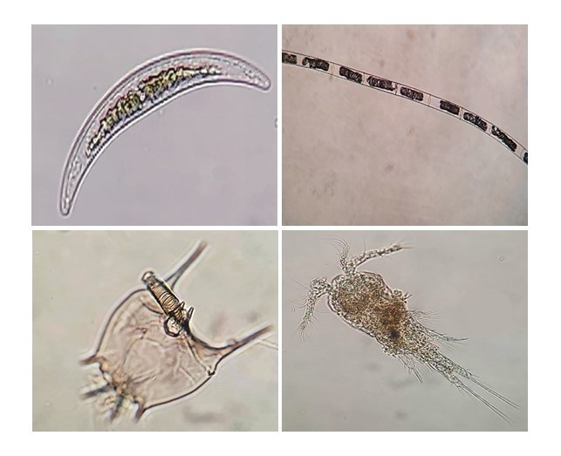

Lake 5 is home to a variety of plankton species; (Clockwise from top left) *Closterium* sp., *Leptocylindrus* sp., *Cyclopoida* sp., and *Lecane* sp.

Beyond its role as a fish farm, Lake 5 also serves as a research hub that drives research innovation among Agriculture students, offering hands-on experience in sustainable aquaculture, water quality management, and ecosystem balance. One of the students involved is Colin Kiu Qi Song, a UTAR Doctor of Philosophy in Biological Science student. Along with his peers, Colin Kiu assists in water sampling and analysing the lake’s conditions. As the fish reach marketable size, students will conduct further analyses to evaluate their health, growth and quality, providing insights into their aquaculture and food security research.

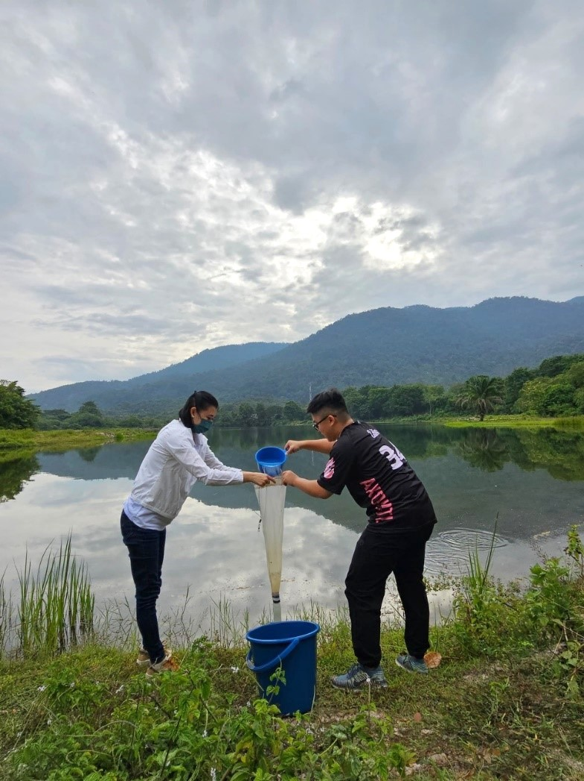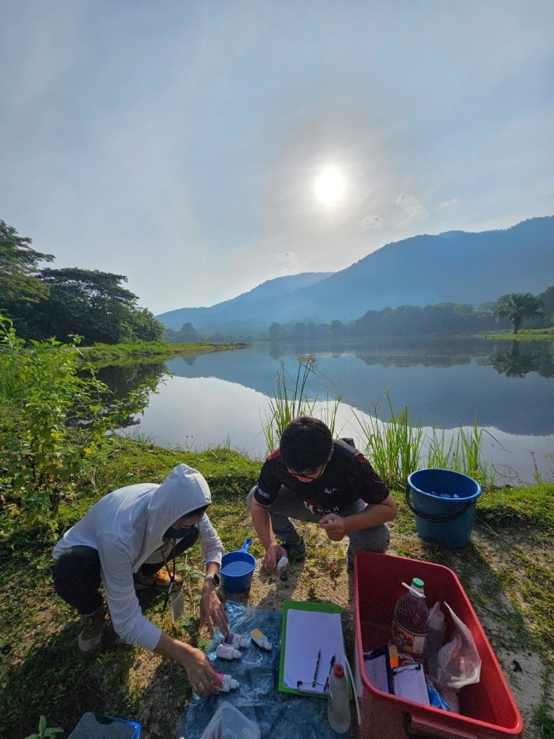

Dr Teoh (left) and Colin Kiu collecting water samples at Lake 5

Maintaining a natural fish farm does not come without its own set of difficulties and addressing the after-effects brought along by the sporadic nature of rainfalls in Malaysia quickly becomes one of them. Dr Wong highlighted the impacts, saying, “In aquaculture, prolonged rainy periods can significantly impact feeding practices and water ecology. Rainwater runoff can introduce sediments, organic matter, and pollutants into the water, leading to increased turbidity and a decline in water quality. This can also alter dissolved oxygen levels, pH, and nutrient availability, potentially disrupting the overall balance of the aquatic ecosystem. These factors can introduce stress among the fish as a result.”

The revitalisation of Lake 5 opens new possibilities for not only environmental but also food sustainability. The aquaculture project, which began its motion as a Knowledge Transfer Programme (KTP), reflects not only UTAR’s but also the Malaysian community’s commitment to preserving and harnessing natural resources.

“As more lakes will be revitalised in the near future, we hope to collaborate with more industry players, as it will help to improve the farming and marketing techniques of local aquaculturists, and at the same time, we can make better use of lakes’ natural resources to sustainably produce freshwater fish for the local market,” Dr Wong enthused about the project’s future.

The transformation of Lake 5 at UTAR Kampar Campus further underscores the university’s commitment to integrating academic and industry expertise to achieve greater heights. It also marks a significant step towards ensuring food security and preserving natural resources for future generations. As the FSc team continues to explore joint initiatives with more industry partners, the Kampar community can look forward to the prospect of enjoying aquatic proteins that are sourced from sustainable and healthy aquaculture farms.