Young Leaders Mentoring Programme 2024 ignites leadership potential in youths
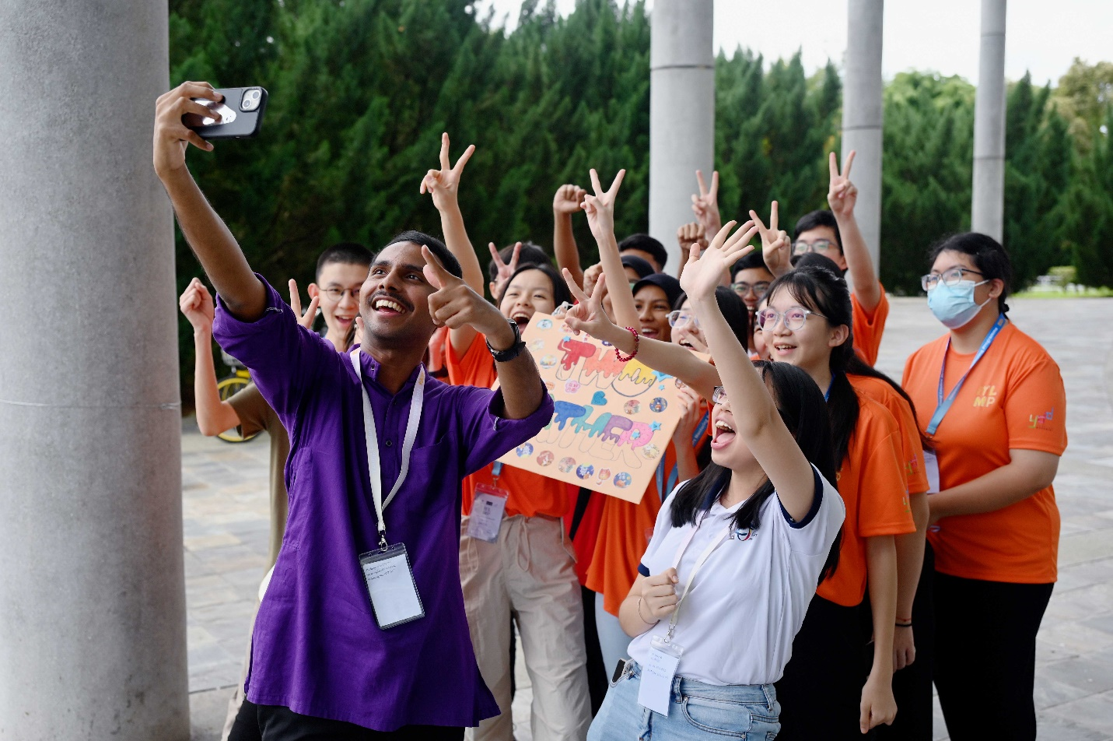
Student facilitators sharing light-hearted moment with their team of scholars during one of the activities
A major part of guiding a team towards achieving its goals in an effective and efficient manner depends on the capability of its leaders. Whether it is a small or a huge team like a conglomerate corporation, it is a leader’s responsibility to empower and unleash the potential of their followers, which is a key point towards achieving collective success.
Everyone will find themselves in leadership roles at various points in their life, whether navigating a team’s pathway or making personal decisions. Hence, it is crucial to cultivate leadership skills at a young age to ensure a solid foundation for future responsibilities.
In the quest to uncover and develop leadership skills among Malaysian youths, the UTAR Division of Programme Promotion (DPP), with support from the UTAR Career Development Club, joined hands with Yu Cai Foundation (YCF) and Yayasan DayaDiri (YDD) to organise the Young Leaders Mentoring Programme (YLMP) 2024 at UTAR Kampar Campus, from 13 to 15 September 2024.
Previously organised in conjunction with the UTARambassador Leadership Camp (ULC) 2023, YLMP 2024 marked the second year of close collaboration between UTAR, YCF, and YDD in cultivating young leaders at UTAR Kampar Campus. This year’s camp gathered a total participation of more than 100 scholars from YCF and YDD, with an addition of more than 20 teacher counsellors from 32 schools across seven states in Malaysia. It was also joined by 42 UTAR students, who assisted in the camp.
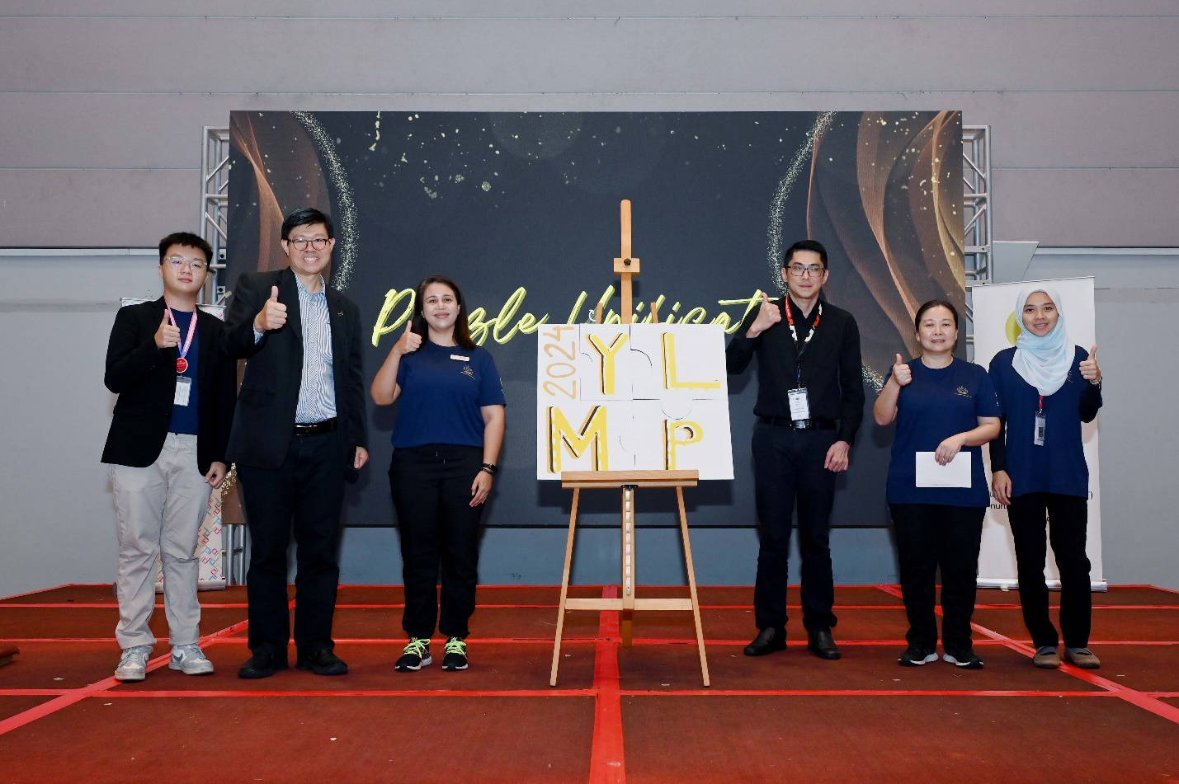
From left: Khor, Prof Choong, Ms Siti Nashrah, Mr Tan, Ms May Quah, and Cik Nur Nafisa inaugurating YLMP 2024
The camp entailed three days of activities, including educational talks, games, workshops, sharing sessions, stage performances, and community service. Through these diverse experiences, the participants were actively engaged in building their skills in various aspects such as communication, empathy, problem-solving, critical thinking, divergent thinking, team-building, self-discovery and adaptability, which are essential for solidifying leadership qualities.
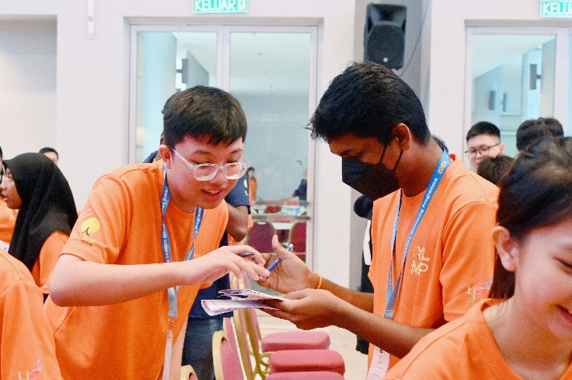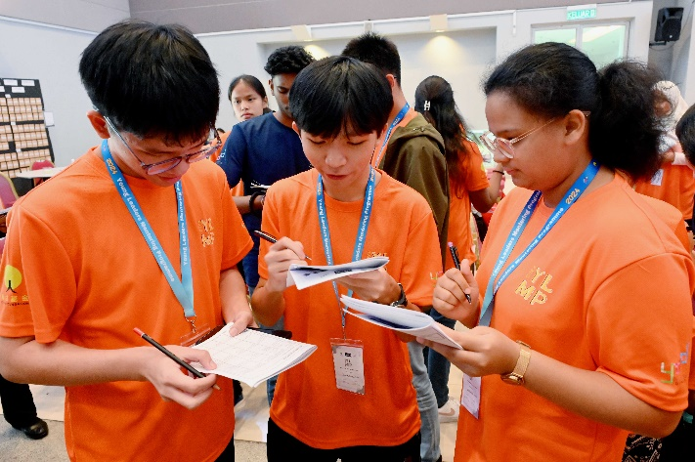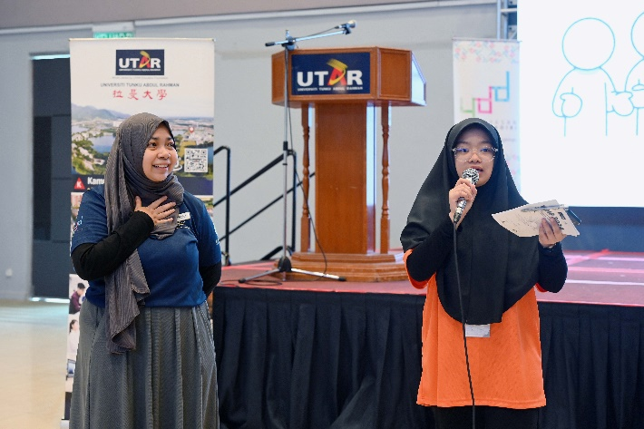
Participants getting to know one another during the ice-breaking session
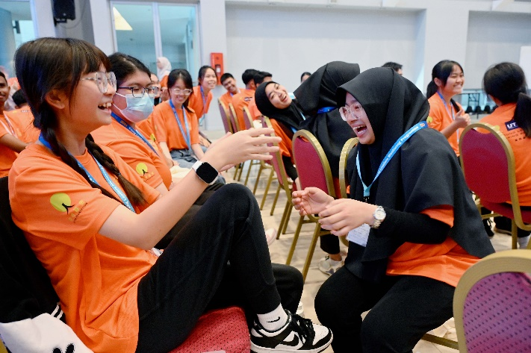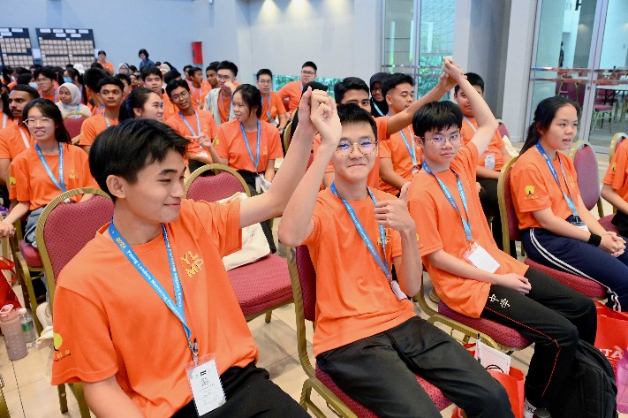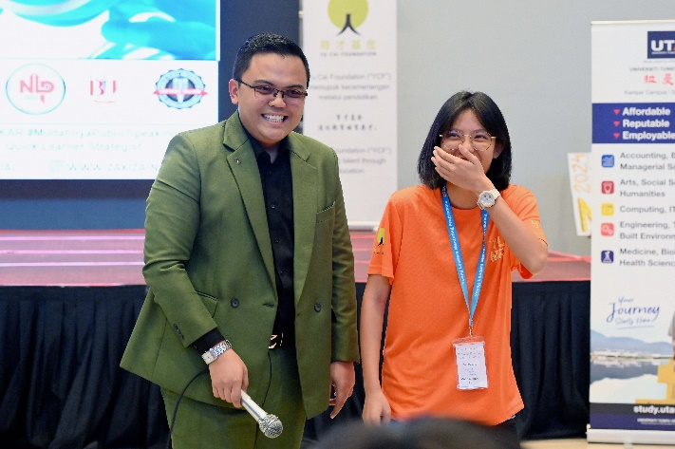
Participants learning the dangers and benefits of social media with En Zaki Zainal, TV Host and Anchor of Astro Arena
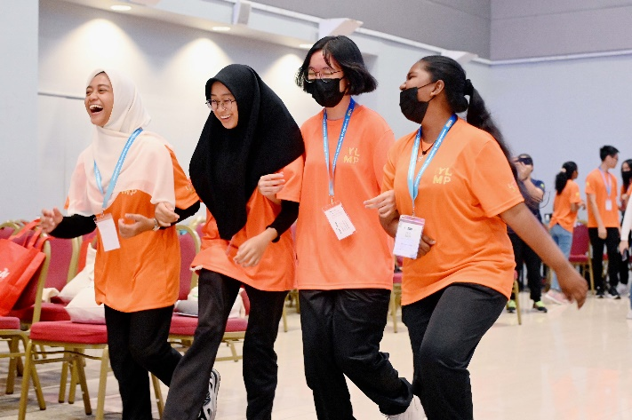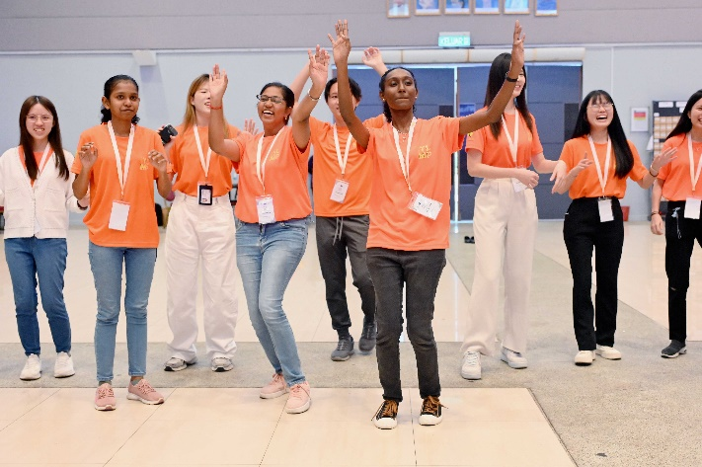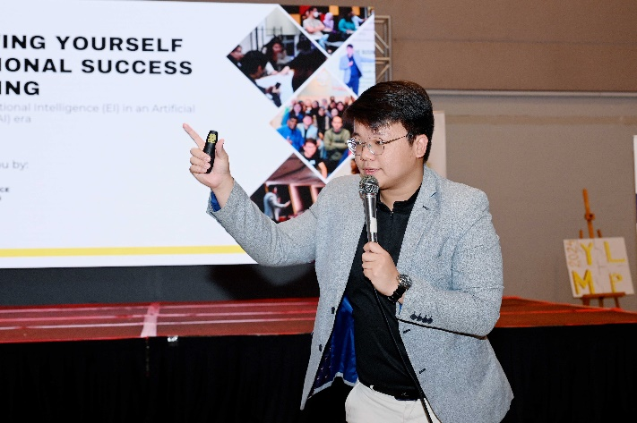
Participants dancing to express and learn about themselves during “Knowing Yourself” Workshop by Mr Jason Fung, Co-Founder of Experience Enablers
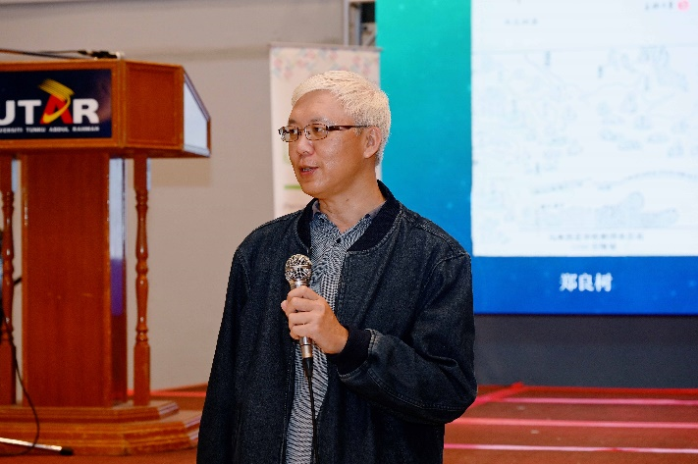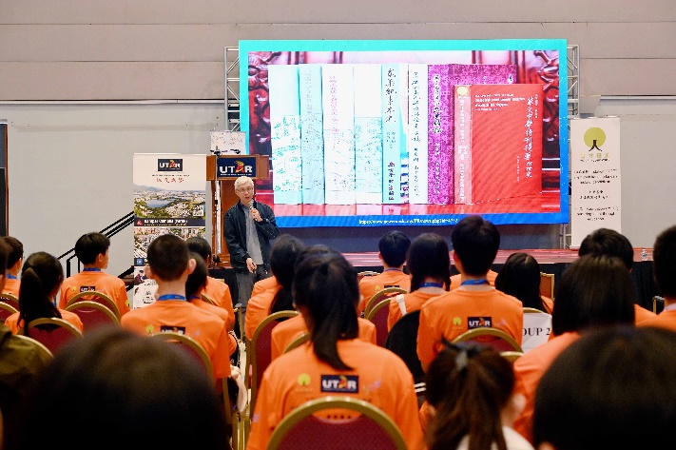
Dr Tan Beng Piou, UTAR Institute of Chinese Studies (ICS) academic, shedding light on the history and modern development of Chinese education
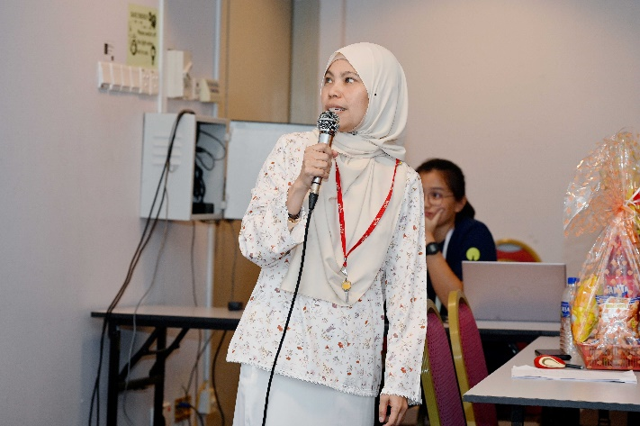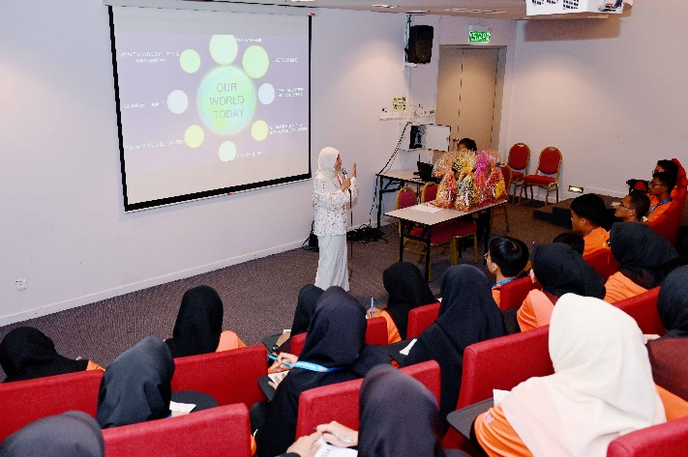
Dr Zam Zuriyati binti Mohamad, Deputy Head of UTAR Centre for Curriculum Development and Innovation (CCCD) of Kampar Campus, exploring global trends with participants
Friendship and open-mindedness were part of the core lessons in the camp. With diverse groups of participants, YLMP 2024 also aimed to instil the spirit of mutual respect among them through its fun and unique activities. Participants were encouraged to share their viewpoints and learning experiences with their peers from other schools, creating an environment where a wide range of ideas were valued and appreciated.
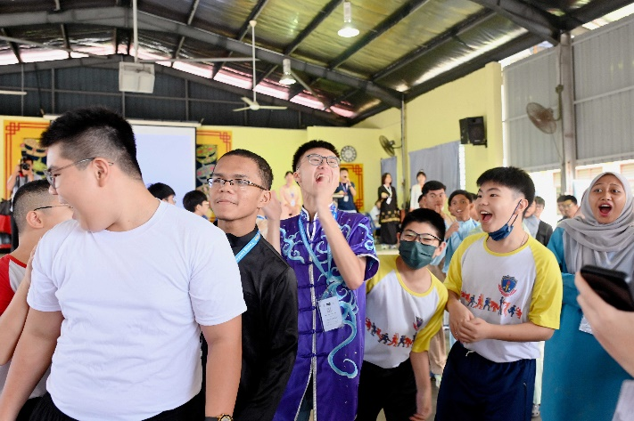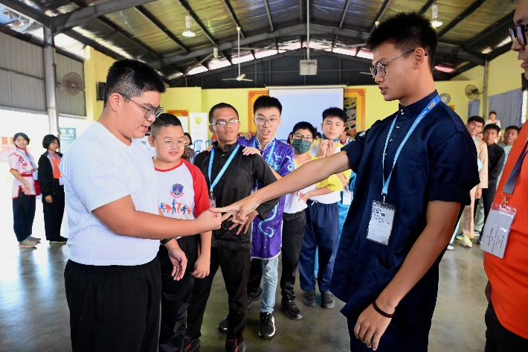
Participants breaking the ice with SJK(C) New Kopisan students with a game of rock paper scissors
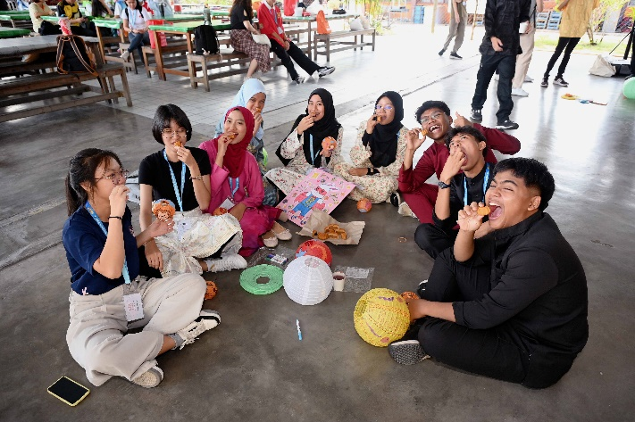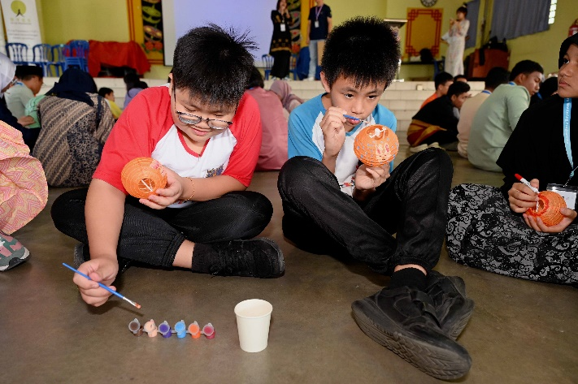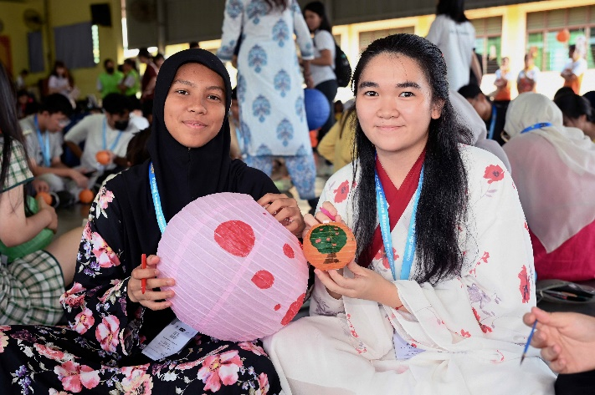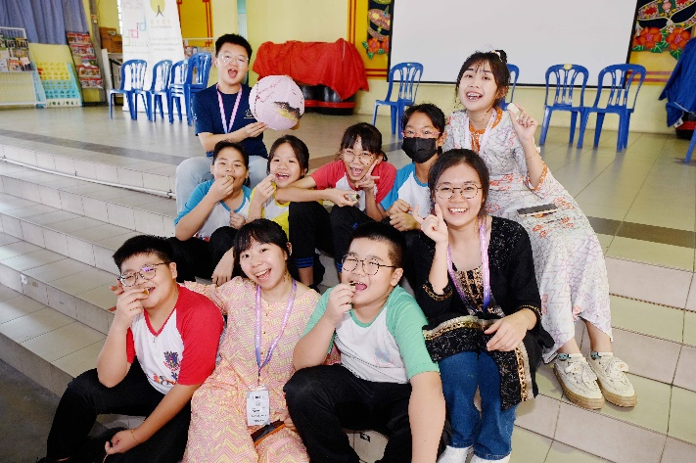
Fun and teamwork displayed during the alliance between SJK(C) New Kopisan students and participants in preparing Mid-Autumn Festival decorations
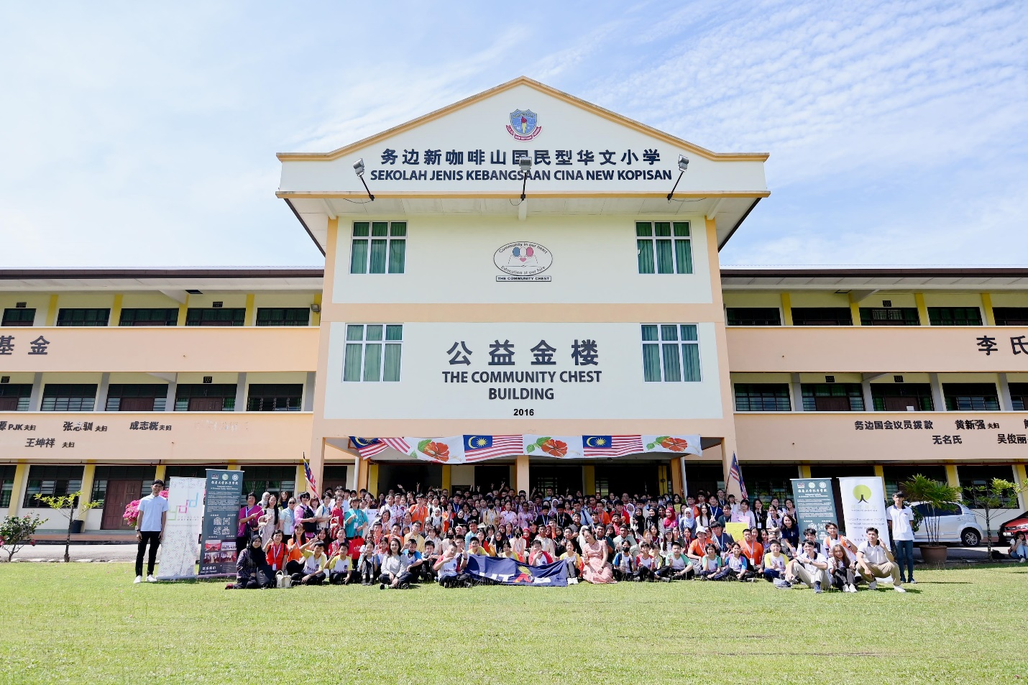
Group photograph of YLMP 2024 group and SJK(C) New Kopisan students
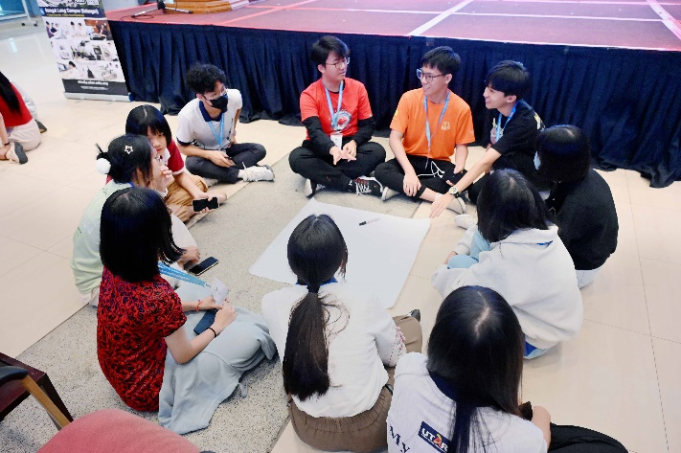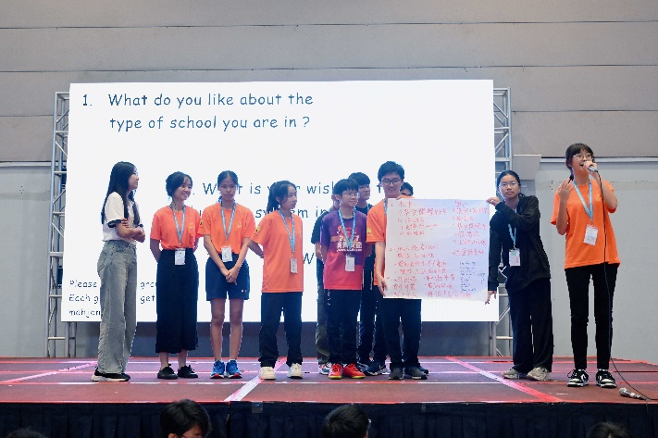
Participants discussing and voicing out the pros and cons of their respective school education systems on stage during a group challenge
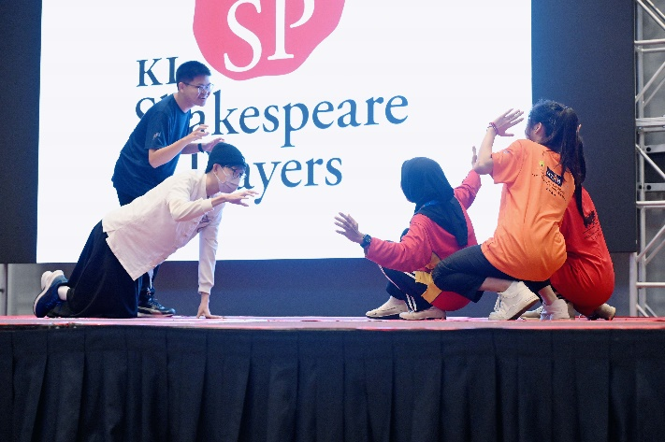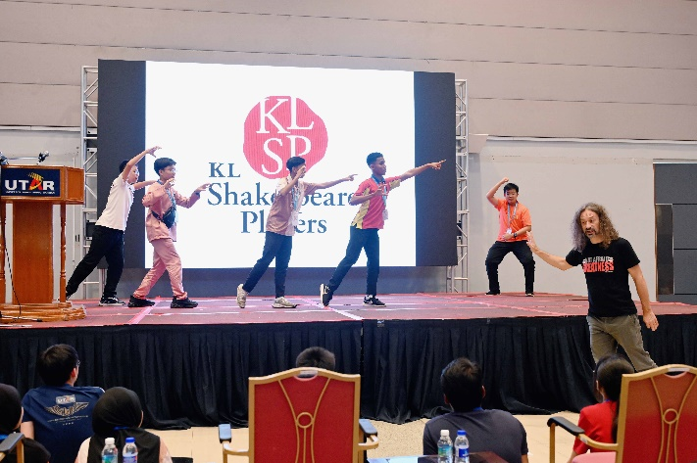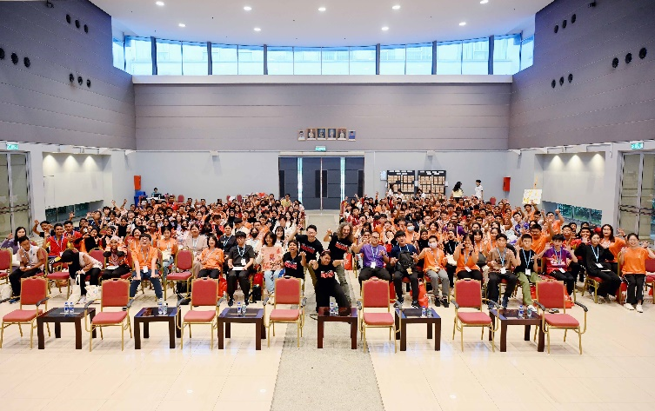
Participants learning effective and impactful emotion expressions through Shakespearean stage play, guided by the KL Shakespeare Players
Besides that, the camp exposed the participants to contemporary technological trends such as artificial intelligence (AI), and provided participants with the opportunities to interact with prominent players in the media industry, offering valuable perspectives on how technology is shaping communication and leadership in today’s world. By gaining knowledge of the media landscape, participants were engaged in exploring skills needed to thrive in the ever-evolving job market and learn about their potential future career paths.
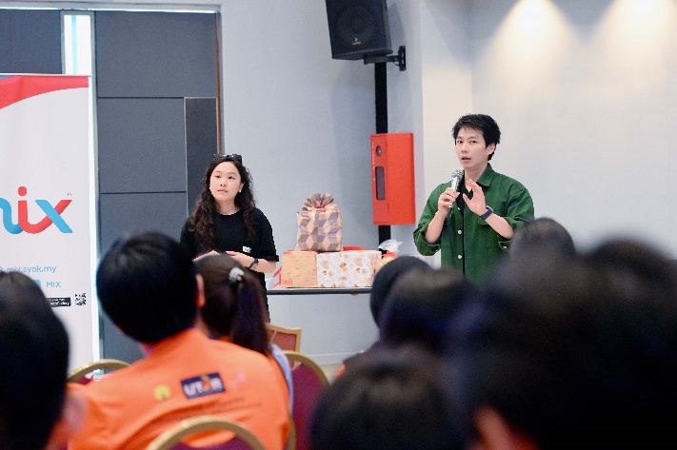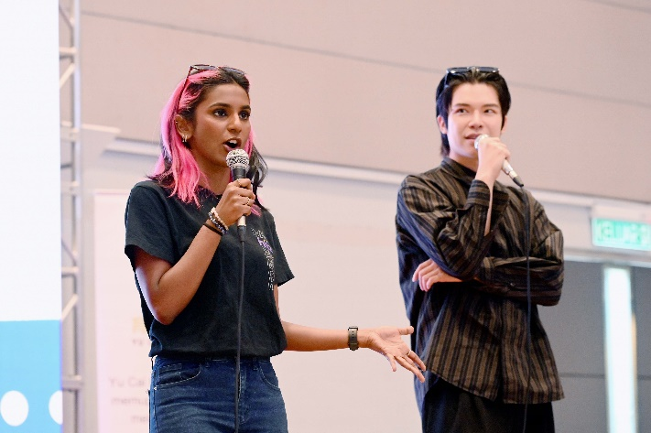
From left: (left photo) Brand Manager of MIX Ms Rosalind Teng, Brand Manager of MY FM Mr Chew Wei Boon, (right photo) Breakfast Announcer of HITZ Ms Anne Jacyntha, and Night Shift Announcer of MY FM Mr Daniel Wong Zhen Yu sharing their valuable insights on the evolving radio and media industry
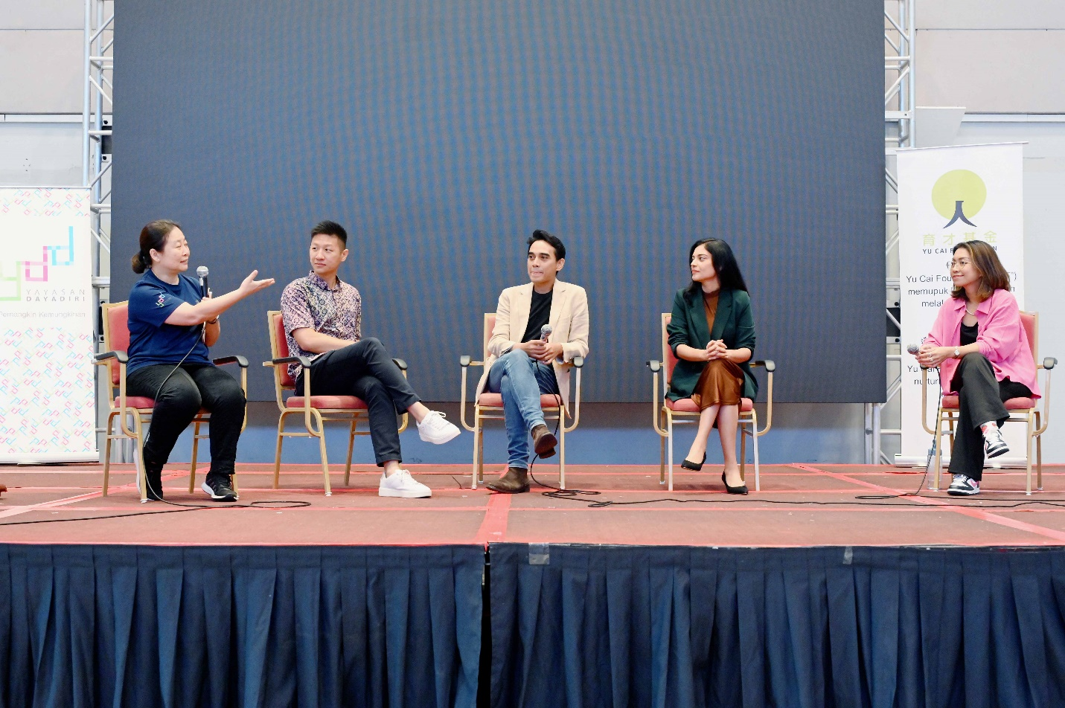
(Second from left onwards) Maxis Head of Corporate Responsibility Mr Saw Yu Shen, Astro AWANI Head and Editor-in-Chief En Ashwad bin Ismail, Malaysian actor and producer Ms Sangeeta Krishnasamy, and Maxis Young Talent Specialist Ms Aisyah Aris sharing their perspectives on developing leadership skills in their respective fields; facilitated by Ms May Quah (far left)
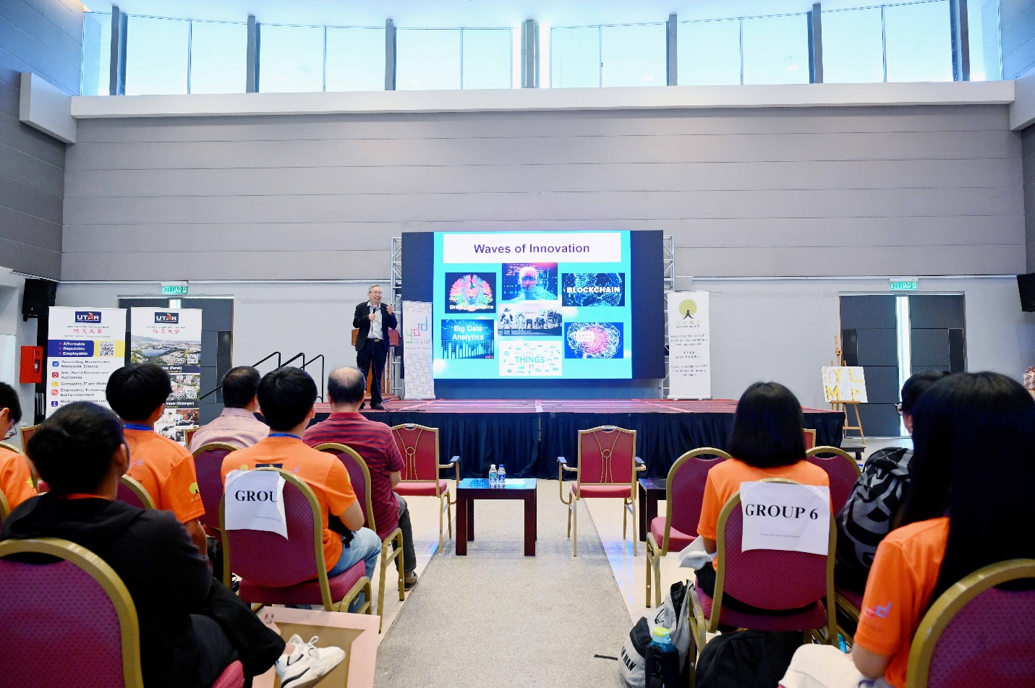
Prof Dato’ Ewe elucidating essential 21st century skills to navigate today’s technologically advanced world
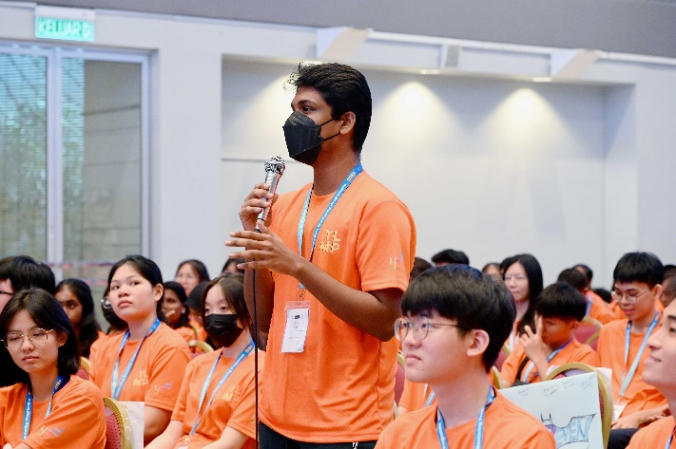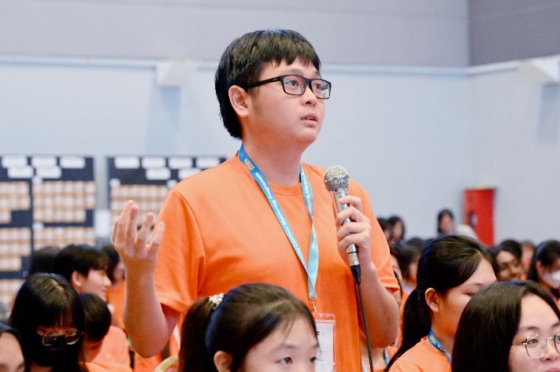
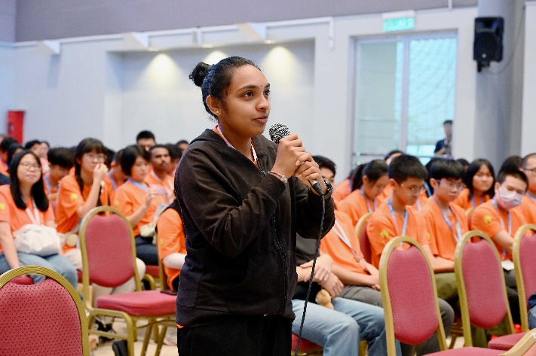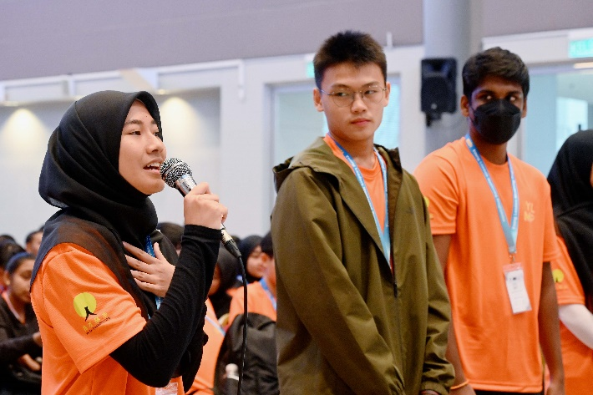
Participants actively presenting their questions to the media industry professionals
UTAR President Ir Prof Dato’ Dr Ewe Hong Tat said, “Throughout the camp, the scholars have engaged in meaningful discussions, gained practical experience, and built networks with their peers and mentors. These experiences are invaluable, not just for their personal growth, but for the communities and industries that they will one day lead. Leadership is not only about knowledge and authority, but also about empathy, resilience, and adaptability, which are crucial traits in today’s ever-changing world.”
He added, “My heartfelt appreciation goes to YCF and YDD, for not only supporting this programme but for their continued trust in UTAR. Their dedication to nurturing talent and fostering intellectual growth through various initiatives is invaluable, and we deeply appreciate their partnership.”
YCF Chairman Mr Chan Chee Beng said, “As the Chinese saying goes, ‘It takes ten years to grow a tree, but a hundred years to cultivate people’. Nurturing talent requires significant planning and investment. YCF and YDD have always believed in nurturing talent and supporting initiatives to uplift underserved communities. The foundations create opportunities for individuals to excel by providing a range of scholarships that cover primary education up to executive education including technical and vocational education and training, granting support for community development in Peninsular Malaysia.”
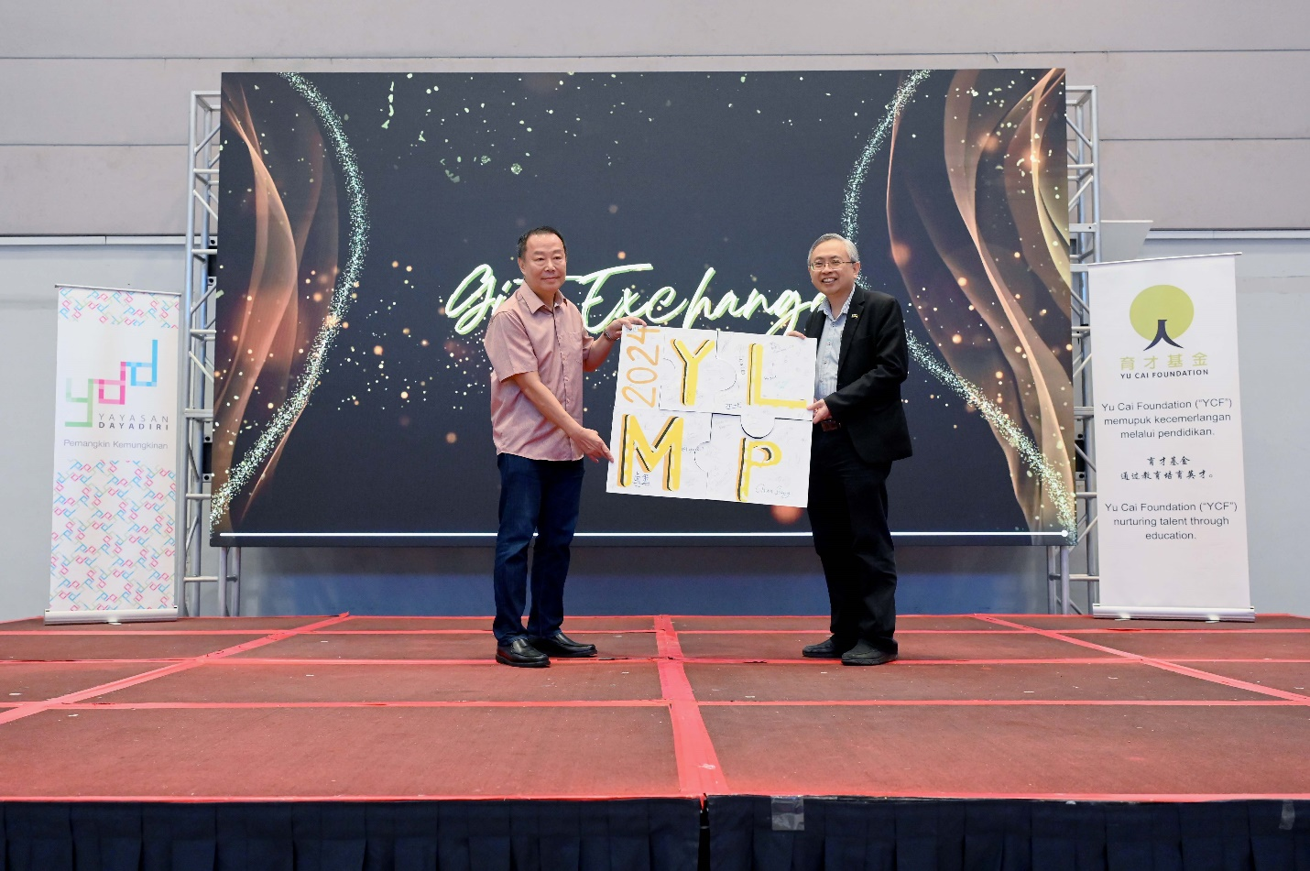
Prof Dato’ Ewe (right) and Mr Chan during the closing ceremony
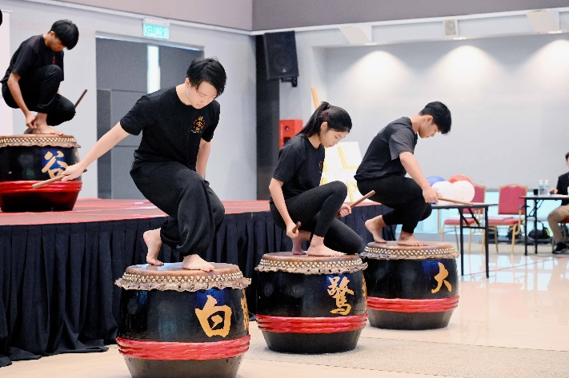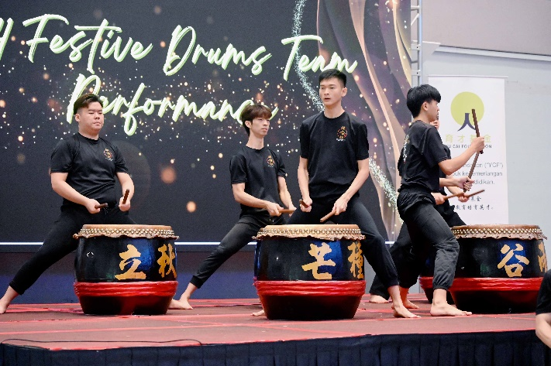
An energetic 24 Festive Drum performance by UTAR Kampar 24 Festive Drums Team, concluded the three-day camp at Kampar Campus
Also present at the opening and closing ceremony of YLMP 2024 were YCF Board of Trustee Mr Ngooi Chiu Ing, YCF Head of Foundation Ms May Quah Bee Fong, YDD Head of Foundation Ms Siti Nashrah Nur binti A. Malek, UTAR Council Member Mr Hew Fen Yee, UTAR Vice President for Student Development and Alumni Relations Prof Dr Choong Chee Keong, DPP Acting Director Assoc Prof Ir Dr Lim Jee Hock, DPP Deputy Director Mr Tan Choon Wah, YLMP 2024 Student Organising Chairperson Khor Chun Sian, DPP Assistant Manager Cik Nur Nafisa binti Salim, school teachers and students, and UTAR staff and students.
With the successful conclusion of YLMP 2024, more Malaysian youths are now better prepared to embrace their potential as future leaders. The camp not only equipped the scholars with essential skills of the 21st century, but also instilled the spirit of unity and mutual respect, empowering them to navigate challenges and inspire innovation in their respective fields through empathy, resilience and adaptability.
UTAR is proud to collaborate once again with YCF and YDD to organise YLMP at UTAR Kampar Campus. This collaboration reflects the organisations’ commitment to providing not only a holistic educational experience, but also opportunities for personal growth and community engagement, ensuring that Malaysian students are well-equipped to face future challenges and make meaningful contributions to society.

Name | State
Chinese High School Batu Pahat | Johor
Chong Hwa High School S.B.R., Batu Pahat | Johor
Pei Chun High School (Independent), Pontian | Johor
Pei Hwa High School, Tangkak | Johor
SMJK Seg Hwa, Segamat | Johor
SBPI Kubang Pasu | Kedah
SM Sultan Abdul Halim, Kubang Pasu | Kedah
SM Keat Hwa (Persendirian), Alor Setar | Kedah
SMJK Keat Hwa, Alor Setar | Kedah
SMJK Sin Min, Sungai Petani | Kedah
Chung Hwa Independent High School, Ketereh | Kelantan
Chung Hua High School Seremban | Negeri Sembilan
SMJK Chan Wa, Seremban | Negeri Sembilan
SM Chong Hwa Kuantan | Pahang
SMJK Hwa Lian, Mentakab | Pahang
Chung Ling Private High School, Ayer Itam | Penang
SMJK Chung Ling, Ayer Itam | Penang
SM Sains Tun Syed Sheh Shahabudin, Bukit Mertajam | Penang
SMJK Jit Sin, Bukit Mertajam | Penang
SMJK Chung Ling Butterworth | Penang
SMJK Phor Tay, Bayan Lepas | Penang
SMJK Union, Georgetown | Penang
Hua Lian High School Taiping | Perak
SMJK Hua Lian, Taiping | Perak
Pei Yuan High School, Kampar | Perak
SM Tsung Wah (SUWA), Kuala Kangsar | Perak
SMJK Ave Maria Convent, Ipoh | Perak
SMJK Poi Lam, Ipoh | Perak
SMJK Choong Hua, Bidor | Perak
SMJK Dindings, Lumut | Perak
SMJK Katholik, Tanjong Malim | Perak
SMJK San Min, Teluk Intan | Perak

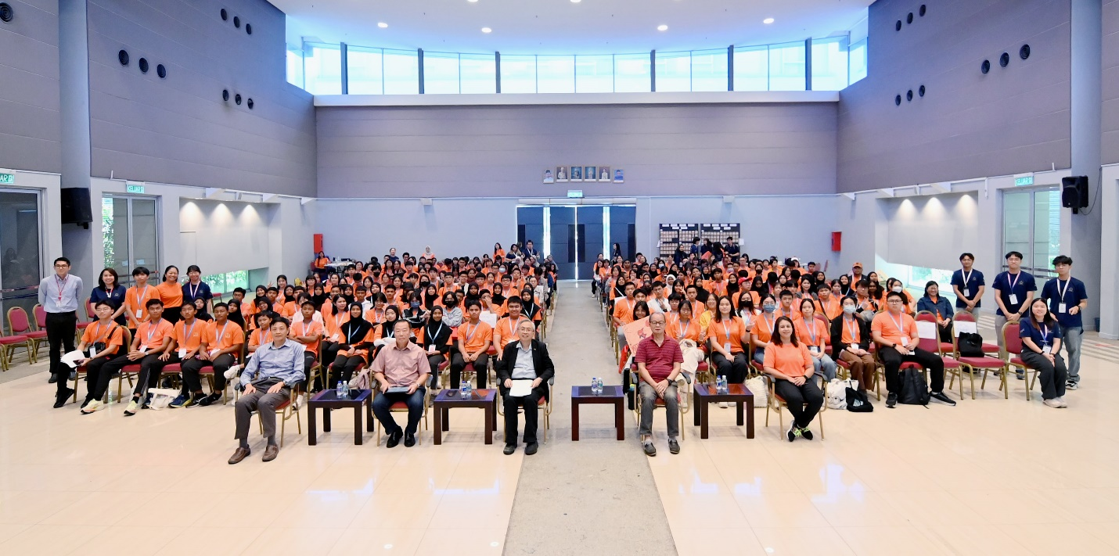
Front row, from left: Mr Hew, Mr Chan, Prof Dato’ Ewe, Mr Ngooi, and Ms Siti Nashrah with participants, teachers, organising committee members, student facilitators and UTAR staff and students during the closing ceremony

