CFS inspires teamwork and self-belief among SMK Pusing school students

In a pursuit to spark motivation and teamwork among secondary school students, the Centre for Foundation Studies (CFS) of UTAR Kampar Campus organised a memorable school engagement project on 11 October 2024. The event brought together over 100 students from SMK Pusing, Batu Gajah.

The day began with an inspiring motivational talk titled, Create Your Own Path, delivered by CFS Kampar Campus academic Ms Chan Wan Ling. Ms Chan shared her personal journey and highlighted the importance of self-belief, education, and goal setting. She encouraged the students to discover their passions and have the courage to pursue their dreams.

Following the enlightening talk, the students were divided into groups for a series of interactive team-building activities facilitated by CFS Kampar Campus academics Ms Yip Mei Theen, Ms Kow Li Fen, Mr Ho Wai Yew, Mr Voon Kah Loon and UTAR student helpers. These activities not only promoted teamwork and communication but also encouraged the participants to think creatively.

The students’ feedback on the event was overwhelmingly positive. Yip Shye Kei from Form 4 ALFA shared, “The motivational talk was truly inspiring. It made me realise that no effort is ever wasted, and every step counts.” Chong Jia Cong, also from Form 4 ALFA, added, “The talk boosted my confidence and helped me realise that I have the power to shape my future.” Seng Wen Han from Form 4 ALFA commented, “I really enjoyed the team-building activities. They improved our teamwork, camaraderie, and communication skills.”

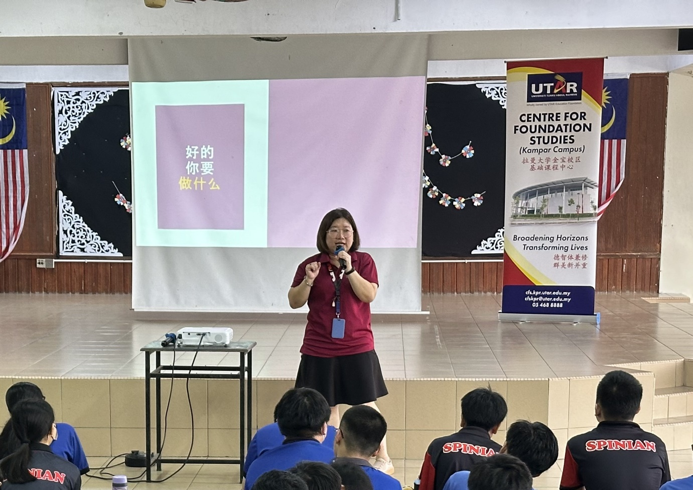
Ms Chan inspiring students to pursue their dreams
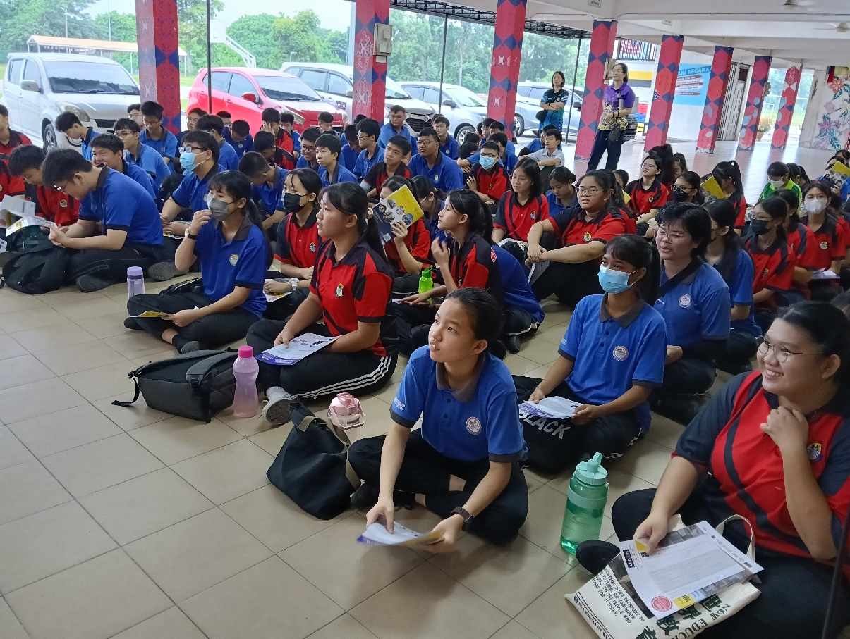
Students engrossed in the motivational talk

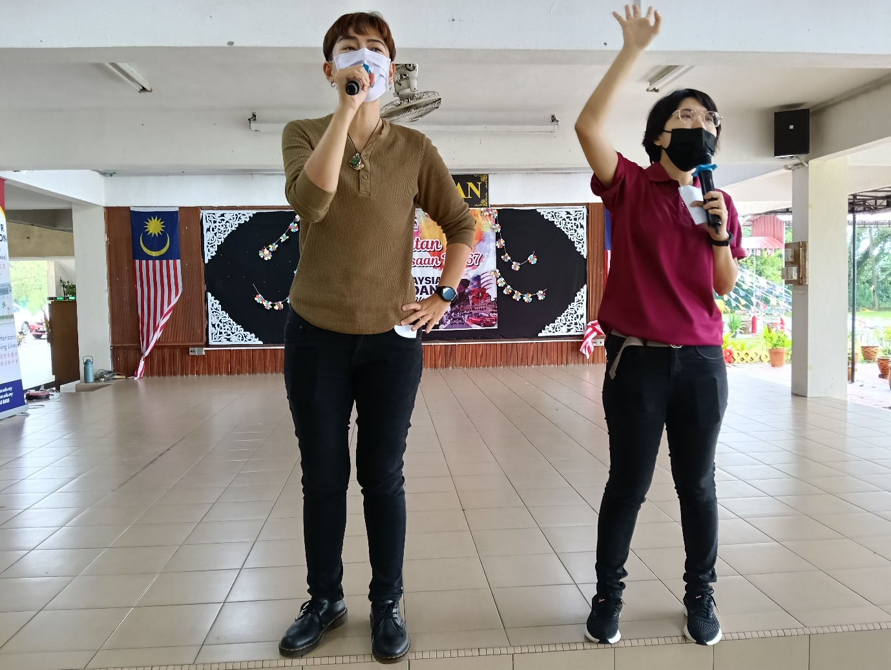
Ms Kow (left) and Ms Yip (right) conducting the team-building activities
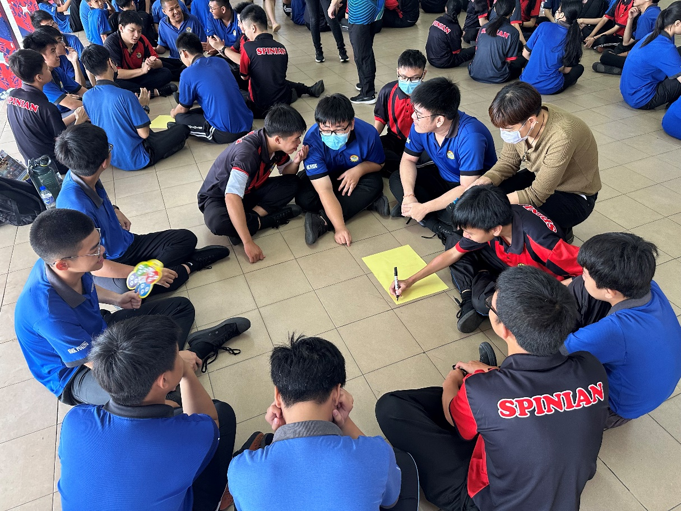
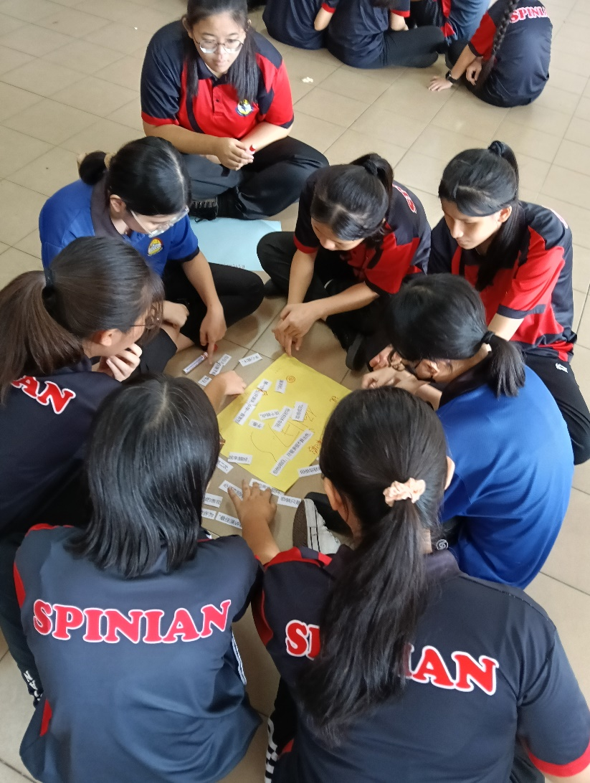
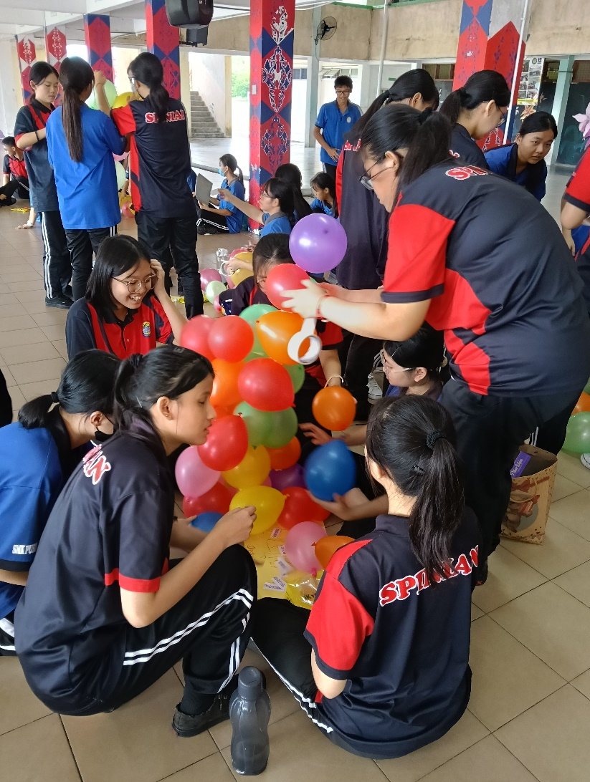
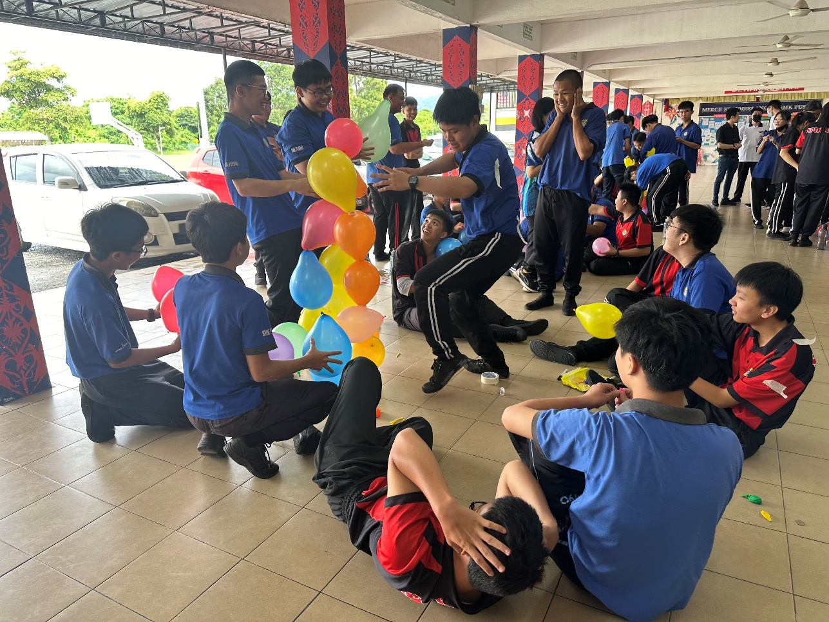

Students immersing themselves in team-building activities

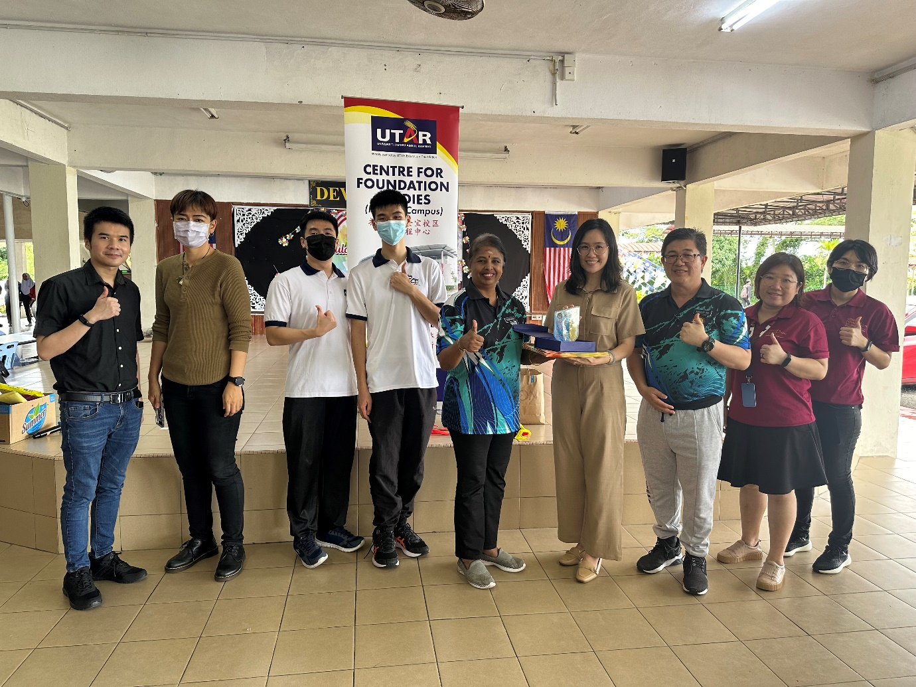
Dr Magaswari Ubbudari, the principal at SMK Pusing (fifth from left) presenting a token of appreciation to CFS Department of Management and Accountancy (Kampar Campus) Head Ms Tsen Tzu Yee (sixth from left)
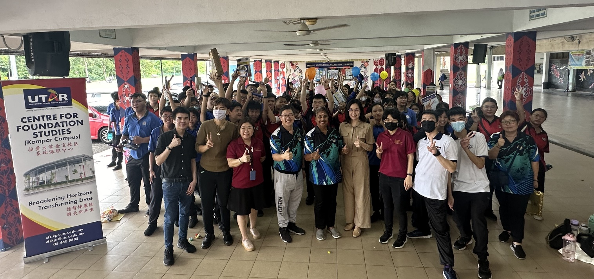
Group photo after the event

