**Bridging culture and knowledge: A collaborative learning journey at UTAR**

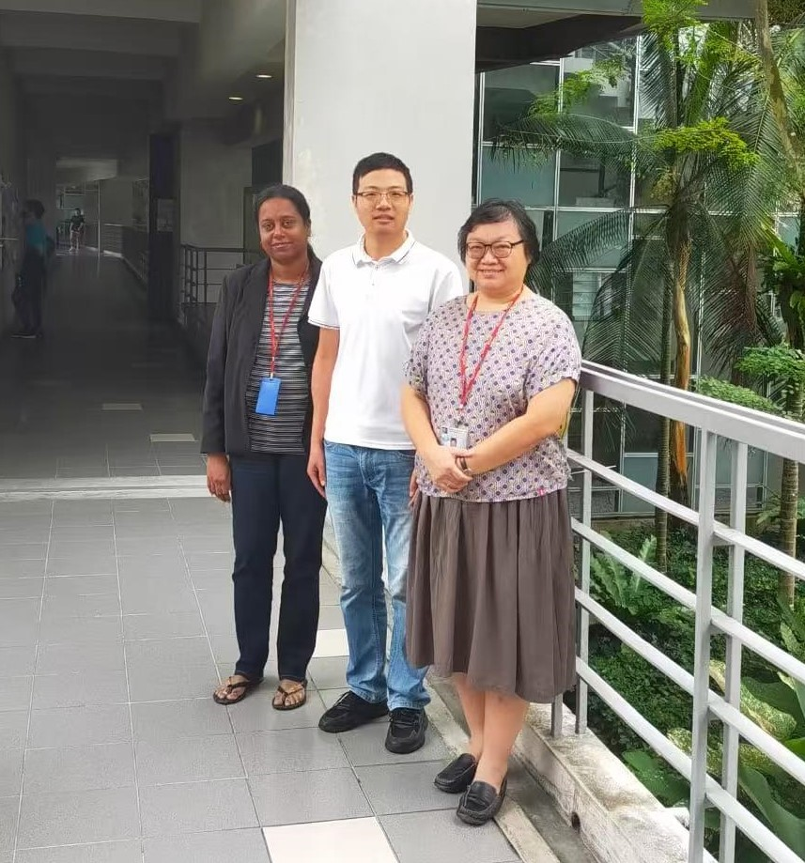

From left: Dr Thavamalar, Mr Lin, and Dr Au Yong

Knowledge is essential in pursuing excellence; it serves as the foundation for addressing global issues because it empowers individuals to foster innovation and overcome challenges. As globalisation becomes the norm around the world, the sharing of knowledge takes on unprecedented significance. With key objectives to cultivate diverse perspectives and innovative ideas among the posterity, UTAR places great importance on collaborative learning, promoting a comprehensive network of partnerships with industry and educational organisations and creating platforms for students and faculties to engage in meaningful exchanges.

One of the notable partnerships that highlight collaborative learning is between UTAR and the Shandong Foreign Trade Vocational College of China (SFTC). As a significant part of the academic exchange programme, Mr Lin Bing, an academic from SFTC, joined UTAR Faculty of Business and Finance (FBF), Kampar Campus for a year-long research attachment, aiming to broaden his knowledge in the field of economics, business and management. During his quest for personal growth in the town of Kampar, he not only gained valuable insights into the systematic aspects of his field of interest, but also formed meaningful friendships with local peers and students from his homeland studying in Kampar.

The aspiring academic embarked on his scholarly journey at UTAR from 31 August 2023 to 19 August 2024.

Mr Lin graduated from his alma mater in China with a master’s degree in Linguistics. By that time, his passion in the field of economics, business and management had not surfaced. It was not until he joined SFTC as a lecturer who assisted in nurturing future international business professionals, that his zeal in this field began to flourish.

“I did not receive systematic education in economics, business and management before. However, my experiences cultivating talents at SFTC for international trade triggered my interest in the field. I began to contemplate some ideas to explore, including vocational reforms in business education, integration of the vocational education system, general education and industry, etc. Hence, my visit to UTAR gave me a good opportunity to explore these ideas more systematically,” Mr Lin said.

His initial research at UTAR entailed the study of business undergraduates’ employability skills after their internship programme. The research was funded under the Shandong Province Social Science Planning Research Programme. His team members included FBF Head of Department of Economics during his research attachment Dr Thavamalar Ganapathy, and academic Ms Chitrah Krishnan. They conducted a comparative study on the employability skills of business undergraduates between Malaysia and China after their internship programmes.

Besides that, his study on business undergraduates’ employability skills led him on the prospect to explore the role of language in digital economy transformation, especially in the rapidly emerging industry of live-streaming e-commerce.

He said, “The rapid development of live streaming e-commerce format has not only given rise to a strong demand for talents, but also highlighted various issues in the absence of a digital marketing talent training system. Live streaming hosts are in great demand nowadays and besides their appealing appearance, they need to demonstrate their marketing tactics through effective use of language. This shows the importance of language in driving online sales.”

The unique language diversity of Malaysia also piqued the academic’s interest. He explained, “In a multi-language society like Malaysia, learning different languages is an invaluable investment for a person’s life-long career development. As one of the factors towards career success, it is interesting to evaluate the investment-return ratio of language learning both for individuals and society as a whole. My time at UTAR may not be enough for more exploration, as it requires a great amount of systematic studies. Nonetheless, this research attachment serves as a beginning to further my studies on these points of interest in the future.”

In conjunction with the 50th anniversary of the establishment of diplomatic relations between Malaysia and China, Mr Lin took on a significant role in a research led by Dr Thavamalar, titled “Work Integrated Learning (WIL) among business students in technical and vocational education and training (TVET): A Comparative Analysis between Malaysia and China”. The study is funded under UTAR Research Fund 2024 Cycle 1. Although his period of research attachment has ended, Mr Lin looks forward to completing the study in the near future with his team.

The journey to share his knowledge and learn from others extended beyond research alone. Throughout his visit, Mr Lin participated in a diverse array of academic and cultural activities, providing fresh perspectives to his worldview and enriching his learning experience in the peninsular land of Southeast Asia.

He shared, “I participated in 14 lecture and training sessions with topics ranging from research paper writing to effective use of research platforms and software, and sustainable education and social development. Besides, I conducted two sharing sessions with UTAR staff and students about my research work. These experiences not only gave me the opportunities to learn more about the key employment points in UTAR, but also broadened my academic horizons.”

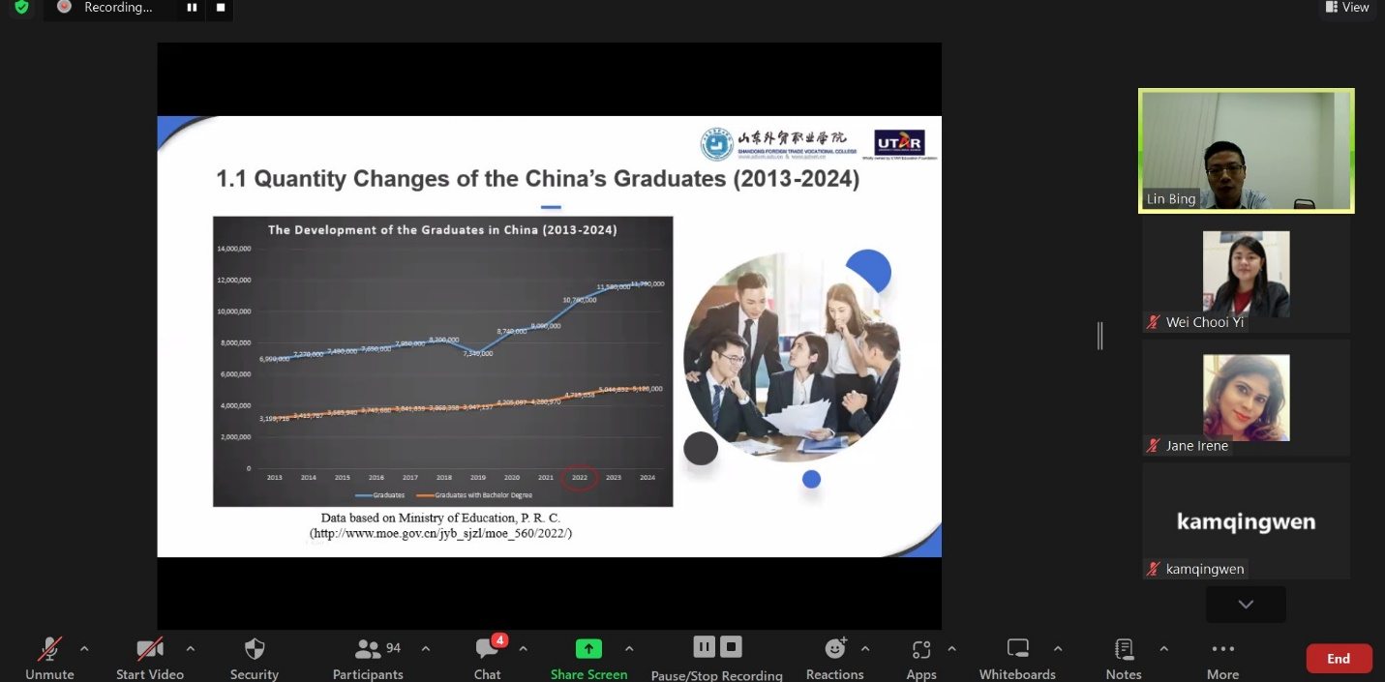

Mr Lin elucidating his research on the employability skills of China’s graduates to researchers and students during a sharing session

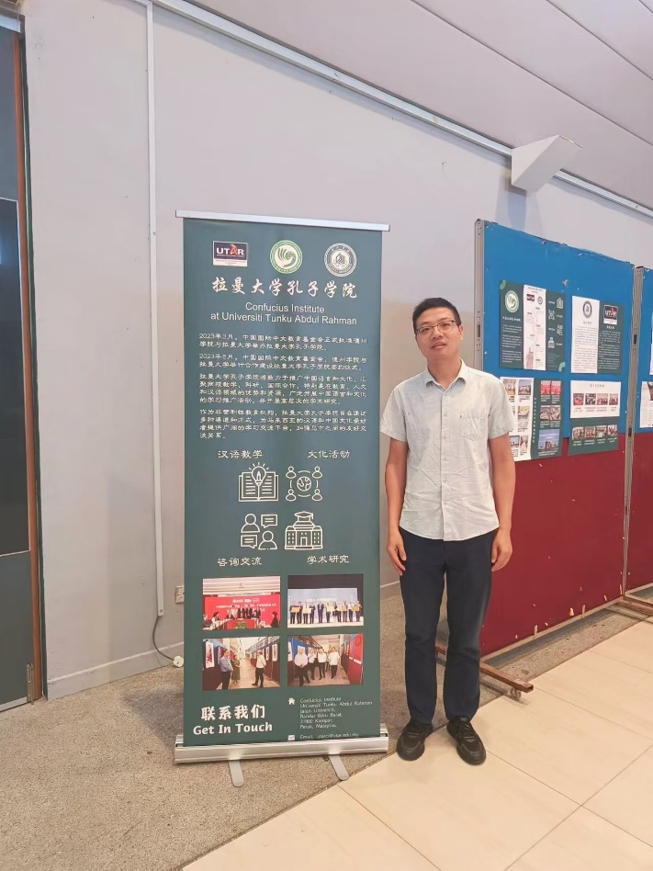

Mr Lin’s participation in the International Conference on the 50th Anniversary of the Establishment of Diplomatic Relations between Malaysia and China

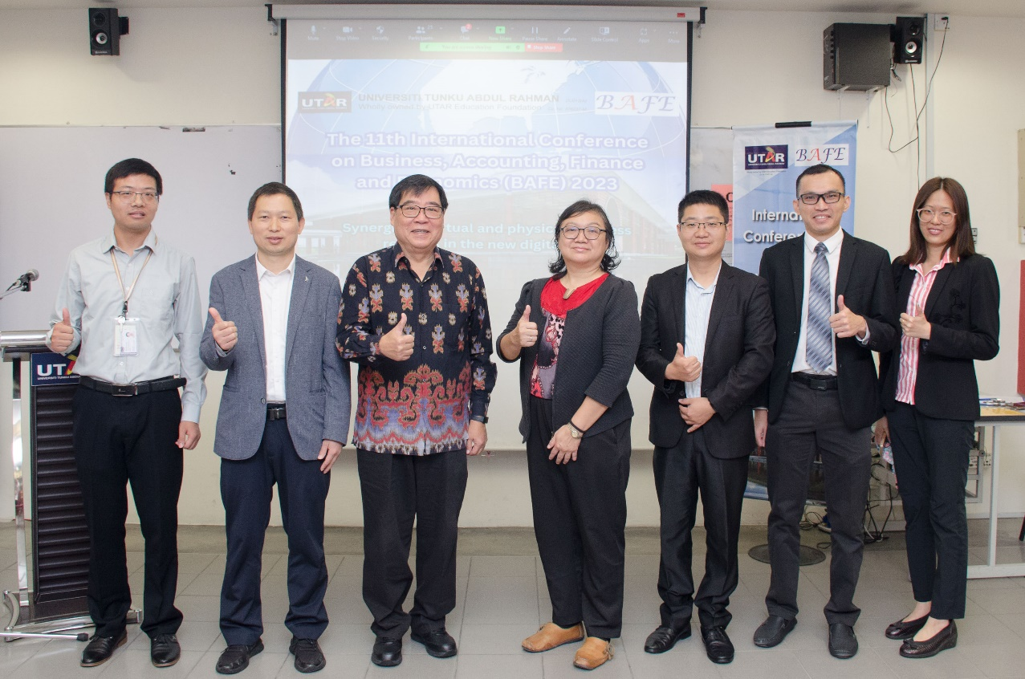

From left: Mr Lin, Dr Liu Shuli from Anhui Normal University, Assoc Prof Dr Tan Wee Liang from Singapore Management University, Dr Au Yong, Dr Fei Xu from Anhui Normal University, UTAR Institute of Postgraduate Studies and Research (IPSR) of Kampar Campus Deputy Director Dr Choong Yuen Onn, and FBF Head of Department of Entrepreneurship and Supply Chain Management Dr Ng Yin Kuan during the opening ceremony of the Business, Accounting, Finance, and Economics (BAFE) International Conference 2023

He added, “I attended the UTAR Alumni Annual Dinner 2023 in Melaka, in which I learned more about the development and achievements of UTAR and its diverse alumni. I had the pleasure to converse with UTAR President Ir Prof Dato’ Dr Ewe Hong Tat during the event. Not only did we share our experiences on visiting China and Malaysia, but he also shared UTAR’s wish to deepen partnerships with the institutions in Shandong, China. Furthermore, I also got to explore the rich historical heritage of Melaka, where I had the opportunity to track down the footsteps of Zheng He, the master navigator from the Ming Dynasty. This trip reminded me of his diplomatic efforts in the past that deepened the friendship between the two economies along the strait of Malacca.”

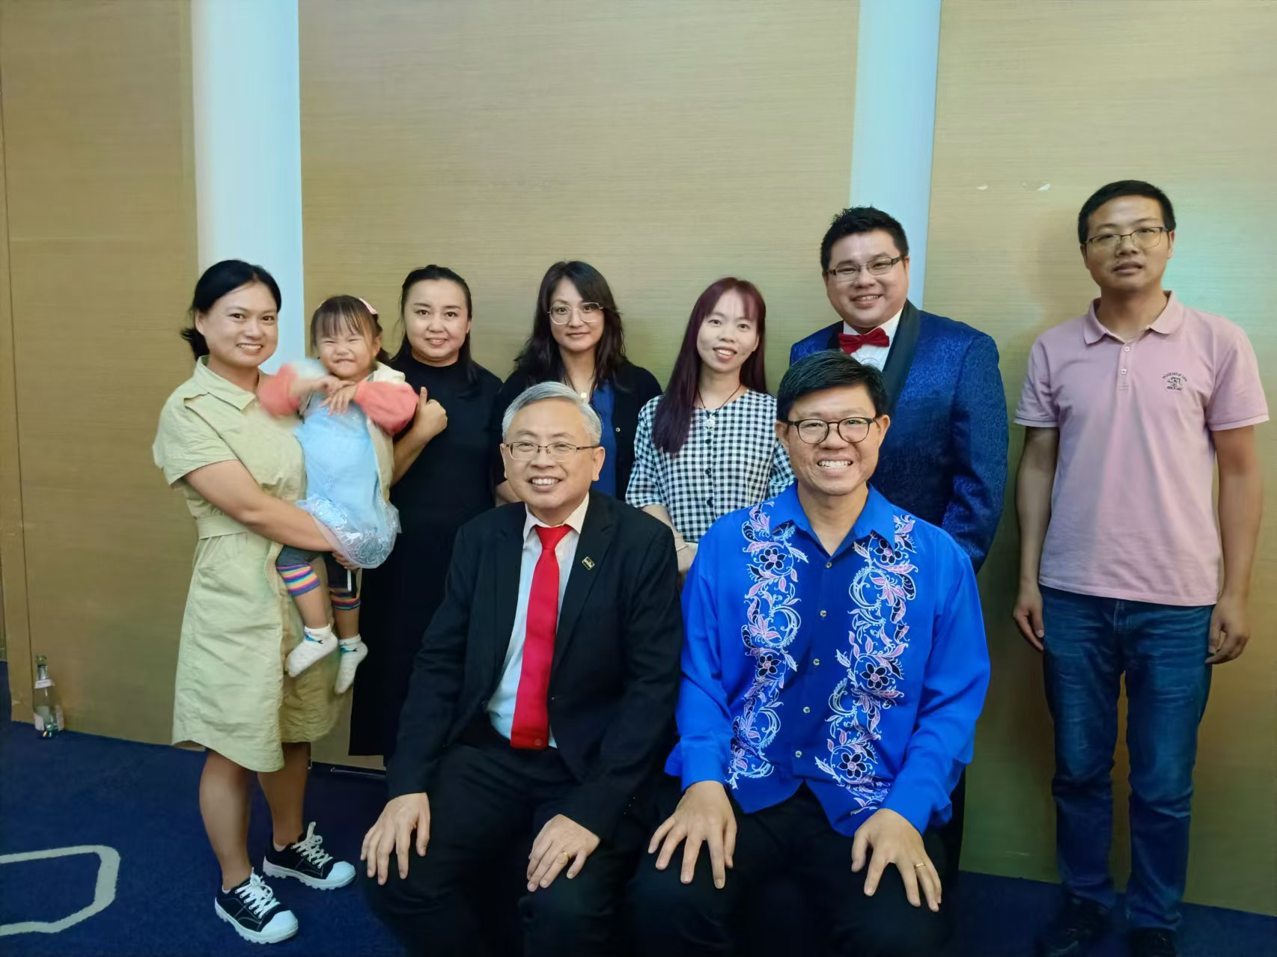

Mr Lin (standing, far right) with Prof Dato’ Ewe (seated, left), Prof Choong, and guests during the UTAR Alumni Annual Dinner 2023 in Melaka

Adapting to the unique conditions of a foreign land may be a great challenge for many individuals, but for Mr Lin, Kampar is a welcoming place that offers diverse opportunities for discovery. “I enjoyed the warm atmosphere in Malaysia, especially Kampar. It is not as hot as the dog days of summer in China and the Kampar community goes on their days at a slower and calmer pace, offering a relaxing ambience ideal for academic studies. Moreover, the diverse cuisine from Chinese, Malay, and Indian communities satisfied my taste buds and appetite, making my visit feel homesickness-free,” Mr Lin enthused.

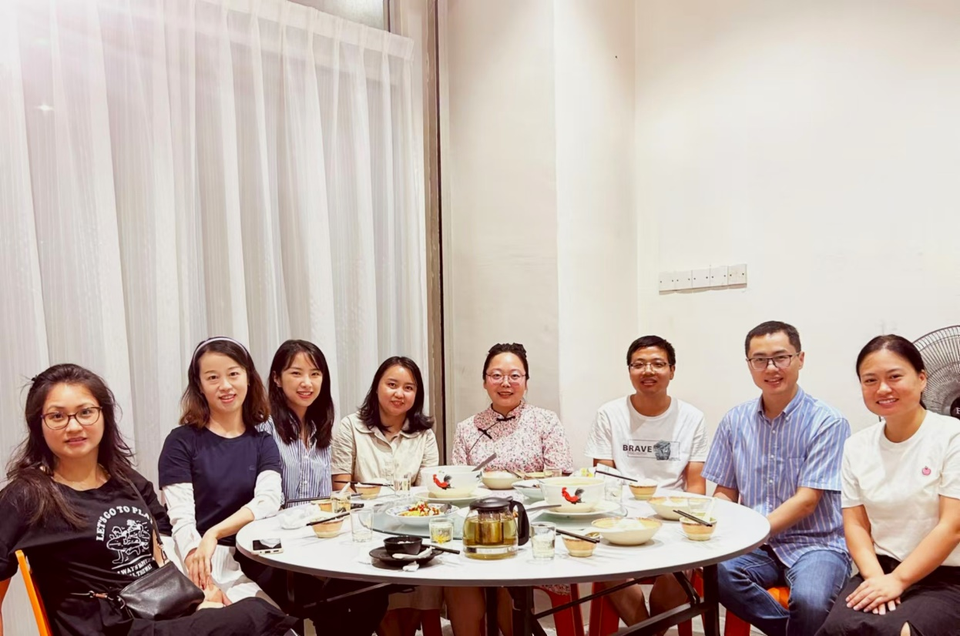

Mr Lin (third from right) celebrating Mid-Autumn Festival in Kampar with a hearty meal alongside his newfound friends

“I made friends with several international students from China, and we often encouraged one another to overcome the challenges of our academic journey. I made friends with the locals too. During our free time, we would cook traditional Chinese dishes and share with one another. These experiences offered valuable opportunities to exchange ideas about our different culinary traditions. Hence, my transition to the Malaysian lifestyle was smooth. The moments I shared here will be cherished as parts of my life’s golden memories,” Mr Lin shared about the bonds he made in Malaysia.

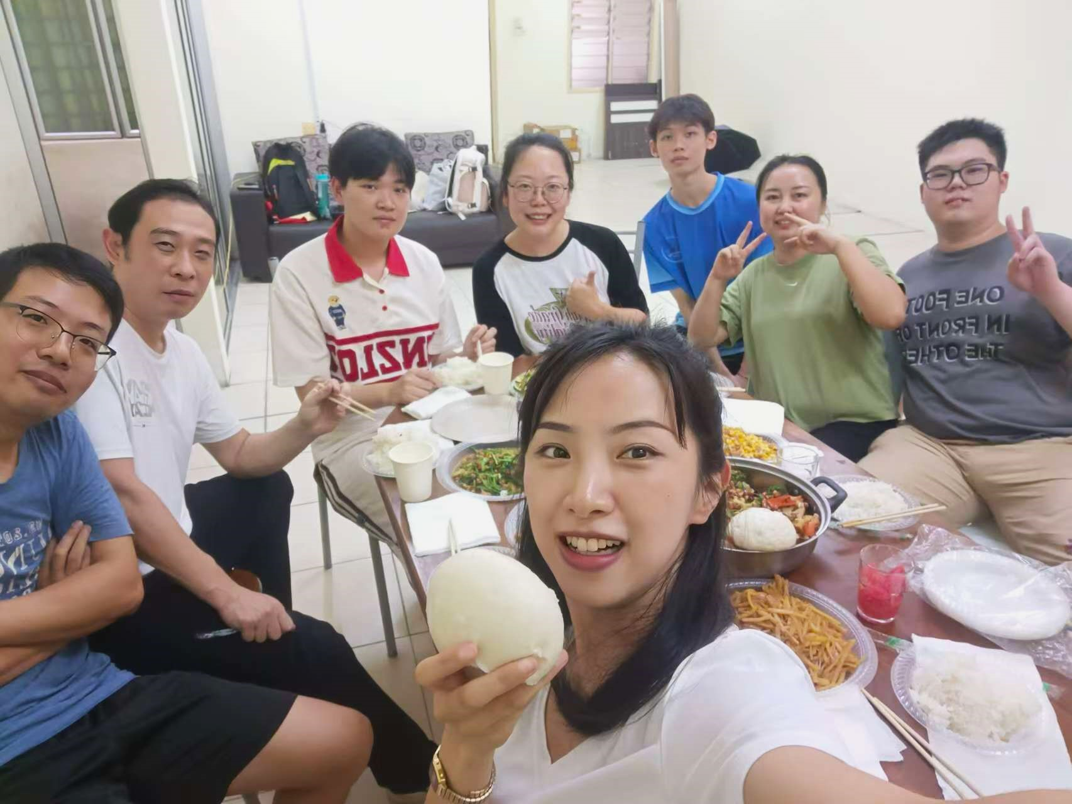

Mr Lin (far left) and his friends sharing home-cooked meals and laughter together

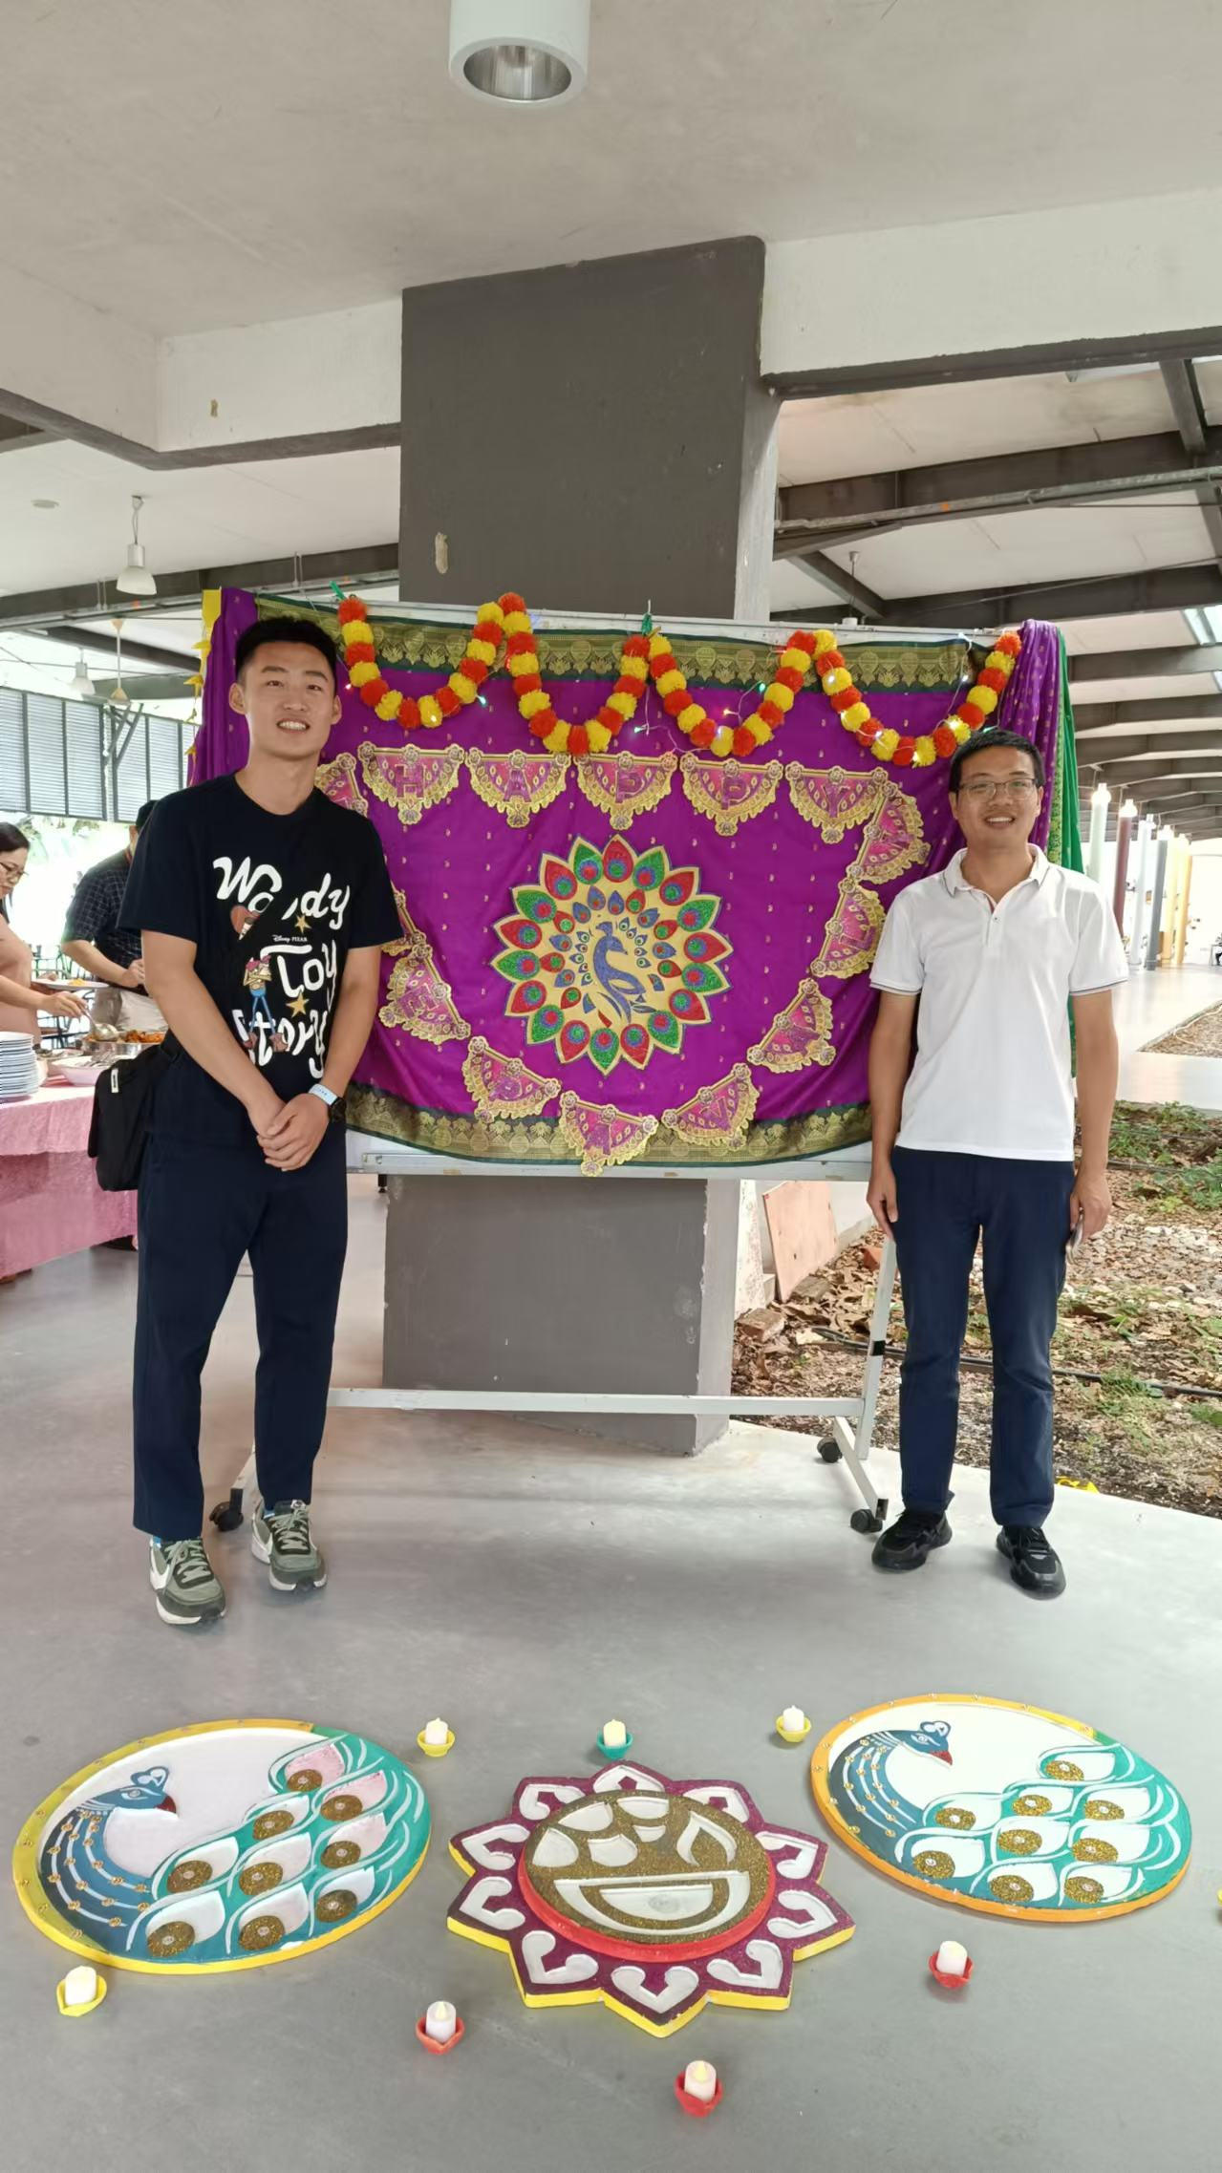

Mr Lin (right) sharing light-hearted moments with his peers and friends at the FBF Deepavali 2023 Luncheon

As an academic who found delight in Malaysian culture, the Asian economy was not Mr Lin’s initial choice. He said, “Before choosing Malaysia as my destination, I had a hard time making a decision as I searched several times for overseas universities to further my studies. It was not until I met UTAR Vice President for Student Development and Alumni Relations Prof Dr Choong Chee Keong, FBF Dean Assoc Prof Dr Au Yong Hui Nee, and other staff from the university during a joint online training between SFTC and UTAR that I took interest in UTAR. I also discovered that many Malaysians, especially the Chinese community, have positive feedback on the university’s good research initiatives. Recollecting my experiences with peers and staff here, I am confident that I made the right choice.”

Mr Lin’s visit reached its conclusion in August 2024, he nevertheless believes that his pursuit of knowledge and nexus with UTAR is just the beginning of his journey towards broader horizons. He enthused, “I had discussions with FBF academics before concluding my visit, including Prof Choong, Dr Au Yong, Dr Thavamalar, Dr Chen Fanyu, and Assoc Prof Dr Choong Yuen Onn. Their encouragement to pursue my research has made me firm in my decision to further my doctoral studies in the future. As the saying goes, ‘UTAR, My Choice.’”