**UTAR Physiotherapy team supports Kuala Lumpur Standard Chartered Marathon 2024**

The UTAR Physiotherapy team once again demonstrated their commitment to community health at the Kuala Lumpur Standard Chartered Marathon (KLSCM) held on 5 and 6 October 2024. Their invaluable support during the event played a crucial role in aiding participants’ post-race recovery.

Led by lecturer Ms Kamala Krishnan, the team on Day 1 comprised four students—Chuar Yu Cheng, Teresa Abraham, Chok Kenneth, and Micole Yeap Sin Yii—alongside five alumni, namely Lim Yu Hui, Ng Zin Ru, Jasmine Song Wen Hui, Wan Cai Hui, and Hwang Ji Yen. The group set off for Dataran Merdeka as early as 3:00 AM, eager to assist marathon participants competing in the 10km, 5km (for adults), and kids’ dash.

Their efforts included providing ice massages, vapocoolant sprays, soft tissue manipulation, passive stretching, and recovery advice. The team skilfully managed participants’ post-race needs, working until 10:30 AM to ensure they received prompt care.

The camaraderie and professionalism displayed by the team on Day 1 not only fostered a supportive environment but also ensured participants received immediate care to aid their recovery.

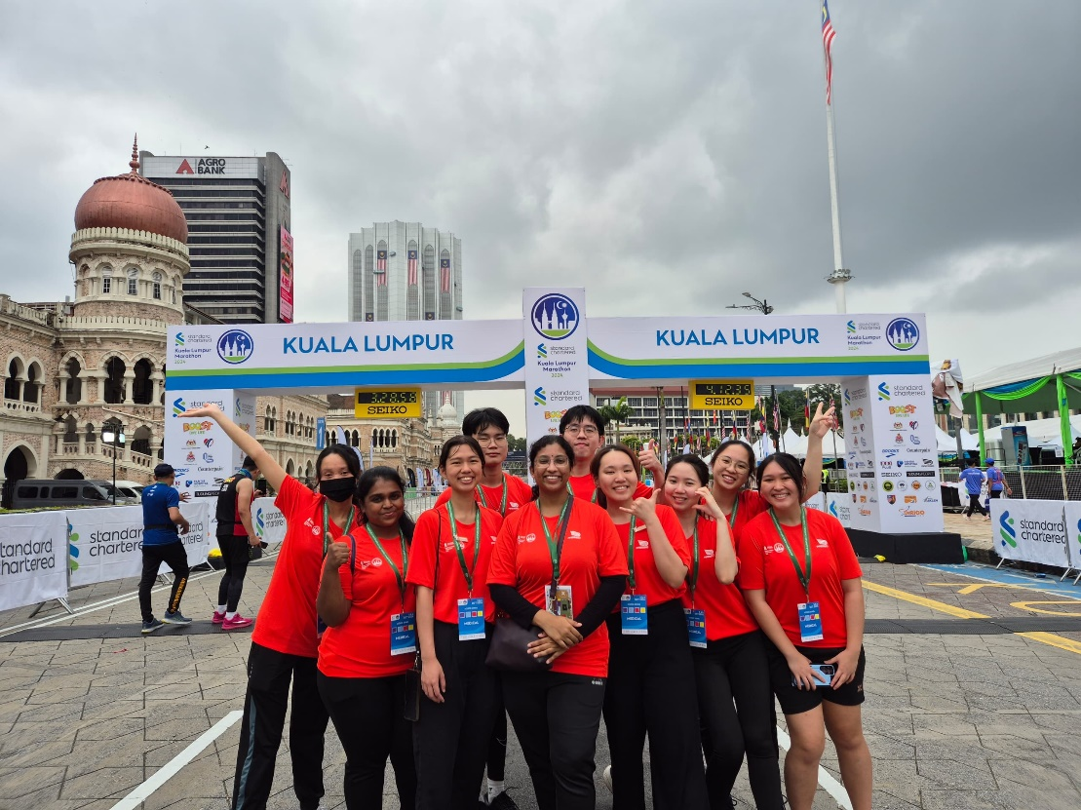

The team on Day 1

Front row, from left: Wan Cai Hui, Teresa Abraham, Jasmine Song Wen Hui, Ms Kamala Krishnan, Hwang Ji Yen, Ng Zi Ru and Micole Yeap Sin Yii

Back row, from left: Chuar Yu Cheng, Chok Kenneth and Lim Yu Hui

On the second day, under the leadership of UTAR physiotherapist Ms Nandakumari Sabapathy, the team continued their essential work. Joining her were Ms Siti Hazirah binti Samsuri, students Khu Khang Zhuang and Tan Sau Fong, and alumnus Ting You Jian. Their contributions were pivotal during the full marathon (42.2 km) and half marathon (21.1 km), which began at 3:45 AM and 5:45 AM, respectively. Their expertise in managing participants’ injuries ensured swift recovery, enabling many to enhance their performance or recuperate quickly after the race.

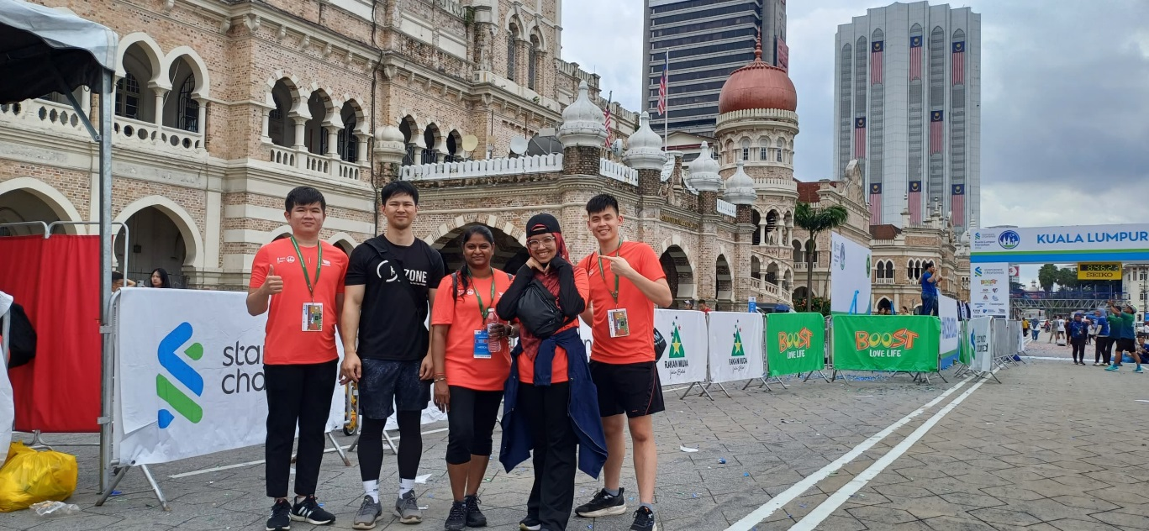

The team on Day 2

From left: Tan Sau Fong, Khu Khang Zhuang, Ms Nandakumari, Ms Siti Hazirah and Ting You Jian

The UTAR team extends their deepest appreciation to the event coordinator (UTAR side, Ms. Nandakumari) for the opportunity to support such a significant event. This collaborative effort underscores UTAR’s dedication to community service and physiotherapy excellence. The team looks forward to supporting many more successful events in the future!

**About KL Standard Chartered Marathon**

The KL Standard Chartered Marathon, held annually in Kuala Lumpur, Malaysia, was established in 1989. It was backed by the Malaysia Athletics Federation (MAF), Federal Territory Kuala Lumpur Athletic Association (FTKLAA), World Athletics, and the Association of International Marathons and Distance Races (AIMS). Organised by Dirigo Events, with Dewan Bandaraya Kuala Lumpur as the venue host, the event drew a diverse crowd. Over 2,500 international running tourists from 45 different economies participated, representing 70 nationalities, including local foreign residents. KLSCM 2024 also saw over 13,300 runners from outside Kuala Lumpur and Selangor, making for a lively weekend in the city.

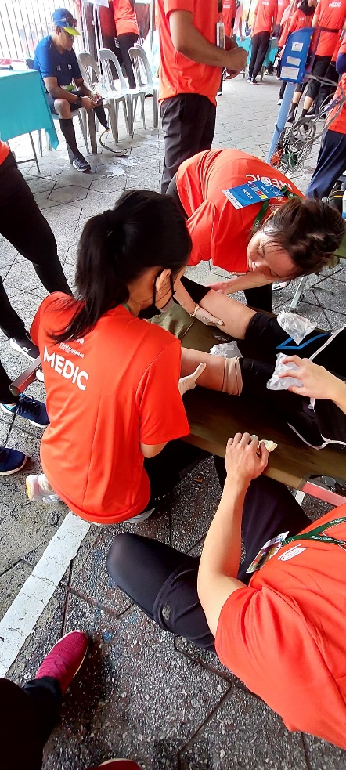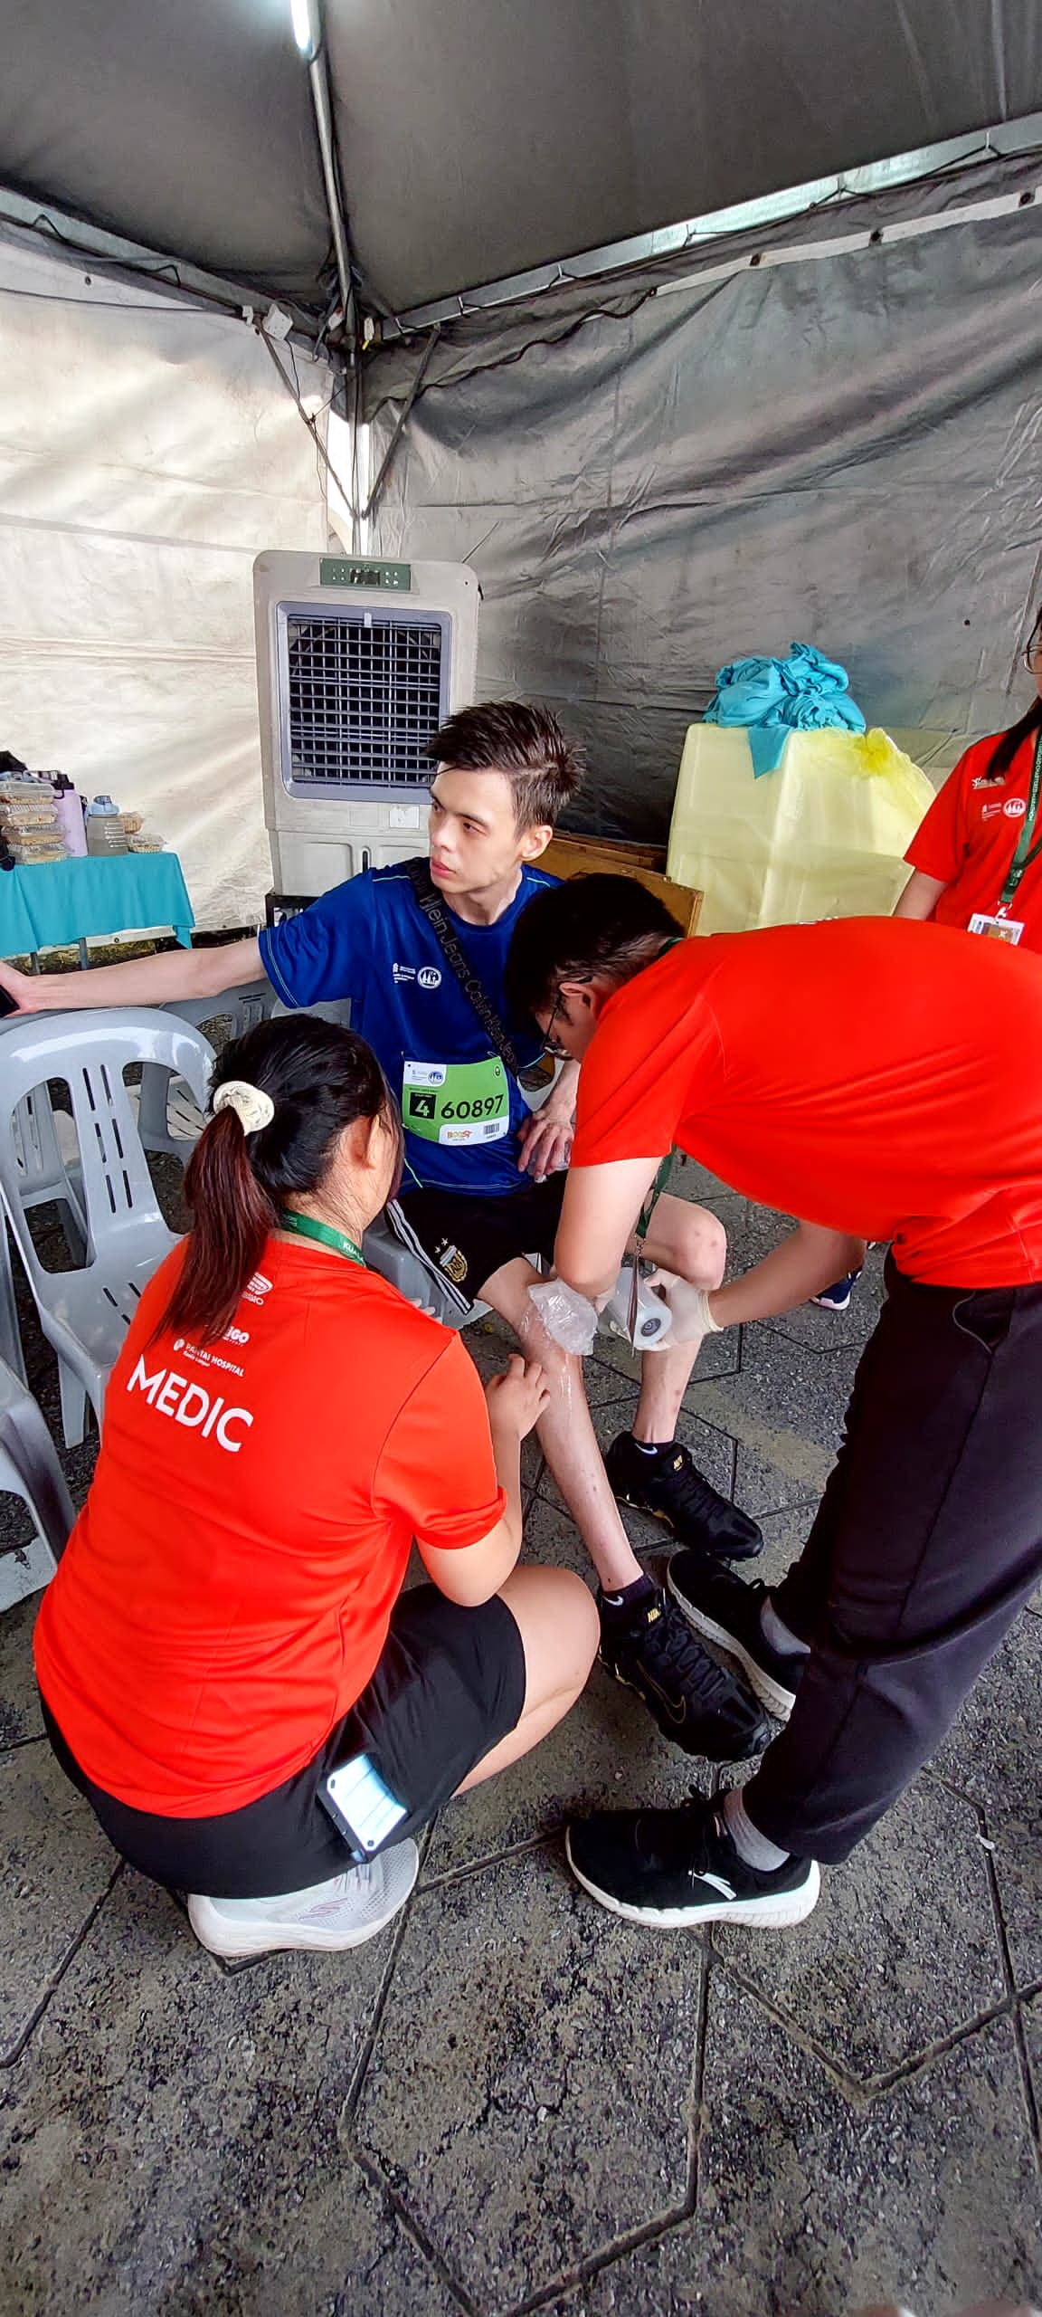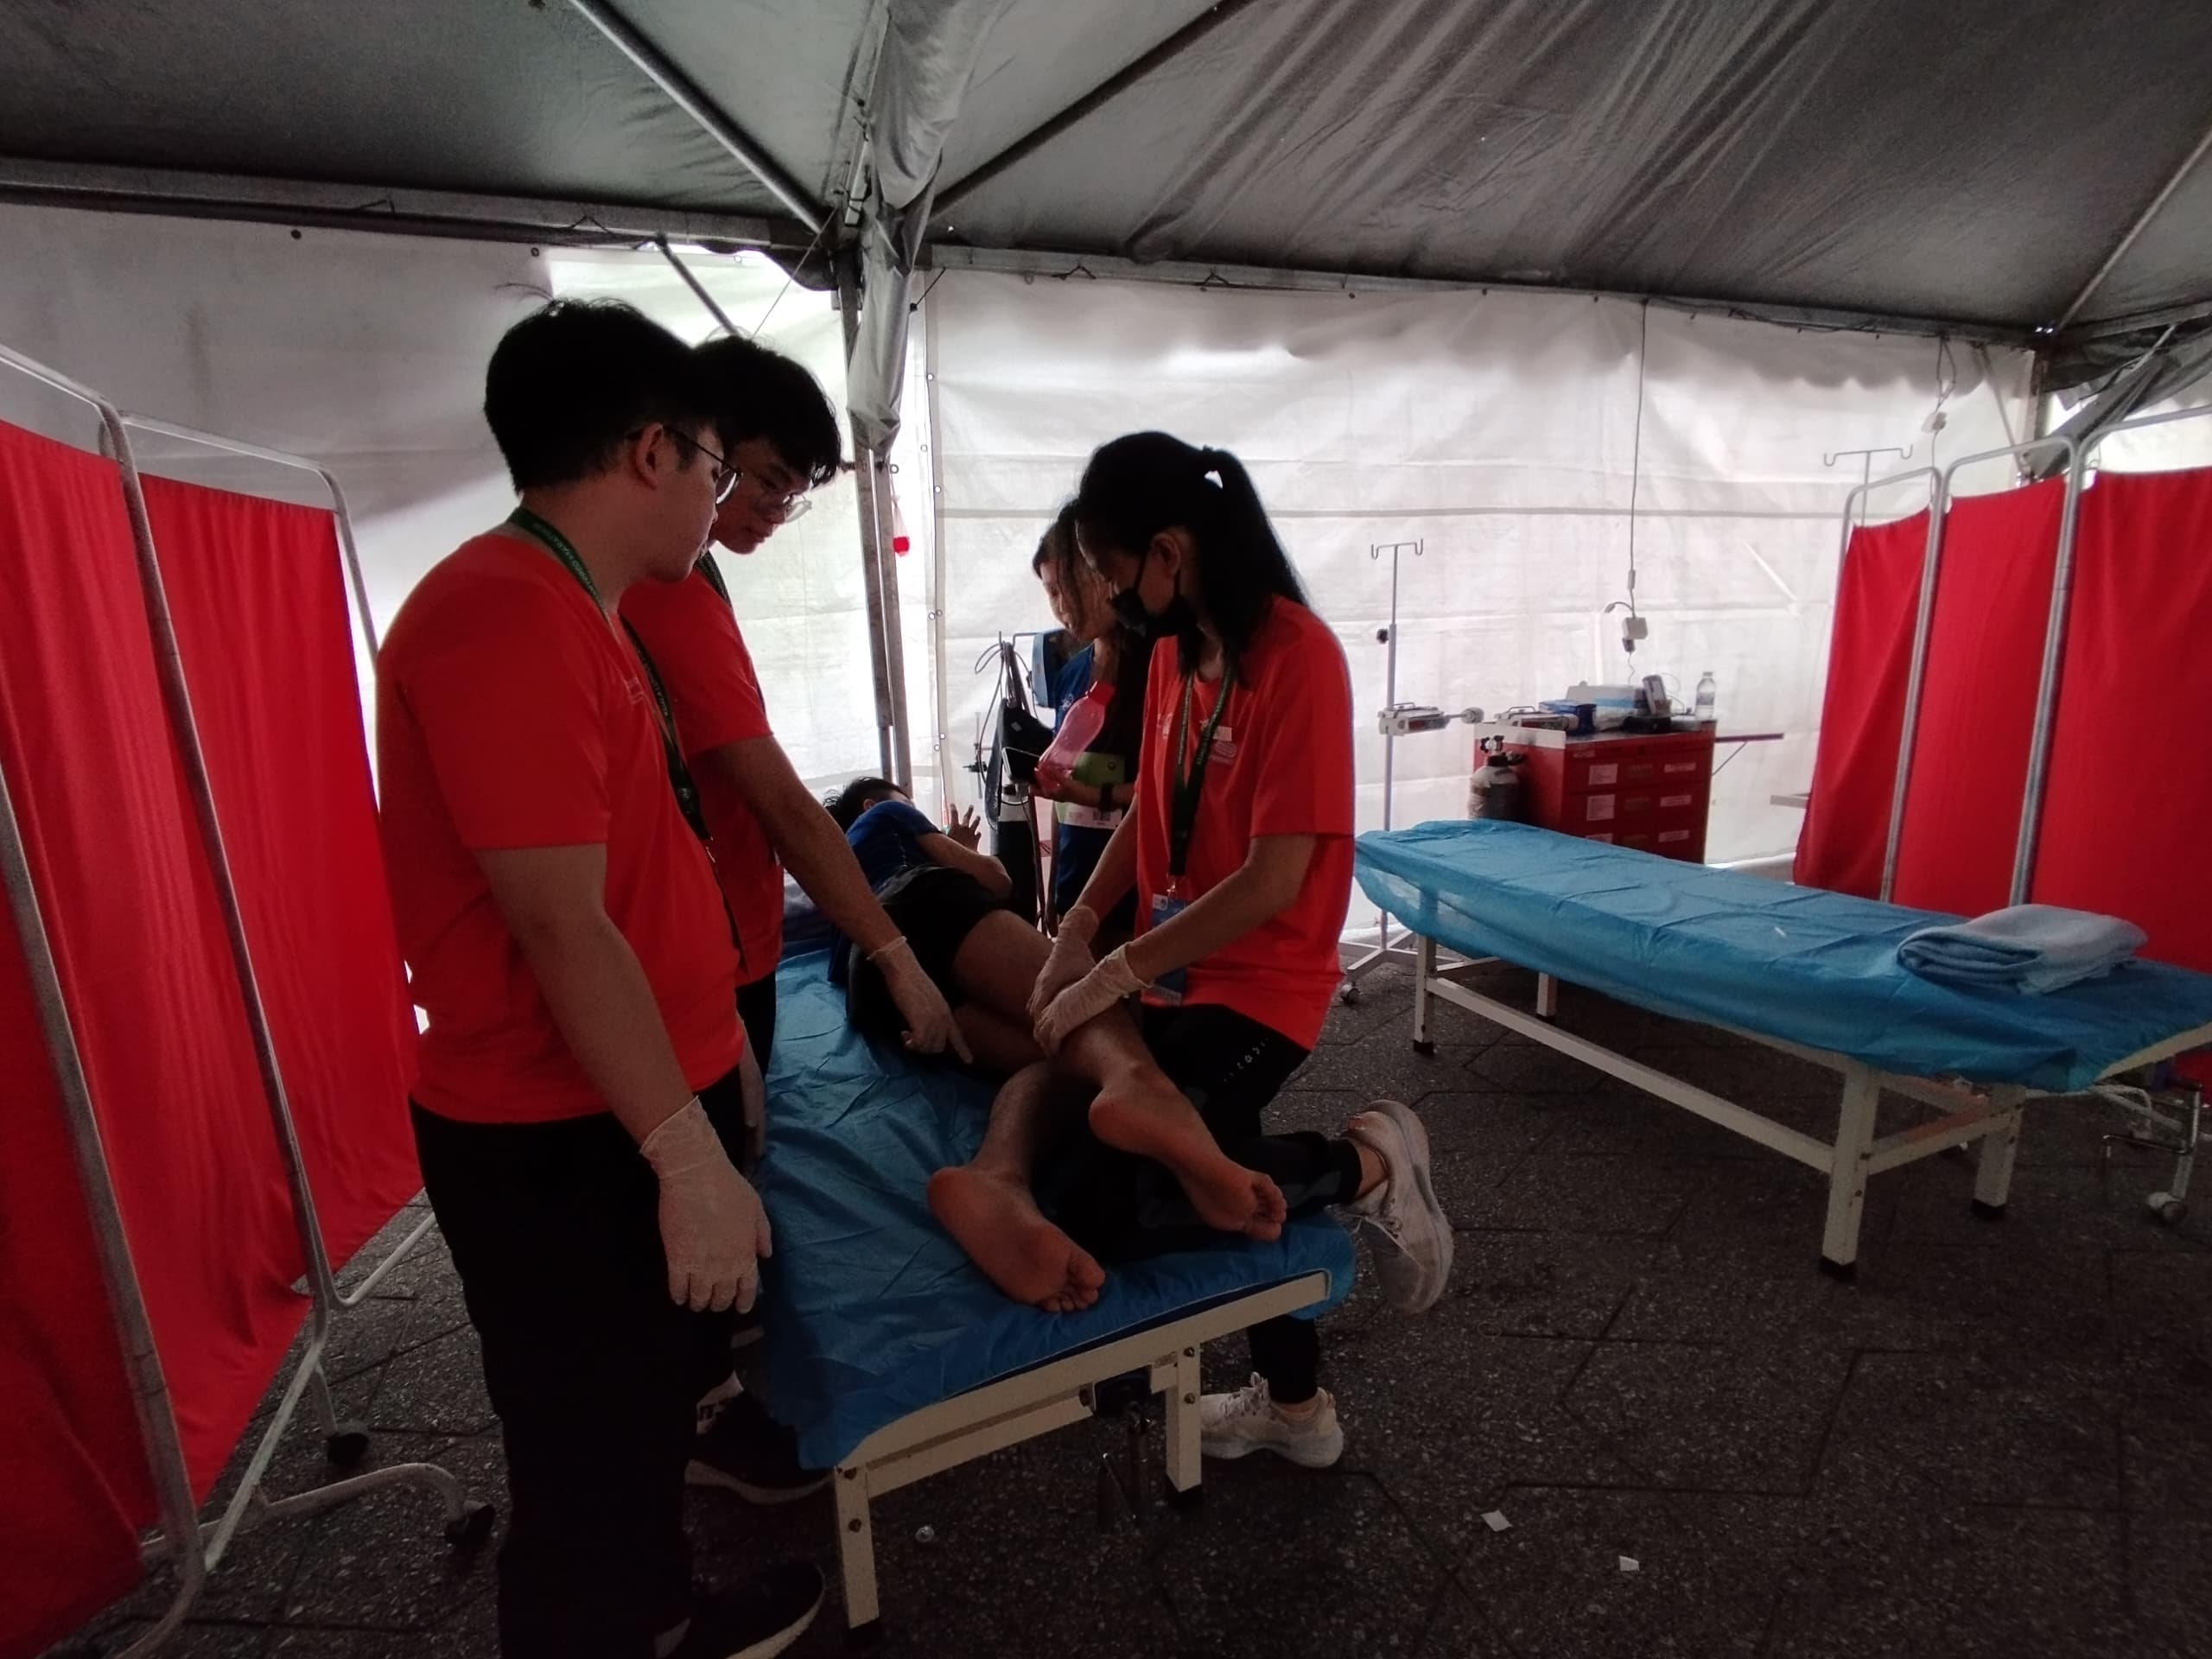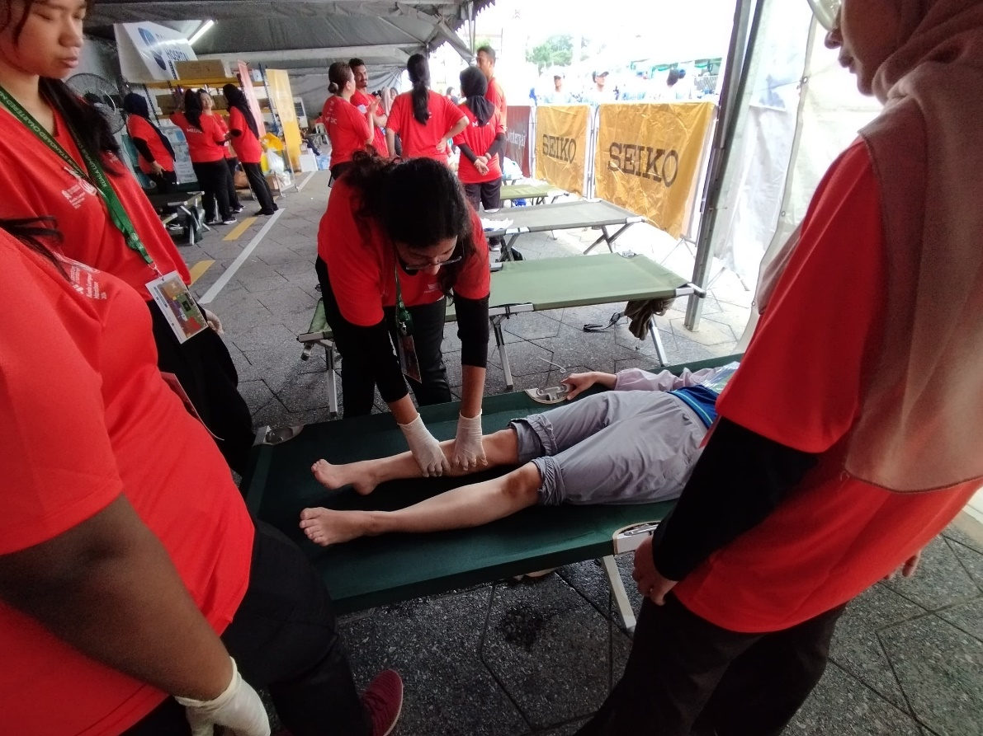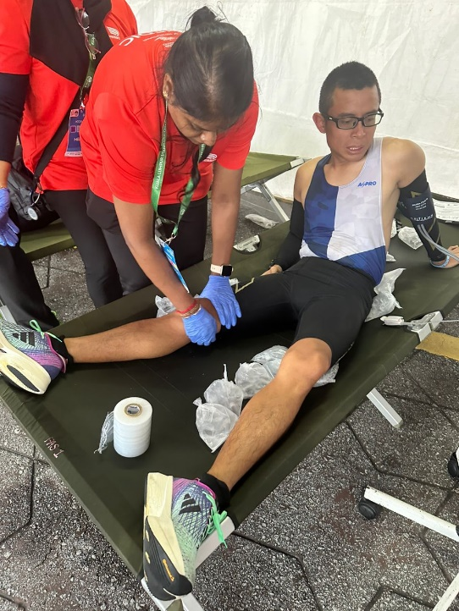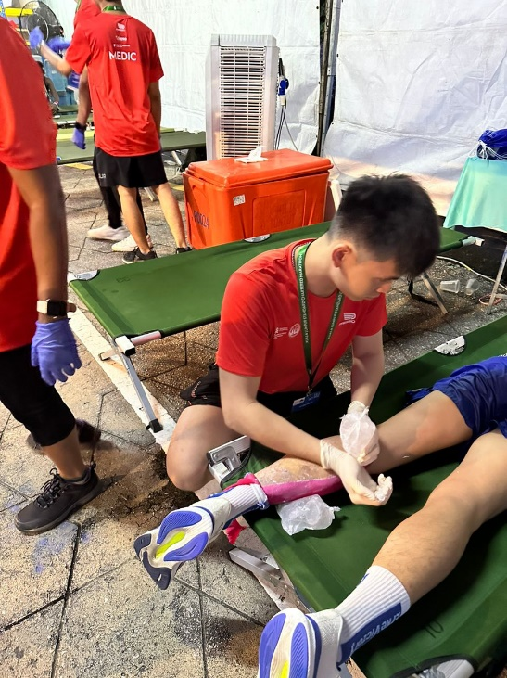

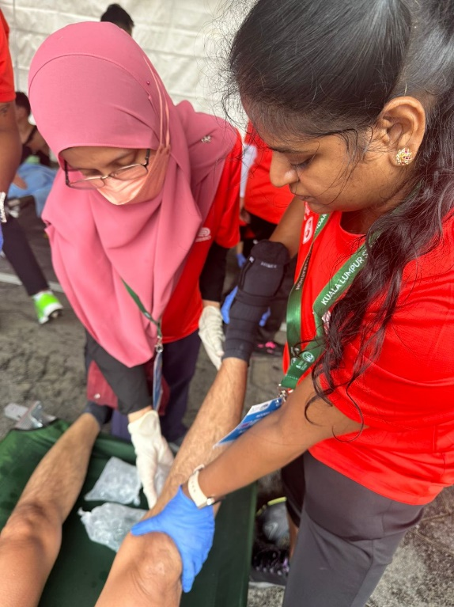

UTAR team providing physiotherapy services to injured participants