**Talk on finance mastery**

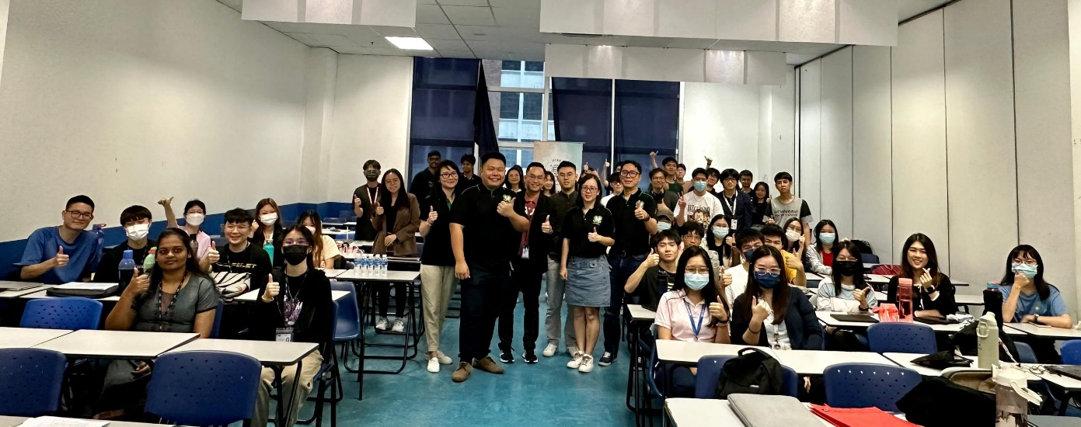

Group photo session among speaker and students

A Solutions Ins Sdn Bhd Manager, Mr Teo Chia Long, delivered an inspiring talk titled “Finance Mastery: Fund Your Future Home” at UTAR Sungai Long Campus on 29 August 2024. The guest lecture talk was organised by the UTAR Faculty of Accountancy and Management (FAM) in collaboration with the UTAR Global Economics Society.

Mr Teo’s talk was insightful with tips on effectively managing finances and planning for a future dream home. In the talk, he emphasised the importance of commitment, credibility, and smart expenditures, offering practical advice that resonated with students and young professionals alike. His approach to simplifying complex financial concepts, combined with real-world examples, made the session both engaging and informative. He also introduced the core business of A Solutions Ins Sdn Bhd, giving students a glimpse into the company’s operations and expertise.

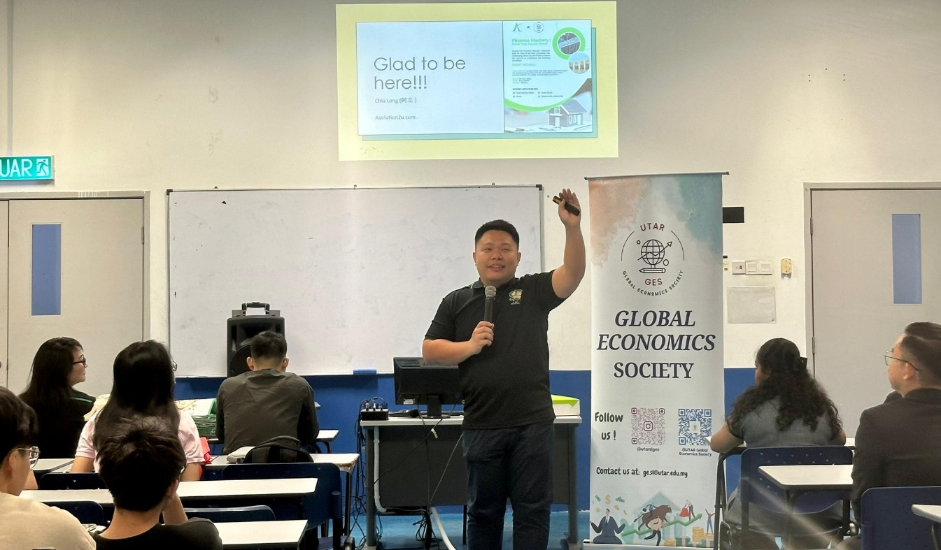

Mr Teo during the Q&A session

Additionally, Mr Teo spoke about the exciting Elite Internship opportunity offered by A Solutions, which allows students to gain cross-industry experience by working with banks, hospitals, and other sectors. This unique internship programme aims to equip students with diverse skills and insights, preparing them for a successful career in a dynamic job market.

Furthermore, Mr Teo highlighted the importance of maintaining a good Central Credit Reference Information System (CCRIS) record, stressing how crucial it is for securing loans and other financial services in the future.

The talk provided attendees with actionable strategies for financial planning, stressing the need for early preparation and informed decision-making. Mr Teo’s expertise and practical tips offered invaluable guidance to those looking to secure their financial future.

In attendance were the FAM Head of the Department of Economics Mr Low Choon Wei, staff from A Solutions Ins Sdn Bhd, and UTAR students. The event was well-received, leaving participants with a clearer understanding of how to navigate their financial journey toward home ownership.

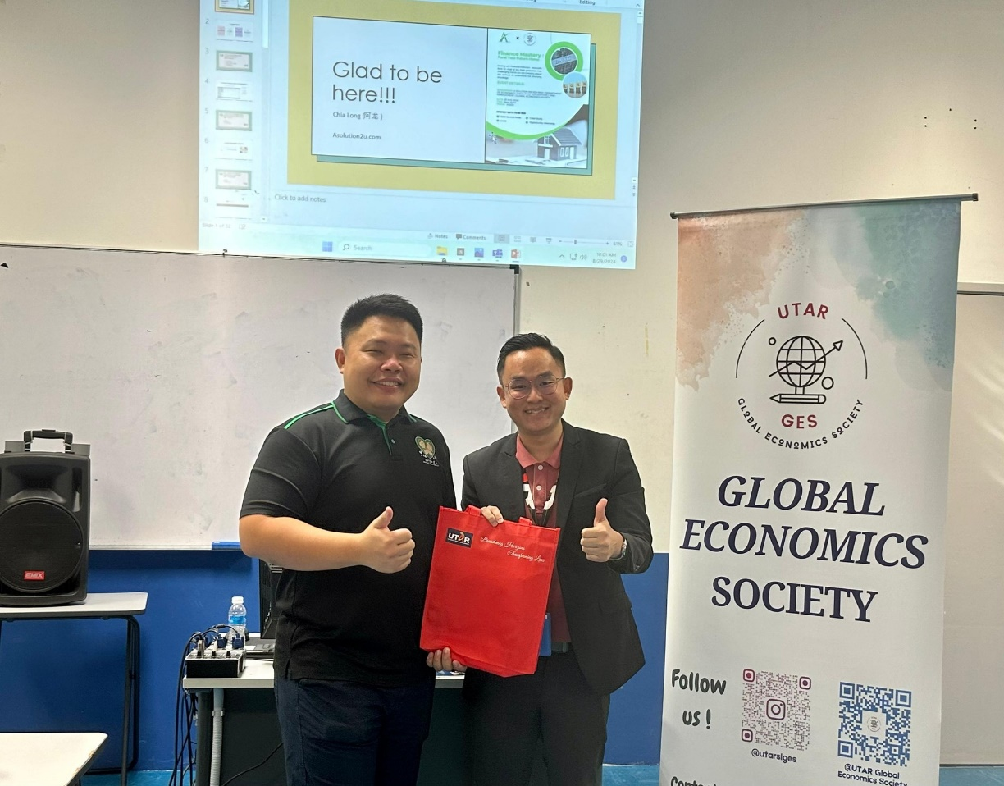

Mr Low (right) presenting a token of appreciation to Mr Teo

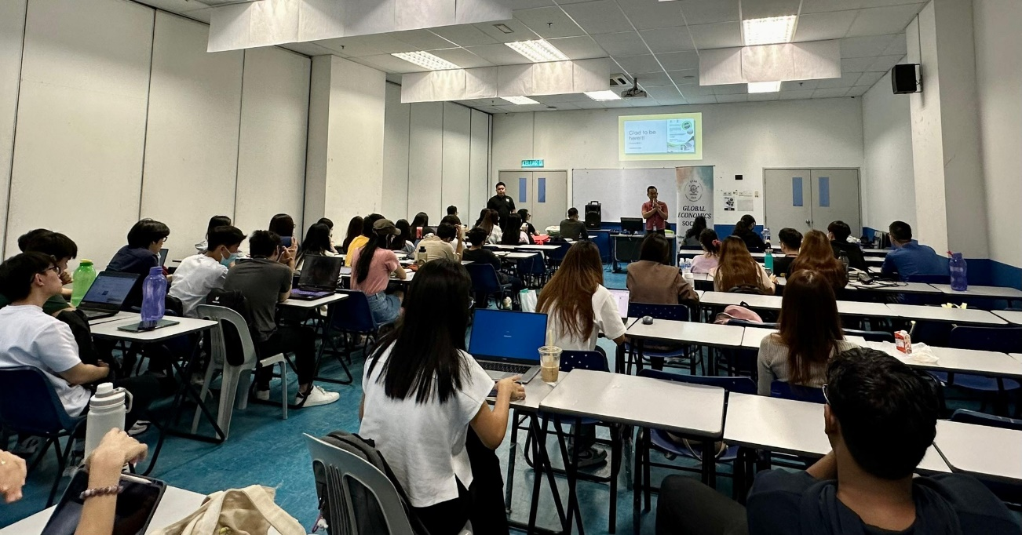

Students during the talk