**GZCCC visits UTAR to discuss joint construction programme**

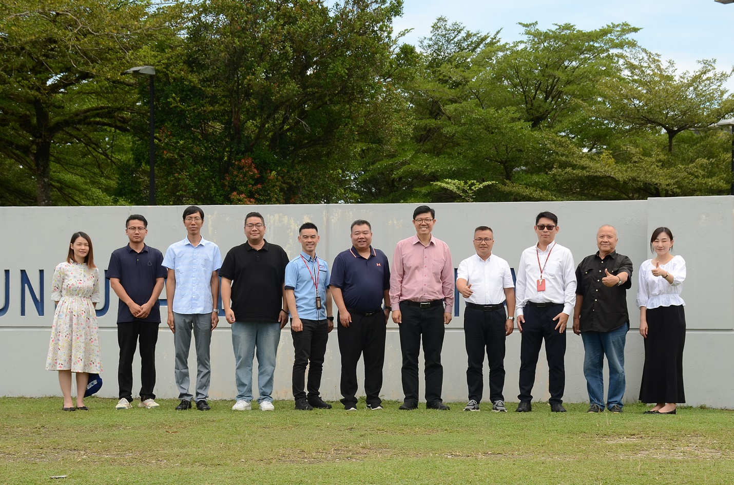

From left: Ms Loi, Mr Yang, Mr Li, Mr Peng, Dr Leong, Assoc Prof Zhang Shuang, Prof Choong, Prof Zhang Deyi, Dr Kwan, Prof Xie and Dr Chen

A team of delegates from the Guangzhou City Construction College (GZCCC), China visited UTAR Kampar Campus on 21 August 2024.

Led by GZCCC Vice President Prof Zhang Deyi, the delegates comprised of GZCCC Foreign Affairs Office Consultant Prof Xie Boyi, School of Continuing Education Dean Assoc Prof Zhang Shuang, School of Humanities Deputy Dean Mr Peng Cong, and School of Civil Engineering and Architecture academics Mr Li Hongyuan and Mr Yang Guang.

The guests were received by UTAR Vice President for Student Development and Alumni Relations Prof Dr Choong Chee Keong, Faculty of Engineering and Green Technology (FEGT) Deputy Dean for Academic Development and Undergraduate Programmes Assoc Prof Ir Ts Dr Leong Kah Hon, FEGT Head of Department of Construction Management Dr Kwan Wai Hoe, Office of International Affairs (OIA) Deputy Director Assoc Prof Dr Chen, I-Chi, and OIA Senior Assistant Manager Ms Loi Sien Mun.

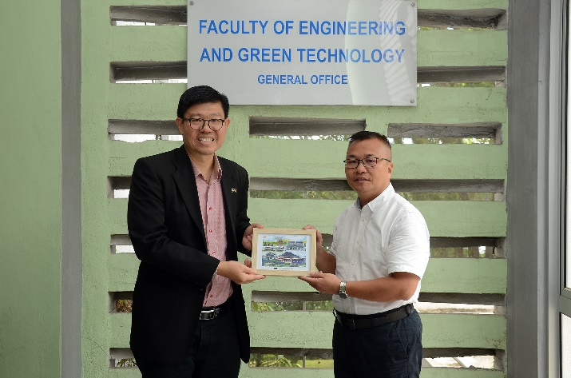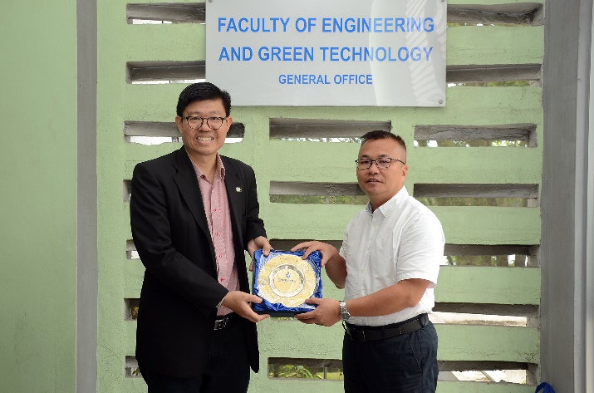

Prof Choong (left) and Prof Zhang Deyi exchanging tokens of appreciation

A discussion was conducted between the two parties and the agenda revolved around topics such as joint talent training programmes, associate to bachelor’s degree programmes, and potential collaborations.

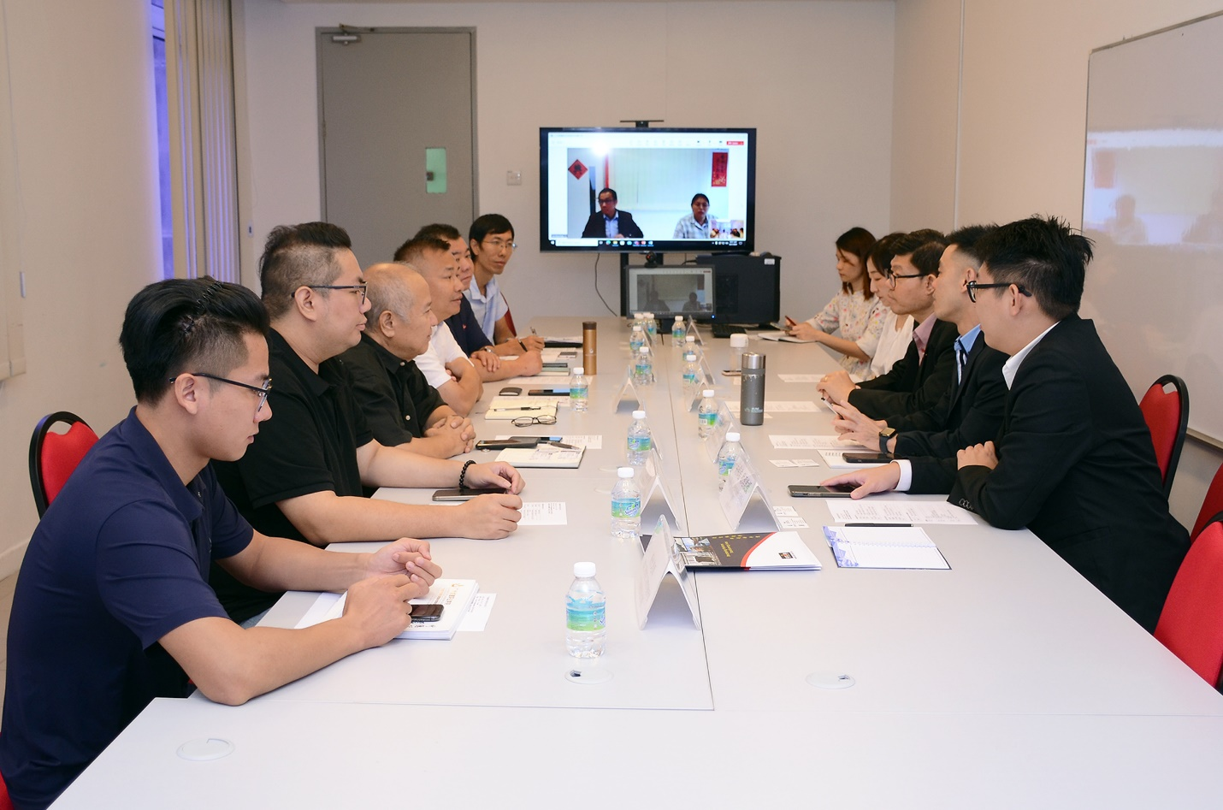

On-going discussion