**Storytelling competition fosters creativity and self-confidence among special needs children**

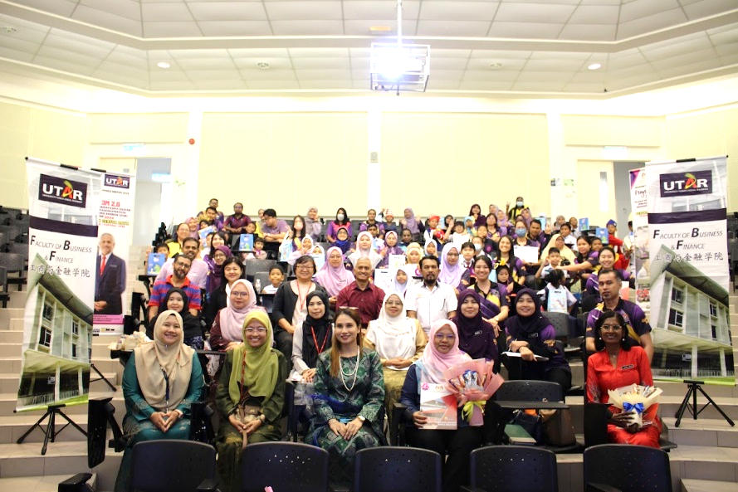

Third row, third from left: Dr Au Yong, Dr Mior Hamdan and Ms Sonia (front row, middle) with PPD Kinta Selatan staff, school teachers and participants

The Department of Commerce and Accountancy at the Faculty of Business and Finance (FBF), and the Centre for Learning and Teaching (CLT) collaborated with Pejabat Pendidikan Daerah (PPD) Kinta Selatan to organise “*Pertandingan Cerita Saya*”, a storytelling competition, on 20 August 2024 at UTAR Kampar Campus.

Present were Dr Mior Hamdan bin Hj Ghazali from PPD Kinta Selatan, FBF Dean Assoc Prof Dr Au Yong Hui Nee, FBF Deputy Dean for R&D and Postgraduate Programmes Prof Dr Abdelhak Senadjki, CLT Chairperson Dr Wei Chooi Yi, and Department of Commerce and Accountancy Head Ms Sonia Johanthan. Thirty primary school teachers under PPD Kinta Selatan were also in attendance, along with 10 organising committee members from PPD Kinta Selatan and 11 organising committee members from UTAR. The storytelling competition saw the participation of 30 special needs students from primary schools namely SK Tronoh, SK Malim Nawar, SK St Bernadette’s Convent, SJKT Changkat, SJKC Gunung Panjang, SJKC Ying Sing, SK Gopeng, Jalan Ilmu, SJKC Man Ming, and SK Pengkalan Baharu.

The storytelling competition aimed to provide students with special needs an opportunity to improve their verbal and non-verbal communication skills through the medium of storytelling. In addition to creating an inclusive environment that fostered self-confidence and social interaction among the special need students, the competition also stimulated their creativity and imagination by engaging them in storytelling, allowing them to share their unique ideas.

The storytelling competition concluded with a prize-giving ceremony. Wan Elhaura Fredella binti Wan Daud from SK Tronoh won first prize for her story “*Gagak Yang Bijak*”, followed by SK Malim Nawar student Nurul Nufah Aini Shamsuri, winning the second prize with her story “*Kisah Monyet yang Degil*”. Nurul Aisyah Fatihah binti Ahmad Ridzuan from SK ST Bernadette’s Convent won third prize for her story “*Anak Ikan Yang Suka Menipu*”.

The collaboration between UTAR and PPD Kinta Selatan provided an enriching experience for special needs students through a unique storytelling event. Furthermore, this initiative offered these students an opportunity to express themselves creatively, enhance their communication skills, and build self-confidence in an inclusive and supportive environment. Storytelling is a powerful tool for personal development, thus the event sought to harness its potential to lead to social interaction, imagination, and a sense of community among the participants.

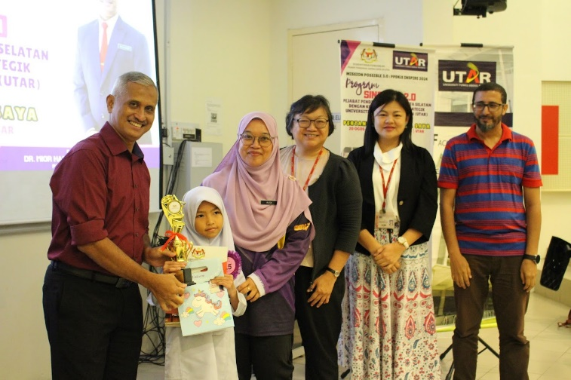

Dr Mior Hamdan (left) presenting prize to first-place winner Wan Elhaura (second from left)

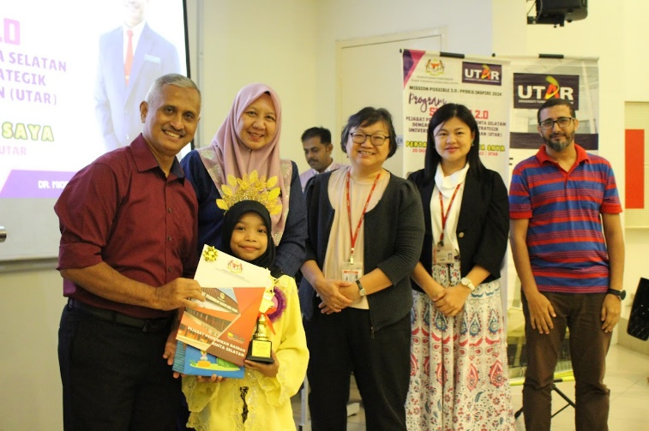

Dr Mior Hamdan (left) presenting prize to second-place winner Nurul (second from left)

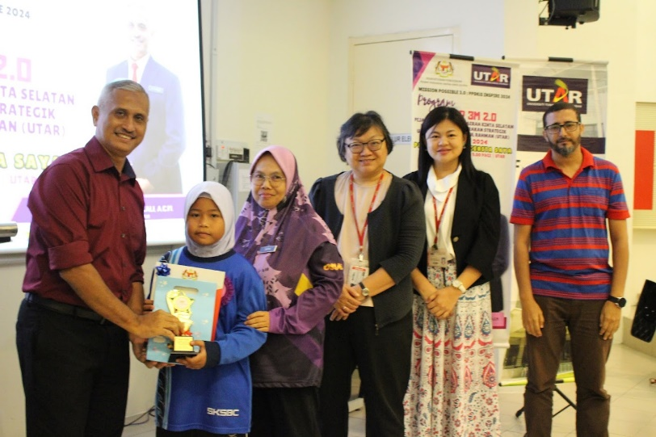

Dr Mior Hamdan (left) presenting the prize to third-place winner Nurul Aisyah (second from left)

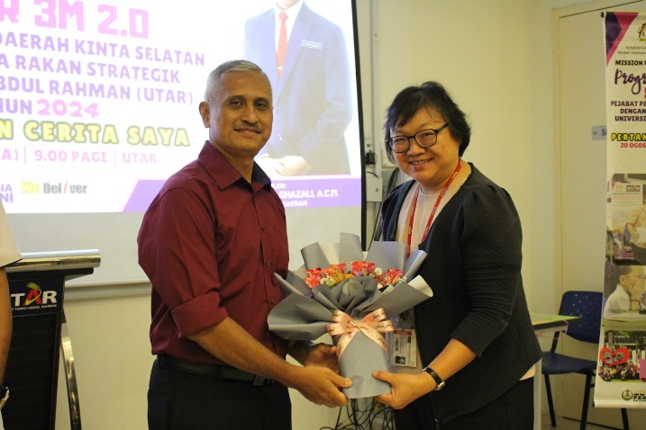

Dr Au Yong (right) receiving a token of appreciation from Dr Mior Hamdan

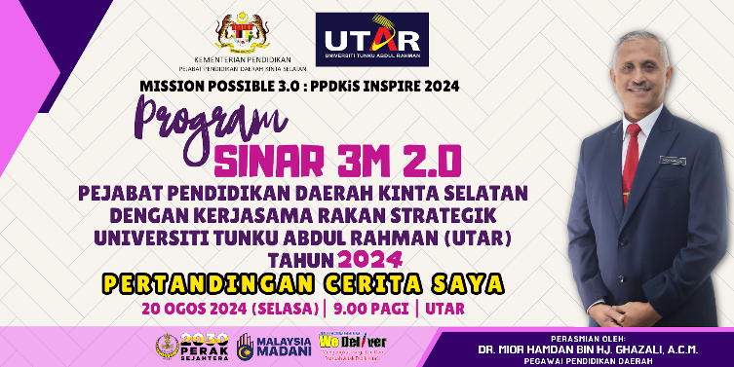

The event poster