**Empowering school teachers through CCCD programme**

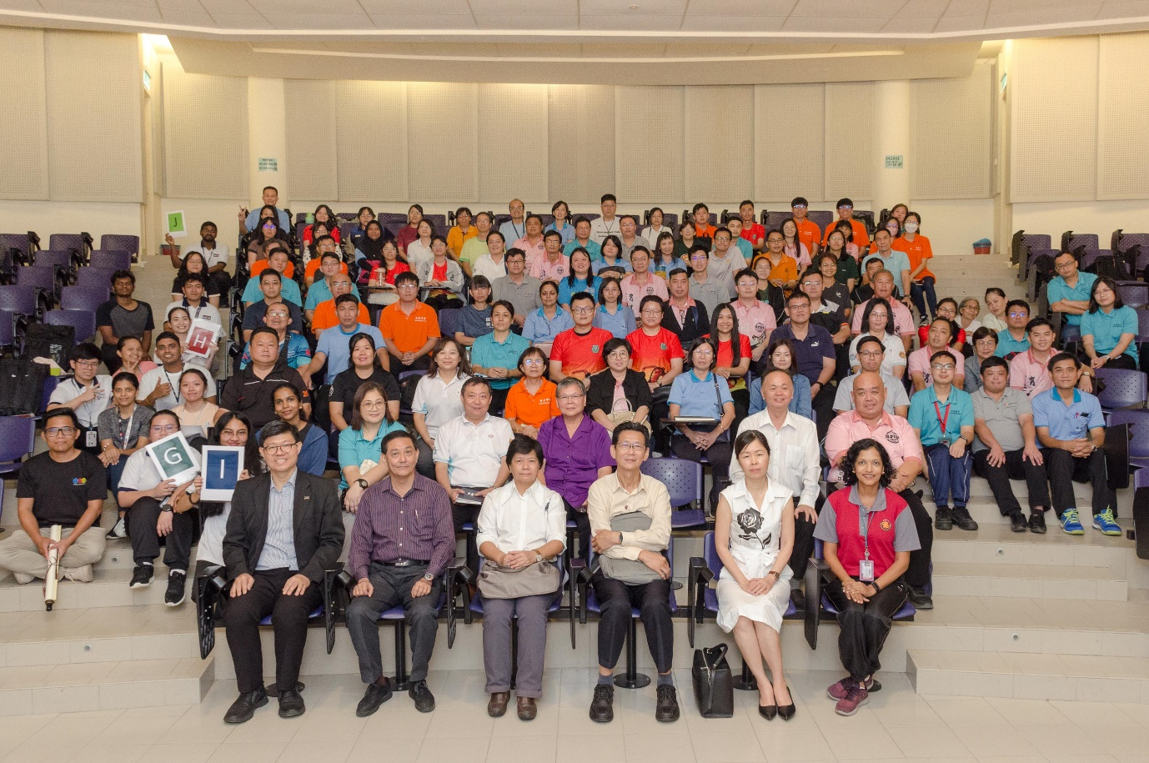

Kick-starting the programme with big smiles

Teachers are more than educators who transfer knowledge and skills to students. They are also important role models to remind students of the need for continuous learning and self-development because changes and progress are continuous aspects of life.

Testifying to that is their participation in “The Thriving Team Equation: Building Collaboration, Mastering Stress, and Leading in the New Era” Programme conducted by UTAR Centre for Corporate and Community Development (CCCD), from 23 to 24 August 2024, at UTAR Kampar Campus. It was jointly attended by 93 Perak Chinese Independent School teachers from Yik Ching High School, Tsung Wah Private Secondary School, Shen Jai High School, Poi Lam High School, Nan Hwa High School, Pei Yuan High School, Sekolah Menengah Yuk Choy (SUWA), San Min Secondary School (Suwa), and Hua Lian High School.

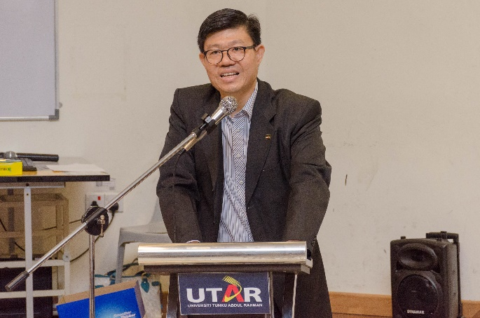 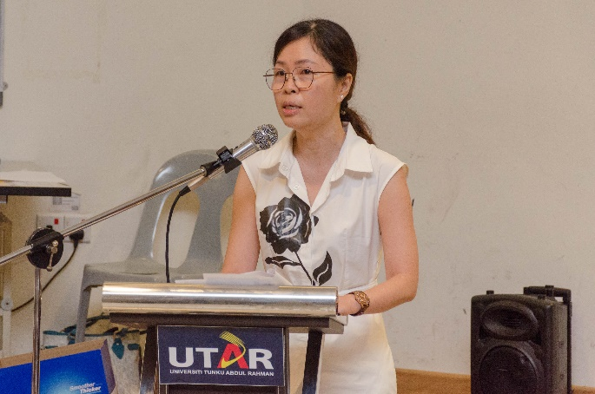

From left: Prof Choong and Dr Chin delivering their insightful speeches

An opening ceremony kick-started the programme. It saw UTAR Vice President for Student Development and Alumni Relations Prof Dr Choong Chee Keong, and Nan Hwa High School Principal Dr Chin Lee Pin, representative of all participating schools, delivering their speeches. They both emphasised the importance of growth and development and applauded the participants for their participation.

Their participation in the first module titled “Synergy Sparks: Igniting and Empowering Teacher Teams”, conducted by HRD Corp Accredited trainers Ms Geetha Veerappan and Ms Sanggari Krishnan, helped improve teamwork, communication and rapport with the aim to enhance collaboration and efficiency. It also fostered a supportive and inclusive team culture among participants, which promoted stronger rapport and cohesion for more effective school management. Ultimately, the activity-based approach fostered a deeper understanding of oneself, colleagues, and team members, and provided new perspectives on these skills. The training indeed helped develop essential skills in communication, empathy, and conflict resolution, paving the way for improved teamwork and effectiveness in managing high school affairs.

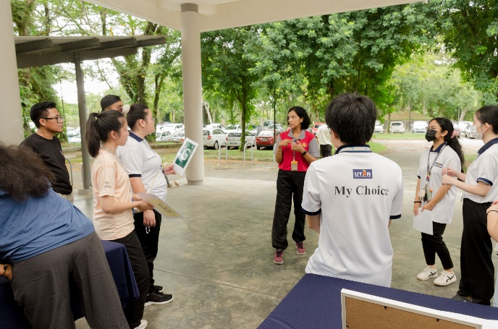 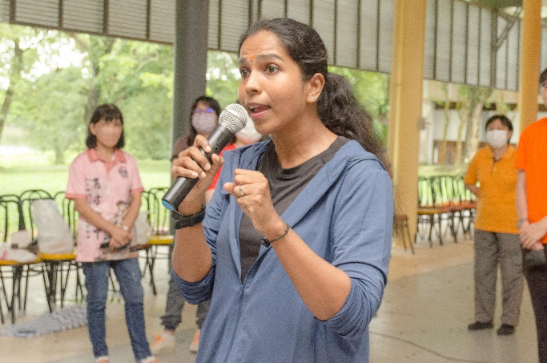

Training sessions by (from left) Ms Geetha and Ms Sanggari

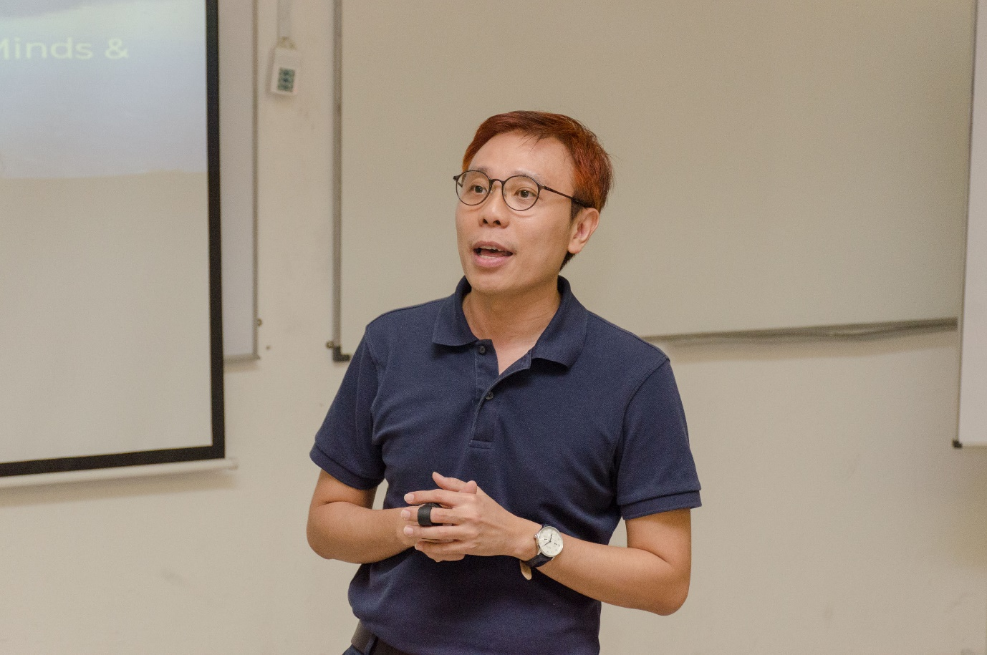

Learning about mindfulness with Mr Angus Ng

As a Mindfulness Teacher from The Present Courses CIC, and certified Choice Theory/Reality Therapy Practitioner, Mr Ng Foo Yek, Angus’ training on “Managing Stress and Fostering Well-being from Inside Out” aimed to support educators in stress management and explore holistic approaches to fostering inner wellbeing through the lens of mindfulness. Participants learnt that mindfulness, the practice of being fully present and aware in the moment, serves as a powerful tool for reducing stress, enhancing self-awareness, and promoting inner balance and vitality. Hence, by exploring the fundamental principles of mindfulness and its role in stress management and enhancing wellbeing, participants also learnt practical strategies for fostering resilience and coping mechanisms to deal with everyday stressors. The session also empowered participants with easy-to-follow steps to cultivate a healthy mindset, promote self-awareness, and foster emotional balance.

The “Leadership for the New Era” training by Dr Seow Ai Na, who is recognised with awards such as the “Most Downloaded Paper” award from Wiley Publisher, emphasised the importance of cultivating leadership skills through a diverse range of interactive approaches within the business environment. It also aimed to enhance leaders’ competence in effectively navigating the academic institution’s environment. Conclusively, the training improved critical skills among participants in the visioning process and provided them with support for managing the organisational working culture. Participants also learnt about inspiring staff to organise and develop complex ideas and fostering a culture of creativity and innovation. Additionally, the participants were able to understand current trends and explore potential options to strategically shape the future business trajectory.

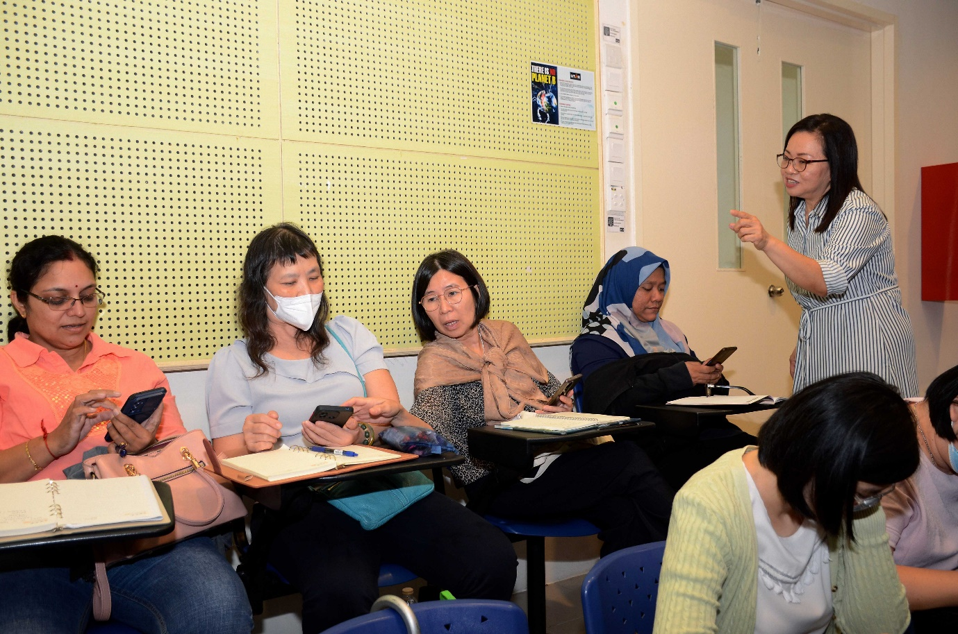

Dr Seow explaining the activity to the participants

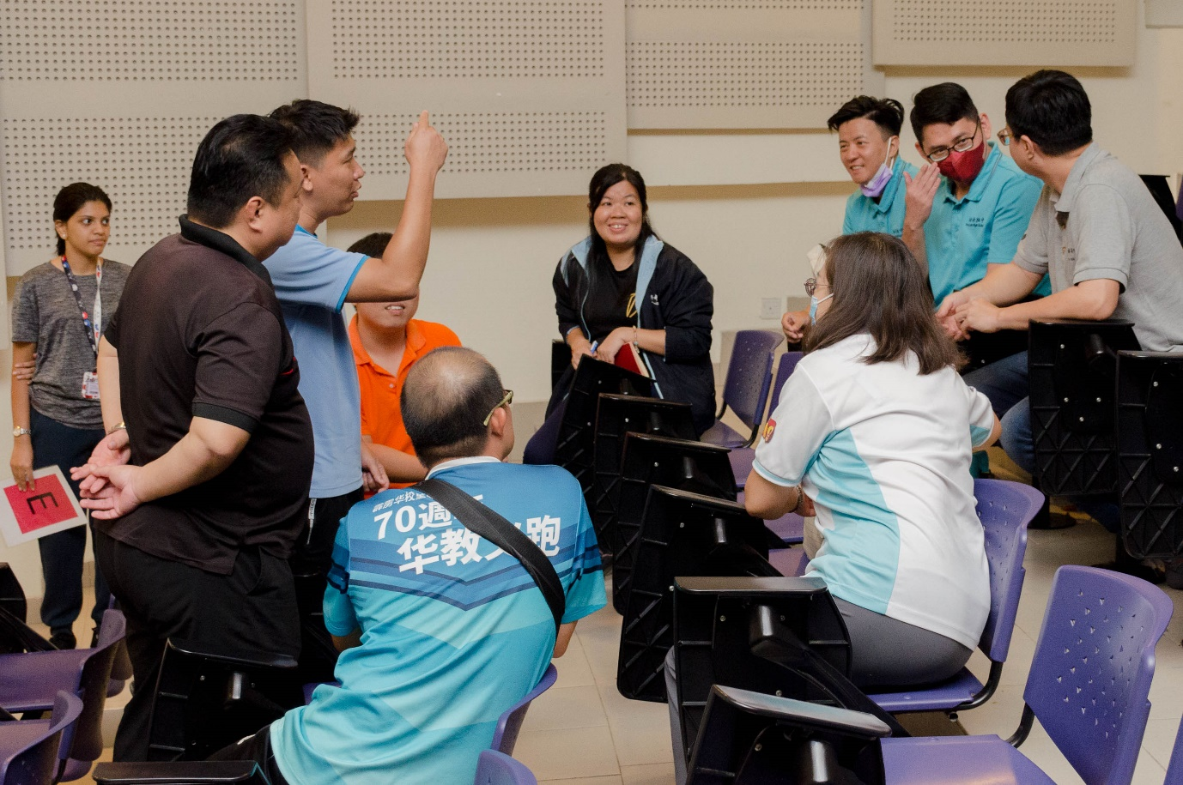 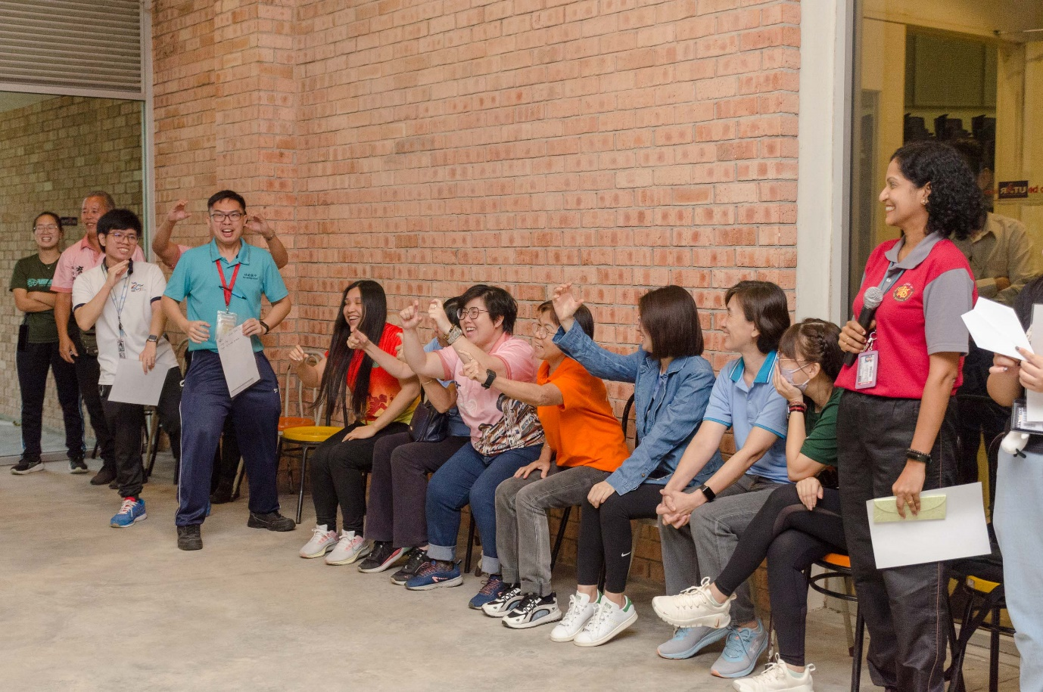 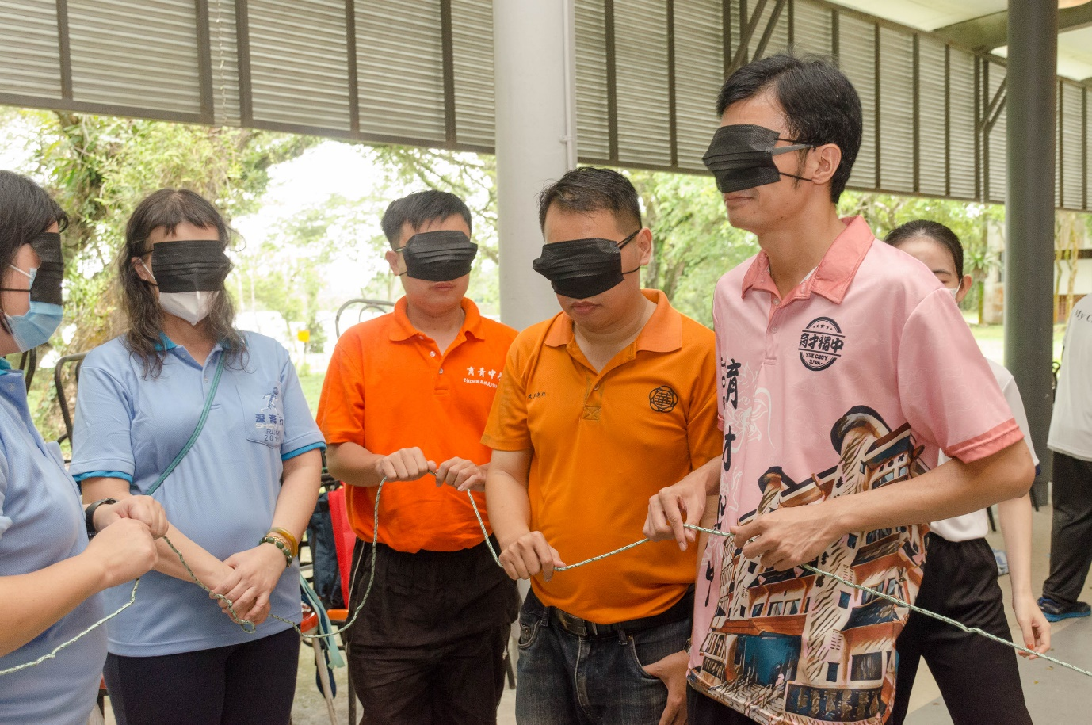 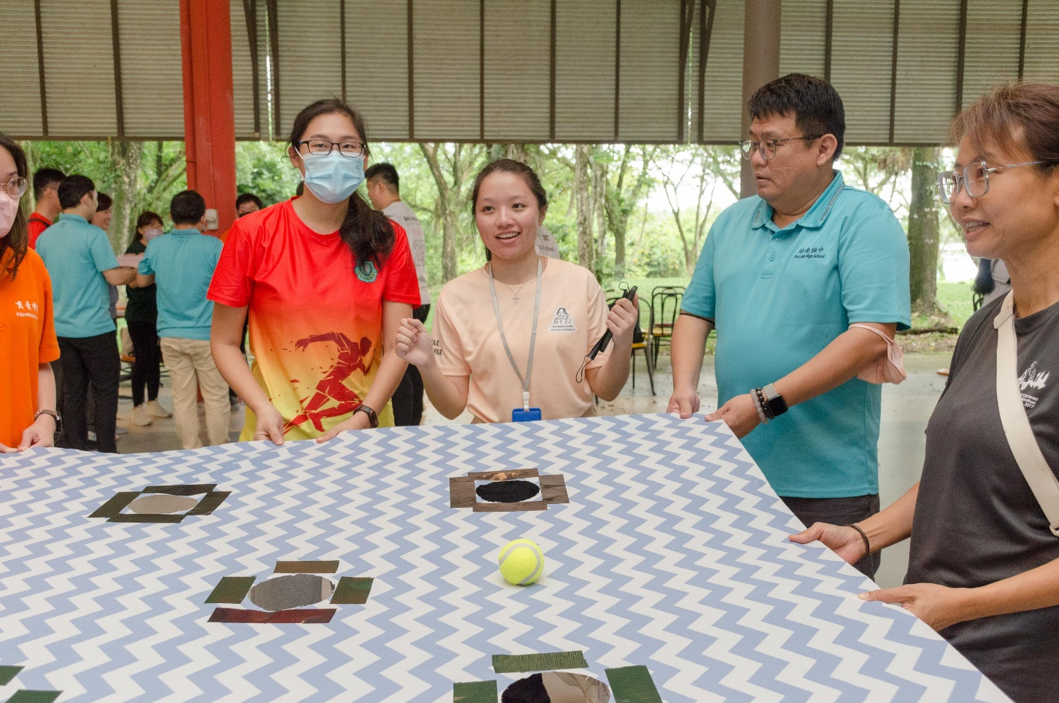

Participants learning about teamwork and leadership through fun and interactive activities

Click [here](https://www.facebook.com/media/set/?vanity=UTARnet&set=a.945829097583606) to view more photos.