**UTAR and CECCM Virtual Career Fair**

The job market is an ever-evolving ground that demands adaptability, and in return inculcates an assortment of practical skills in job seekers. Accompanied by the in-depth integration of undeniably efficient digital technology, this combination has provided countless opportunities for both employers and job seekers of any professional backgrounds.

Utilising digital convenience, the UTAR and China Enterprises Chamber of Commerce in Malaysia (CECCM) Virtual Career Fair is being organised for the second time in 2024. It aims to provide a platform filled with opportunities for Chinese enterprises with a keen interest in expanding their pools of talent, as well as UTAR alumni and students who are ready to embark on their new journey in the job market.

Twenty-four Chinese-funded enterprises are participating in the online career fair, offering more than 120 job opportunities to UTAR talents. With various professional fields such as finance, construction, transportation and logistics, electronic technology, and manufacturing included in the selection, the virtual event is taking place from 26 August to 25 October 2024.

An opening ceremony was organised on 26 August 2024 via Zoom to mark the second collaborative effort between the UTAR Department of Alumni Relations and Placement (DARP) and CECCM.

During the ceremony, UTAR President Ir Prof Dato’ Dr Ewe Hong Tat said, “Our collaboration with CECCM not only establishes a connecting link between university and workplace, but it also serves as a bridge to promote academia-enterprise collaboration and match talents with their desired careers. We believe the in-depth synergy between academia and industry is a crucial driving force for social and economic development.”

He added, “This virtual event is one of our efforts to explore new modes of academia-industry collaboration and broaden student employment channels. Therefore, we look forward to further exploring our collaborative efforts with CECCM and contributing to cultivate more talents that meet society’s demands.”

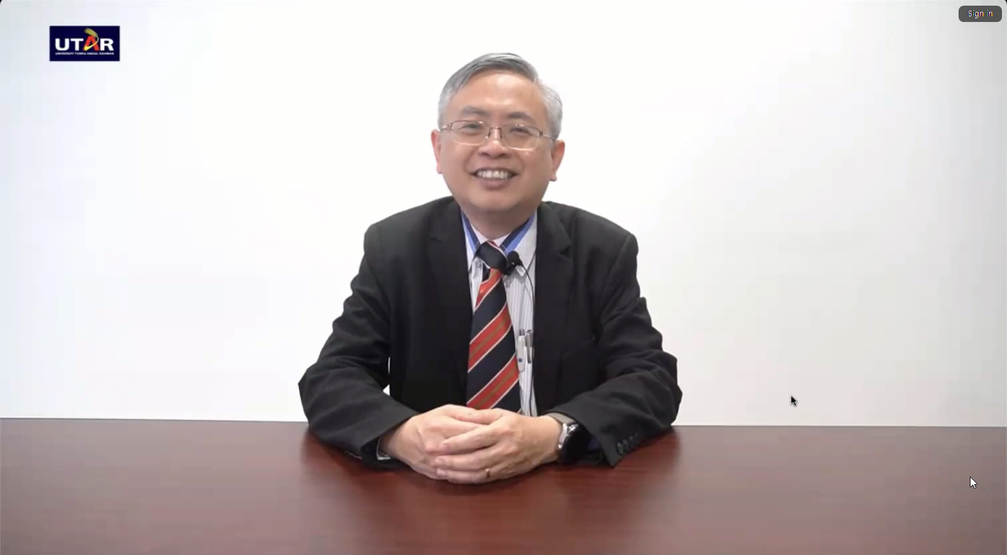

Prof Dato’ Ewe expressing his wish to deepen the collaborative effort with CECCM in the future

Delighted to join hands with UTAR once more after the success of the first virtual career fair in 2022, CECCM President Mr Ni Qingjiu said, “With the rapid development of globalisation, talent is the number one resource to promote development. Through this virtual event, we hope to provide a platform for fresh graduates and students to learn more about Chinese-funded enterprises. At the same time, we also hope to source and train more high-quality talents for the enterprises.”

He added, “CECCM has always put great importance on the interaction between Chinese-funded enterprises and Malaysian talents. Hence, we are honoured to work together with UTAR once more to organise this career fair, which serves as a platform for mutual understanding and exchange, connecting the enterprises with students.”

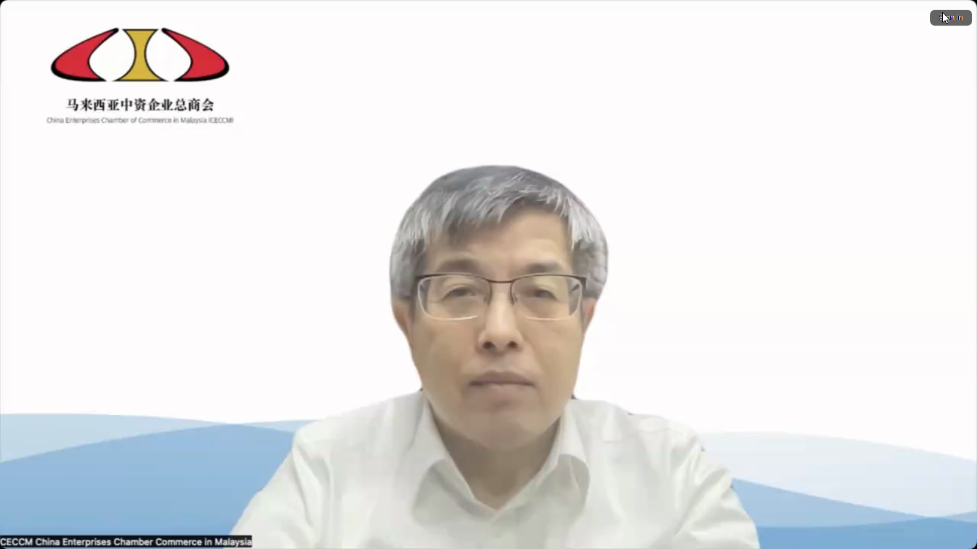

Mr Ni emphasising CECCM’s effort to source and train local talents

For more information on this year’s UTAR and CECCM Virtual Career Fair, please visit the official website [here](https://utarvcf.utar.edu.my/temporarysite/Home.php).

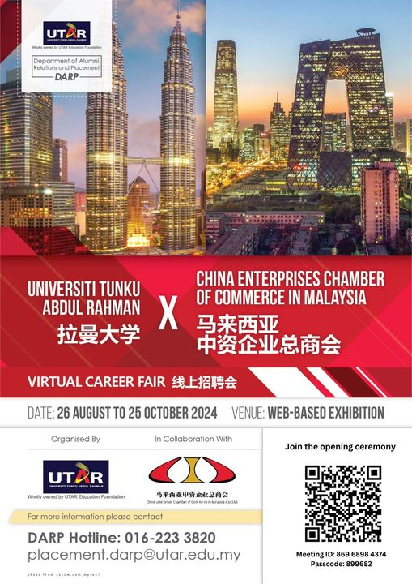

Event poster