N²RTU launches GENEY programme to promote precision nutrition among Malaysian youth
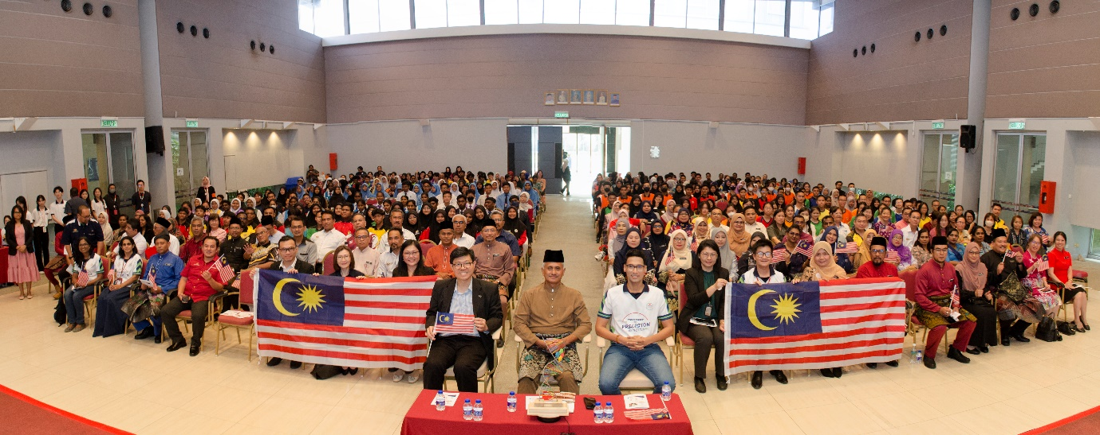
Research in the emerging field of nutrigenetics has continued to show that personalised nutrition strategies are a promising approach to combat obesity and related non-communicable diseases (NCDs) in Malaysia. Now, this knowledge and technology transfer is extended to our Malaysian youth through the Gene Environment Nutrition Education for Youth (GENEY) programme, allowing the younger generation to join in this effort to ensure healthier lives among Malaysians.
The GENEY programme was launched by the Nutrigenetics and Nutrigenomics Research and Training Unit (N²RTU) at UTAR Kampar Campus on 30 August 2024 during its School Outreach Event 2024. This initiative, funded by the British Council and the Malaysian Industry-Government Group for High Technology (MIGHT), with support from the University of Reading, UK, aims to introduce the concept of precision nutrition to young Malaysians by integrating it into school science activities.
The GENEY programme is designed to engage students and educators through interactive talks and discussions, laying the foundation for a deeper understanding of the effectiveness of personalised nutrition in enhancing health outcomes. To measure the impact of this initiative, follow-up evaluations will be conducted immediately after the programme and again six months later, providing insights for continuous improvement.
Present to launch the programme were Pegawai Pendidikan Daerah, Pejabat Pendidikan Daerah (PPD) Kinta Selatan Dr Mior Hamdan bin Haji Ghazali, UTAR Vice President for Student Development and Alumni Relations Prof Dr Choong Chee Keong, and Deputy Director of Institute of Food, Nutrition and Health, University of Reading, UK Prof Dr Vimaleswaran Karani Santhanakrishnan. Also present were Director of the Institute for Postgraduate Studies and Research (IPSR) Prof Ts Dr Lim Yang Mooi, IPSR Deputy Director Assoc Prof Dr Choong Yuen Onn, Director of the Centre for Corporate and Community Development (CCCD) Ms Lim Guat Yen, and Faculty of Science (FSc) Dean Assoc Prof Dr Lim Tuck Meng, along with 350 primary and secondary school students from 15 schools in Kinta Selatan District.
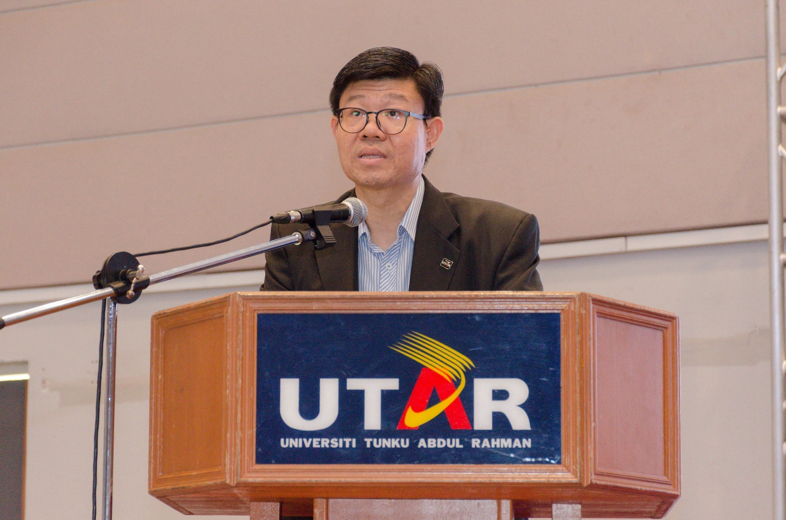
Prof Choong emphasising the importance of early education and involvement among Malaysian youth
Prof Choong said, “With the GENEY programme, the knowledge and technology transfer is extended to our Malaysian youth, which educates them on the principles of precision nutrition, which lays the foundation for a deeper understanding of how personalised nutrition can enhance health outcomes. Ultimately, the students will learn about the interactions and applications of genes, diet, and environment, in preventing the escalating obesity epidemics and its co-morbidities in the country. Their early involvement and education are important because they are the future leaders who will lead changes, drive innovation, and progress societal evolution, while also inheriting global challenges. This is truly a step necessary to ensure that they are prepared and empowered to create a sustainable future.”
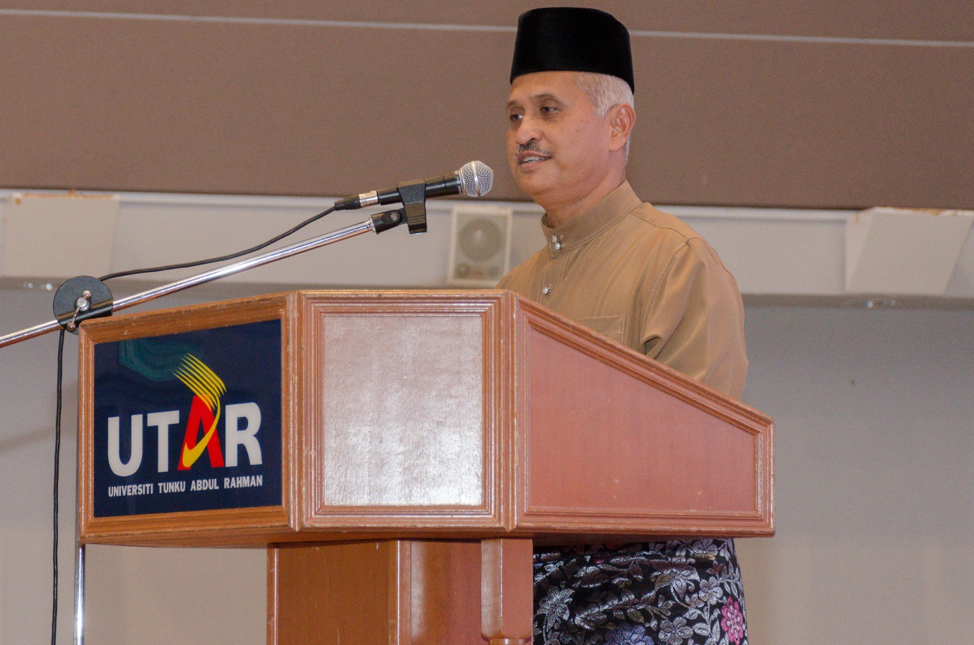
Dr Mior expressing his support on behalf of PPD towards the initiative
In his inaugural address, Dr Mior welcomed the integration of GENEY into science club activities, emphasising the importance of starting health awareness at a young age. He promised that the initiative would be jointly organised by PPD Kinta Selatan and could even be expanded to primary school children. Dr Mior assured the N²RTU team of his full support in advancing precision nutrition in Malaysia, setting a benchmark for other schools.
A keynote session by Prof Vimal Karani saw participants engaging in an interactive and engaging session on precision nutrition. He also explained the way genes interact with food to mitigate the risk of NCDs. Participants’ interest was piqued further by the fun quizzes and discussions conducted. Following was a briefing by N²RTU-GENEY project lead and Chairperson of the outreach event Dr Anto Cordelia Tanislaus Antony Dhanapal, who explained the implementation of GENEY in school science activities. Her briefing included information on ways to execute and monitor the programme, and competitions that will be held to motivate schools’ participation, including the GENEY Rolling Trophy that will be awarded to the school with the most innovative precision nutrition activities, at the dissemination event in April 2025.
Ms Subhashini from SMK Methodist ACS, Kampar, in her felicitation message, praised the precision nutrition concept, describing it as fresh and the need of the hour to prevent the escalating burden of non-communicable diseases. Meanwhile, Dr Lim’s closing remark emphasised the importance of collaboration among schools, PPD, UTAR, the British Council, and MIGHT to ensure the success of this initiative. In conjunction with Malaysia’s 67th Independence Day, the singing of the national song “Jalur Gemilang” gave a spirited end to the ceremony.
The overwhelming attendance underscored the reach and impact of this successful initiative. Moving forward, the GENEY programme will be introduced to all schools in Perak, continuing its mission of promoting precision nutrition among the youth.
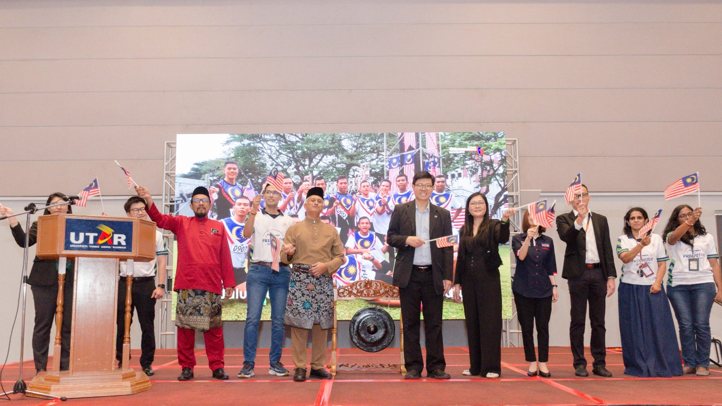
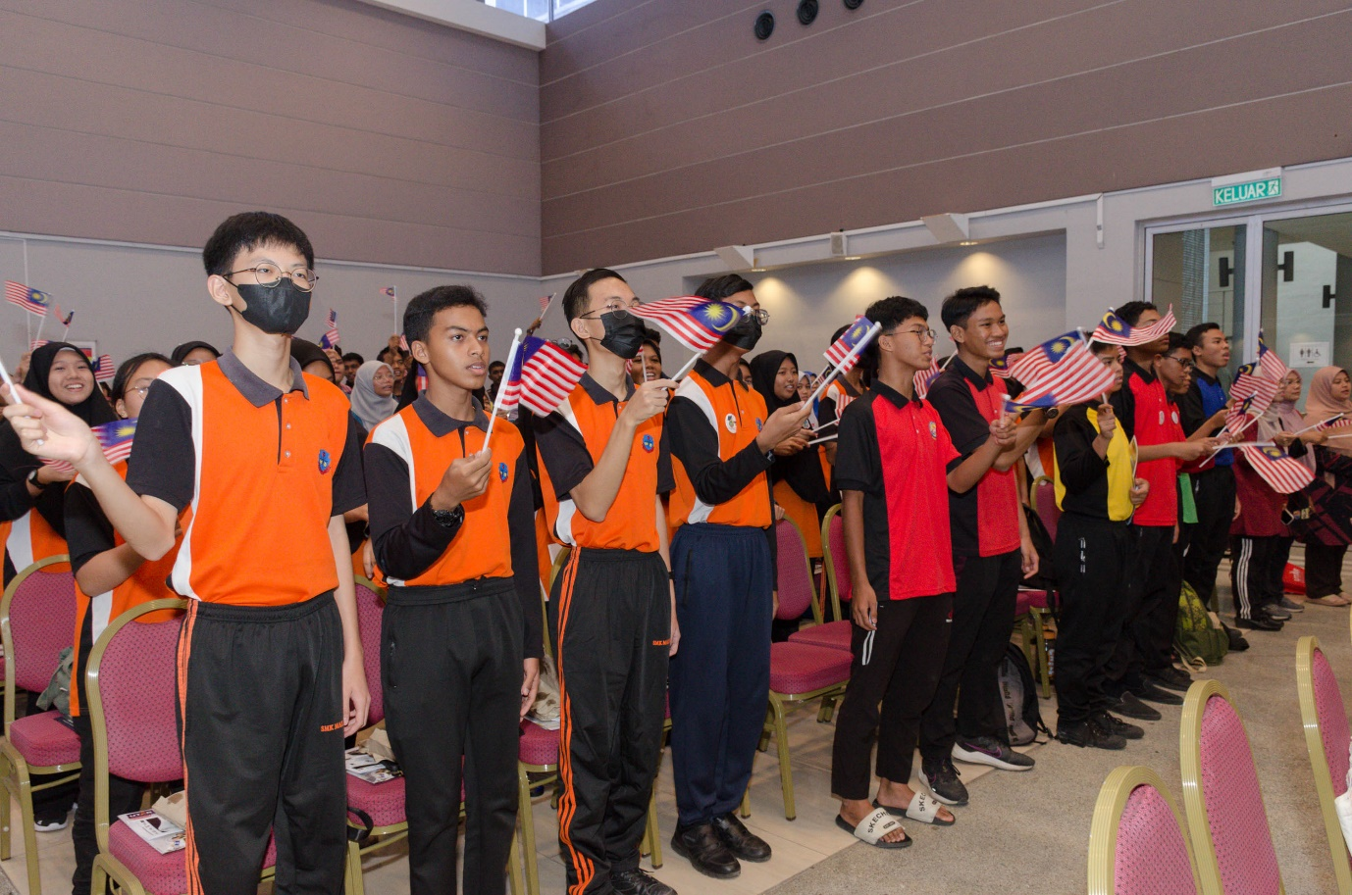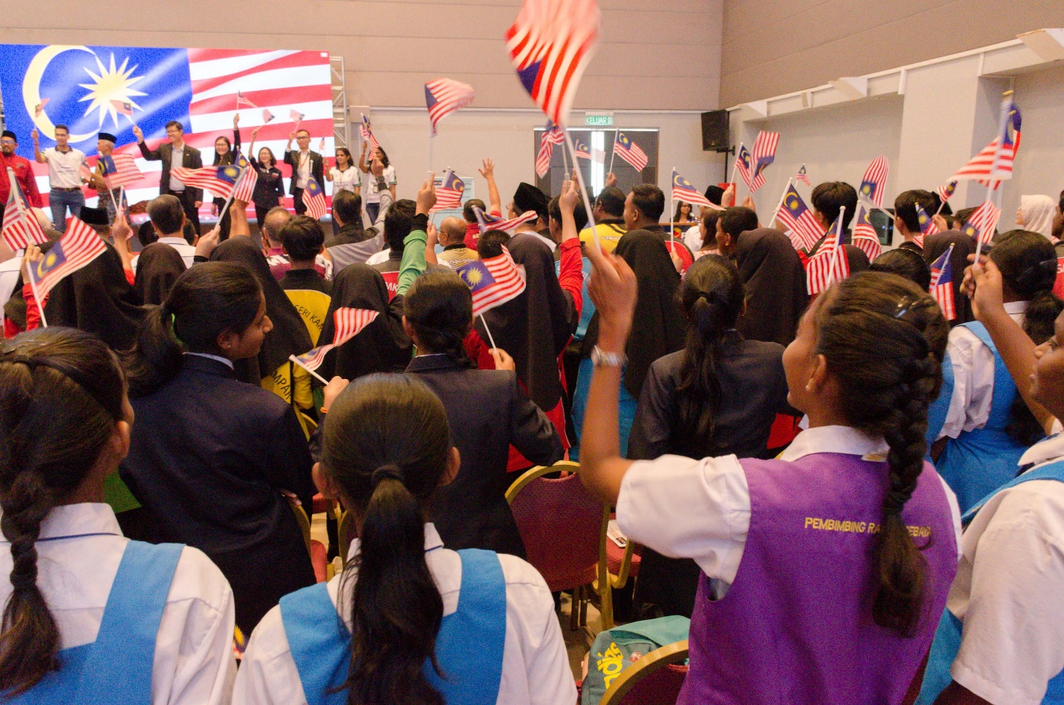
Celebrating Malaysia’s National Day with Jalur Gemilang

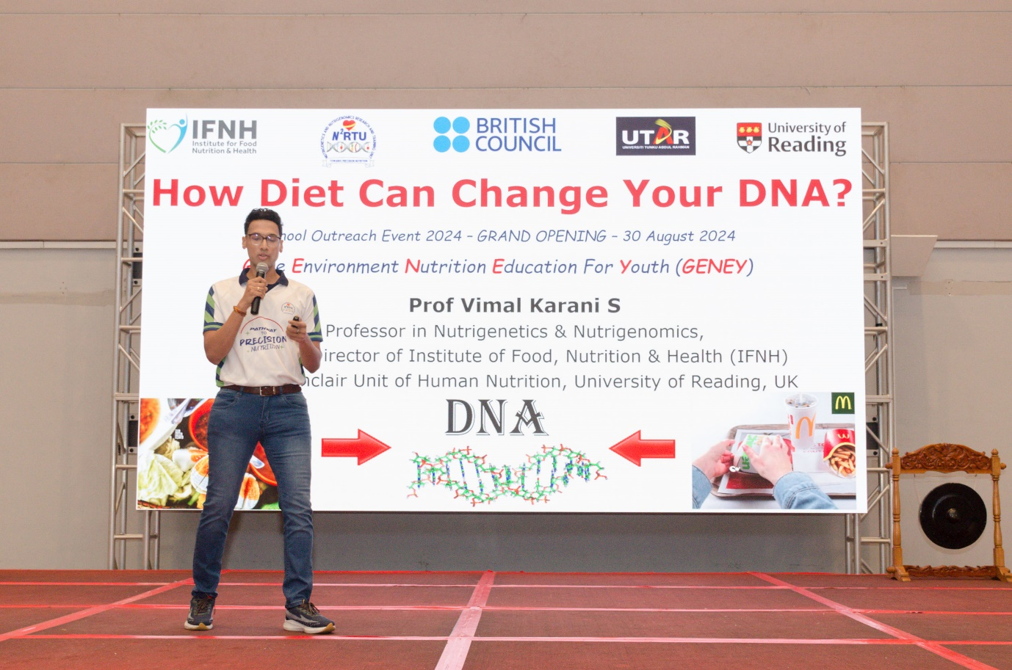Prof Vimal Karani introducing his keynote title
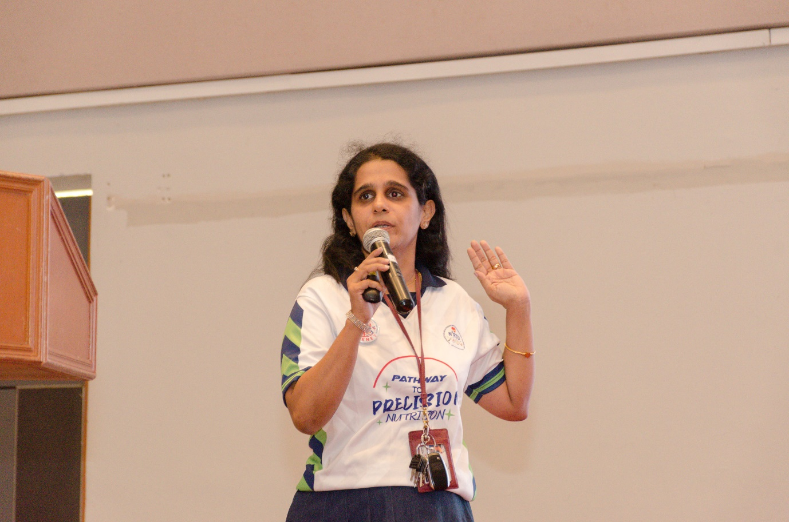
Dr Anto Cordelia briefing the school teachers and students on integrating GENEY into school science activities
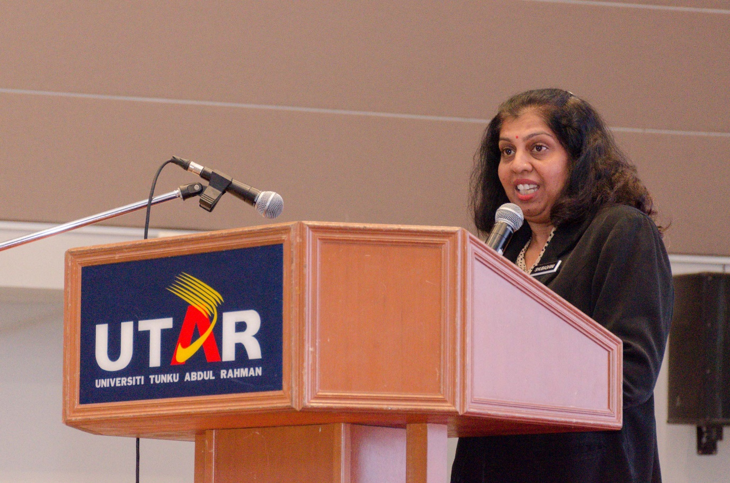
Puan Subhashini from SMK Methodist ACS, Kampar, complimenting the efforts of the team
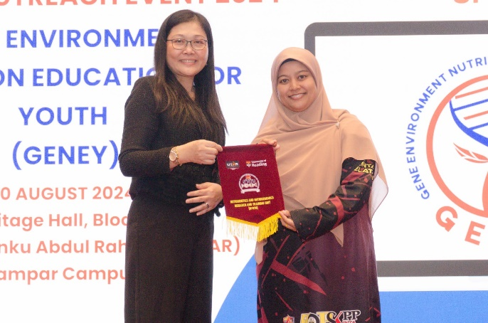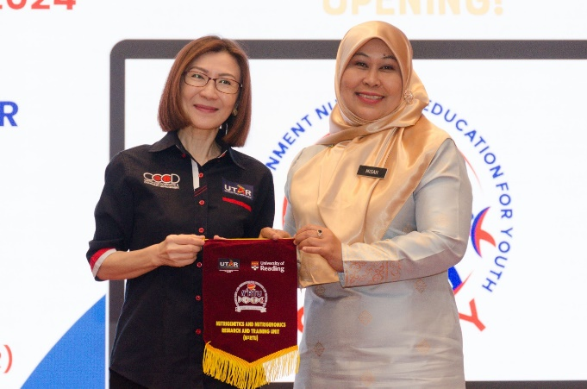
From left: Prof Lim and Ms Lim presenting tokens of appreciation to the school representatives
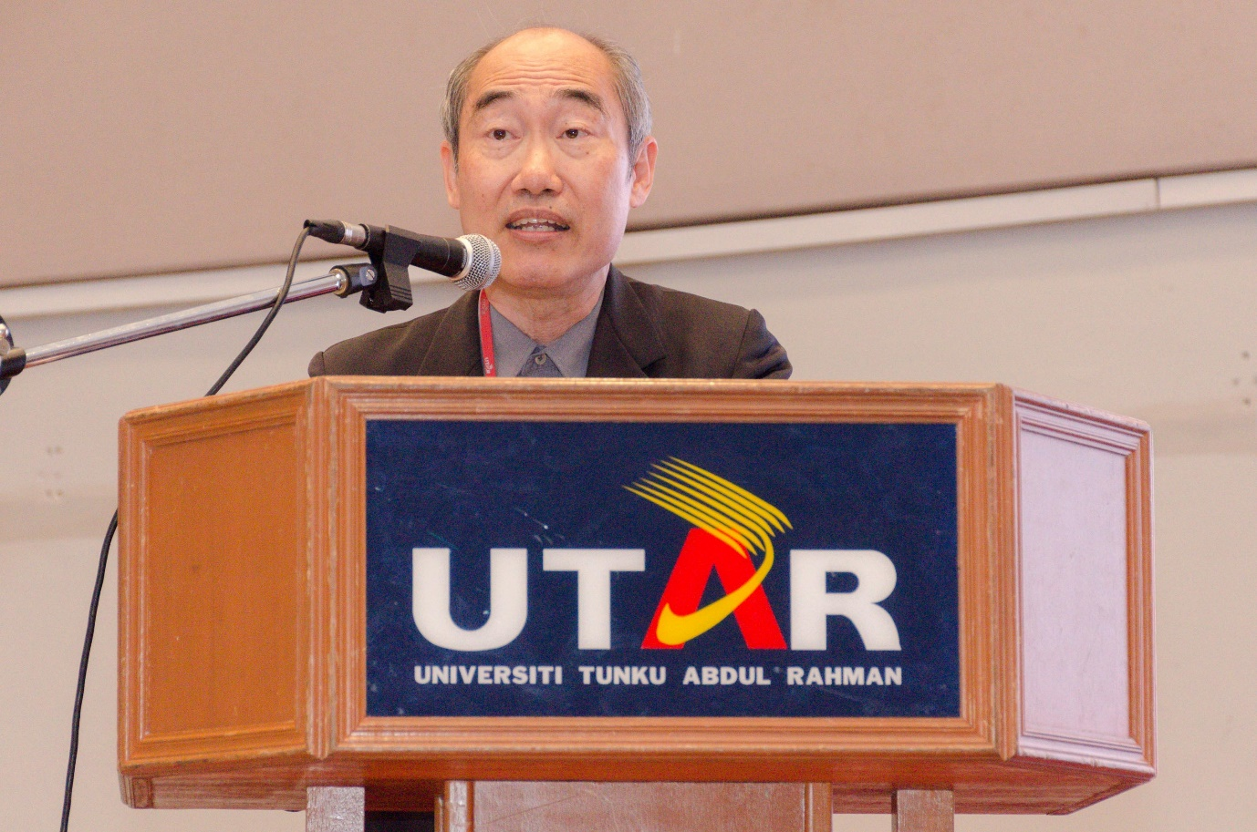
Dr Lim emphasising the need for collaboration to ensure the success of this initiative
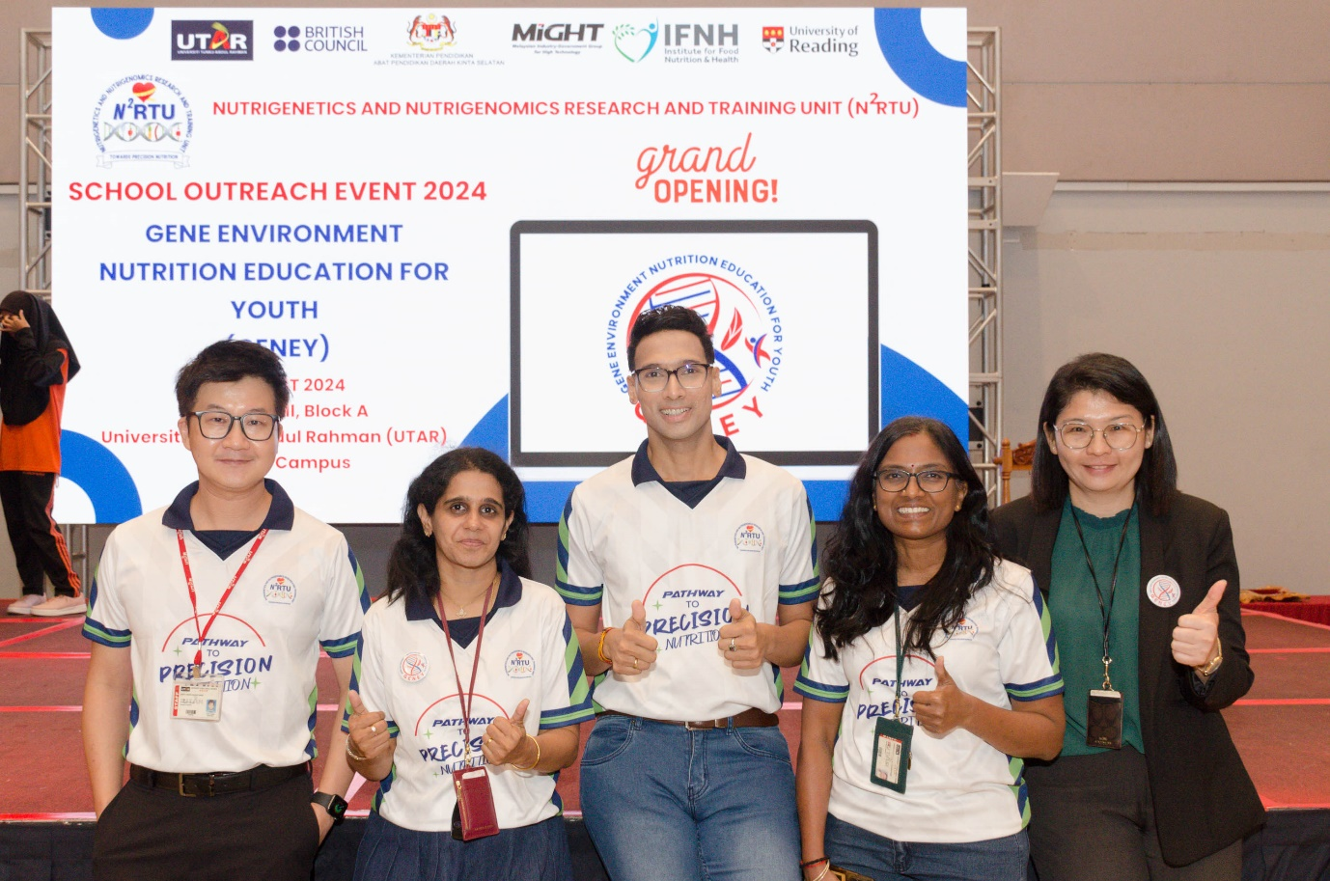
The N²RTU team, the brain behind GENEY programme
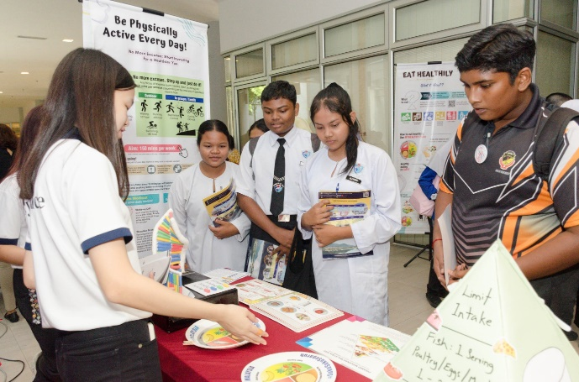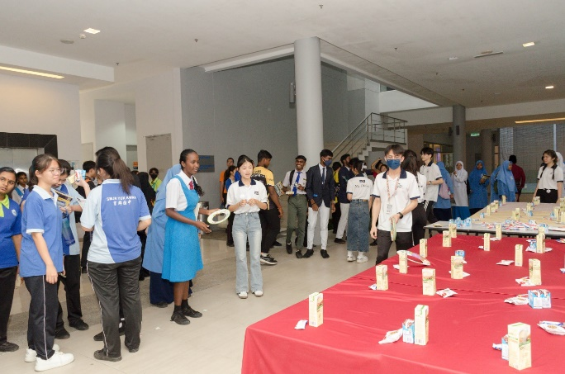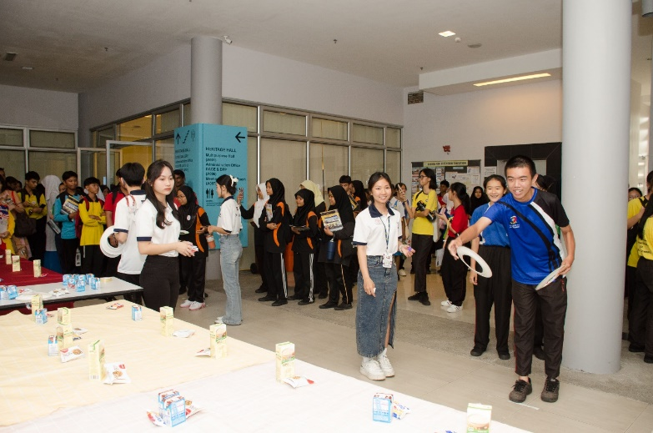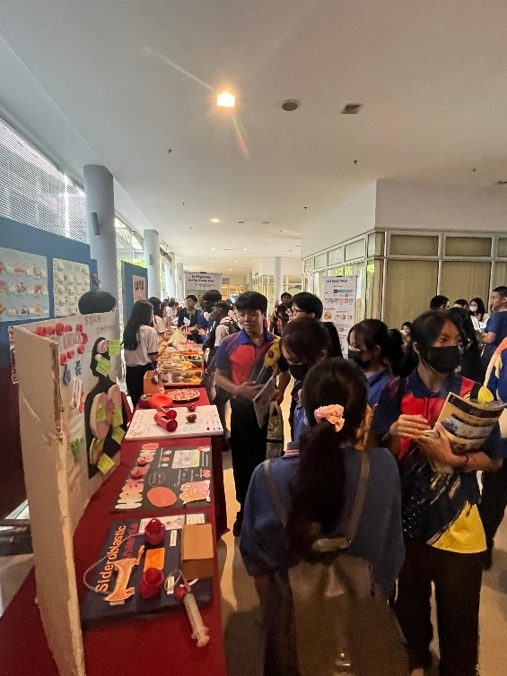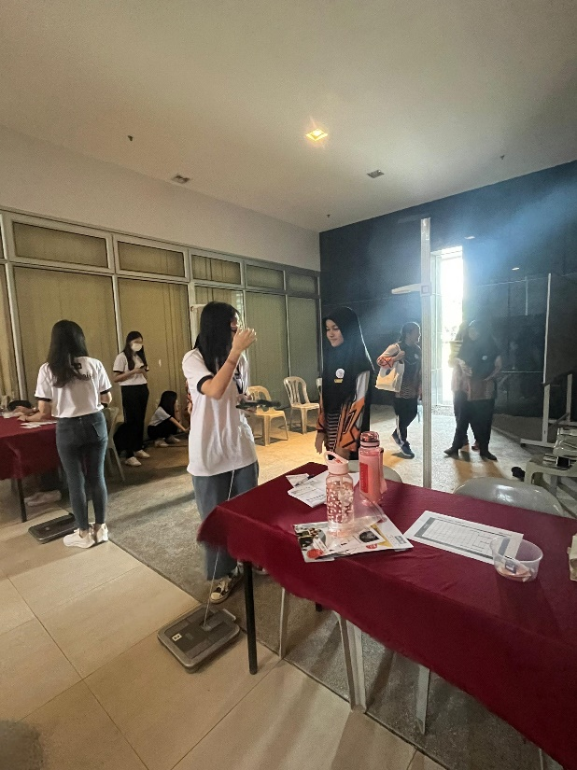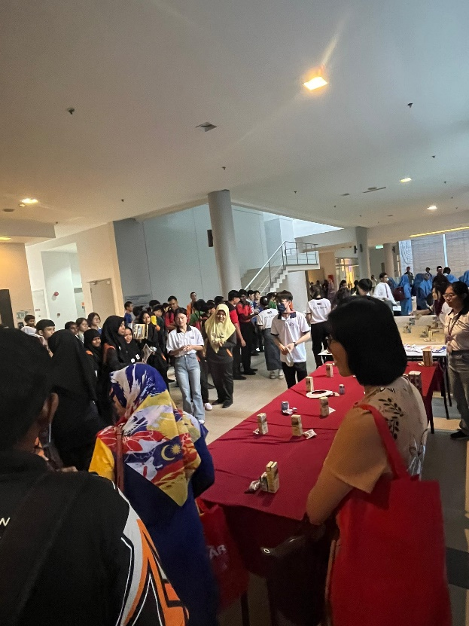
Participants visiting the Nutrition and Health Education booths

