**ZAST and technology institutions from Zhejiang, China visit UTAR**

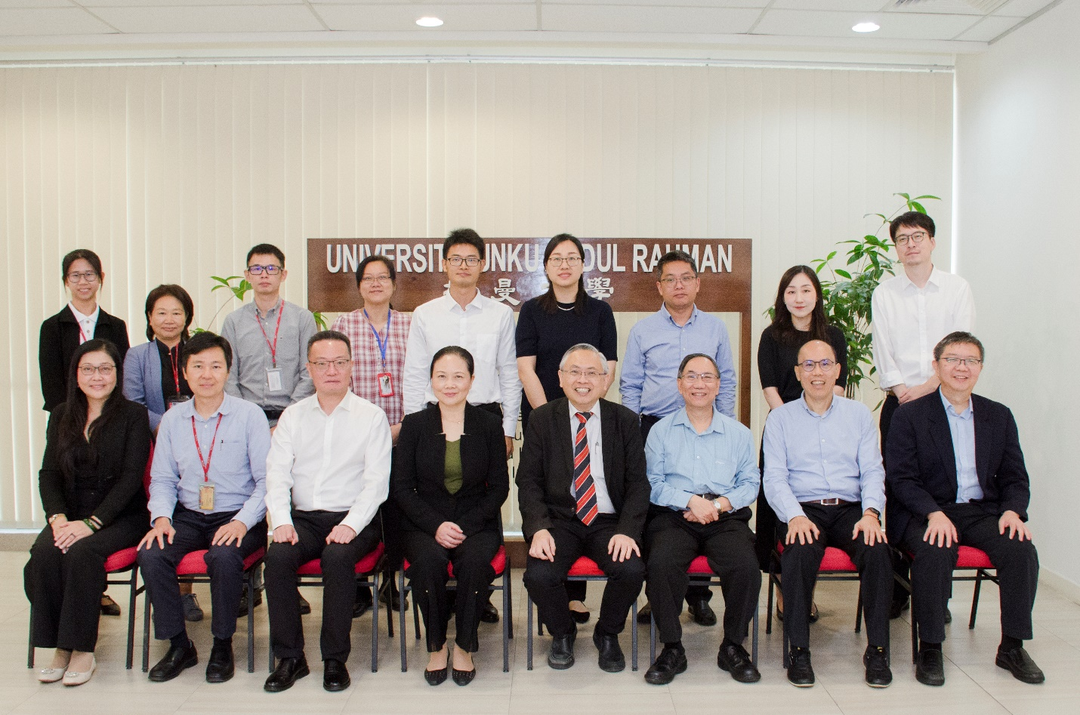

Front row, from left: Prof Lim, Prof Ng, Mr Ruan, Ms Zeng, Prof Dato’ Ewe, Tan Sri Chuah, Dr Tan and Prof Liew

Second row, from left: Ms Neoh, Prof Ma, Dr Leong, Dr Lo, Mr Cui, Ms Xiang, Prof Yan, Dr Chen and Mr Wang

A group of visitors representing multiple technology institutions from Zhejiang, China visited UTAR Kampar Campus on 30 August 2024.

The group of guests was comprised of Zhejiang Association for Science and Technology (ZAST) Vice President Ms Zeng Xiaopeng, Taizhou Association for Science and Technology President Mr Ruan Jimin, Zhejiang International Science and Technology Exchange Centre Director Ms Xiang Yulin, Zhejiang University of Technology (ZJUT) Department of Science and Technology Vice Director Prof Yan Mi, Zhejiang University (ZJU) Polytechnic Institute Senior Manager of International Affairs Mr Wang Dawei, and Taizhou Association for Science and Technology staff Mr Cui Yuhui.

They were received by UTAR President Ir Prof Dato’ Dr Ewe Hong Tat, UTAR Hospital Board Chairman and UTAR Council Member Ir Academician Emeritus Prof Tan Sri Dato’ Seri Dr Chuah Hean Teik; Faculty of Engineering and Green Technology (FEGT) Dean Ir Prof Dr Ng Choon Aun, Faculty of Information and Communication Technology (FICT) Dean Prof Ts Dr Liew Soung Yue, UTAR Confucius Institute Director (China) Prof Dr Ma Yingxin, FEGT Deputy Dean for R&D and Postgraduate Programmes Dr Lo Po Kim, Institute of Postgraduate Studies and Research (IPSR) Director Prof Ts Dr Lim Yang Mooi, FEGT academic Dr Leong Sim Siong, Office of International Affairs (OIA) Deputy Director Assoc Prof Dr Chen, I-Chi, OIA Senior Assistant Manager Ms Chin Sau Lai, Unovate Centre Assistant Manager Ms Neoh Shi Yii, and the Federation of Engineering Institutions of Asia and the Pacific (FEIAP) Secretary General Ir Dr Tan Yean Chin.

A discussion was held, in which the parties discussed the possibilities of research collaboration, talent training, joint technology programmes and future collaborations.

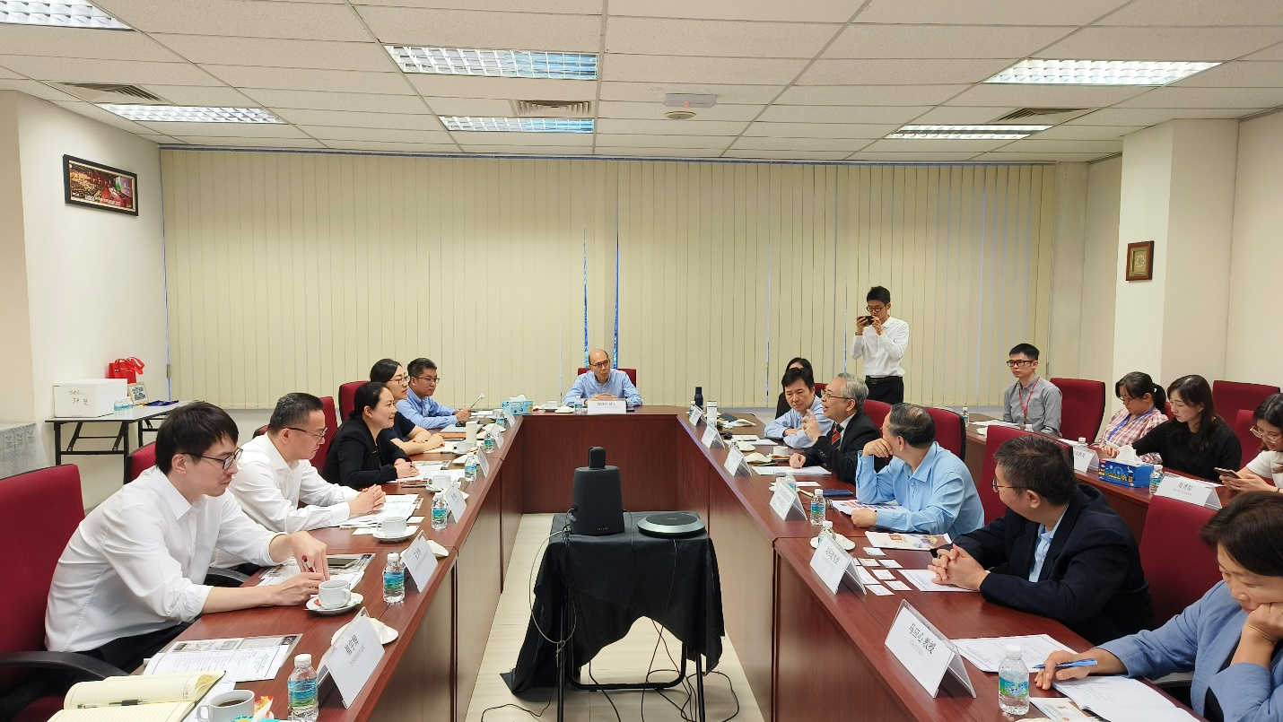

On-going discussion

The parties gave brief introductions to their respective institutions. They also showed keen interest in joining hands in various fields of collaboration such as engineering, science, and information technology.

Besides, as the President of UTAR and ASEAN Academy of Engineering and Technology (AAET), Prof Dato’ Ewe also voiced AAET’s interest in working together with the technology institutions in the future.

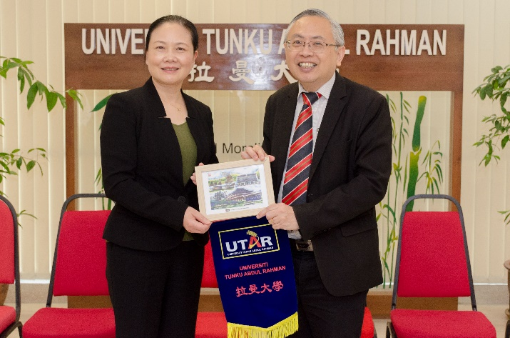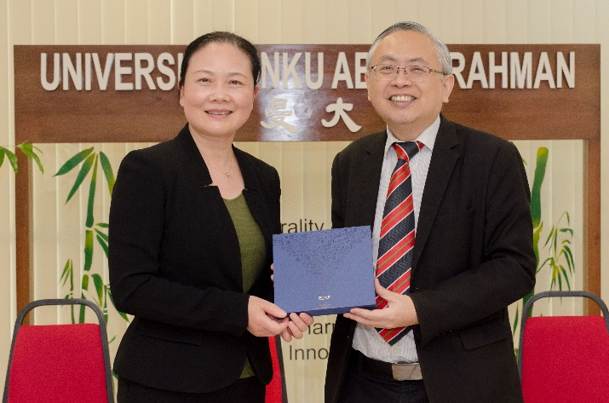

Prof Dato’ Ewe (right) and Ms Zeng exchanging tokens of appreciation

The visit ended with a group photography session and a tour around UTAR Kampar Campus and UTAR Hospital.

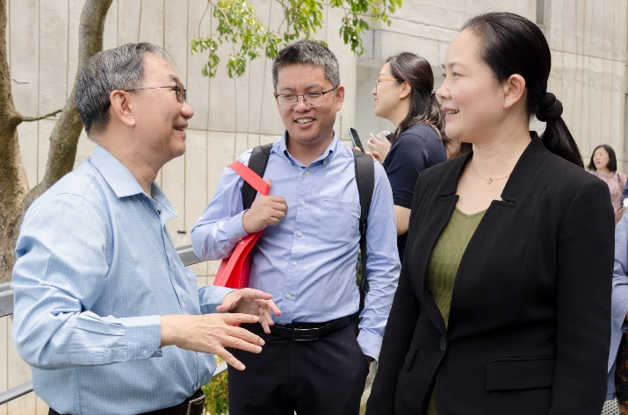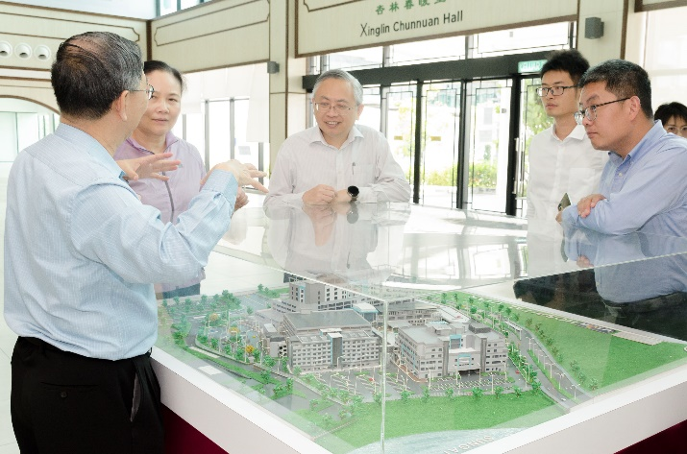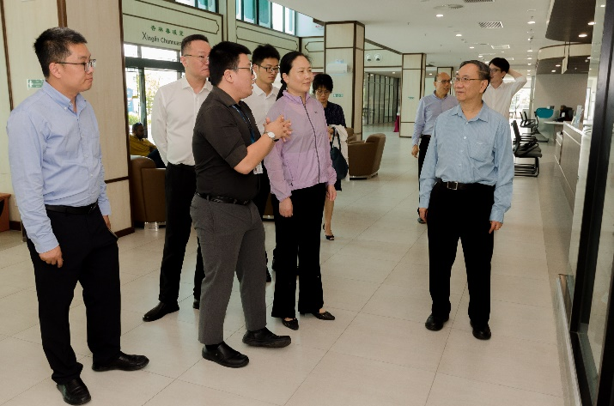

Tour around the campus and UTAR Hospital