**A test of wits gathers young minds at Kampar Campus**

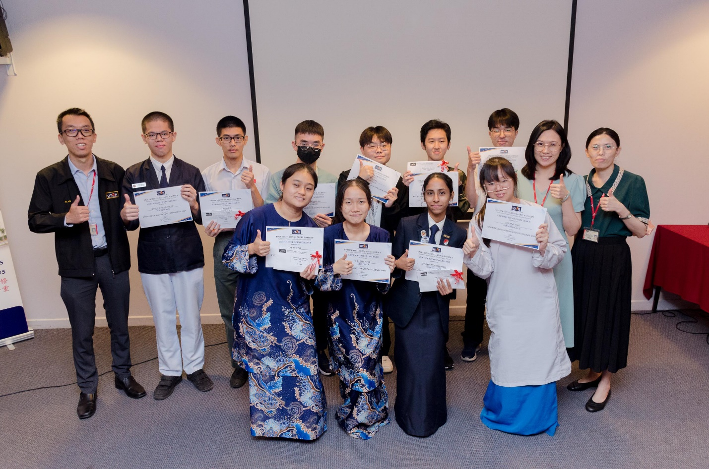

The winning teams

"Knowledge is power" and "Knowledge is the key…" are familiar phrases often encountered by those curious about the world. Gaining new knowledge serves various purposes—whether to elevate status, benefit others, or appreciate the diversity of life. While ideals may clash among brilliant minds, a common belief remains universal: one can never know too much.

To strengthen the spirit of learning and curiosity among the young and avid learners, UTAR Centre of Foundation Studies (CFS) of Kampar Campus and the Rotary Club of Sitiawan jointly organised the “Knowledge Masters Quiz Challenge 2024” in August 2024, putting 310 students from 29 schools and institutions across Perak to a test of quick wit and knowledge.

The challenge was open to students aged between 16 to 19 years old. It entailed a total of three rounds. The Preliminary Round was organised via Microsoft Forms on 10 August 2024, while the Semi-final Round and Final Round were organised physically at UTAR Heritage Hall Building, Kampar Campus on 22 August 2024.

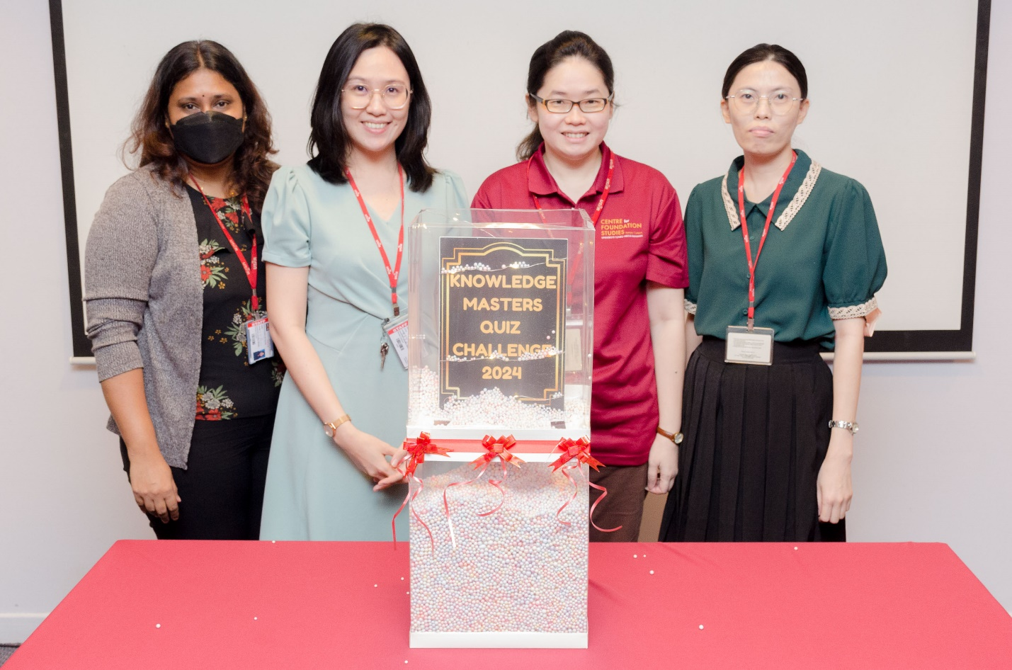

From left: Ms Pakialetchumy, Ms Tsen, Ms Phang and Ms Ooi inaugurating the event

The leader of the project, Ms Tsen Tzu Yee, who is also the head of CFS (Kampar Campus) Department of Management and Accountancy, said, “The Knowledge Masters Quiz Challenge 2024 is more than just a competition. It is a celebration of learning and curiosity. With a wide range of topics, the challenge aims to cultivate a lifelong love of learning and equip students with the critical thinking skills needed to excel in the 21st century.”

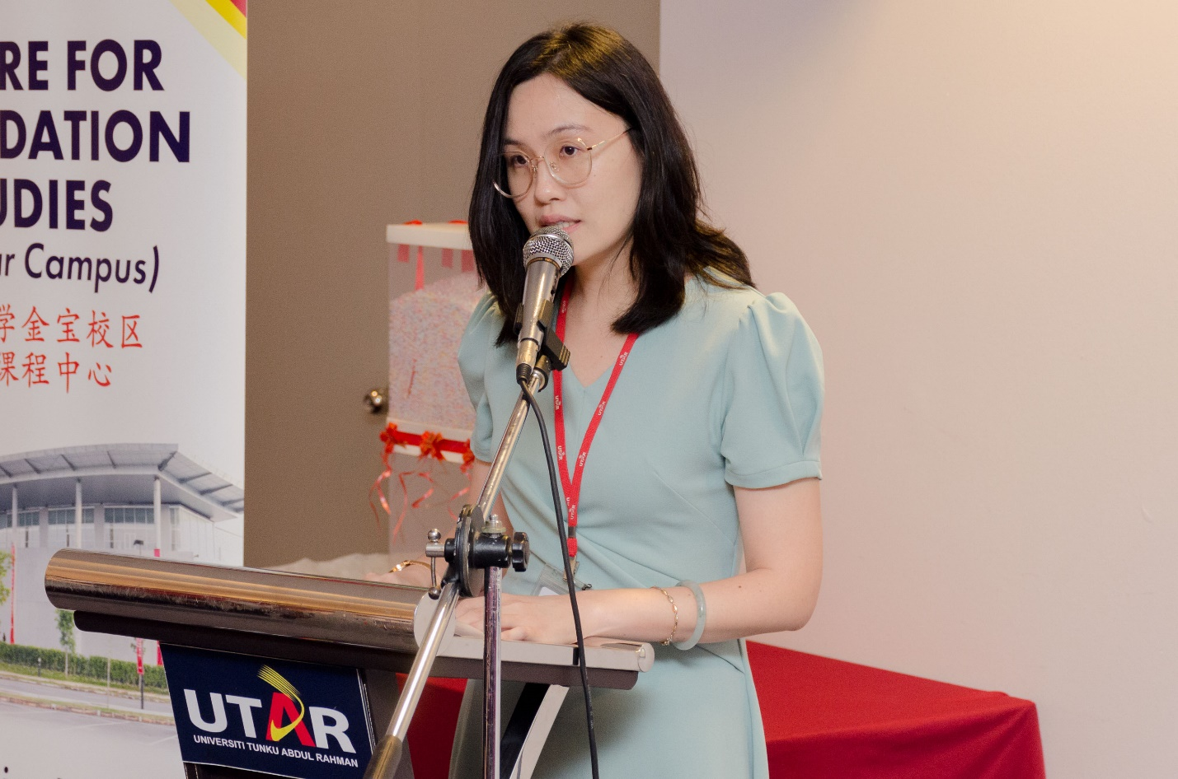

Ms Tsen encouraging the youths to embrace the spirit of curiosity

The participants were divided into two individuals per team. Each team were tasked to work together in several fast-paced Quizizz sessions, answering questions filled with an extensive array of topics, ranging from arts and literature to history and politics, science and technology, geography, economics and finance, and contemporary affairs.

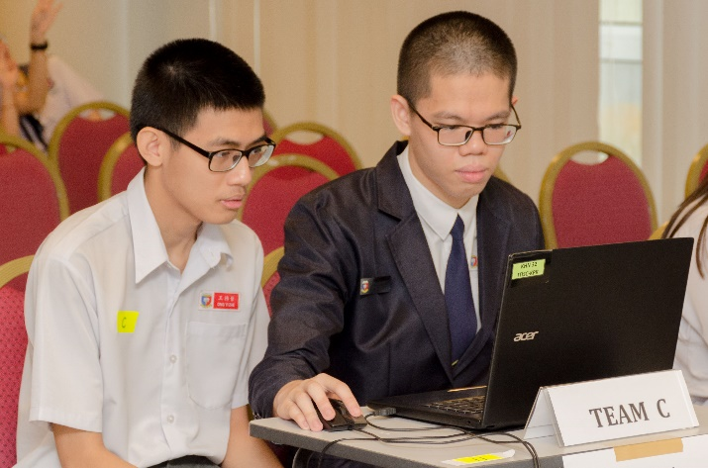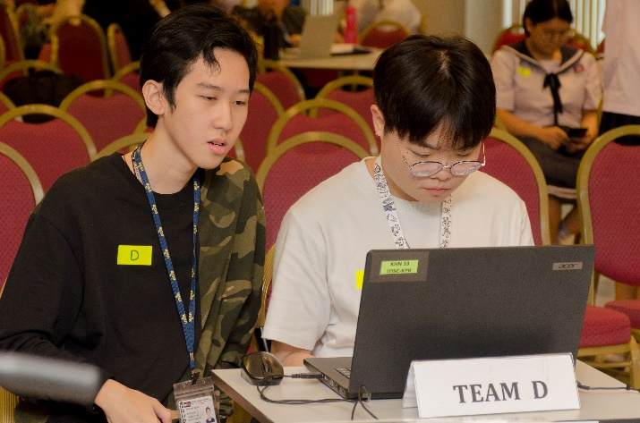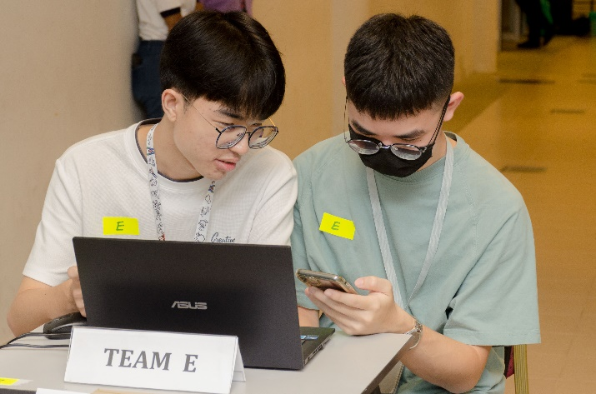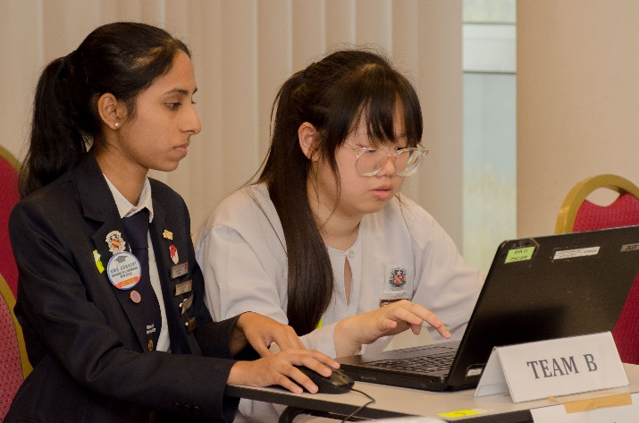

Participants working together with their partners to solve quizzes

The list of the top five teams is as follows:

|  |  |  |  |
| --- | --- | --- | --- |
| **Position** | **Name** | **Institution** | **Prize** |
| 1st Place | Cryus Choong Min Jie | SMJK Pei Yuan | RM500 & Certificate |
| Ong Yi Zhe |
| 2nd Place | Samuel Chan Ming Hao | UTAR | RM300 & Certificate |
| Chooi Hong Er |
| 3rd Place | Chin Qian Tong | SMK Methodist (ACS) Ipoh | RM200 & Certificate |
| Lee Bee Yee |
| 4th Place | Luvinya a/p N. Thavaraj | SMK Convent Ipoh | RM100 & Certificate |
| Lee Xing Yuet |
| 5th Place | Tang Xing Hoong | UTAR | RM80 & Certificate |
| Kok Qi Jian |

The institutions that participated in the Semi-final Round included Shen Jai High School, SMK Convent Ipoh, SMK Methodist (ACS) Ipoh, SMK Seri Keledang, SMK Seri Puteri, and SMK St Michael, SMJK Pei Yuan, SMK Convent Sitiawan, SMK Methodist (ACS) Sitiawan, SMJK San Min, SMJK Shing Chung, Universiti Teknologi PETRONAS (UTP), Tunku Abdul Rahman University of Management and Technology (TAR UMT), and UTAR.

Besides the quiz challenge, multiple booths were also set up by UTAR Confucius Institute, providing moments of relaxation for the participants from the competition. The booths included activities such as traditional Chinese chess, Chinese tea culture experience, and Hanfu (traditional Chinese clothing) experience.

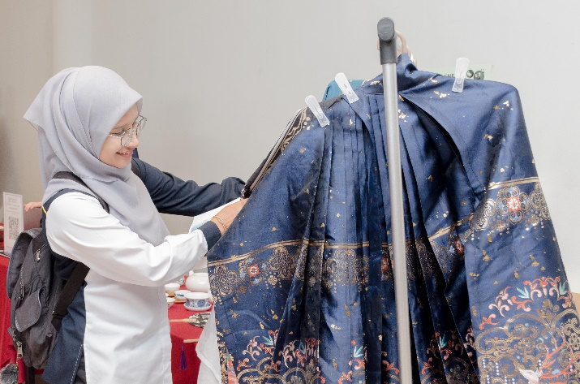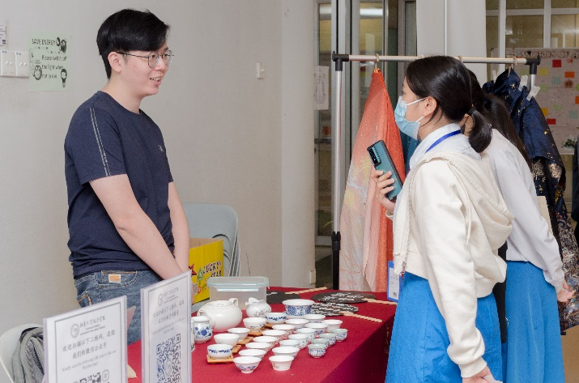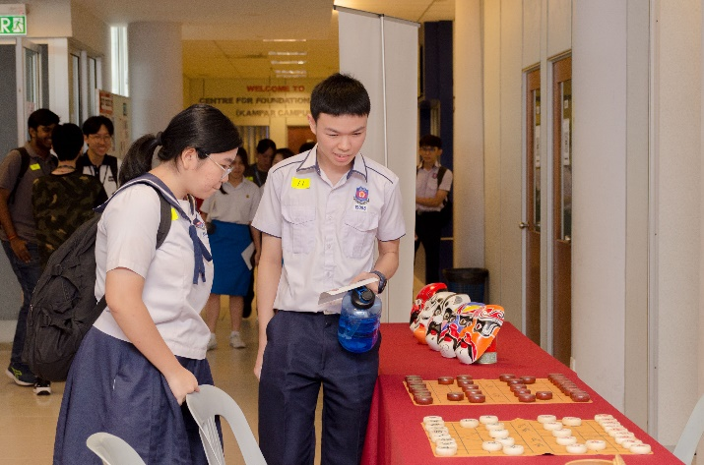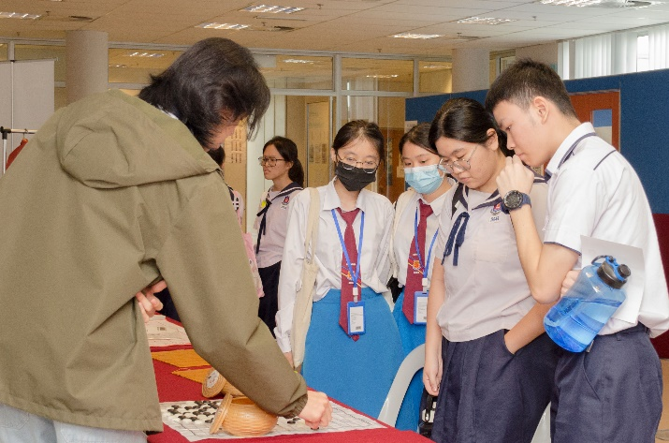

Participants taking a short break to learn about Chinese heritage at the booths

Also present at the opening and closing ceremonies were CFS (Kampar Campus) Deputy Director for Academic Ms Phang Ying Ning, Deputy Director for Student Affairs and Development Mr Lim Khiew Loon, Head of Department of Science and Engineering Ms Ooi Siew Fong, Head of Department of Arts and Social Science Ms Pakialetchumy Antoni, UTAR academics Ms Chan Wan Ling, Ms Chia Phee Phee, Ms Chooi Wen Xin, Mr Goh Kai Wey, Ms Kanimozhi Govindasamy, Ms Kow Li Fen, Mr Sree Amertharaj Ratnam, Ms Yip Mei Theen, Ms Yuvashini Salvamani, school teachers and students, UTAR staff and students.

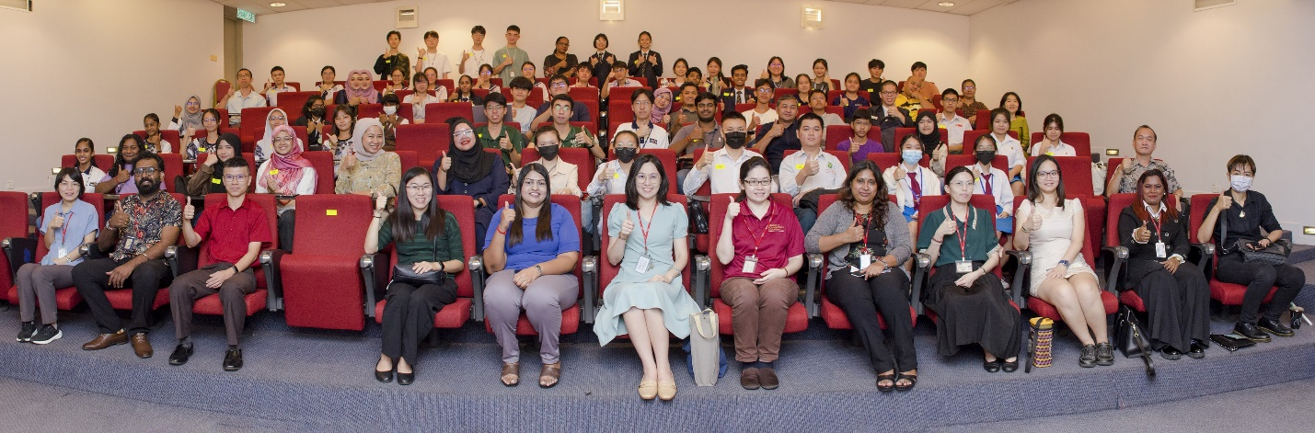

From left: Ms Yip, Mr Sree Amertharaj, Mr Goh, Ms Chia, Ms Yuvashini, Ms Tsen, Ms Phang, Ms Pakialetchumy, Ms Ooi, Ms Chooi, Ms Kanimozhi and Ms Kow with school teachers and participants at the opening ceremony