**Communication workshop for SJKT Ladang Kota Bahroe students**

UTAR and UUM facilitators with SJKT Ladang Kota Bahroe students

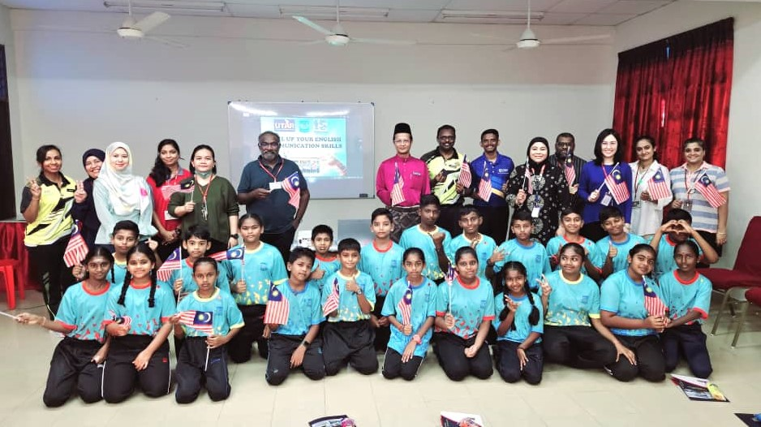

The Department of Public Relations at UTAR Faculty of Arts and Social Science (FAS) collaborated with Universiti Utara Malaysia (UUM) to organise an English communication workshop at ~~at~~ SJKT Ladang Kota Bahroe on 30 August 2024. The workshop attracted a total of XXX participations from Year Four to Year Six students ~~facilitators from UTAR and UUM~~.

The workshop aimed to bolster the English communication skills of young learners, focusing on critical aspects such as pronunciation, vocabulary development, and public speaking.

The workshop commenced with a lively ice-breaking session where students participated in the “Two Truths and a Lie” game. The game focused on encouraging students to speak in English from the outset. In addition, the participants were engaged in a series of interactive station games designed to enhance their conversational English skills.

The ongoing activities

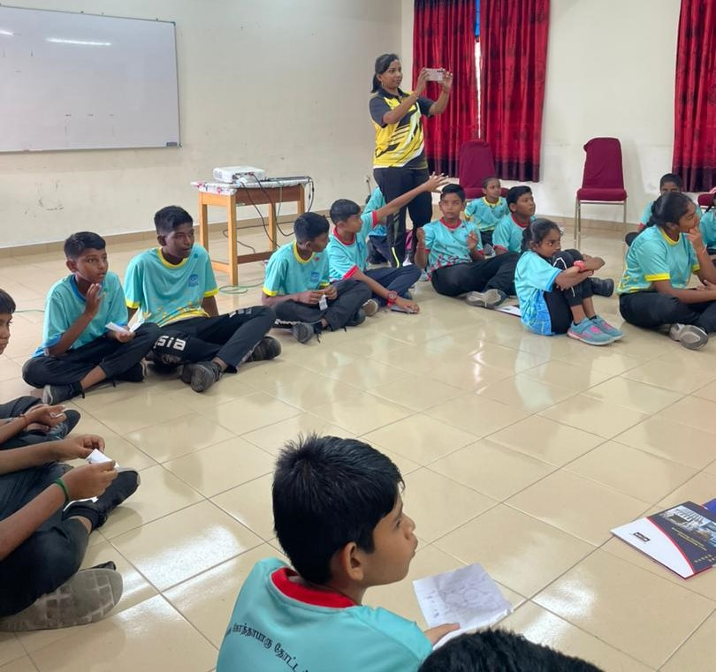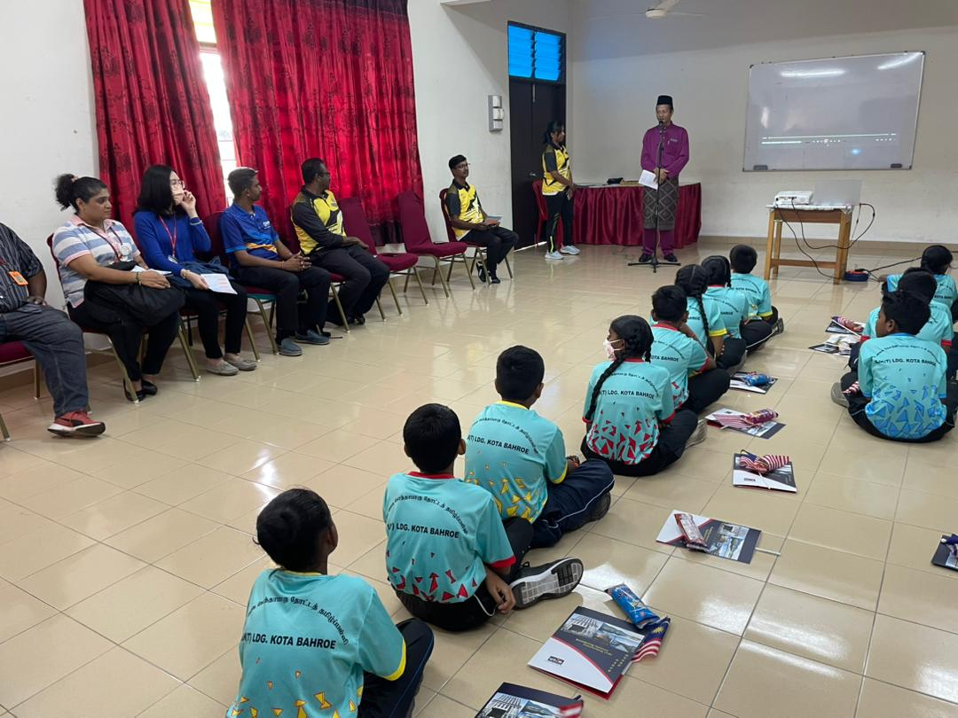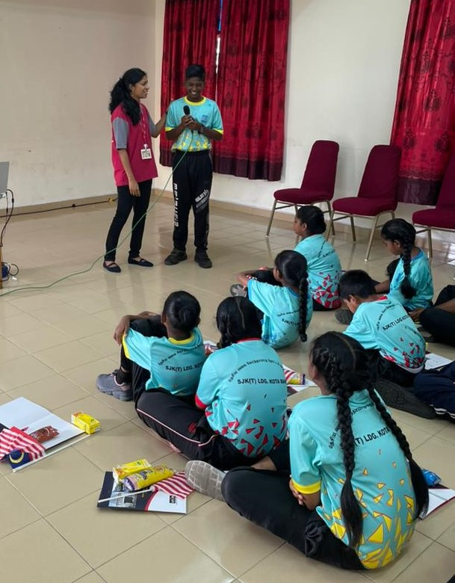

The workshop continued with four station activities, namely Idioms, Tongue Twisters, Spelling, and Crossword Puzzles, all of which gave students a fun way to practice their English speaking, listening, and thinking skills. One of the highlights of the workshop was the Creative Speaking Activity, where students paired up and role-played various scenarios, such as ordering food at a restaurant or asking for directions. This activity provided an excellent platform for students to use English in real-life situations, boosting their confidence and creativity in the language.

Overall, the workshop was a resounding success, achieving its goal of enhancing the English communication skills of the participating students. The event received positive feedback from both students and teachers, highlighting the importance of such initiatives in empowering young learners to communicate effectively in English. The collaboration between UUM and UTAR, along with the dedication of the facilitators, played a crucial role in making this event a memorable and impactful experience for all involved.

SJKT Ladang Kota Bahroe students with UTAR and UUM facilitators

