**Workshop highlights significance and strategies of personal branding**

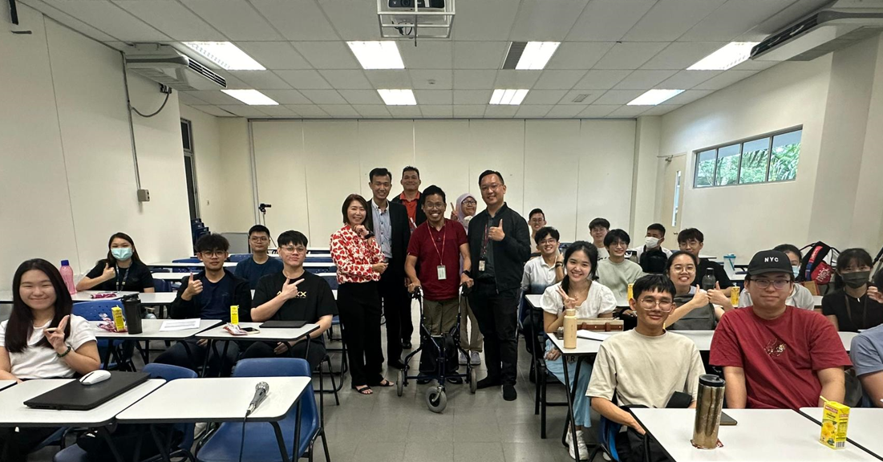Standing, most left: Dr Angeline Ng with FBF staff and students

UTAR Faculty of Business and Finance (FBF) Department of Banking and Risk Management organised a workshop titled “Strategies for Personal Branding” on 26 August 2024 at UTAR Kampar Campus. The workshop attracted a total of 27 FBF students in attendance. The objectives of the workshop were to help participants understand the concept of personal branding, analyse their individual strengths and weaknesses, and practice networking skills.

Invited to deliver the talk was the Head of Credit Administration at Pembangunan Leasing Corporation, Bank Pembangunan Bhd (MOF) Dr Angeline Ng Siew Huan. Dr Angeline Ng also serves as the Industrial Advisor for the Bachelor of Business Administration (Honours) Risk Management at FBF, UTAR. The workshop was moderated by FBF staff Cik Zainon binti Md. Yunus and coordinated by En Muhammad Ashraf bin Anuar and Puan Nik Nuraisyah binti Nik Azmi. Also present at the workshop was FBF Department of Banking and Risk Management Head Mr Chong Tun Pin.

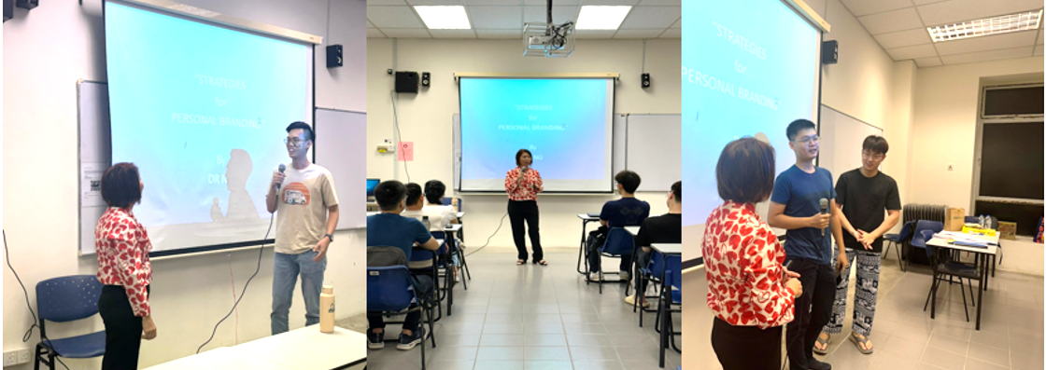

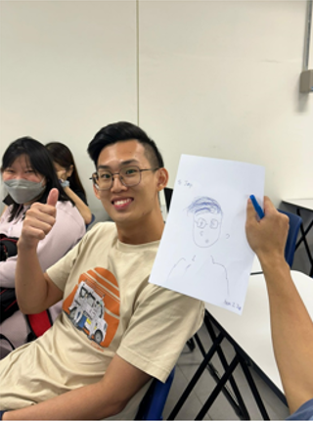 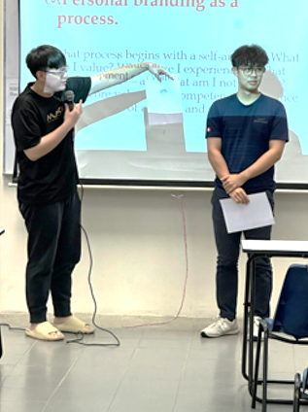

Ice-breaking session

The workshop began with an introduction by Dr Angeline Ng, who welcomed the participants and provided an overview of the workshop’s learning outcomes and relevance. She initiated an ice-breaking session to engage with the students, encouraging them to interact. It was followed by a discussion on the importance of personal branding in today’s competitive landscape, where participants shared their thoughts and experiences.

Highlighting the importance of personal branding, Dr Angeline Ng emphasised the significance of personal branding as a strategic process to define and communicate one’s unique identity. She clarified the distinction between "personal brand" and "personal branding," noting that while these terms are related, they are not the same. “Personal branding can be explained as a continuous process that begins with self-analysis, including understanding one’s core values, experiences, strengths, and weaknesses. This process involves two key strategic efforts: defining who you are and communicating that identity effectively. ~~Besides~~ On the other hand, personal brand can be described as the outcome of personal branding efforts—the reputation or image that others recognise. ~~and~~ The image is highlighted as the immediate perception others have of you based on appearance, demeanour, and behaviours.”

Moreover, Dr Angeline Ng also outlined the key differences between these concepts. She said, “Personal branding is the process of creating a personal brand; while personal brand is the result or reputation that is built through this process; and image is the visual and immediate aspect of how a person is perceived by others.”

The speaker also discussed the importance of personal branding, stating that it builds trust and credibility, reflects leadership impact, helps individuals stand out uniquely, and focuses on self-transformation to prioritise what matters most. The session helped participants understand that a strong personal brand enhances professional opportunities by building a reputation based on trust, credibility, and distinctiveness.

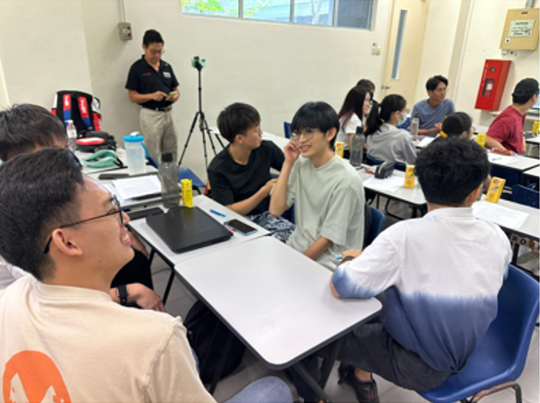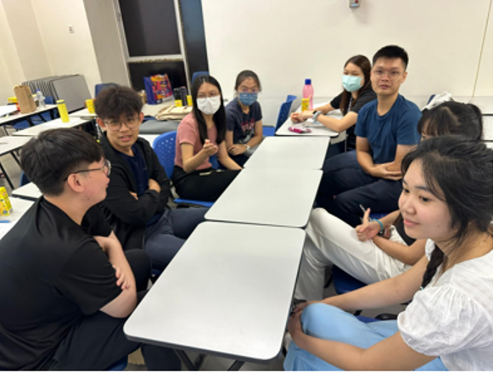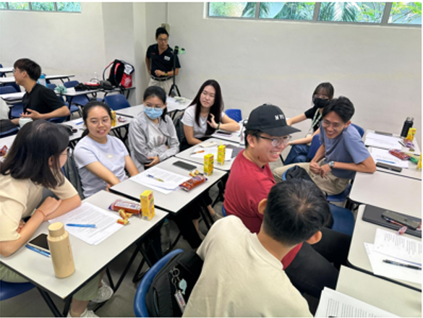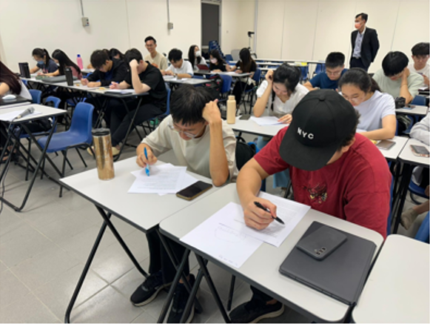

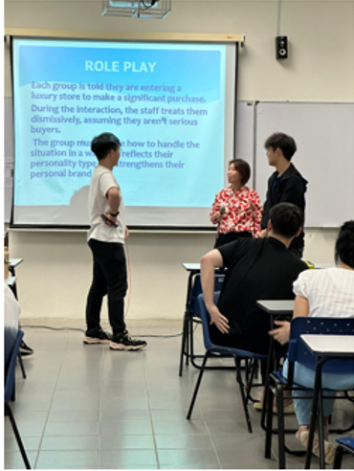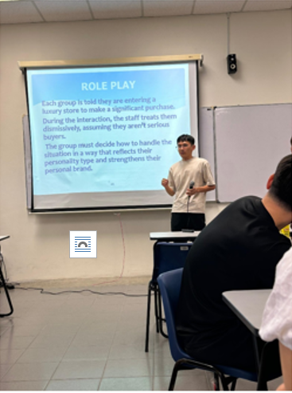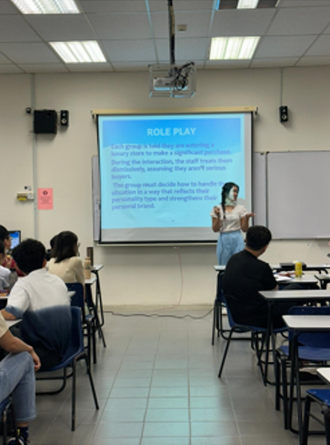The ongoing group activity sessions

Moving on to the interactive activities,Dr Angeline Ng conducted two activities to help participants understand their personal brand ~~through self-reflection and practical exercises~~. Beginning with a personality test, "Which Animal Represents You?" participants took the test to identify which animal—Eagle (visionary leadership), Owl (wisdom and analysis), Dove (peace and collaboration), or Peacock (confidence and visibility)—best represented their traits. This encouraged self-reflection on how their personalities could align with personal branding efforts.

Next was a Role Play activity where participants grouped themselves according to their personality type (Eagle, Owl, Dove, or Peacock) ~~as identified in the earlier personality test. Each group then~~ and engaged in scenarios that reflected their unique characteristics and ~~reinforce their~~ personal branding. After the role-play, Dr Angeline Ng provided feedback to each group, suggesting responses and explaining how their actions and strategies connected them to their personality traits. This helped participants understand how their approaches aligned with their natural strengths and characteristics. The activity allowed participants to apply their understanding of personal branding in practical situations, enhancing their ability to communicate their unique strengths effectively.

~~Furthermore,~~ Dr Angeline also shared strategies for developing a personal brand, encouraging participants to define their core message, craft a brand statement, refine their branding approach, and consistently revise their efforts. She emphasised the importance of ongoing personal branding and practical networking skills as key takeaways.

The workshop concluded with a Q&A session and a group photo.

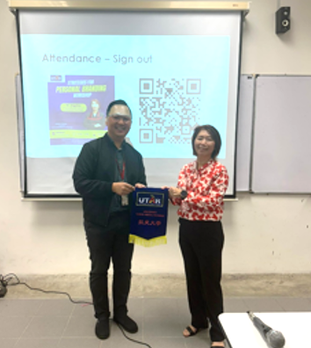

Mr Chong presenting a token of appreciation to Dr Angeline Ng (right)