**Talk addresses** **Malaysia’s social security system in providing LTC for ageing population**

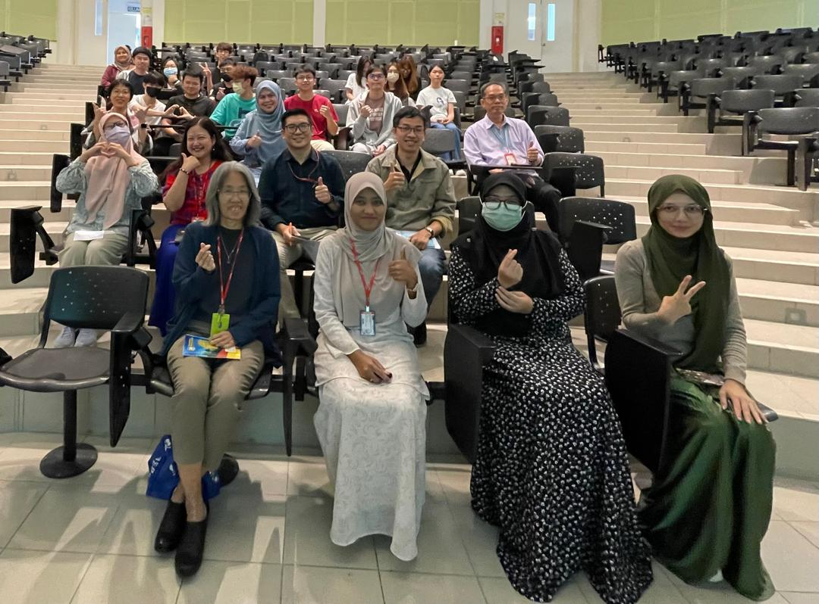Dr Nurul (second from left) with the participants

The Centre for Accounting, Banking and Finance, parked under the Faculty of Business and Finance, organised a talk titled “Ageing and Long-Term Care: The Missing Piece in Malaysia’s Social Security System” on 28 August 2024 at UTAR Kampar Campus.

Dr Nurul Afidah binti Mohamad Yusof from the Faculty of Business and Finance delivered a talk addressing the shortcomings of Malaysia’s social security system in providing long-term care (LTC) for its rapidly ageing population. She also analysed current deficiencies and examined the challenges that individuals and policymakers face in meeting the urgent need for comprehensive long-term care financing.

Dr Nurul’s talk commenced with a discussion on the global ageing trend and the importance of understanding these trends for future social security planning. She said, “Similar to many countries, Malaysia is undergoing a demographic transition which is characterised by declining fertility rates and increased life expectancy. Additionally, women generally live longer than men. Therefore, this necessitates policies to address the specific needs of older women.”

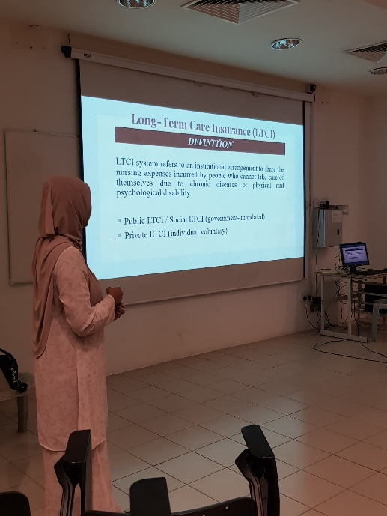  
Dr Nurul explaining the definition of LTC

“The LTC services are essential for individuals who cannot perform daily activities independently. However, LTC services are expensive. Thus, a structured social security system is necessary to provide accessible quality care while easing the financial burden on families,” she added. Dr Nurul also showed examples of public and private LTC insurance schemes implemented in Singapore, suggesting that Malaysia could adopt similar systems to meet the future needs of its ageing population.

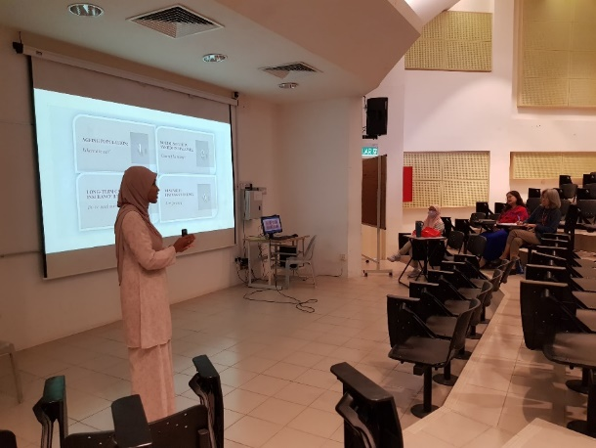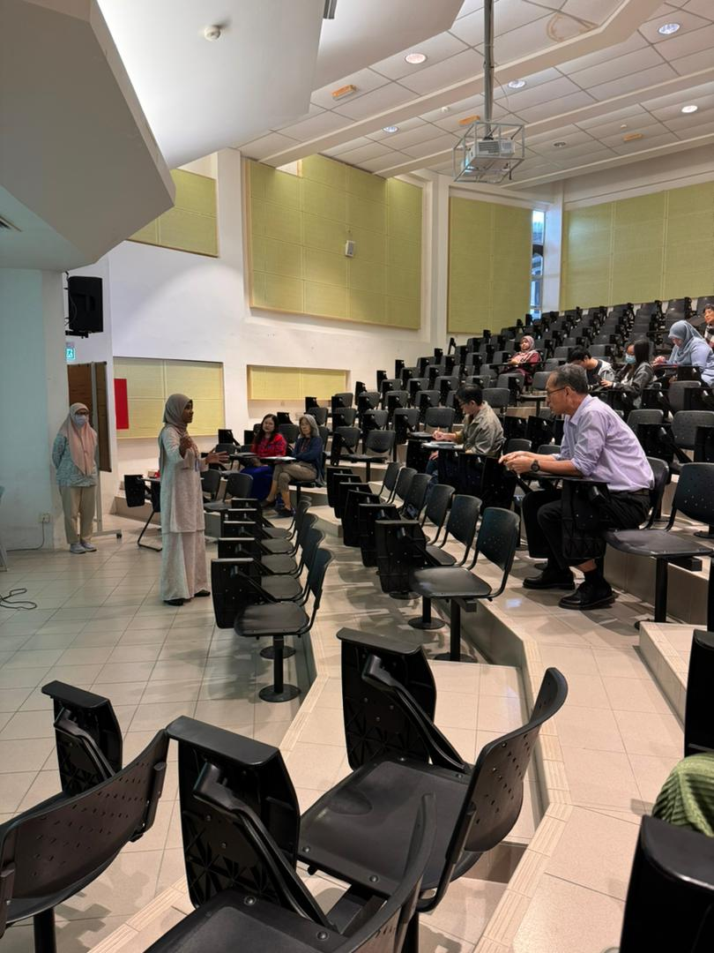  
Dr Nurul engaging with the audiences

She added, “Currently, Malaysia’s social security system includes the Employees Provident Fund (EPF), a retirement savings scheme for private sector employees, and the Social Security Organisation (SOCSO), which provides social insurance. While these systems involve contributions from both employees and employers, they lack specific provisions for long-term care insurance, which is important for developing LTC services to support individuals with physical or cognitive decline.”

Furthermore, Dr Nurul complemented her talk with several policy recommendations. She suggested that Malaysia should develop a comprehensive LTC system, using Singapore as a model. This would involve professionalising the care sector and establishing a social security system to address the needs of the ageing population. She also recommended a shift in the policy focus from welfare to a more developed approach that provides for the financial security and productivity of the elderly.

Overall, Dr Nurul’s presentation provided valuable insights and practical recommendations for policymakers, healthcare professionals, and the general public. According to Dr Nurul, Malaysia can enhance the quality of life for its ageing population by addressing these challenges.

The talk concluded with a lively Q&A session, during which Dr Nurul discussed various aspects of ageing and social security with the participants.