CFS fosters language skills through interactive workshops for school students

Driven by a commitment to cultivate a vibrant learning environment and inspire the next generation, UTAR Centre for Foundation Studies (CFS) at Kampar Campus spearheaded a series of dynamic English workshops at SJK (T) Methodist Malim Nawar and SMK Methodist (ACS) Kampar.

The CFS Kampar Campus brought excitement to SJK (T) Malim Nawar with a workshop titled “Adventure in Word: Exploring English Together” for students ranging from Standard 3 to Standard 6 on 7 June 2024. Aimed to nurture students’ English language proficiency and communication skills, CFS Kampar Campus academics Ms Devagi Erusan and Ms Kanimozhi Govindasamy led the students through an enchanting journey of learning. They took part in a range of interactive and enjoyable activities, including games, music, storytelling, role-playing, and essay writing.

The day was filled with laughter and learning as students showed improvement in their ability to write well-structured essays and understand grammar.
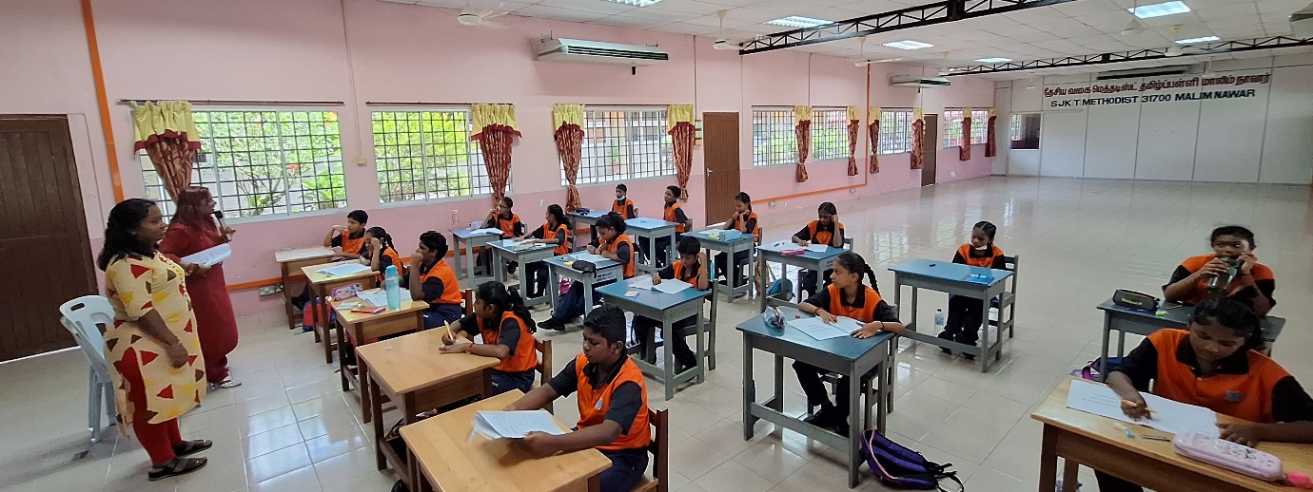
Ms Devagi and Ms Kanimozhi conducting the activities

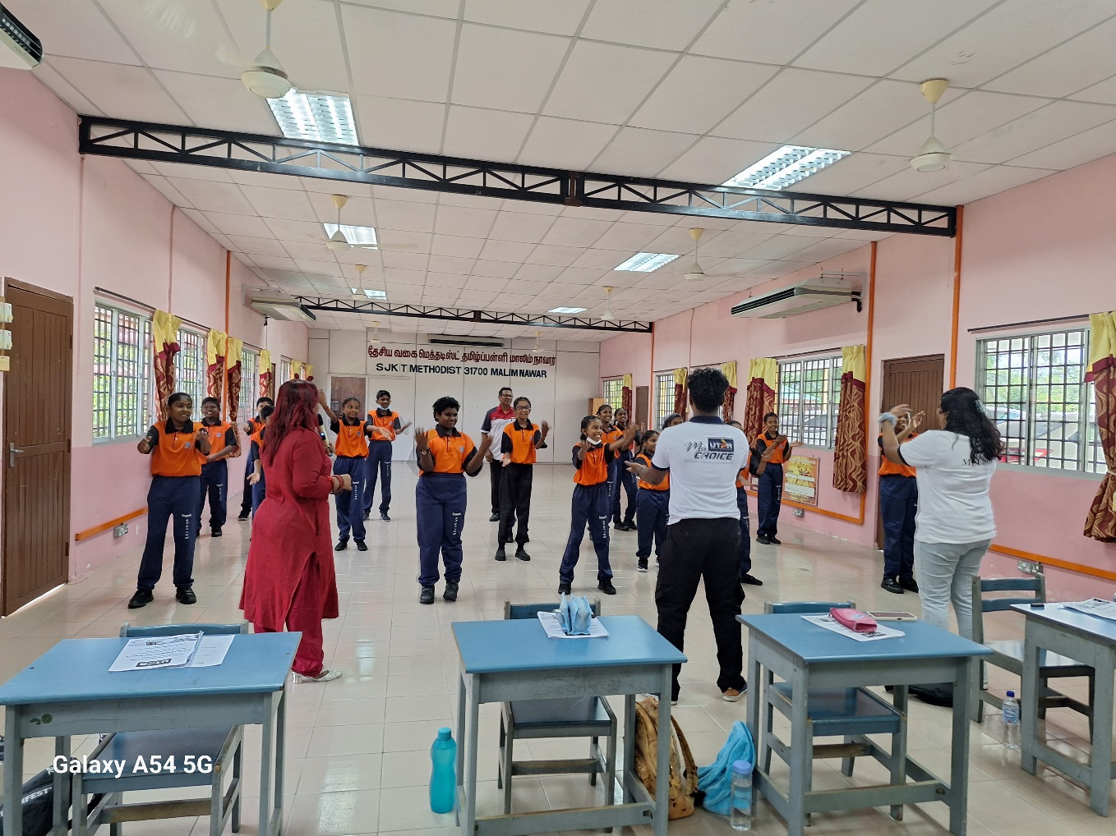
Students enjoying the activities
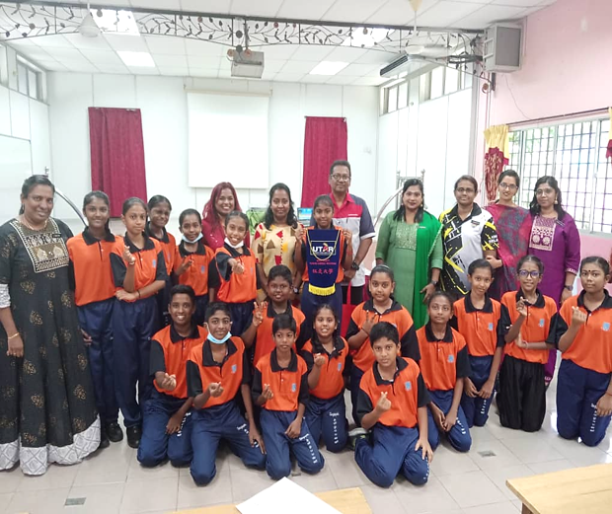

Group photo after the event

On another occasion, CFS Kampar Campus academics Pn Siti Sarah binti Muhamad Azmi, Ms Soon Cai En and Ms Tulasi Subramaniam conducted an English Writing Workshop for Form 5 students at SMK Methodist (ACS) Kampar on 12 July 2024, with the objective of enhancing students’ English language proficiency in preparation for their SPM exams.

Ms Soon started the workshop with a talk titled “Writing Construction: A Step-by-Step Method That Gets Results”. She provided valuable insights on how to tackle writing questions effectively and highlighted the do’s and don’ts of effective writing. This was followed by Ms Tulasi’s presentation titled “Creative Ways to Learn Vocabulary”, which emphasised the importance of vocabulary and offered ways for improvement. The workshop concluded with a fun language game led by Pn Siti Sarah, in which students fully enjoyed and immersed themselves.

Chloe Lau Zhi Qing from Form 5T commented, “I really enjoyed the activities. My writing skills have improved, and I feel more confident in my exams.”

Darvin Seelan from Form 5P shared, “The workshop was fun and useful. I learned a lot of new vocabulary and ways to improve my English.”
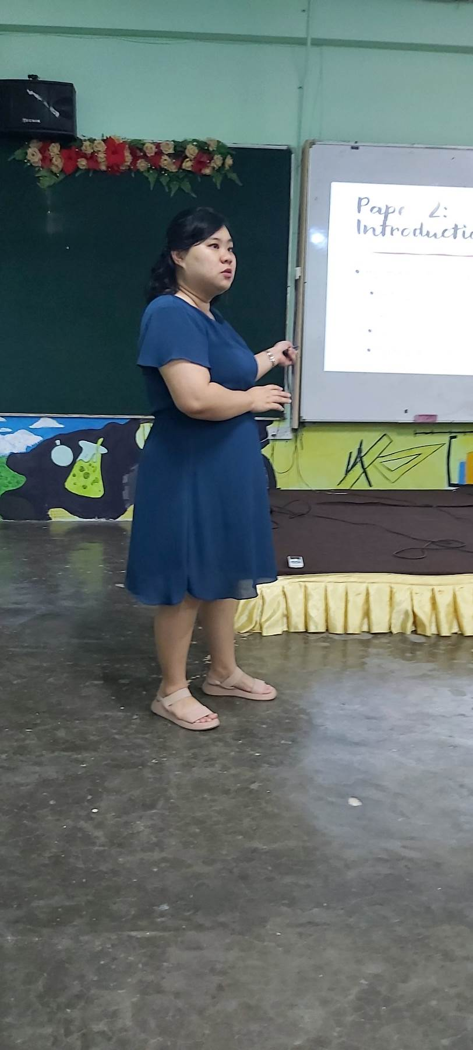

Ms Soon sharing insights on tackling writing questions
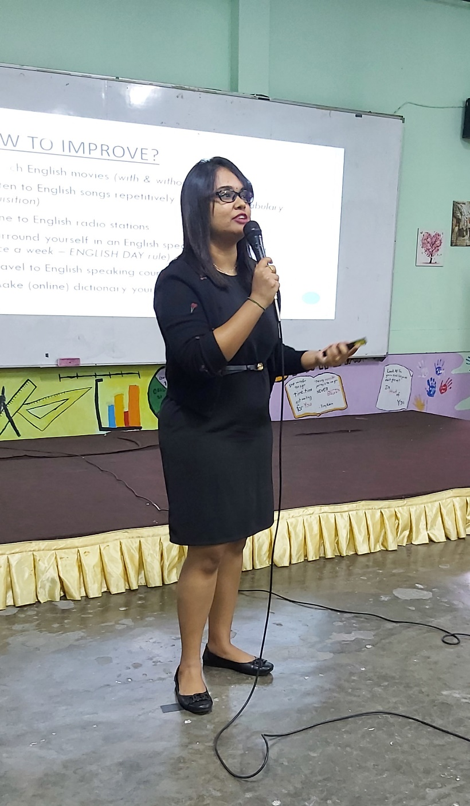

Ms Tulasi introducing ways to learn vocabulary

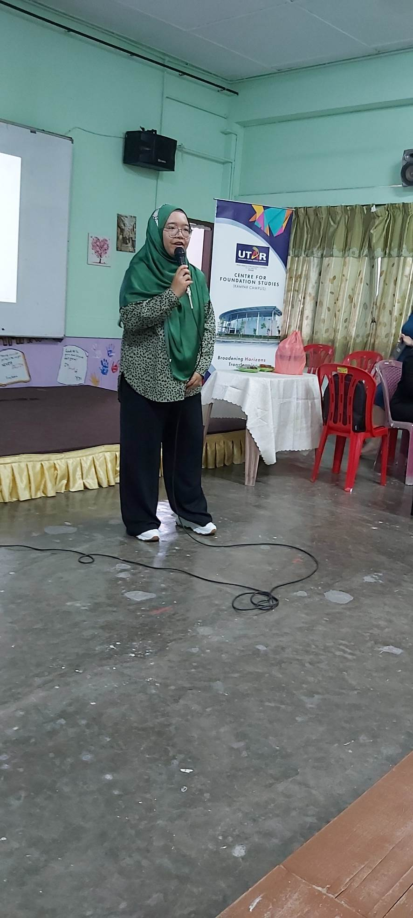

Pn Siti Sarah conducting the language game

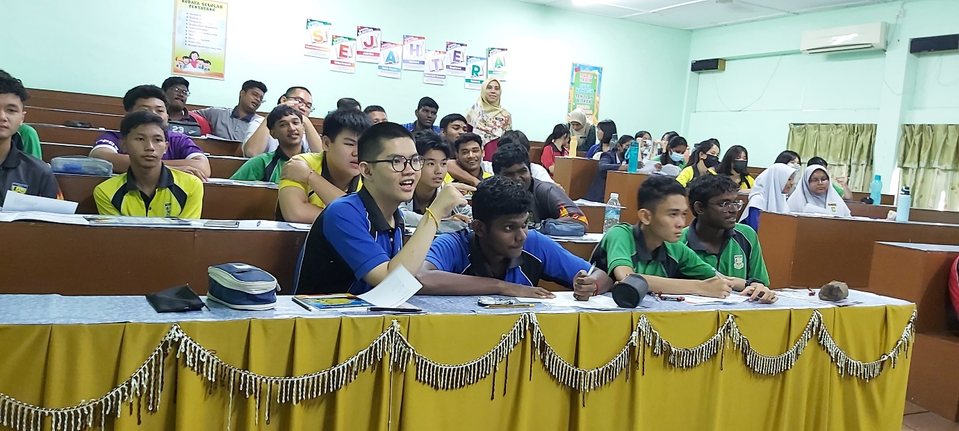
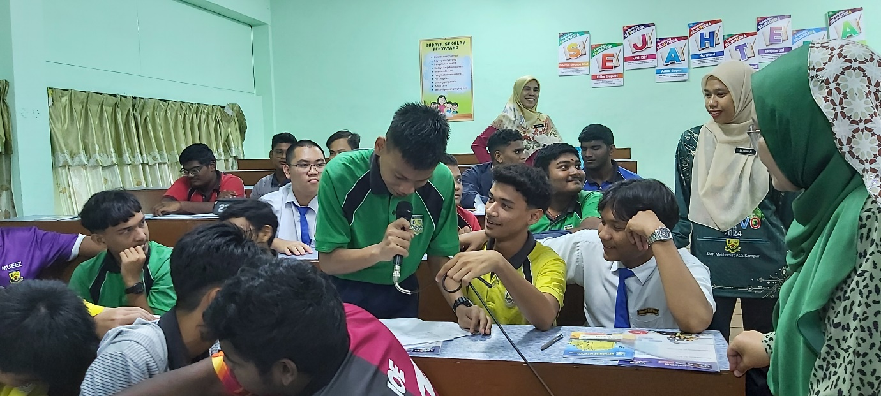
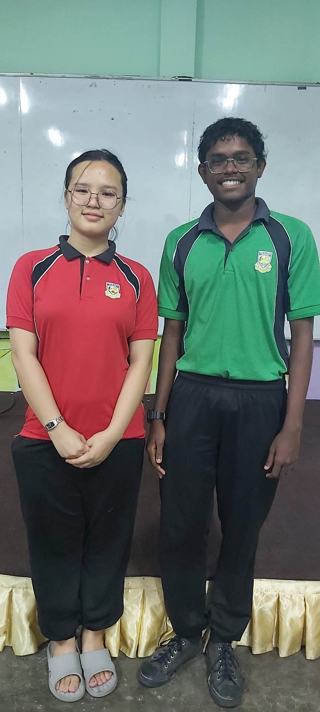
Students participating in the workshop

Students sharing their thoughts after the workshop
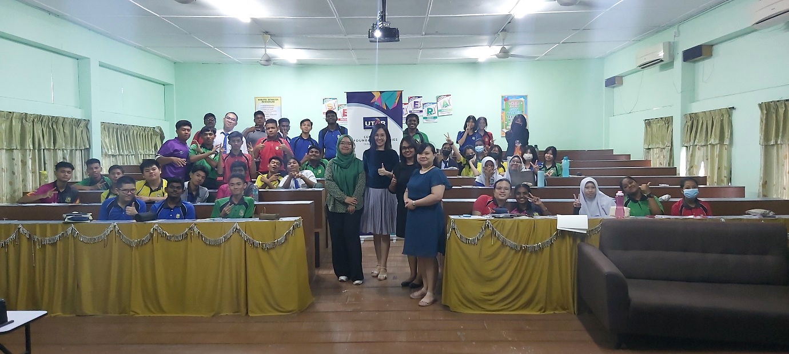

Group photo after the workshop

Additionally, on 15 July 2024, CFS Kampar Campus academics Mr Abel Lee Cheng Ian and Mr S. Tamil Arasan Naidu conducted another impactful public speaking workshop for Form 1 and Form 2 students at SMK Methodist (ACS) Kampar. The workshop was designed to encourage and enhance public speaking skills among young students.

Mr Abel Lee began the workshop with his session titled “No Fear to Public Speaking,” where he addressed common fears associated with public speaking. Through relatable examples and practical tips, he empowered the students to overcome their anxieties and embrace public speaking with confidence.

Mr Tamil then led two engaging activities: “Two Truths and One Lie” and “Impromptu Speech - Pick a Topic”. These activities encouraged students to step out of their comfort zones and practice speaking in front of their peers. Prizes were awarded to those who excelled during the activities.

Form 2A student Thejaana Sri Ramachandran shared, “I was able to overcome my stage fright. The workshop provided good information, and I loved the activities conducted as well.”

Form 1A student Mohd Irfan Adli added, “I gained a lot of information about public speaking. I learned to talk confidently and will definitely try speaking in front of the public one day with confidence.”

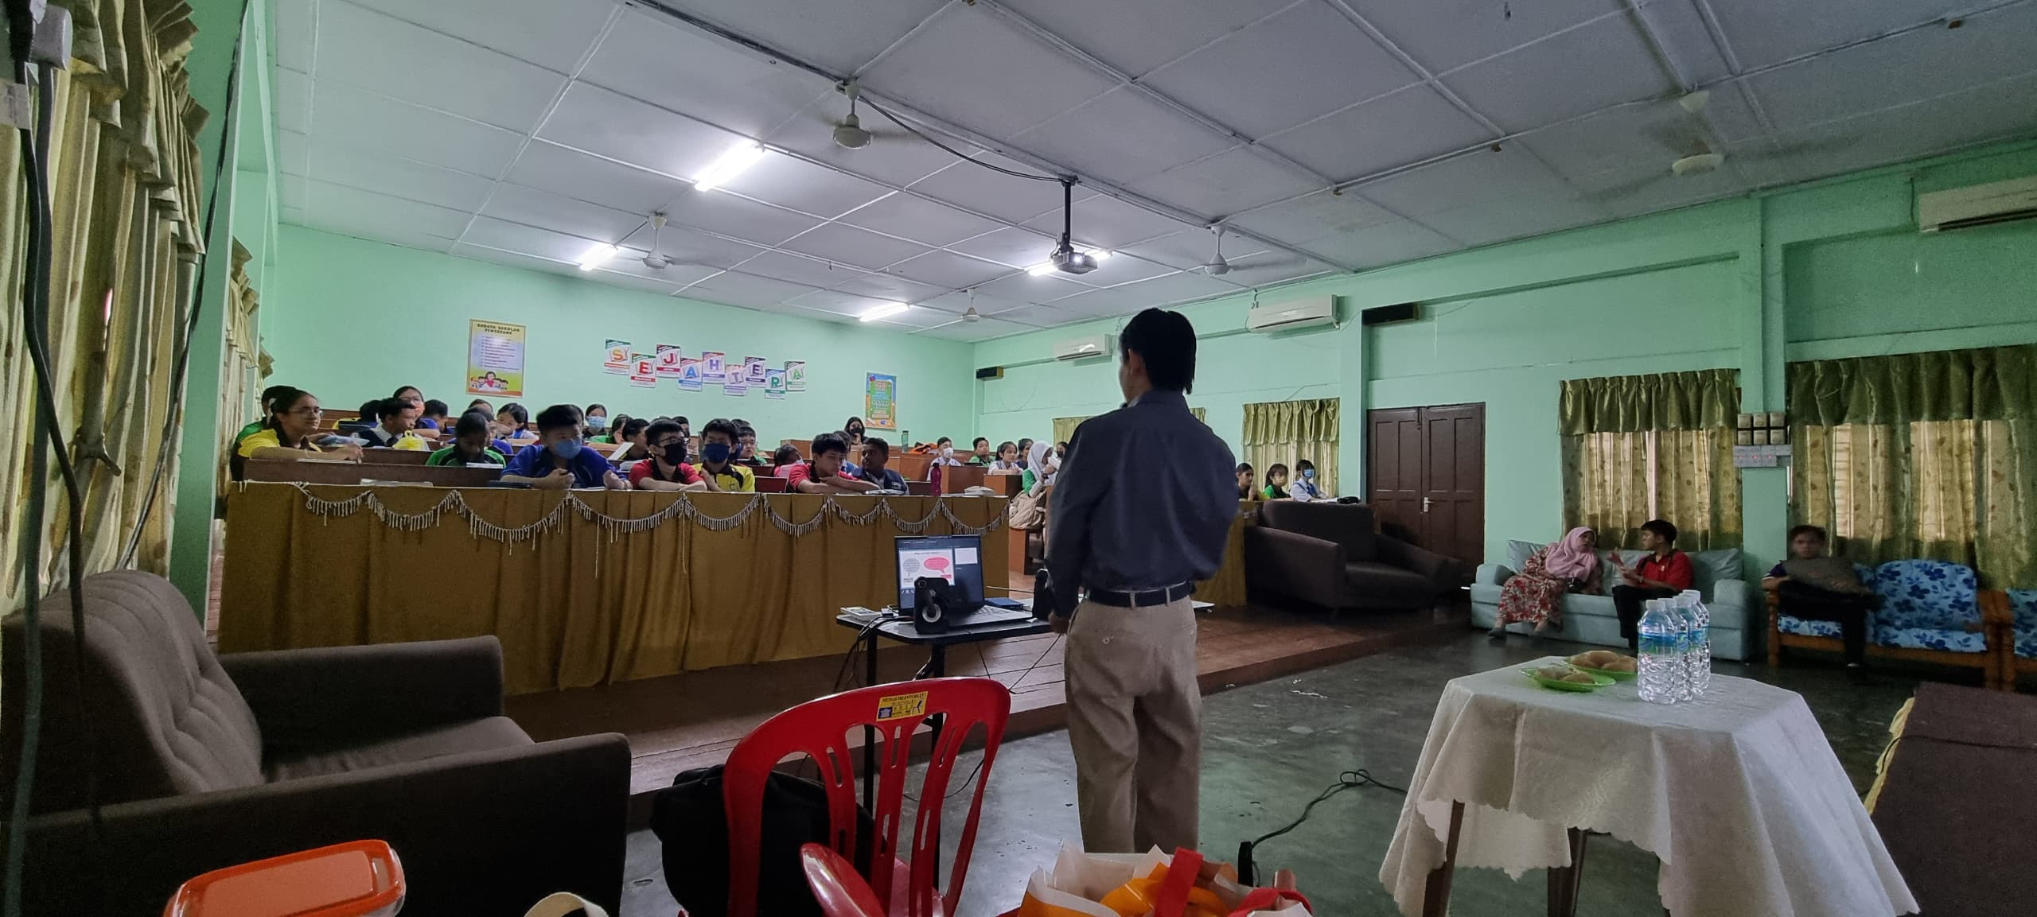

Mr Abel Lee explaining the common fears associated with public speaking
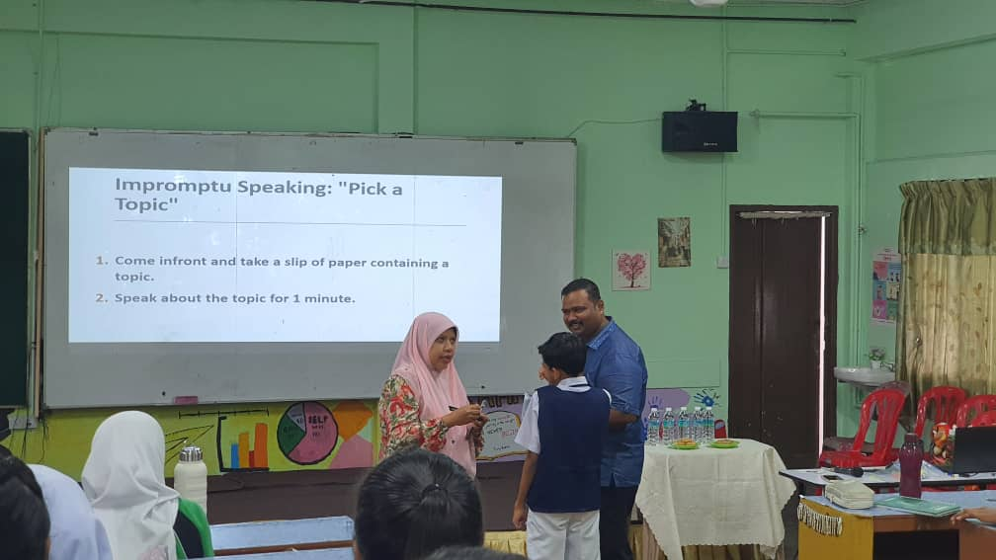

Mr Tamil conducting an engaging activity with a teacher and a student

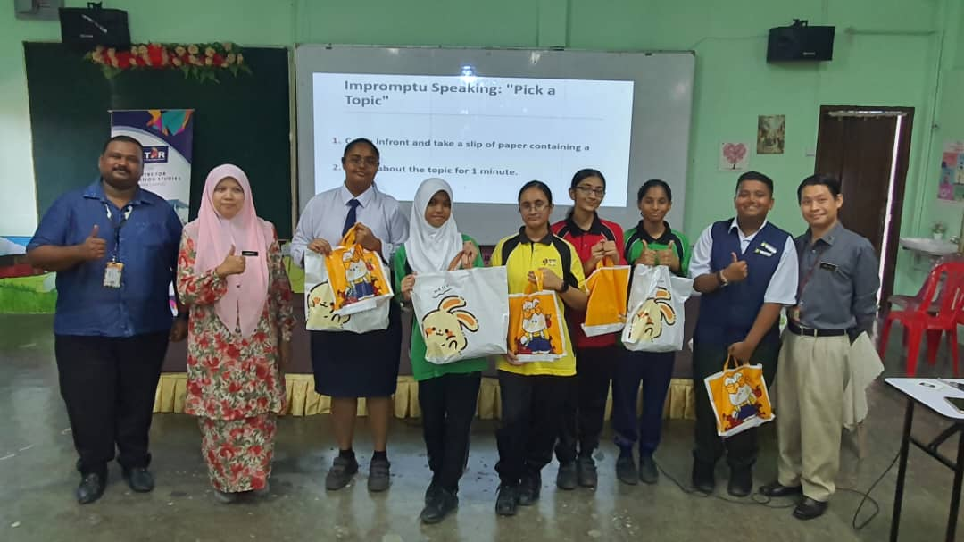
Students receiving prizes after the activities

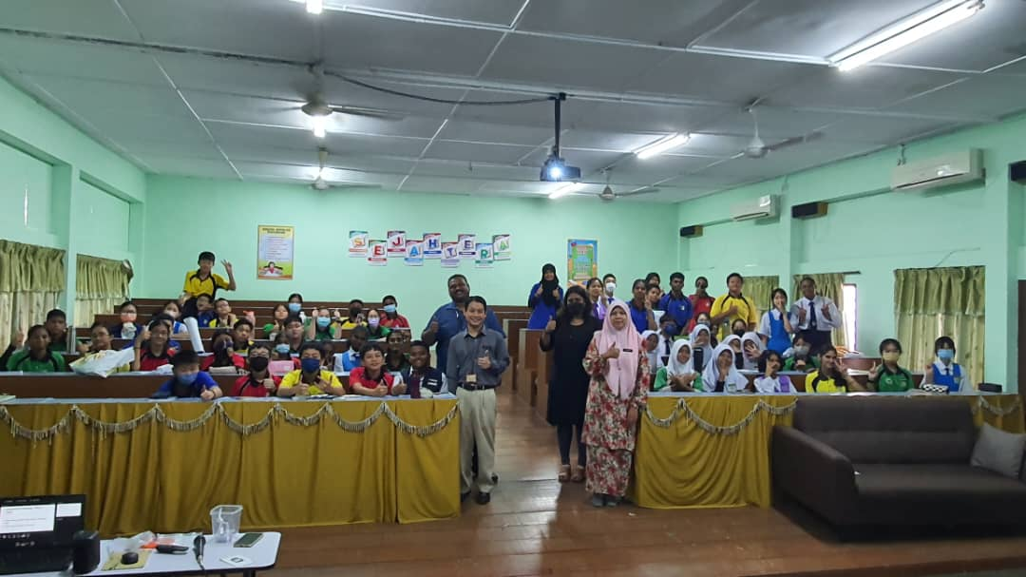
Group photo after the workshop

