Empowering financial decision-making through insights from the Wealth Flow Simulation Game
The Faculty of Business and Finance (FBF) at UTAR Kampar Campus organised a Wealth Flow Simulation Game training session on 29 August 2024. The event brought together eight trainers from Prudential Assurance Malaysia Berhad (PAMB) under the PSR agency, Ipoh, and nine FBF lecturers, including those from the Department of Finance, Department of Banking and Risk Management, and Department of Economics. The training aimed to provide lecturers with practical insights into a 40-year life rehearsal journey focused on wealth creation and accumulation.
The session was led by Ms Nichole Lee, the main trainer from Prudential Company, who guided the participants through the Wealth Flow Simulation game. The lecturers were divided into two groups to play the game concurrently, which involved them taking on roles with specific monthly salaries and expenses. Each participant had to choose a dream to achieve and make various strategic decisions throughout the game, such as investing in different types of assets and navigating significant life events like marriage, childbirth, unemployment, and severe illness. The game simulated the process of financial planning and wealth accumulation, giving the lecturers a chance to experience different financial scenarios and their implications.

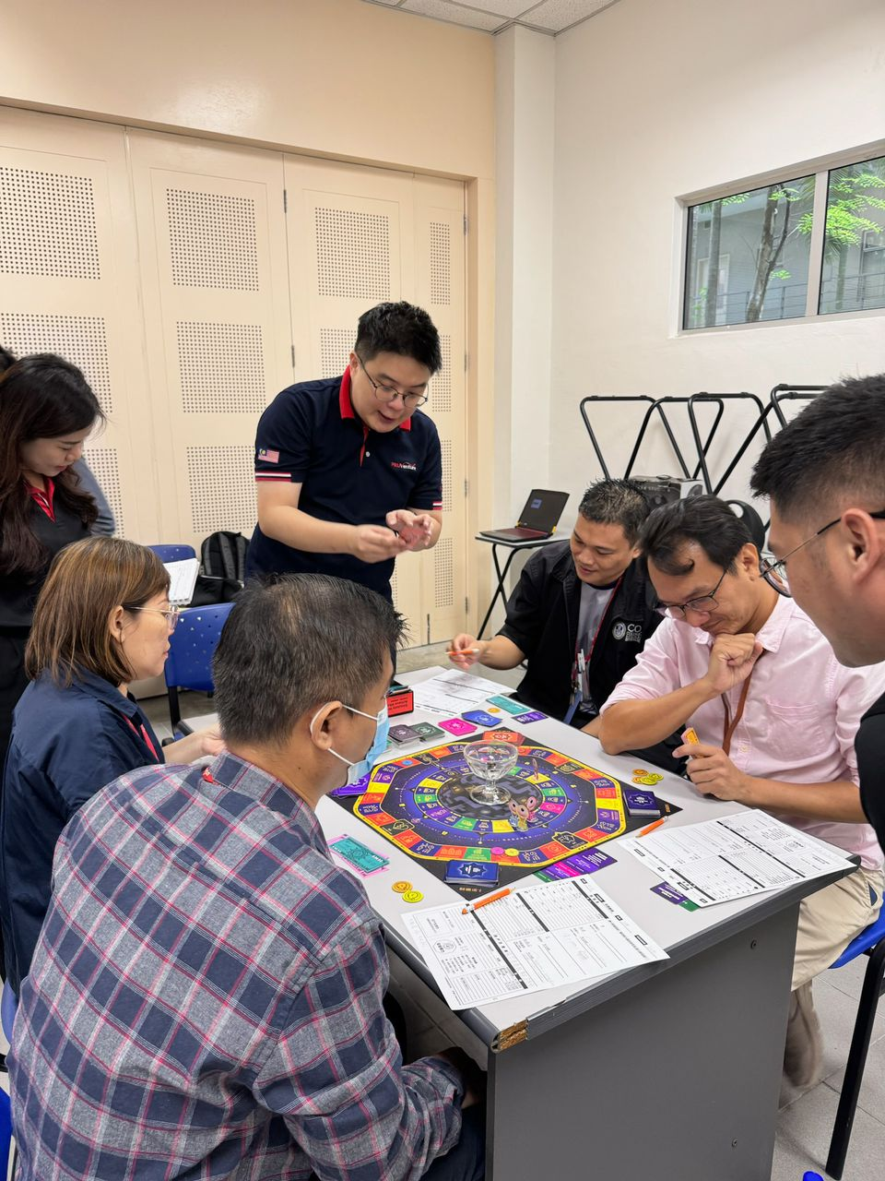

“Wealth flow trainer” guiding lecturers as they play the game
After the game, the lecturers participated in a sharing session where they discussed their insights and lessons learned. Some lecturers highlighted the importance of generating additional income by taking on part-time jobs at a young age to invest in assets early. Others emphasised the need to maintain good health while earning money, noting that wealth is meaningless without health. There were also discussions on the importance of maintaining a positive attitude during challenging life stages, such as facing unemployment or severe illness, and how resilience can play a crucial role in achieving financial stability.
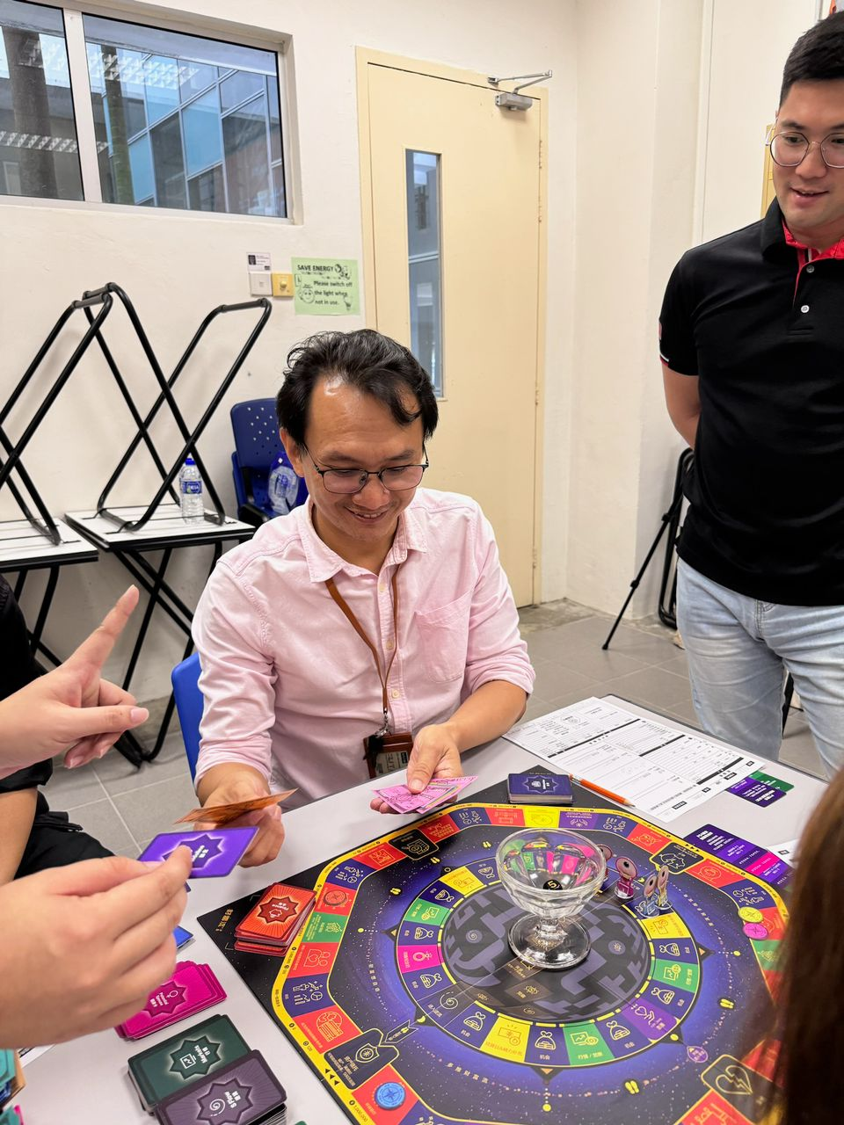
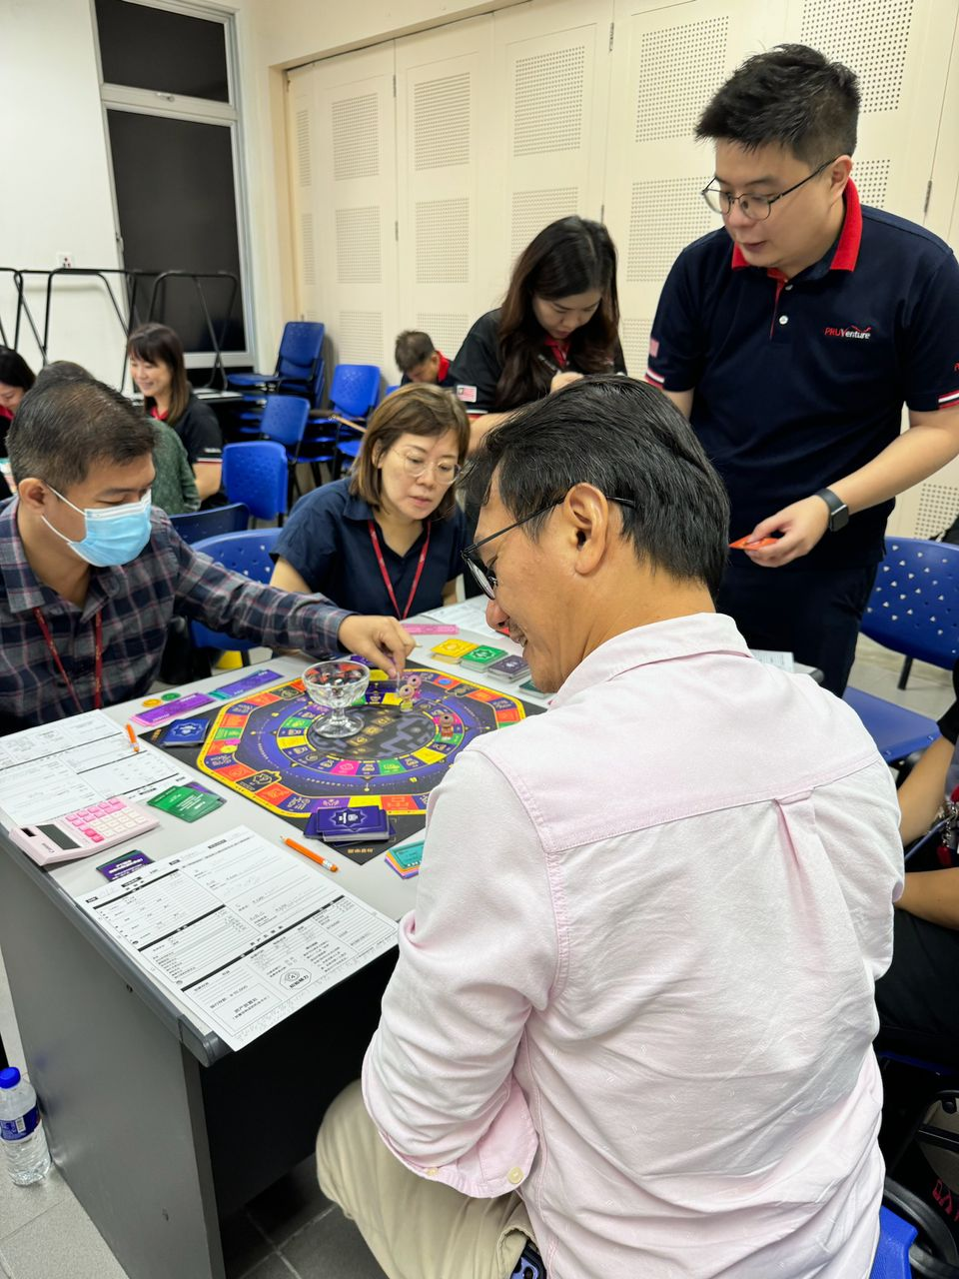

Lecturers strategising during the game and discussing the reasoning behind their decisions
The Prudential consultants expressed their hope to bring this simulation game to the campus, allowing more students and lecturers to learn about the importance of financial planning and the need to maintain financial well-being. They emphasised that every choice made in life, whether financial or personal, can significantly impact one’s future outcomes. The game serves as a practical tool to illustrate how different decisions can alter the course of life, reinforcing the importance of informed decision-making in achieving financial stability and overall well-being.
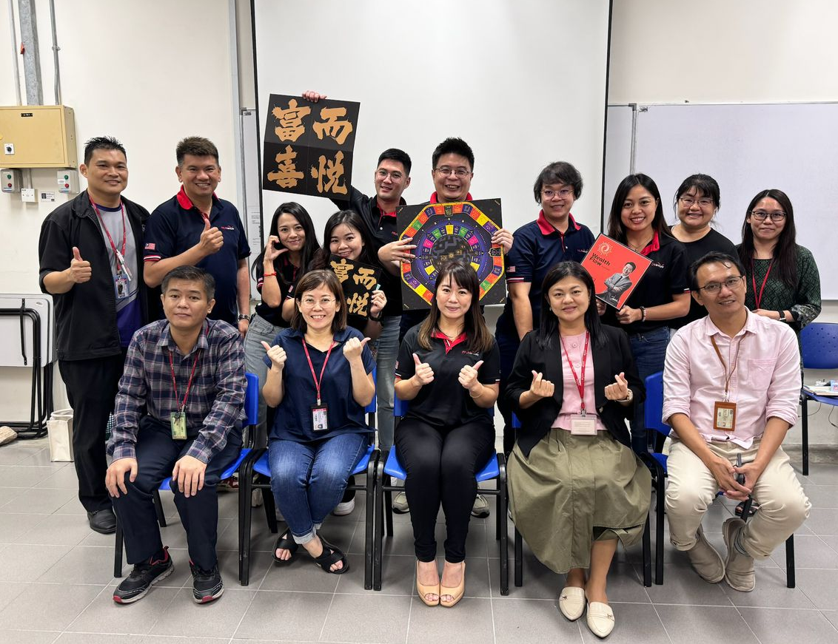
Overall, the Wealth Flow Simulation Game training was a valuable experience for the lecturers, providing them with deeper insights into financial planning, wealth accumulation, and balancing life goals. The collaboration with Prudential consultants brought real-world perspectives into the training, making it both engaging and educational. The event succeeded in fostering discussions on financial strategies and the importance of aligning financial decisions with life priorities.

Group photo of lecturers from UTAR and consultants from Prudential

