UTAR’s Sustainable Development Club and Green Bank Project merge for a greener future

A total of 62 students from the UTAR PR CSR Project June 2024: We Want No Plastic, guided by Ms Diong Fong Wei from the Faculty of Arts and Social Science (FAS), organised a ceremony at UTAR Kampar Campus to celebrate the merger of the Sustainable Development Club and the Green Bank Project. The event, held on 2 September 2024, featured an insightful industrial talk by the Managing Director of Zantat Holdings Berhad and CEO of Zaneco Sdn Bhd Mr Ivan Chan Bin Iuan.
The ceremony also saw the presence of UTAR Vice President for Student Development and Alumni Relations Prof Dr Choong Chee Keong, Project Leader of the Green Bank Project Ts Dr Wong Ling Yong, Club Advisor of the Sustainable Development Club Dr Vikniswari Vija Kumaran, Research and Development Manager of Zaneco Sdn Bhd Dr Tai Nyok Ling, Lead Corporate Storyteller of Zantat Sdn Bhd Miss Alicia Tan Yih Chia and Dean of UTAR Faculty of Engineering and Green Technology Ir Prof Dr Ng Choon Aun.
The event began with a symbolic gimmick ceremony for the merger and the introduction of the new Executive Committee for the Sustainable Development Club 2024/2025.
The highlight of this event was the industrial talk delivered by Mr Ivan Chan, titled “Earthya: The Shift from Single-Use Plastics to Compostable Options”. He captivated the audience with his insights into sustainable practices within the industry. He stated that Zantat Holdings Berhad is a company that actively prioritises sustainability in its process of production.
He highlighted that single-use plastics are harmful while some plastics, like those used in medical equipment, are less damaging. He emphasised reducing plastic consumption and corporate responsibility in environmental conservation. Dr Tai from Zaneco Sdn Bhd also spoke about their compostable food waste bags, Earthya, which support a circular economy.
The industrial talk was followed by an engaging Q&A session, that provided an opportunity for students and attendees to directly interact with Mr Ivan Chan and Dr Tai to gain valuable knowledge on sustainability practices and industrial innovation. The event concluded with a lucky draw, souvenir presentation, and closing remarks, leaving attendees inspired and motivated to contribute to a more sustainable future.
In his closing speech, Prof Choong praised UTAR PR CSR students for their initiative of joining the Green Bank Project and conducting such a meaningful event. He also talked about the significance of UTAR’s decision to restrict the usage of non-degradable plastic bags and straws at UTAR events starting on 1 October 2024. “UTAR’s goal is to raise awareness among our staff, students, and the public about the importance of environmental protection and encourage them to stop using non-degradable and single-use plastic bags and straws,” he said.
Meanwhile, Dr Wong highlighted the global plastic pollution crisis and the need for effective recycling practices. Dr Vikniswari emphasised the importance of a circular economy and thanked the We Want No Plastic Project members for their efforts.
Chen Zhi Shan, Project Director of We Want No Plastic, stressed the importance of education in changing waste management behaviours and expressed enthusiasm for the merger’s potential to address global environmental issues.
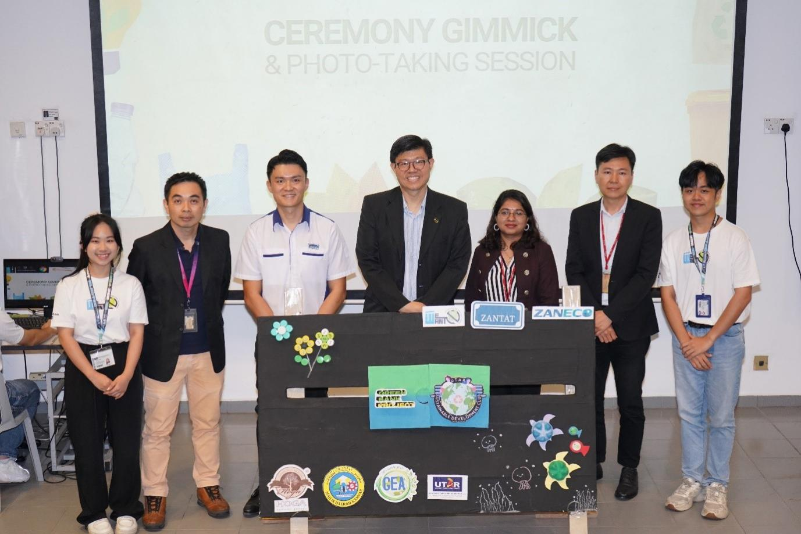
Special guests (second from left): Dr Wong, Mr Ivan Chan, Prof Choong, Dr Vikniswari, Prof Ng, We Want No Plastic Project Director Chen (far left), and Head of Programme Department Lui Kai Jian (far right) engaging in a gimmick session that symbolised the official merger of Sustainable Development Club and Green Bank Project
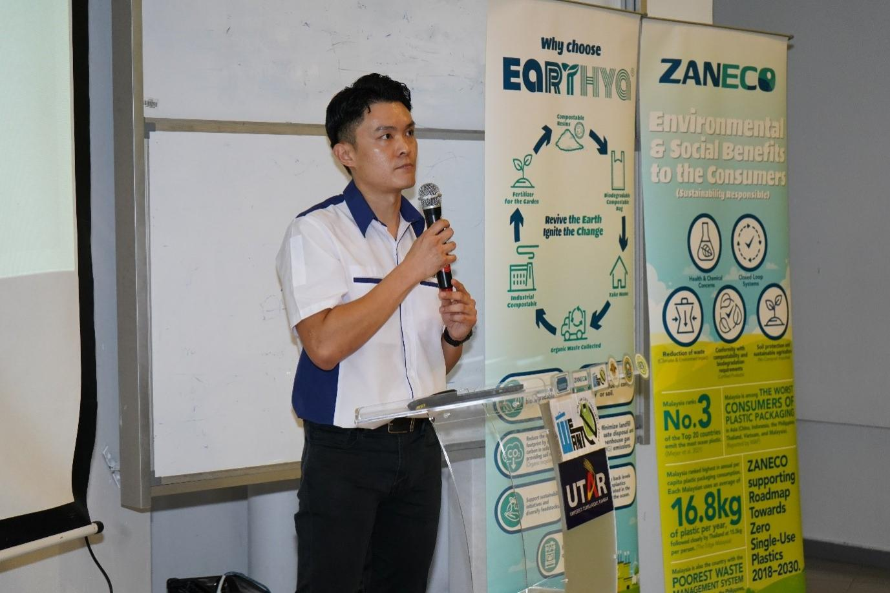
Mr Ivan Chan delivering an industrial talk titled Plastic, Good or Evil
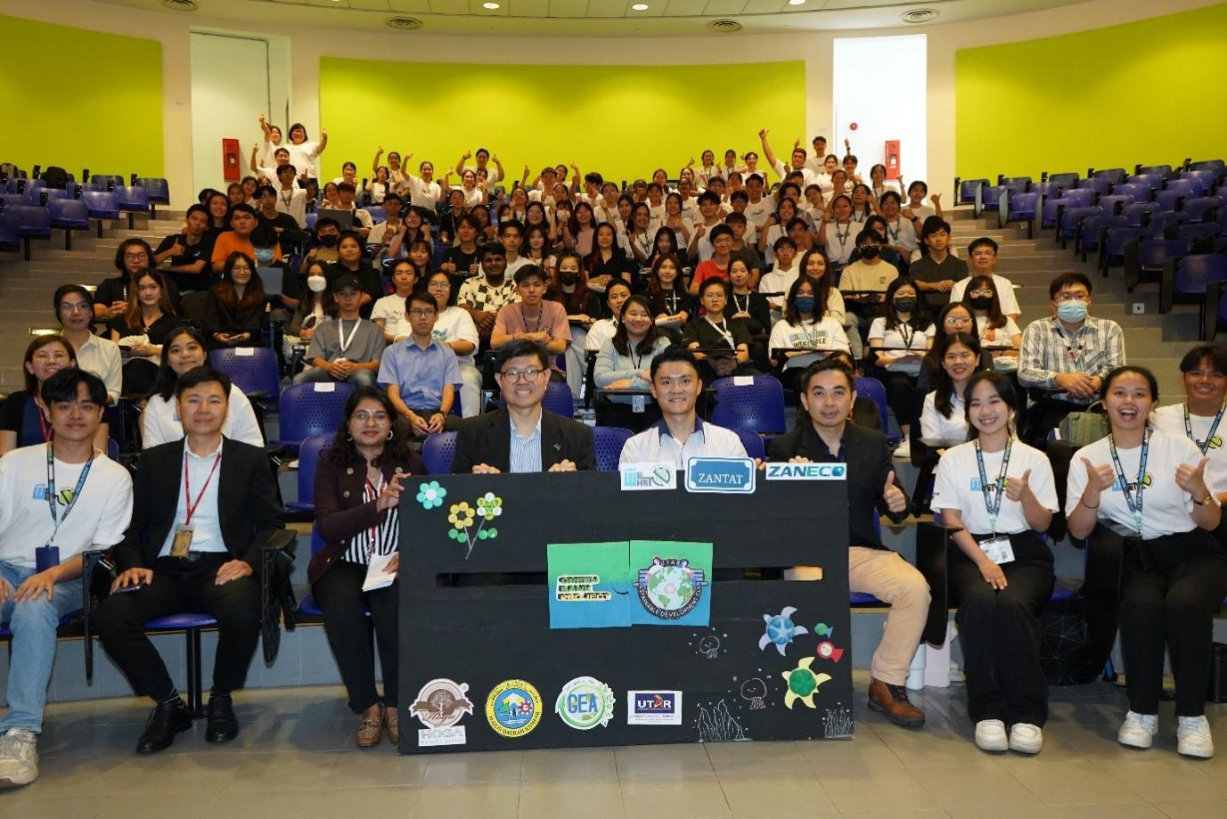
Front row, second from left: Prof Ng, Dr Vikniswari, Prof Choong, Mr Ivan Chan, Dr Wong and participants, alongside We Want No Plastic Project members

