UTAR-UMSIDA forum emphasises sustainability in digital economy
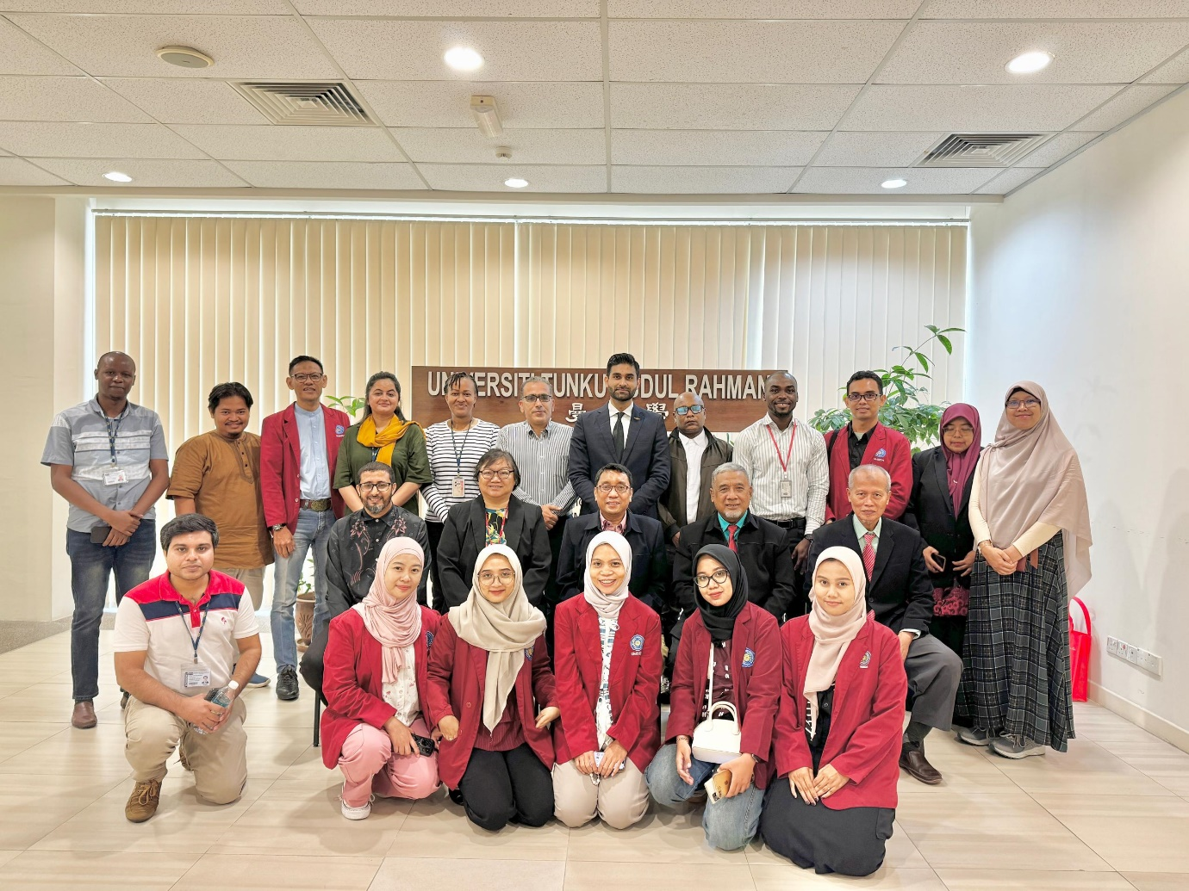
Smiles to seal a successful exchange of knowledge
The “Sustainability in the Digital Economy Forum”, which took place on 28 August 2024 at UTAR Kampar Campus, was enlightening with the delivery of insightful presentations on integrating sustainable practices within digital business models.
The jointly organised forum by UTAR’s Faculty of Business and Finance (FBF) and Universitas Muhammadiyah Sidoarjo Indonesia (UMSIDA) emphasised the importance of sustainability within the rapidly evolving digital economy, and facilitated discussions on exploring sustainable digital transformation’s challenges and opportunities among the participants. The forum was attended by faculty members and postgraduate students of both universities.
Presentations from UMSIDA offered varying yet enlightening perspectives from their respective fields. Dr Sigit Hermawan, who presented “Intellectual capital performance and sustainability”, discussed the enhancement of knowledge management and innovation capabilities, as part of the intellectual capital, in contributing towards organisational sustainability. Meanwhile, Dr Supardi’s presentation on “Analysis of financial structure on profitability and non-financial performance in industrial companies” provided information on the impact of financial structure on both profitability and non-financial outcomes, and emphasised the need for balanced financial strategies in industrial firms.
In the field of tourism, M Ruslianor Maika’s presentation titled “AI in tourism industries”, facilitated discussion on the applications of artificial intelligence (AI) in tourism, and the impact of AI in enhancing customer experience, optimising operations, and driving growth in the industry. The last UMSIDA presenter, Kusno, spoke on “Operational management” and provided insights into the role of operational management in ensuring efficient and sustainable business practices, particularly in the context of the digital economy.
UTAR presenters also shared their thoughts. For instance, the presentation titled “Fourth industrial revolution (4IR) and digital transformation” by Iddrisu Mohammed Awal, provided much information on the impacts of 4IR on digital, and highlighted the role of automation, AI, and IoT in reshaping business operations. Meanwhile, Mohammed M I Alnajjar’s presentation titled “Artificial intelligence and Malaysian small and medium enterprises (SMEs) performance” shed light on the roles of AI in enhancing the performance of Malaysian SMEs, focusing on efficiency, decision-making, and innovation.
Farah Akhtar from UTAR presented “Digital Transformation and the Mediating Role of Intellectual Capital” and explored the relationship between digital transformation and intellectual capital, arguing that the successful adoption of digital technologies relies heavily on leveraging intellectual capital. The last presenter from UTAR, Huzaifa Ahmad shared on “COVID-19 policy response and ESG” and discussed the implications of COVID-19 policy responses on Environmental, Social, and Governance (ESG) factors, highlighting the effects of these policies on corporate sustainability practices.
Ensued was an interactive Q&A session among presenters and participants. The event concluded with a closing remark by FBF Dean Assoc Prof Dr Au Yong Hui Nee, who highlighted that the forum marks an important step towards fostering a more sustainable digital economy, in line with both UTAR and UMSIDA’s commitment to academic excellence and social responsibility. She also encouraged continued collaboration between the academic institutions and industry stakeholders in promoting sustainability in the digital economy. Also present was FBF Deputy Dean for R&D and Postgraduate Programmes Prof Dr Abdelhak Senadjki.

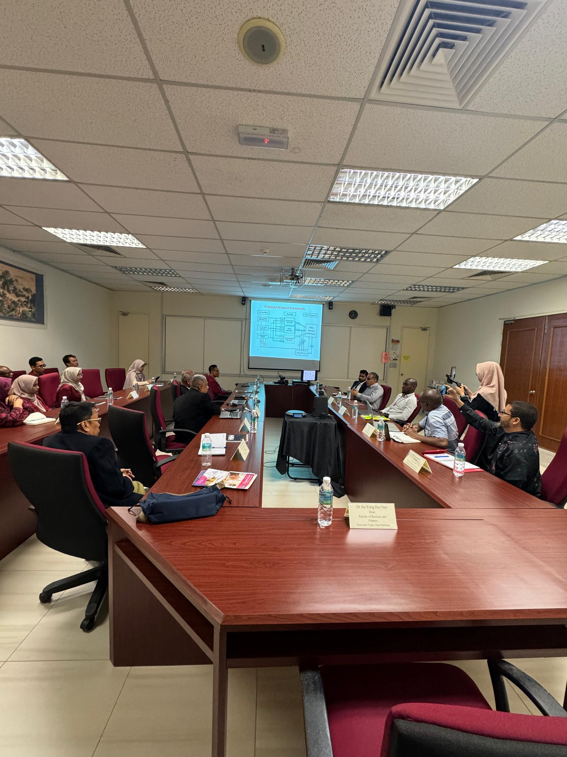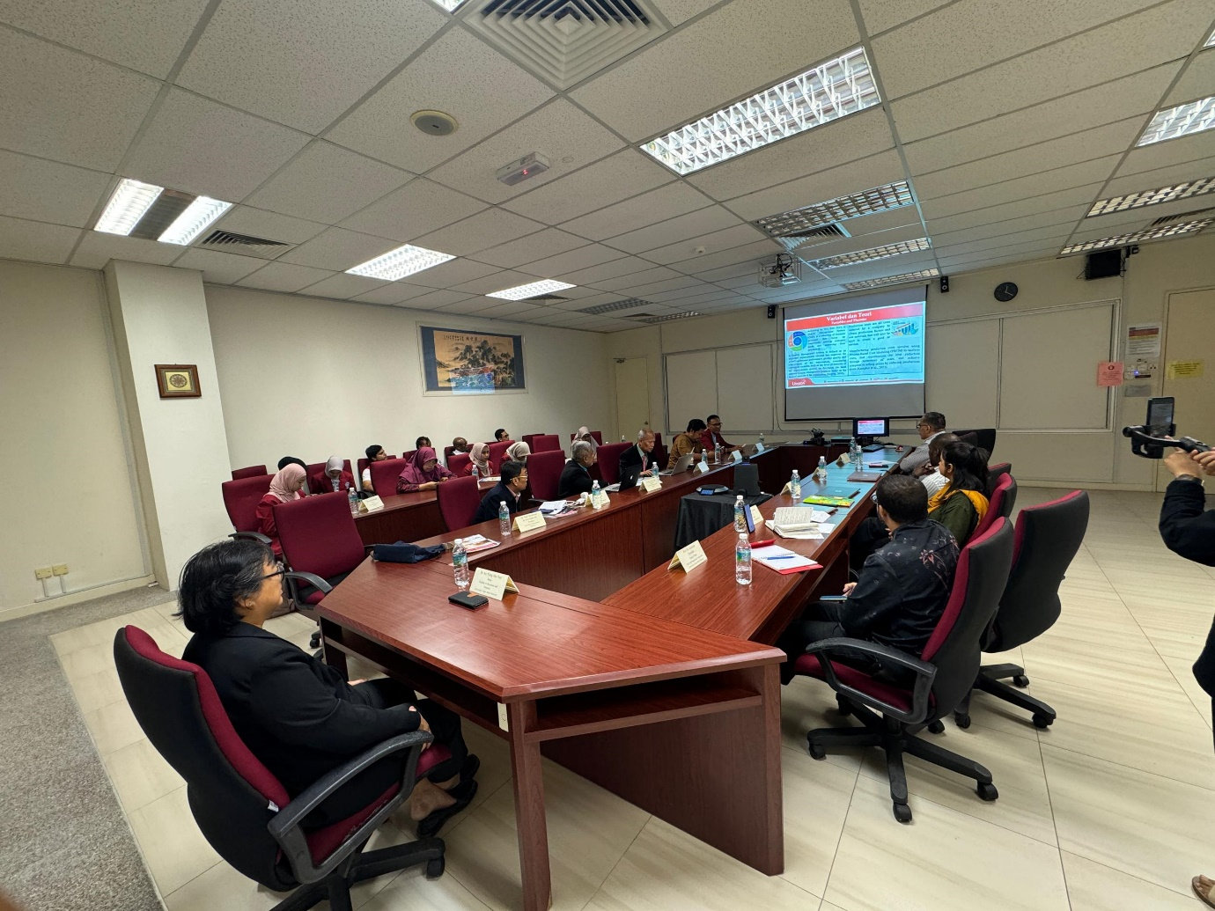
Discussions between UTAR and UMSIDA academics
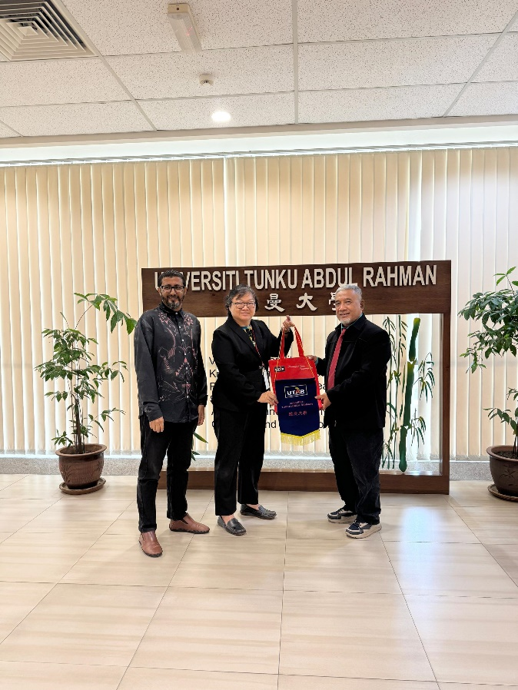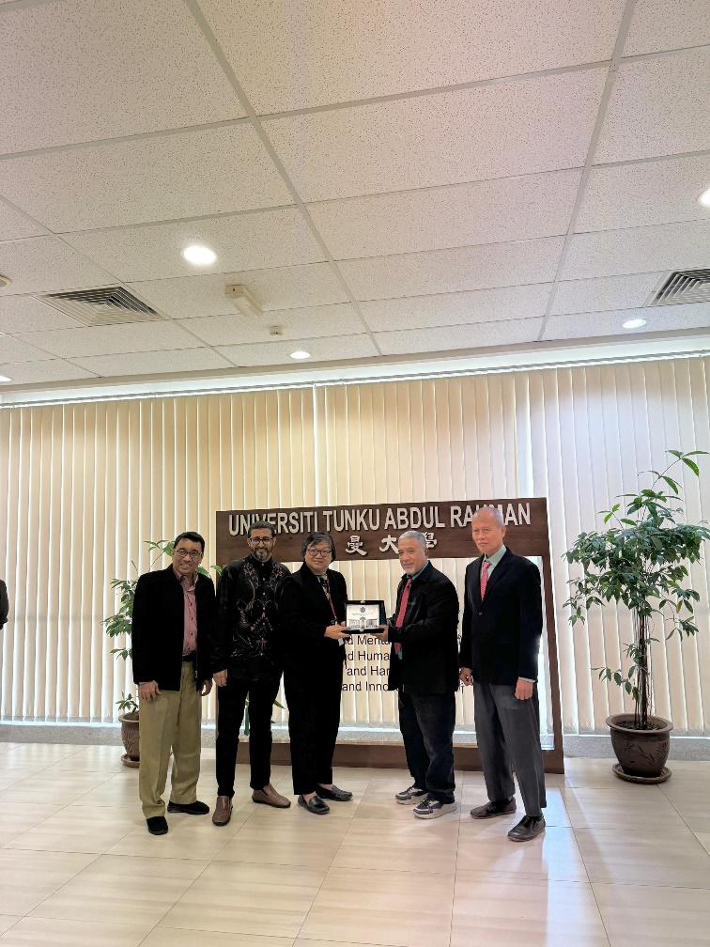
Exchanging of tokens of appreciation between UTAR and UMSIDA
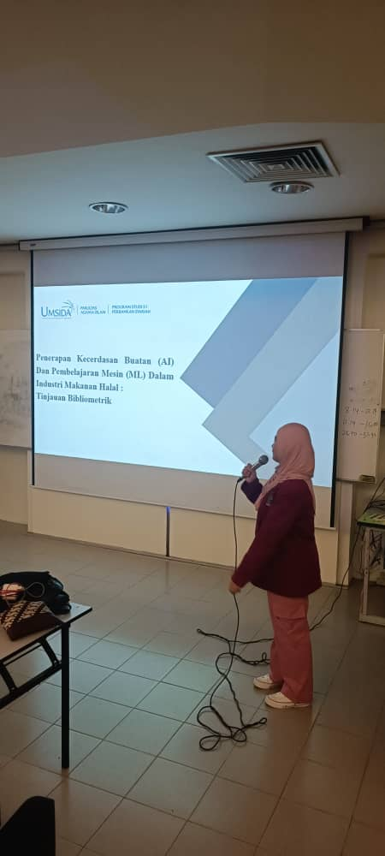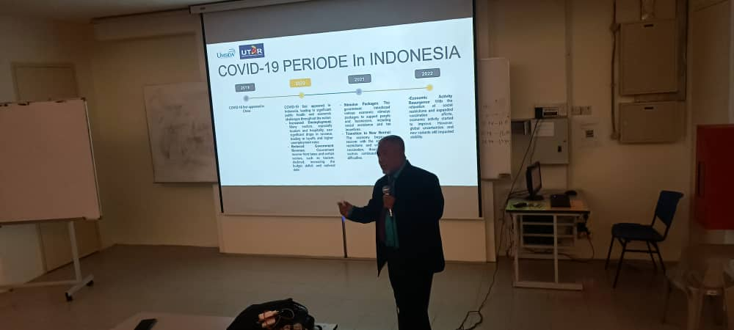
Enlightening presentations by some of the UMSIDA presenters
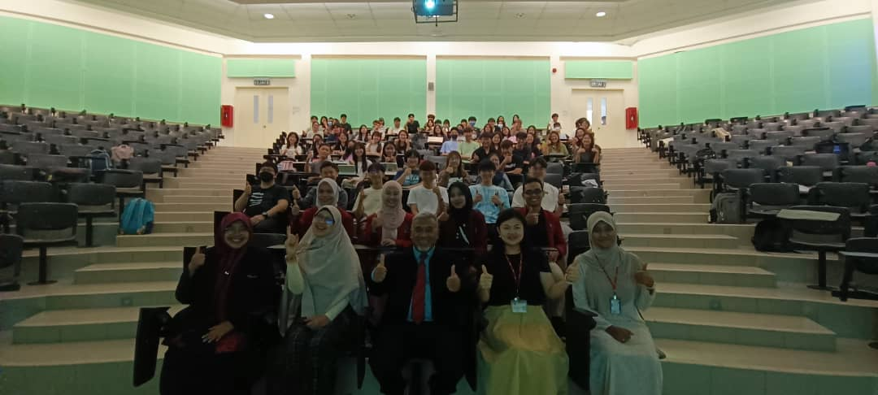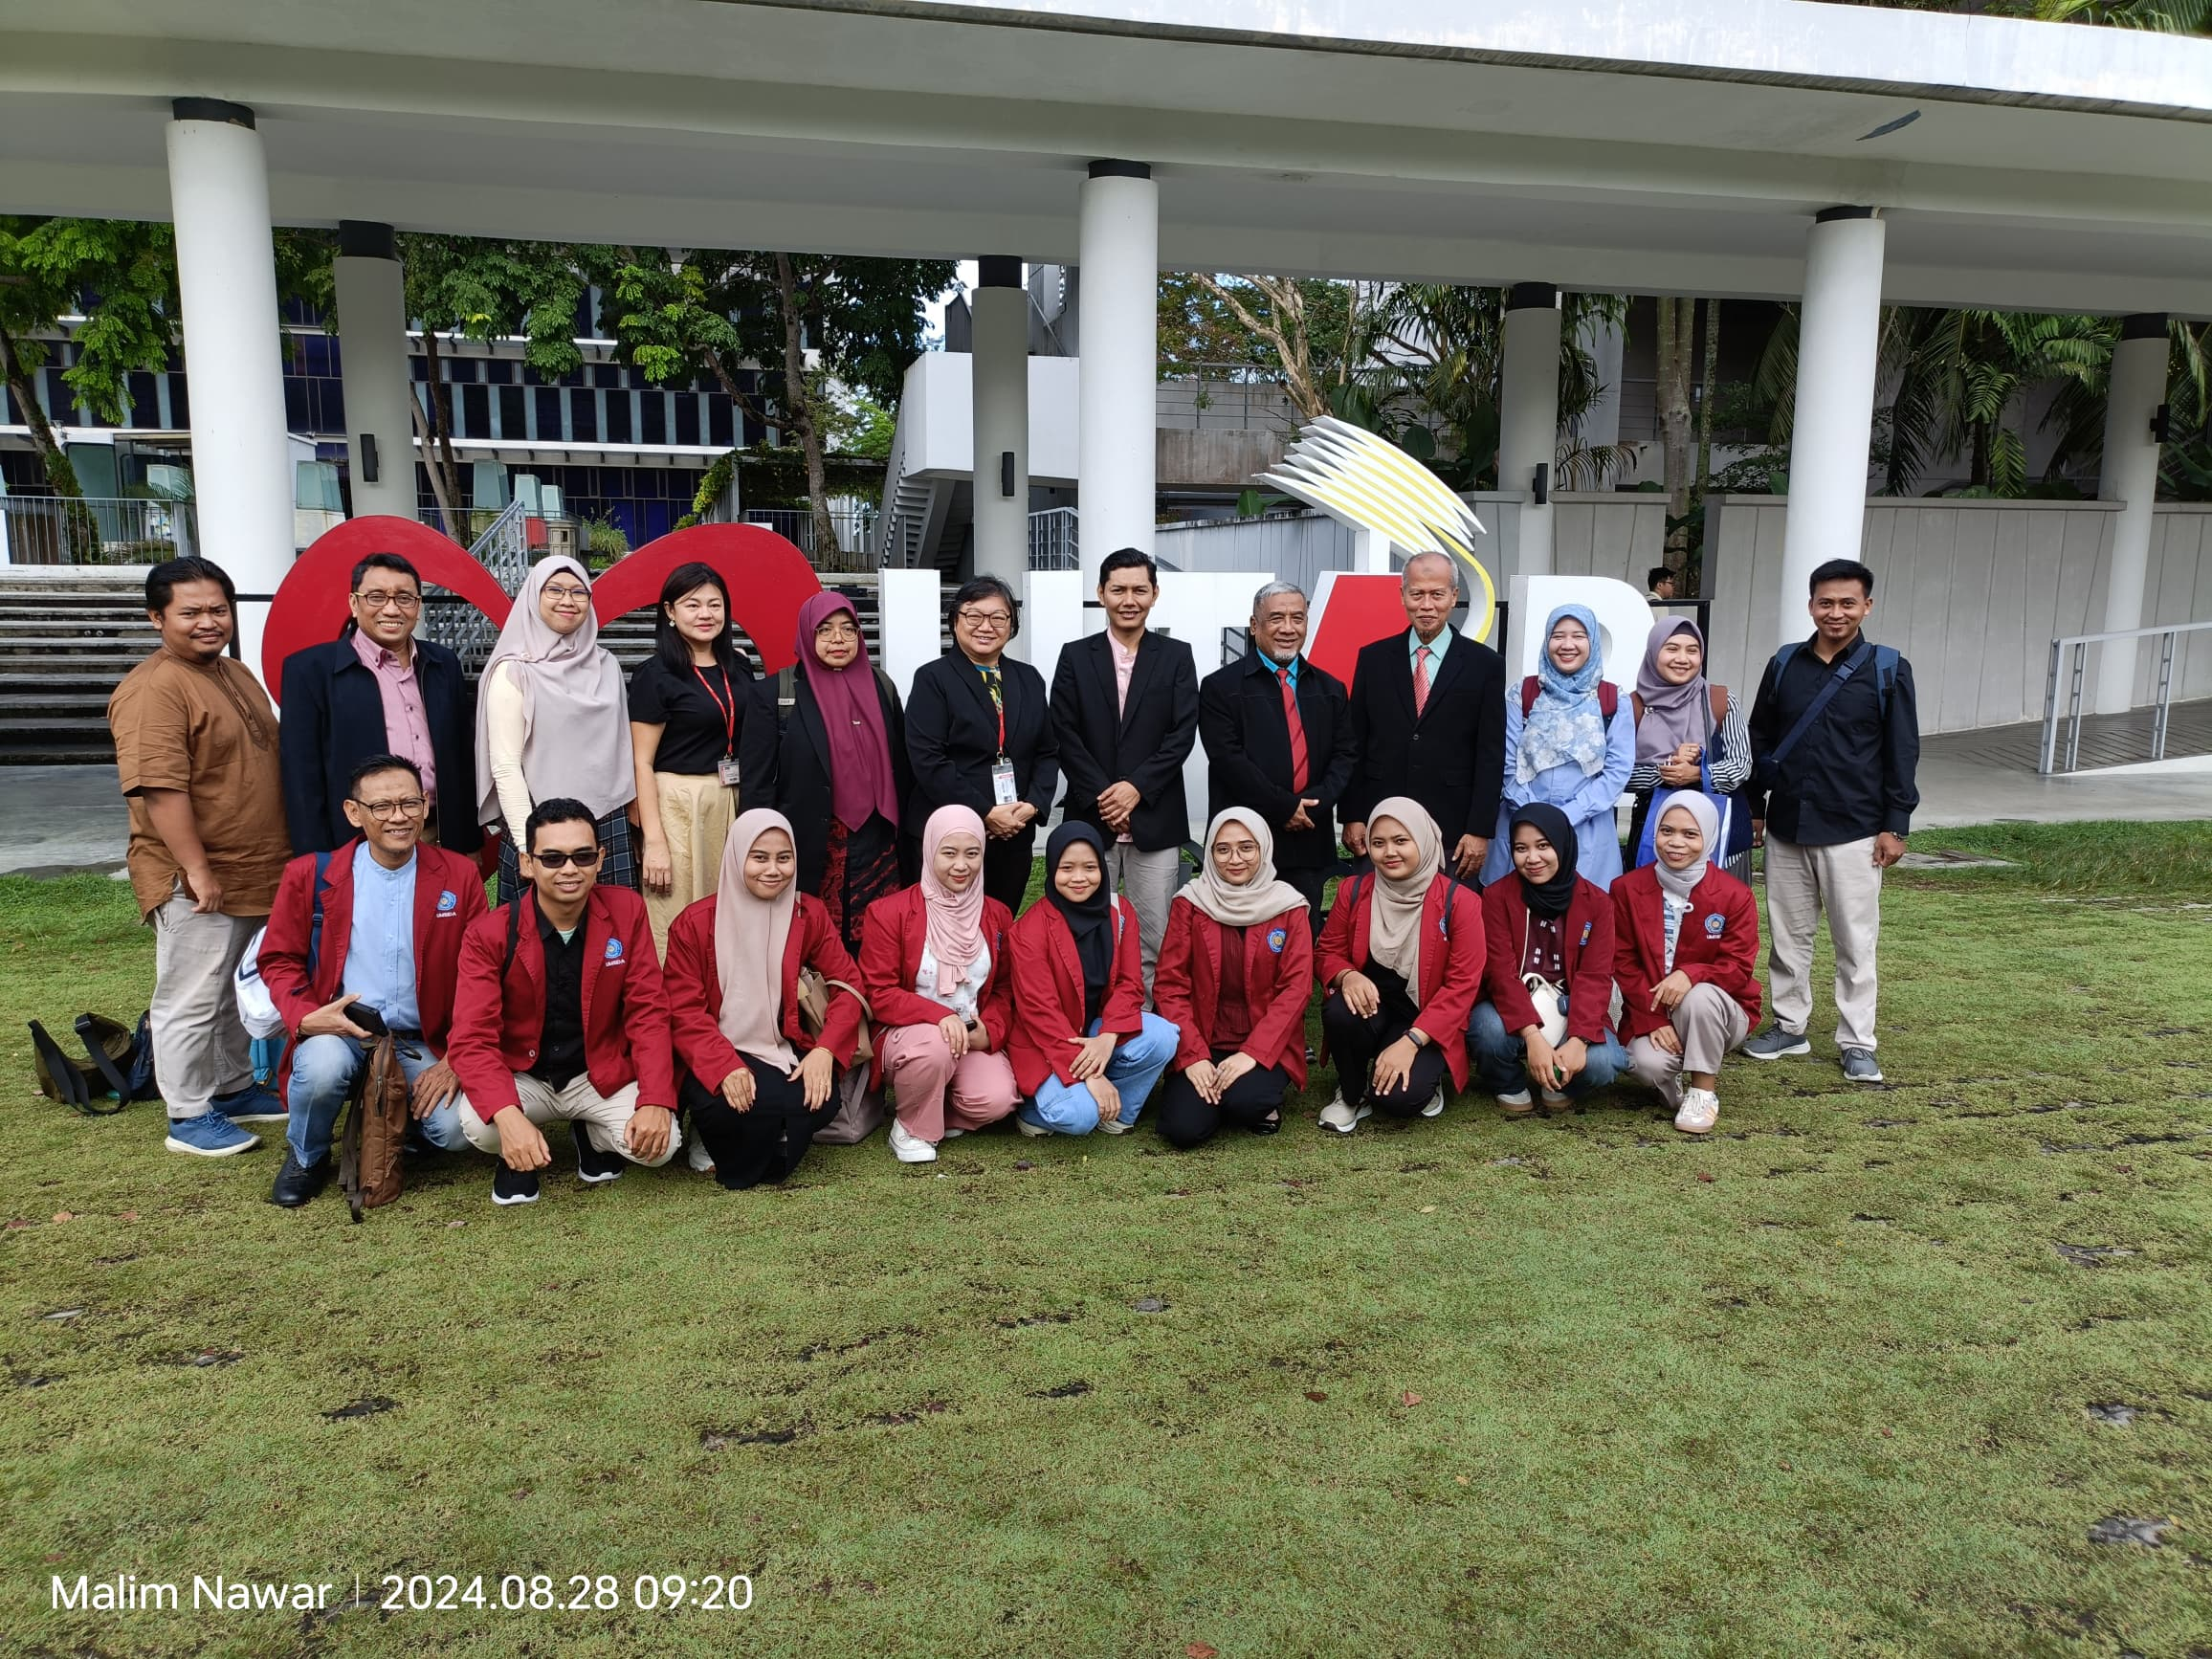
Group photos to commemorate a successful collaborative forum

