**Hybrid talk on risk management and cybersecurity**

The Department of Commerce and Accountancy at the Faculty of Business and Finance (FBF) collaborated with the Institute of Internal Auditors, Malaysia (IIA) to organise a hybrid talk, titled “Secure Your Future: A Career in Risk Management and Cybersecurity”, ~~held~~ at Block H, UTAR Kampar Campus and via Zoom on 23 August 2024. The hybrid talk was moderated by FBF academic Dr Kogilavani Apadore.

Invited to deliver the talk was the General Manager of Internal Audit of Malaysia Airports Holdings Berhad (MAHB), Puan Ainon Mahat, ~~Puan Ainon is~~ a highly experienced and qualified internal auditor with over 27 years of experience in the areas of Governance, Risk, Compliance, Strategy, Operations and IT. ~~In addition, she is also passionate about the internal audit profession and is committed to promoting professionalism, building high-performance teams, and communicating effectively with stakeholders at all levels.~~

The virtual talk aimed to introduce Accounting degree students to IIA Malaysia and its role in promoting the internal auditing profession. It also sought to enhance students’ understanding of the various career paths in risk management and cybersecurity, highlighting the connections between these fields and accounting. Additionally, the talk encouraged students to pursue certifications and training offered by IIA Malaysia, emphasising the importance of building expertise and professional networks early to improve their career prospects in these high-demand areas.

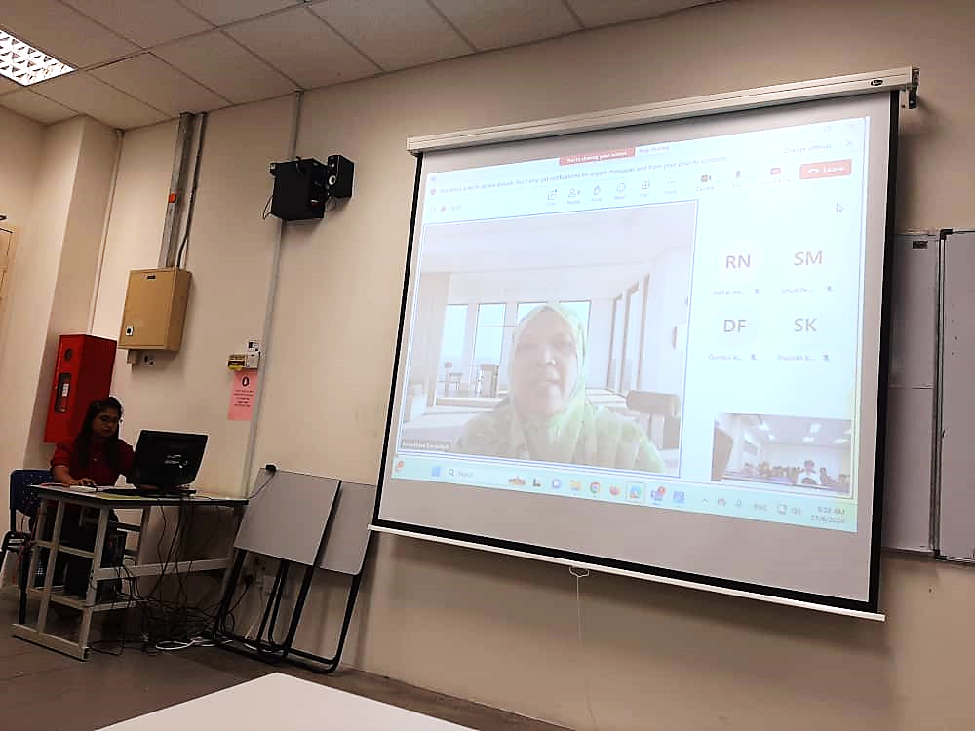  
Puan Ainon introducing herself

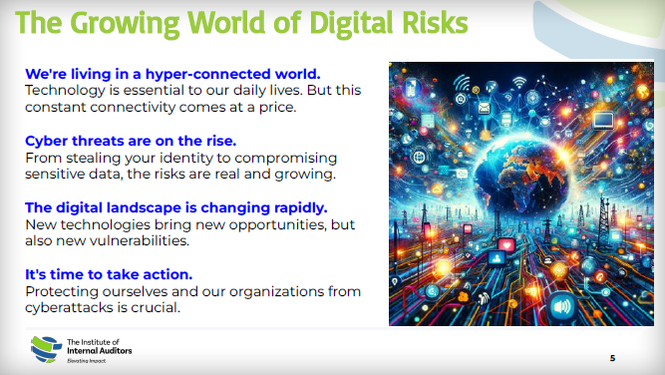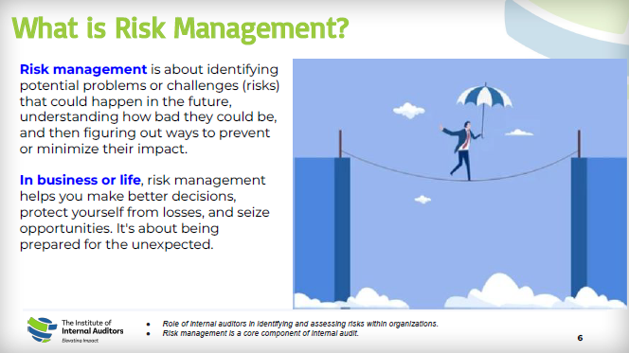  
Puan Ainon introducing digital risks and risk management

Puan Ainon started her talk by explaining the growing world of digital risks. She said, “We are living in a hyper-connected world where technology is essential to our daily lives, but this constant connectivity comes at a price. ~~The~~ Cyber threats are on the rise as the digital landscape changes rapidly. So it is crucial for us to protect ourselves and our organisations from cyberattacks.”

“Risk management is about identifying potential problems or challenges (risks) that could happen in the future, understanding how bad they can be, and then figuring out ways to prevent or minimise their impact. In business or life, risk management helps you make better decisions, protect yourself from losses, and seize opportunities. It’s about being prepared for the unexpected,” she added. According to the speaker, some of the common risks included ~~the~~ weather-related disruptions, security threats, air traffic congestions, operations challenges, technology hiccups and human error.

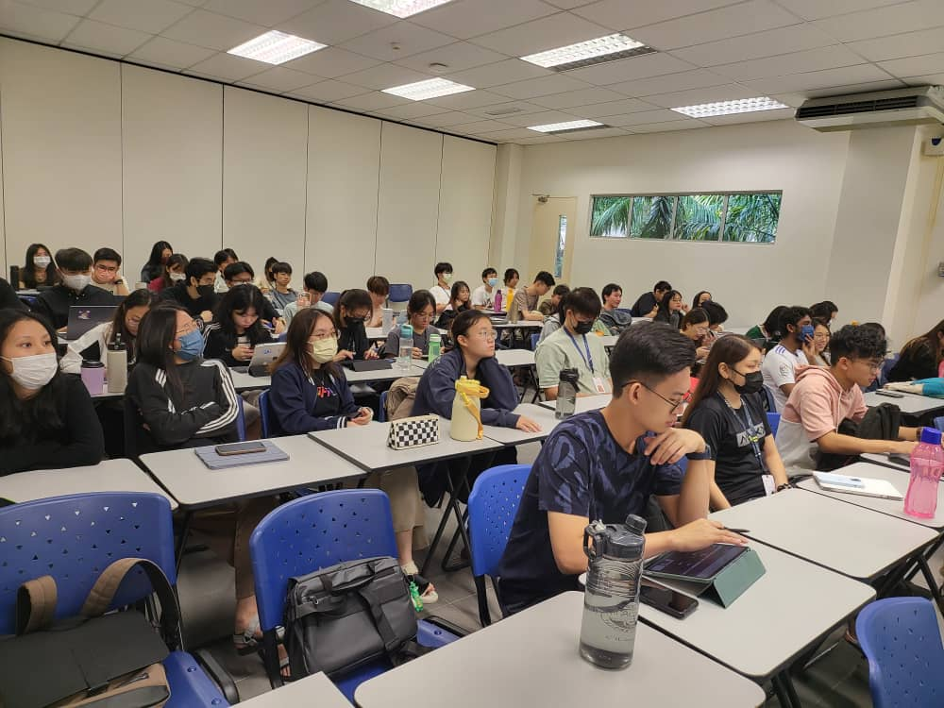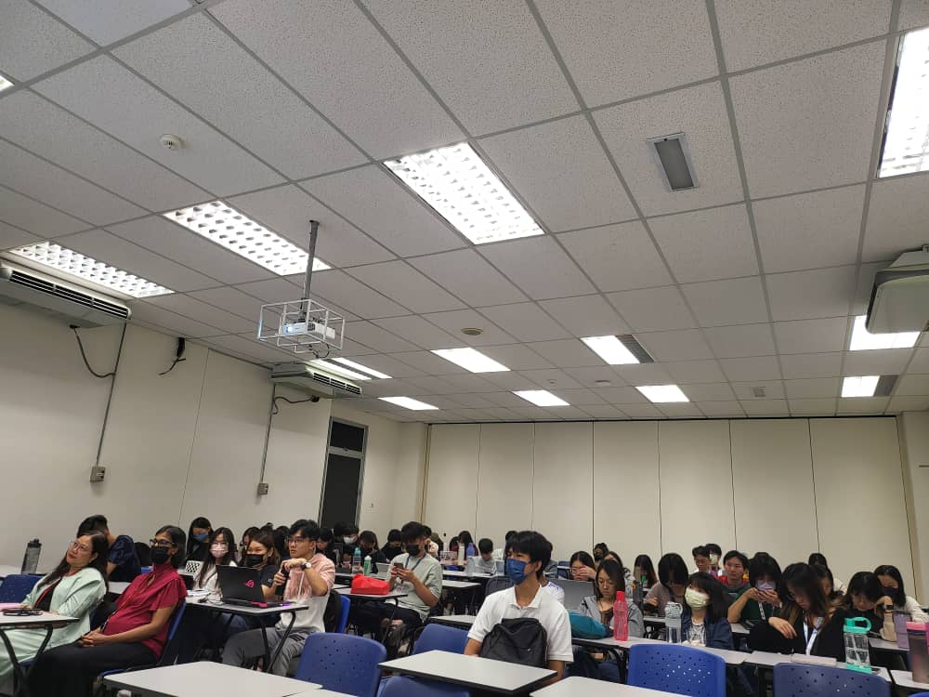

Participants listening attentively

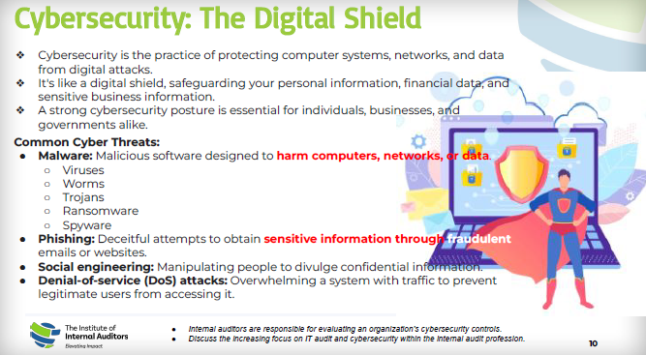  
Puan Ainon explaining cybersecurity practices and threats

Additionally, Puan Ainon highlighted that the most common cyber threats include malware such as viruses, worms, Trojans, ransomware, and spyware; phishing—an attempt to deceive individuals into revealing sensitive information through fraudulent emails and websites; social engineering—manipulating individuals to disclose confidential information; and denial-of-service (DoS) attacks—flooding a system with traffic to block legitimate users from gaining access.

“Cybersecurity is the practice of protecting computer systems, networks, and data from digital attacks. It is like a digital shield, safeguarding your personal information, financial data, and sensitive business information. A strong cybersecurity posture is essential for individuals, businesses, and governments alike,” she enthused.

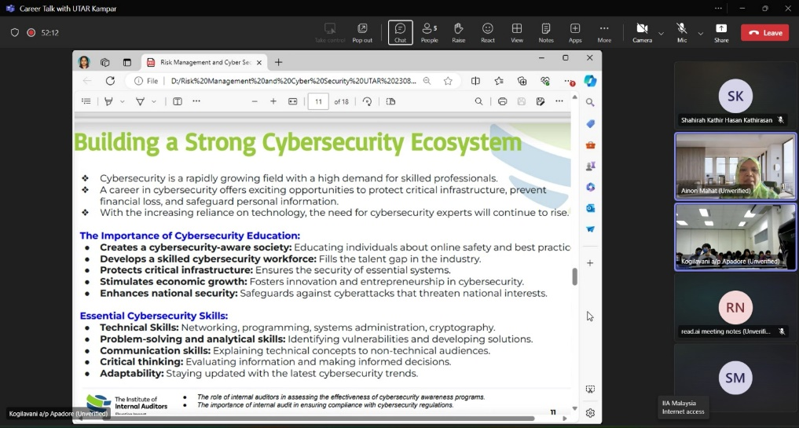  
Puan Ainon explaining how to build a strong cybersecurity ecosystem

Explaining the method to build a strong cybersecurity ecosystem, Puan Ainon said, “Cybersecurity is a rapidly growing field with a high demand for skilled professionals. With cybersecurity education, we are able to create a cybersecurity-aware society by educating individuals about online safety and best practices; develop a skilled cybersecurity workforce and fill the talent gap in the industry; protect critical infrastructure and ensure the security of essential systems; stimulate economic growth by fostering innovation and entrepreneurship in cybersecurity; and enhance national security against cyberattacks that threaten national interests. Furthermore, it is vital for a cybersecurity expert to have ~~these skills such as~~ technical skills, problem-solving and analytical skills, communication skills, critical thinking and adaptability.”

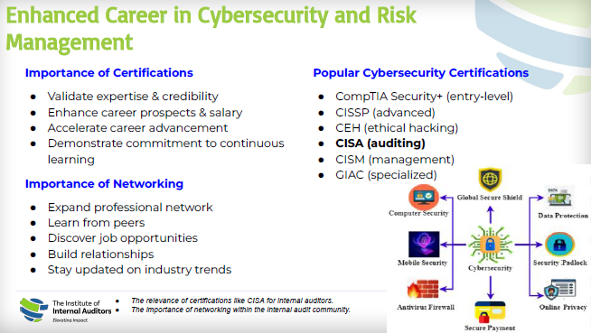  
Puan Ainon highlighting opportunities for career advancement

The hybrid talk ended with Q&A session.

**Institute of Internal Auditors**

The Institute of Internal Auditors promotes the profession and prepares internal auditors worldwide with a supportive community, relevant resources, and professional development opportunities to mitigate current and future risks, provide assurance, add real value, and elevate the impact of their organisations. The collaboration between UTAR and the Institute of Internal Auditors Malaysia aims to bridge the gap between academic learning and professional practice, providing students with valuable insights into the internal auditing profession. By fostering closer ties between education and industry, this collaboration also opens up new opportunities for professional development, networking, and career advancement for UTAR students.