**Secure Your Future with a Career in Risk Management and Cybersecurity**

UTAR Department of Commerce and Accountancy parked under Faculty of Business and Finance (FBF) in collaboration with Institute of Internal Auditors, Malaysia (IIA) organised a hybrid talk, held at Block H and via Zoom titled “Secure Your Future: A Career in Risk Management and Cybersecurity” on 23 August 2024 at UTAR Kampar Campus. The hybrid talk was moderated by FBF academic Dr Kogilavani Apadore.

Invited to deliver the talk were General Manager of Internal Audit of Malaysia Airports Holdings Berhad (MAHB) Puan Ainon Mahat. Puan Ainon is a highly experienced and qualified internal auditor with over 27 years of experience in the areas of Governance, Risk, Compliance, Strategy, Operations and IT. In addition, she is also passionate about the internal audit profession and is committed to promoting professionalism, building high-performance teams, and communicating effectively with stakeholders at all levels.

The virtual talk aimed to familiarize the participants on the accounting degree students with IIA Malaysia and its role in advancing the internal auditing profession, improve understanding for students about the diverse career opportunities available in risk management and cybersecurity and how these fields intersect with accounting and how students can leverage their degrees to enter these high-demand professions, as well as to motivate accounting students to pursue certifications and training offered by IIA Malaysia, encouraging them to start building their expertise and professional networks early, which will enhance their career prospects in risk management and cybersecurity.

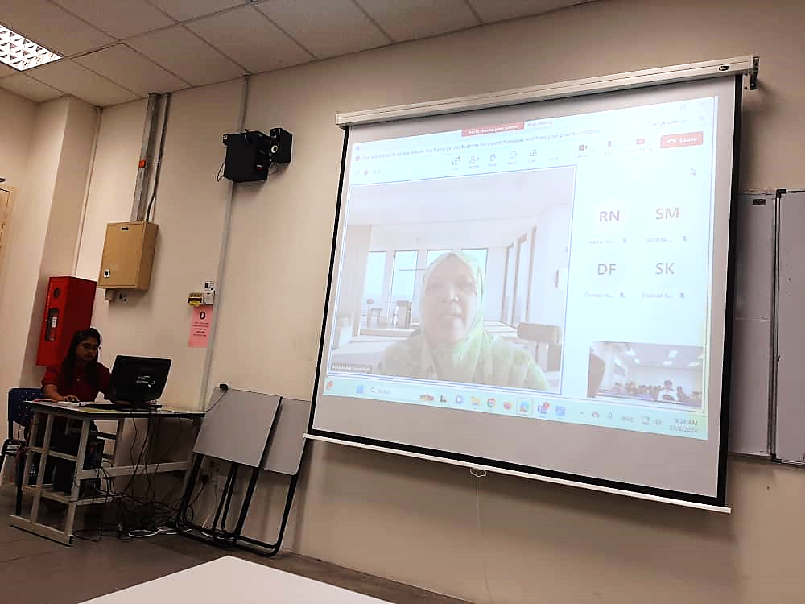  
Puan Ainon introducing herself

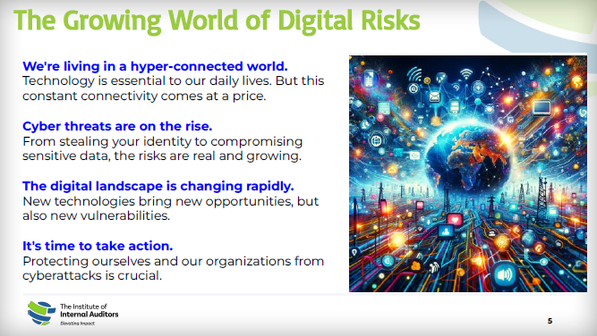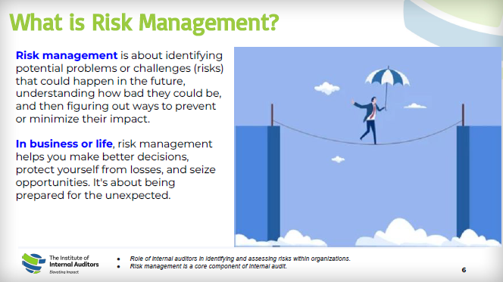  
Puan Ainon introducing the digital risks and risk management

Puan Ainon started her talk by introducing the growing world of digital risks. She said, “We are living in a hyper-connected world where technology is essential to our daily lives, but this constant connectivity comes at a price. The cyber threats are on the rise as the digital landscape is changing rapidly. So it is crucial for us to protect ourselves and organisation from cyberattacks.”

“The risk management is about identifying potential problems or challenges (risks) that could happen in the future, understanding how bad they could be, and then figuring out ways to prevent or minimise their impact. In business or life, risk management helps you make better decisions, protect yourself from losses, and seize opportunities. It's about being prepared for the unexpected”, she added.

The speaker further underlining the common risks are including the weather-related disruptions, security threats, air traffic congestions, operations challenges, technology hiccups and human error.

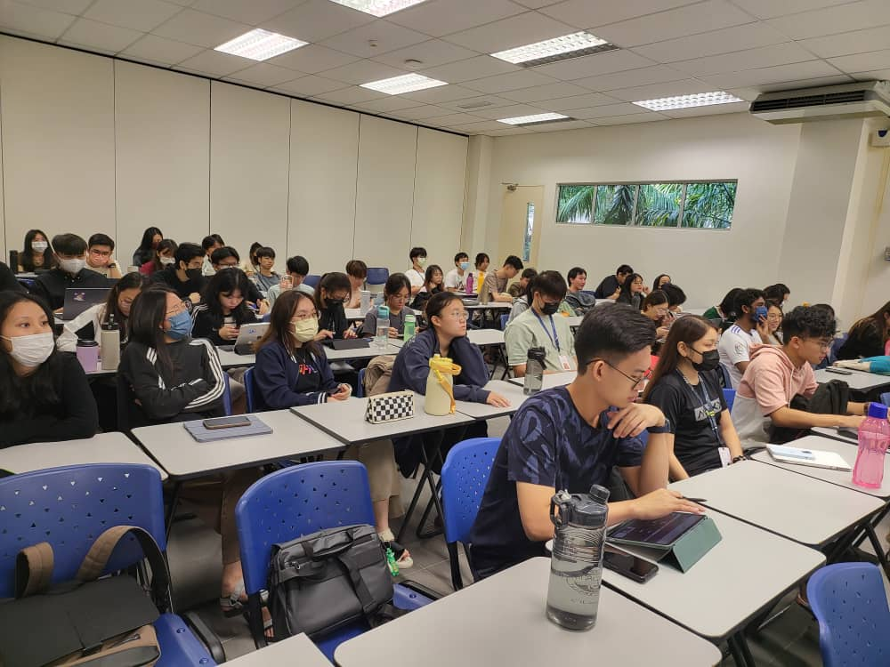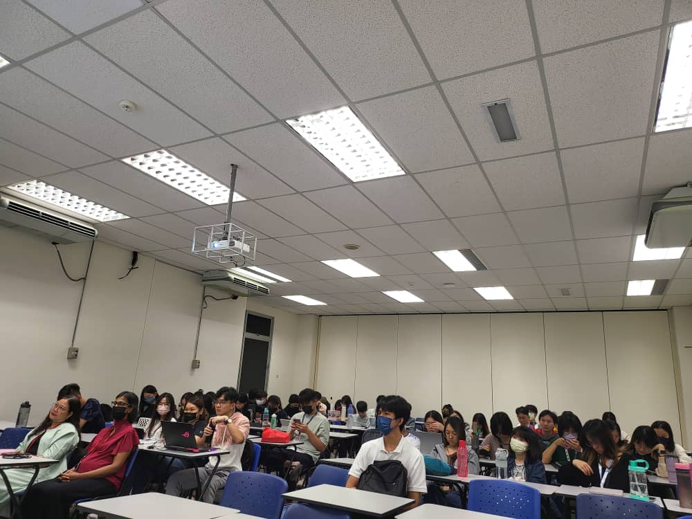

The participants listening attentively

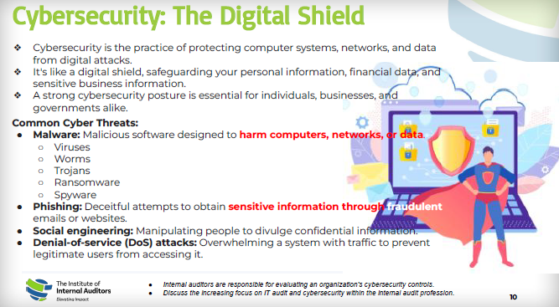  
Puan Ainon explain the cybersecurity practices and cyber threats

Moreover, Puan Ainon further emphasising the most common cyber threats are malware - viruses, worms, Trojans, Ransomware and Spyware; phishing – a deceitful attempt to obtain sensitive information through fraudulent emails and website; social engineering – manipulating people to divulge confidential information; and denial-of service (DoS) attacks – overwhelming a system with traffic to prevent legitimate users from accessing it.

“Cybersecurity is the practice of protecting computer systems, networks, and data from digital attacks. It's like a digital shield, safeguarding your personal information, financial data, and sensitive business information. A strong cybersecurity posture is essential for individuals, businesses, and governments alike”, she enthused.

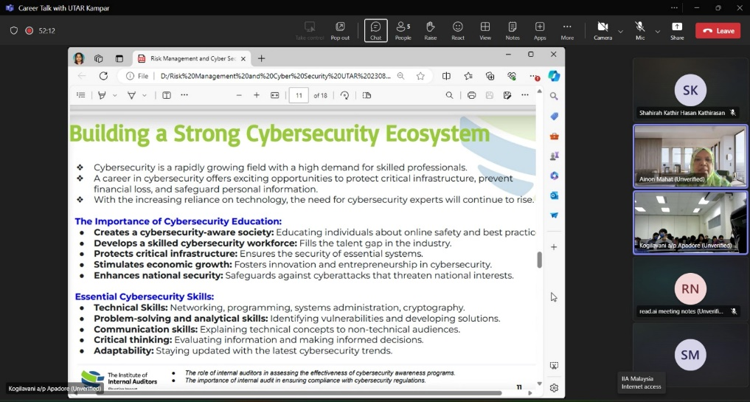  
Puan Ainon demonstrating how to build a strong cybersecurity ecosystem

In order to build a strong cybersecurity ecosystem, Puan Ainon stressed, “Cybersecurity is a rapidly growing field with a high demand for skilled professionals. With the cybersecurity education, we are able to create a cybersecurity-aware society by educating individuals about online safety and best practices; develops a skilled cybersecurity workforce and fills the talent gap in the industry; protects critical infrastructure and ensures the security of essential systems; stimulates economic growth by fostering innovation and entrepreneurship in cybersecurity; and enhances national security against cyberattacks that threaten national interests. Furthemore, it is vital for a cybersecurity expert to have these skills such as technical skills, problem-solving and analytical skills, communication skills, critical thinking and adaptability.”

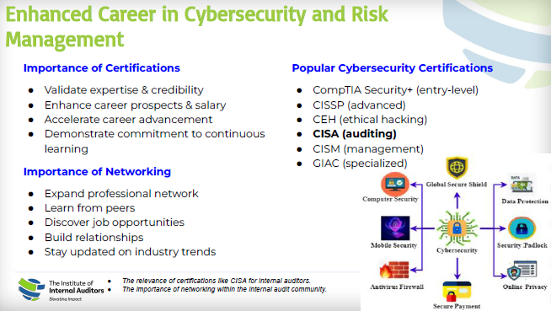  
Puan Ainon highlighting the new opportunities of career advancement for UTAR students

The hybrid talk ended with Q&A session.

The Institute of Internal Auditors supports the profession and prepares internal auditors worldwide with a real community, relevant resources, and professional development to mitigate current and future risks, provide assurance, add real value, and elevate the impact of their organizations. The collaboration between UTAR and the Institute of Internal Auditors, Malaysia, aims to bridge the gap between academic learning and professional practice, providing students with valuable insights into the internal auditing profession. By fostering closer ties between education and industry, this collaboration also opens up new opportunities for professional development, networking, and career advancement for UTAR students.