**Exploring the Micro World: CFS Hosts Hands-On Biology Workshop for Children**

The Centre for Foundation Studies (CFS) organised a biology workshop titled “A microscopic view on your neighbourhood” in conjunction with the Mathematics and Science Fair (MSF) 2024 at UTAR Sungai Long Campus on 7 September 2024.

The workshop aimed to provide young participants with hands-on experience in science, technology, engineering, arts, and mathematics. Furthermore, the event was designed to stimulate curiosity and foster creativity by engaging children in various activities related to microorganisms and demonstrating the practical applications of STEAM concepts in an enjoyable and interactive manner. By involving parents in the experience, the workshop also aimed to strengthen the bond between family members through shared learning.

A total of ten children, aged eight and nine years old, along with ten parents, attended the workshop. The workshop was facilitated by CFS academic Ms Heng Sze Lu and assisted by Ms Harttini Neeni binti Hatta, Ms Lee Cin Dee and Pn Wan Nur Farisha binti Wan Mohd Tajuddin, all of whom were also academics from CFS. Additionally, 12 student helpers from the Foundation programme supported the event. The workshop began with a storytelling session using a storybook related to fungi, which introduced children to the fascinating world of fungi. This was followed by a slide presentation on microorganisms, providing children with a deeper understanding of the unseen world. After the introduction, both children and parents engaged in five interactive STEAM activities using binocular microscopes, light microscopes, agar plates, etc. The workshop concluded with a handicraft session where children designed and built their own virus models using craft materials, applying their newfound knowledge of microorganisms in a creative and fun way.

The participants responded positively to the event. The children were highly engaged, and the presence of their parents contributed to a supportive and motivating environment. Many parents expressed their appreciation for the opportunity to bond with their children over such educational activities.

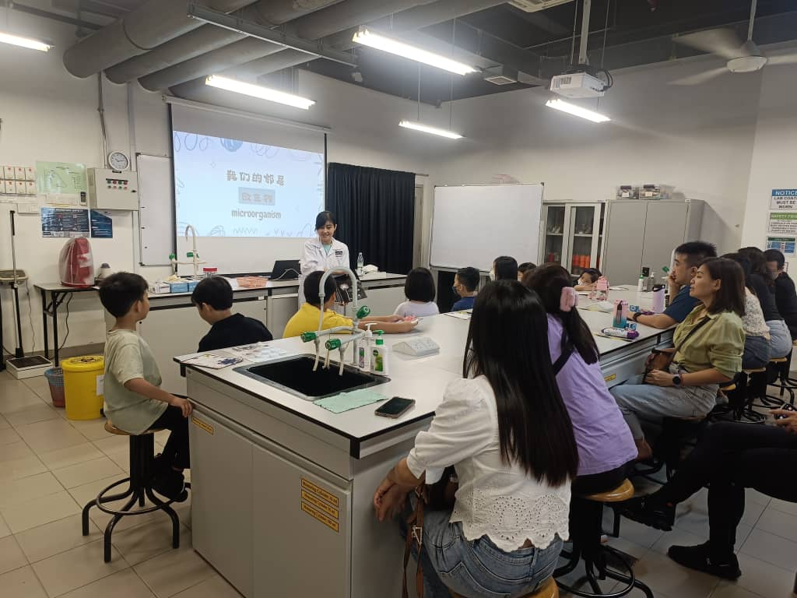

The storytelling session presentation on microorganisms

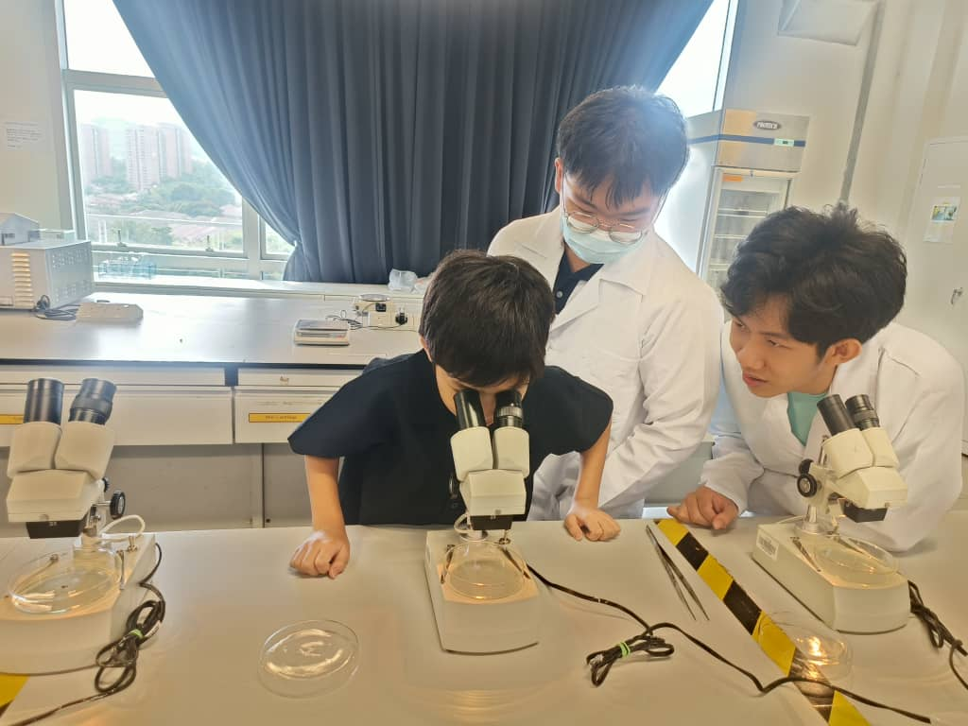

Mini Beasts Revealed: A Binocular Microscope Adventure Station

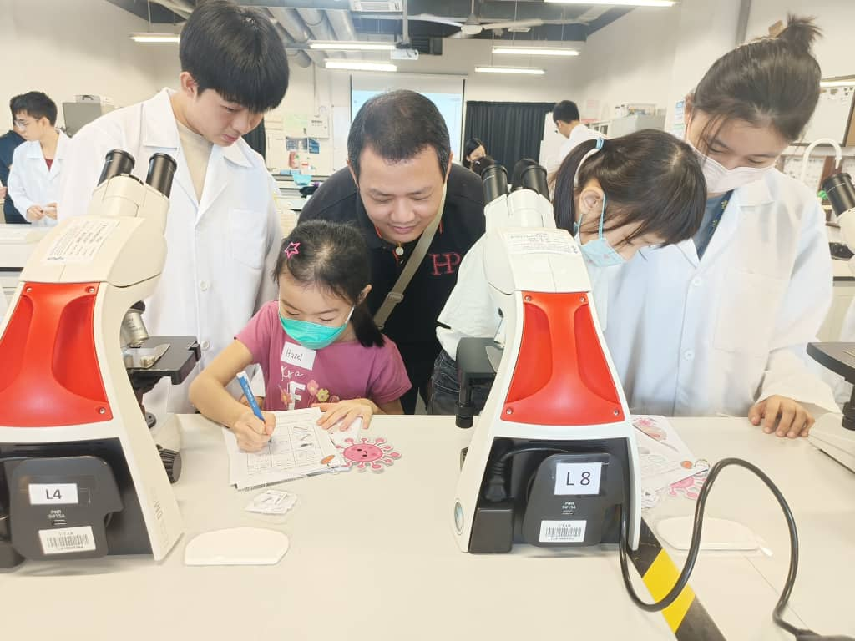 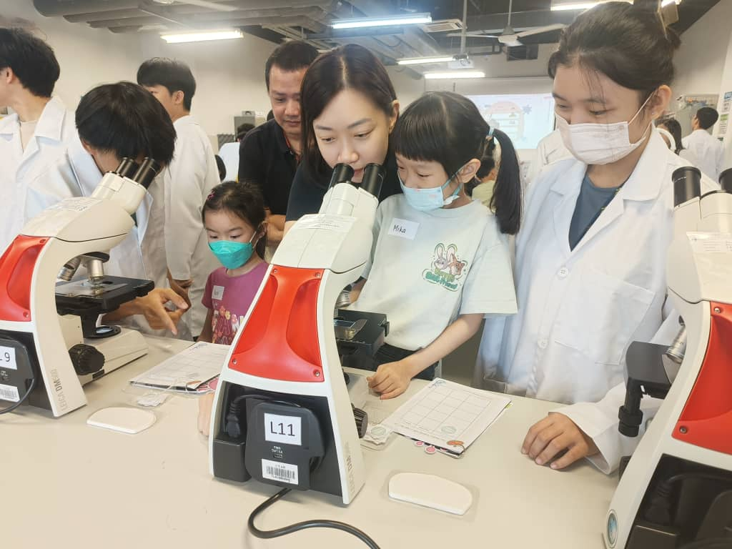

Tiny Wonders: Light Microscope Station

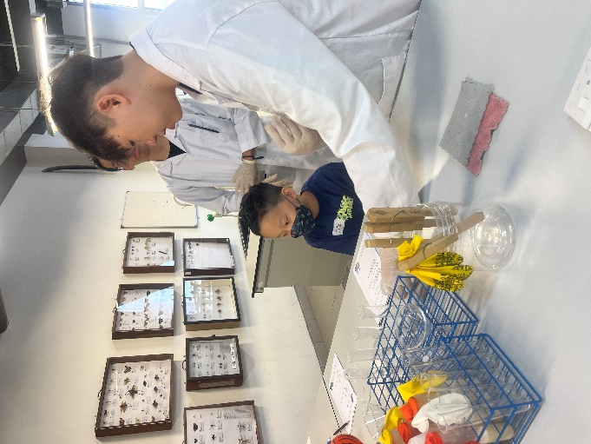 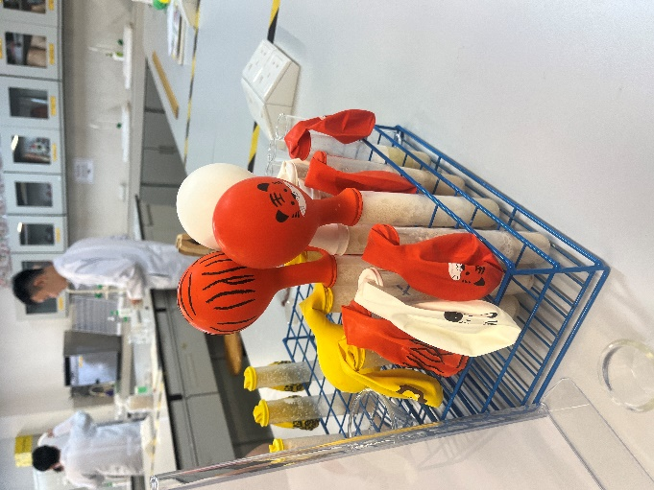

Balloon Lab: The Magic of Yeast Fermentation Station

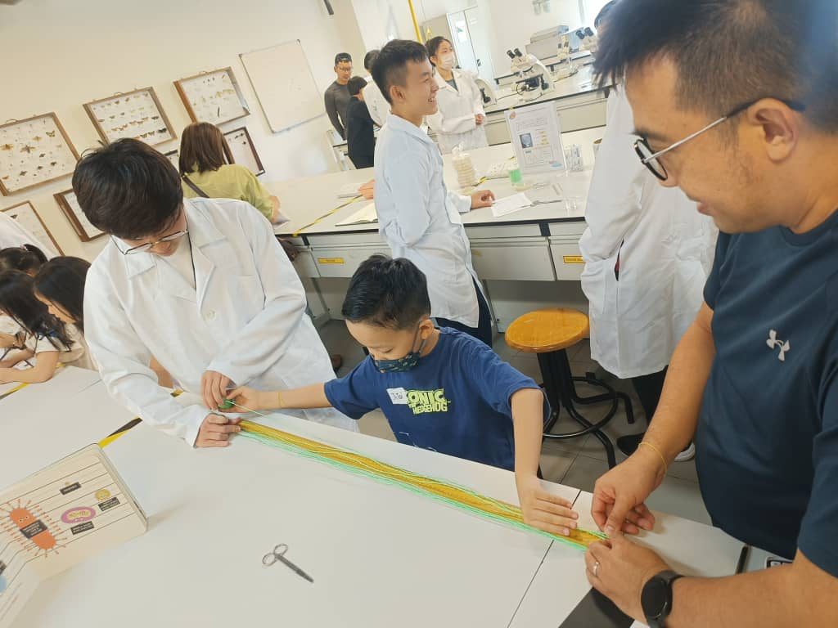 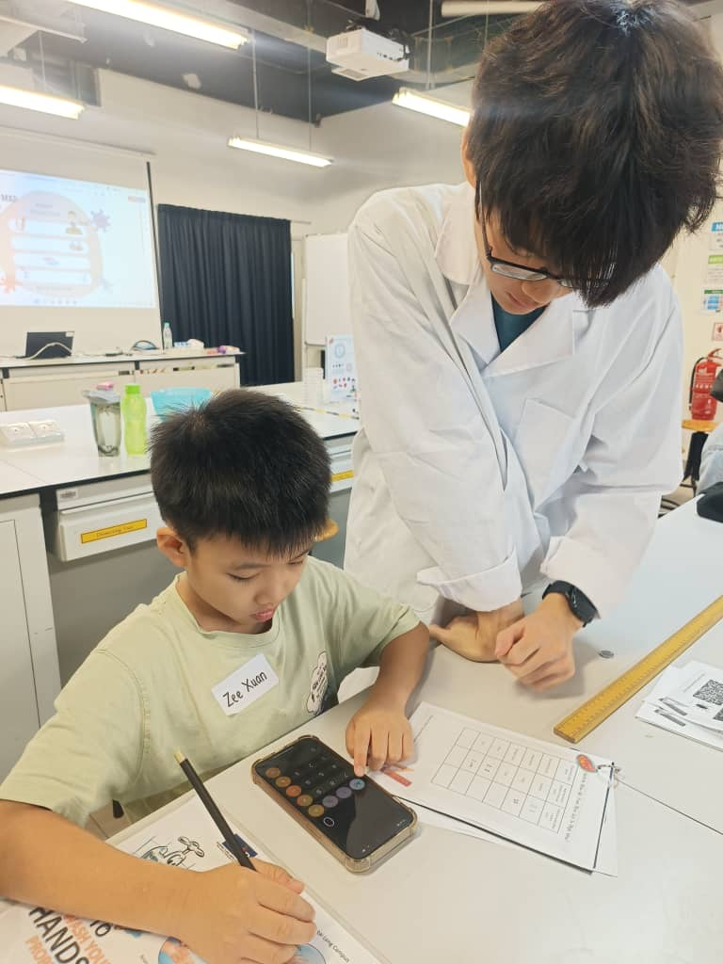

Bacteria Blow-Up: From Micro Size to Mega View Station

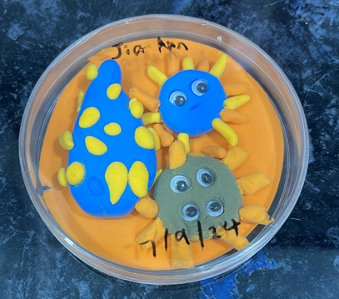 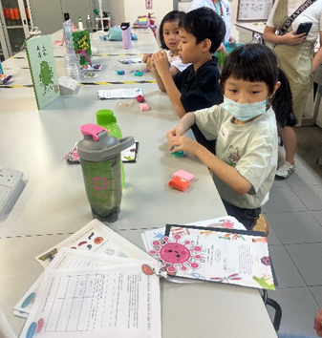

A handicraft session titled Virus Architects: Designing the Micro Monster

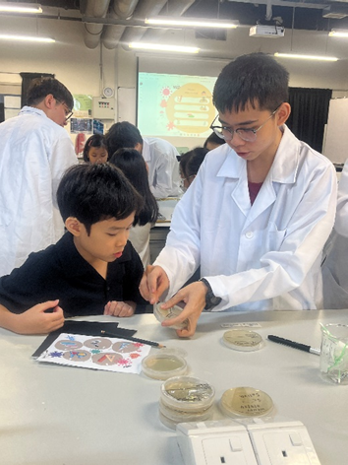

Germ Detectives: Growing Bacteria on Agar Plates Station

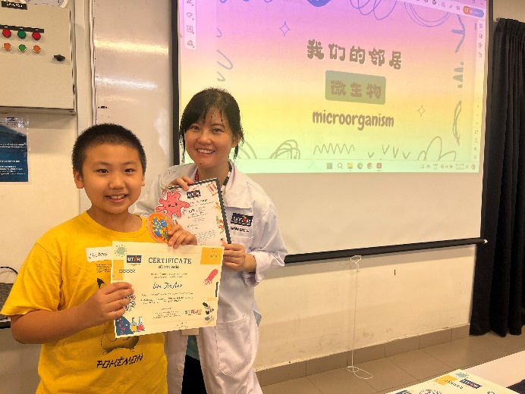 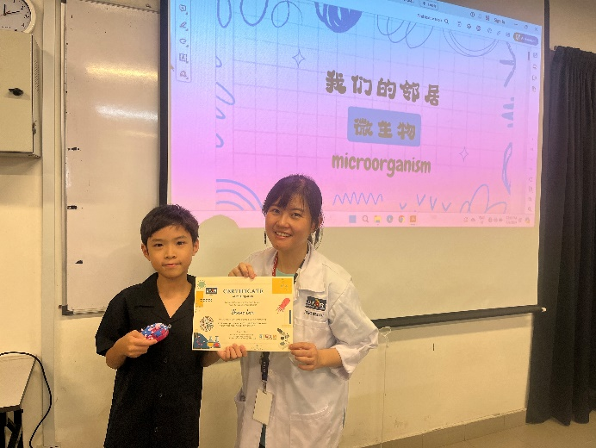

Presentation of certificates and workshop worksheets

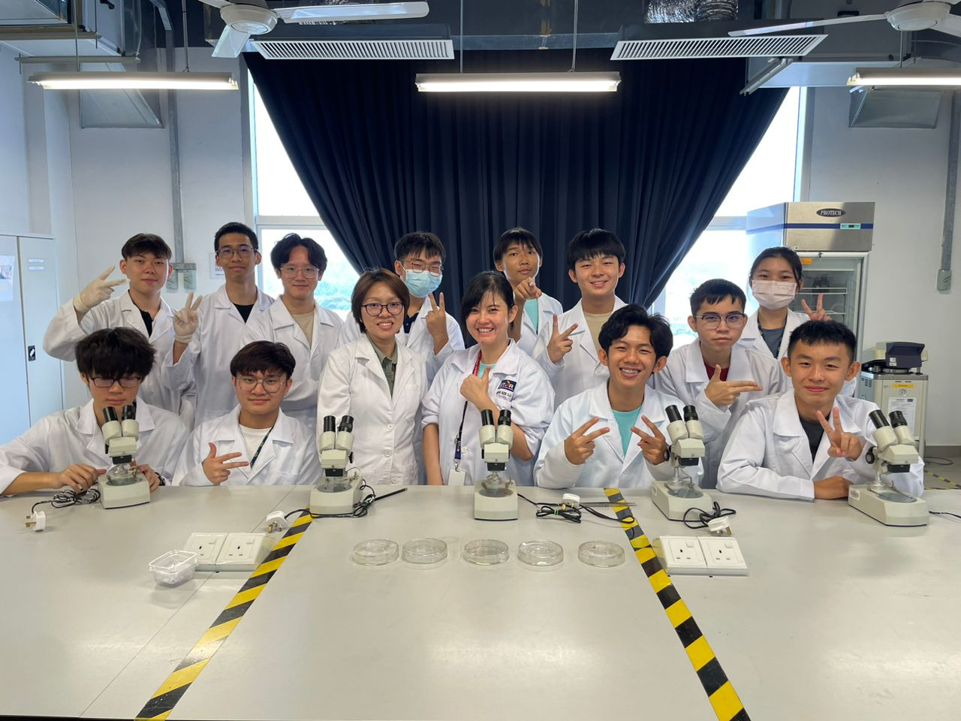

Group photo with the helpers