**UTAR-Tsinghua University Asian Business Talent Cultivation Forum**

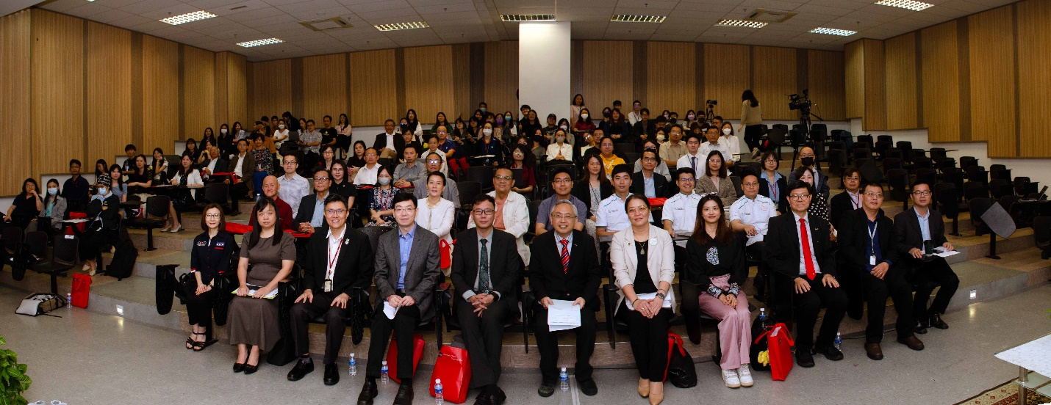

Front row, from left: Ms Lim, Dr Pok, Prof Goi, Dr Liu, Prof He, Prof Dato’ Ewe, Dato’ Ho, Ms Ravenna Chen, Prof Choong, Dr Sia and Dr Lai

UTAR and Tsinghua University School of Economics and Management (Tsinghua SEM) hosted the inaugural “UTAR-Tsinghua University Asian Business Talent Cultivation Forum” on 11 September 2024, at UTAR Sungai Long Campus. The event brought together a distinguished group of academics, industry leaders, and professionals for insightful discussions on key issues, such as talent development, retention, acquisition, and global talent management—topics of critical importance in today’s rapidly evolving economic landscape.

The forum was jointly organised by UTAR Centre for Entrepreneurial Sustainability (CENTS), the Office of International Affairs (OIA), and the Faculty of Accountancy and Management (FAM), in collaboration with Tsinghua SEM.

Present at the forum were UTAR President Ir Prof Dato’ Dr Ewe Hong Tat, Tsinghua SEM Associate Dean Prof He Ping, Tsinghua SEM Associate Dean Assoc Prof Dr Liu Qing, UTAR Vice President for Student Development and Alumni Relations Prof Dr Choong Chee Keong, Vice President for Internationalisation and Academic Development Ir Prof Dr Goi Bok Min, EcoWorld Divisional General Manager Dato’ Ho Kwee Hong, President of Tus Cross Board E-Commerce and CEO of TusStar Malaysia Ms Ravenna Chen Yaohui, Faculty of Accountancy and Management (FAM) Dean Dr Pok Wei Fong, Office of International Affairs (OIA) Director Assoc Prof Dr Lai Soon Onn, CENTS Chairperson Dr Sia Bik Kai and Centre for Corporate and Community Development (CCCD) Director Ms Lim Guat Yen.

The forum commenced with a welcoming speech by Prof Dato’ Ewe. He remarked, “Today, we not only celebrate the collaborative achievements between our two institutions since the signing of the Memorandum of Understanding (MoU) last September, but also embark on a new chapter of partnership; exploring new pathways for talent development and business growth together. Through this exchange platform, we aim to foster deeper integration between academia and industry, spark innovation, and contribute insights and strength to the prosperity of businesses in Asia and beyond.”

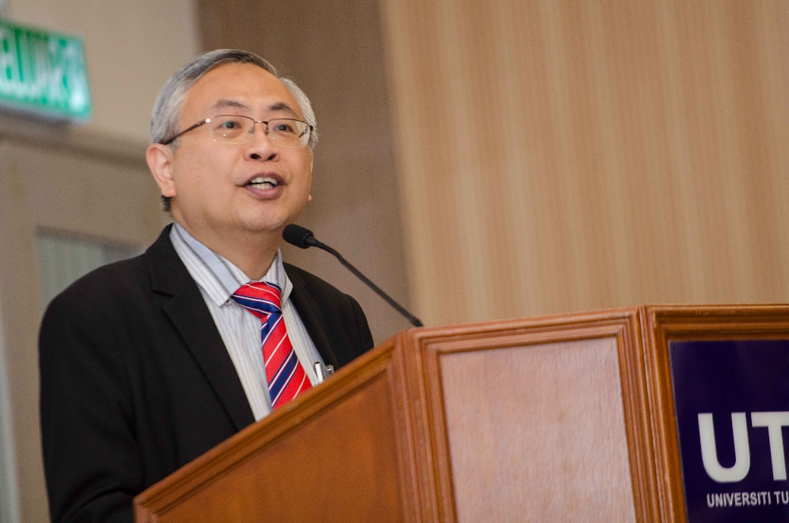

Prof Dato’ Ewe delivering a welcoming speech

Tsinghua SEM Associate Dean Prof He Ping highlighted that cultivating Asian business talents requires grounding in Asian cultural systems while embracing globalisation and developing global competence. He emphasised Tsinghua SEM efforts to promote dual-degree programs and student exchange initiatives through partnerships with leading global universities. Tsinghua SEM also enhances innovation and entrepreneurship education by collaborating with top companies and institutions, offering students opportunities to build entrepreneurial skills. Staying at the forefront of technology, SEM equips new students with AI growth assistants, and offers courses powered by generative AI. He also invited UTAR students to study at Tsinghua.

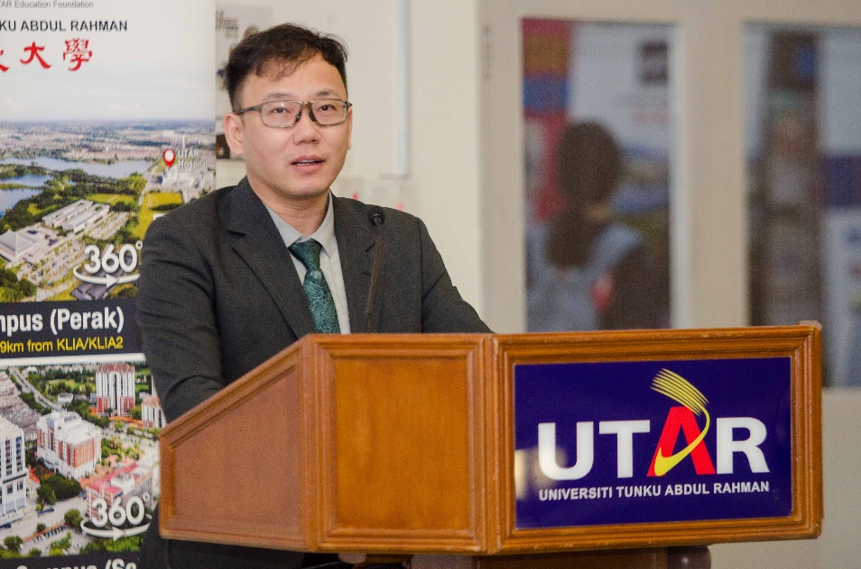

Prof He highlighting Tsinghua SEM features

Three keynote addresses followed, delivered by UTAR Vice President for Student Development and Alumni Relations Prof Choong, Dr Liu Qing and Dato’ Ho, who shared their perspectives on the evolving demands of global talent management, the significance of nurturing young professionals, and strategies for retaining top talent in a competitive market. A lively Q&A session followed, allowing participants to engage directly with the speakers.

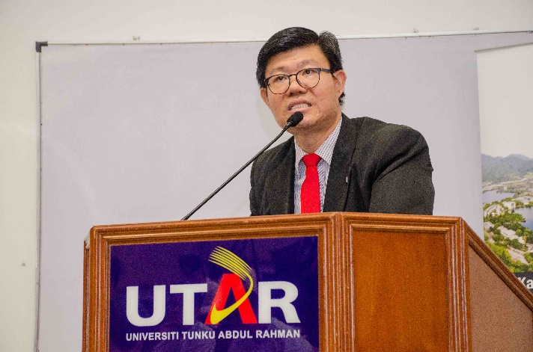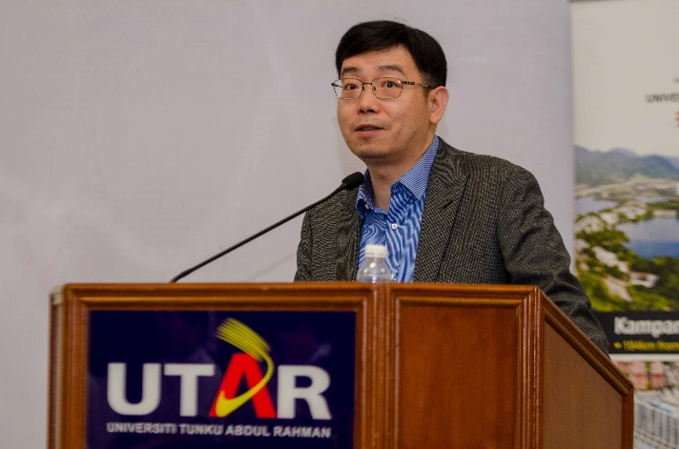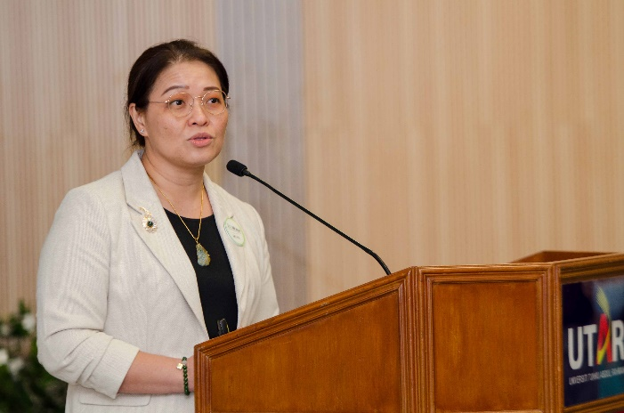

From top left, clockwise: Prof Choong, Dr Liu and Dato’ Ho

One of the forum’s highlights was the panel discussion on “UTAR – Tsinghua University Asian Business Talent Cultivation”. The panellists included, UTAR President Ir Prof Dato’ Dr Ewe Hong Tat, Tsinghua University School of Economics and Management Associate Dean Prof He Ping, Dato’ Ho, and Ms Ravenna Chen. FAM Dean Dr Pok Wei Fong moderated the session. The panellists discussed emerging trends in talent cultivation, the critical role of cross-border collaborations, competencies for the future job market, and the increasing significance of industry-academia partnerships in preparing future business leaders.

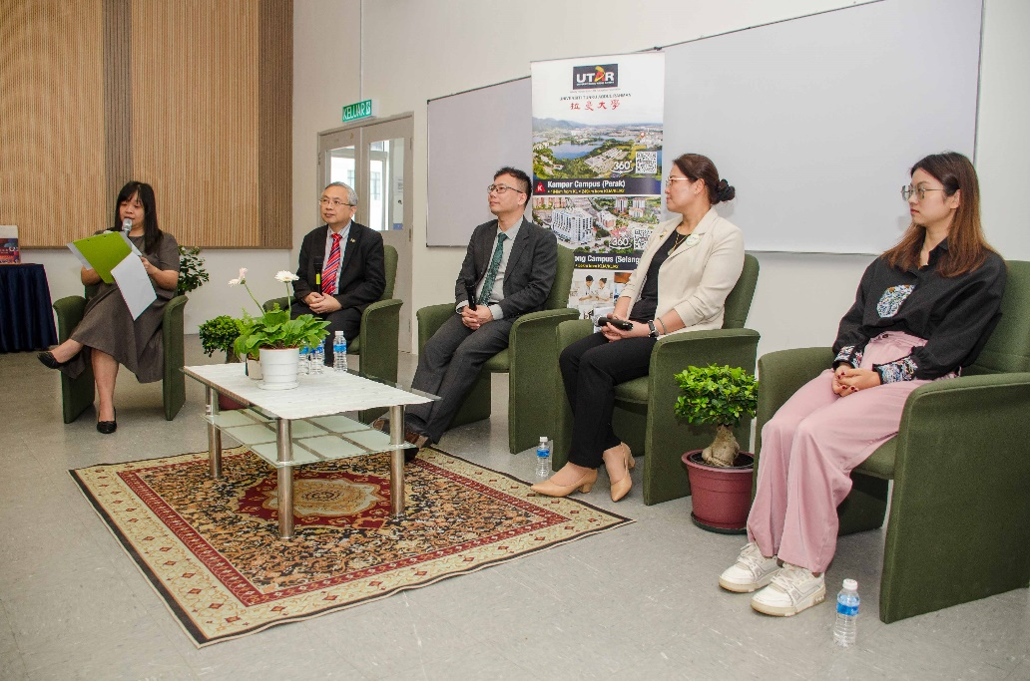

During the forum. From right: Ms Ravenna Chen, Dato’ Ho, Prof He, Prof Dato’ Ewe and Dr Pok

In a symbolic step towards furthering these collaborations, the event also included the signing of a MoU between UTAR FAM, Faculty of Business and Finance (FBF), and Tsinghua SEM. The MoU aimed to establish an MBA Double Degree Programme, EMBA overseas study modules, tailored Executive Education courses, and semester or short-term exchange programmes for undergraduate students. The MoU marked the beginning of a new chapter in academic and professional cooperation among the faculties and the school.

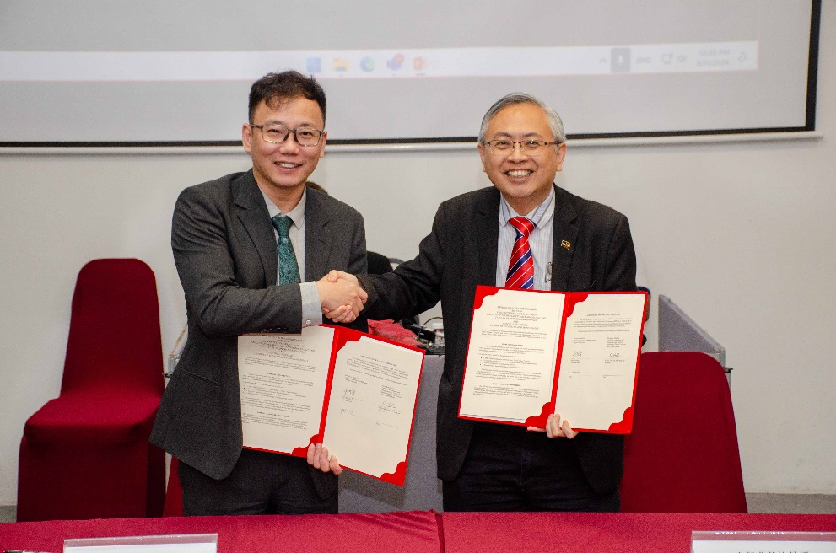

Prof Ho (left) and Prof Dato’ Ewe displaying the signed documents

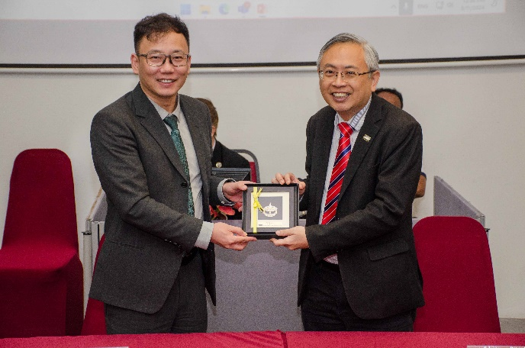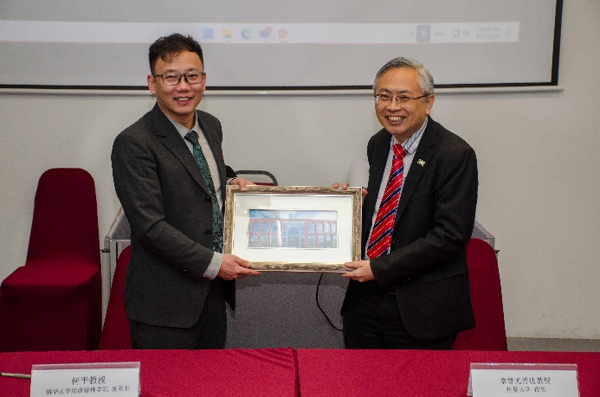

Souvenir exchange session

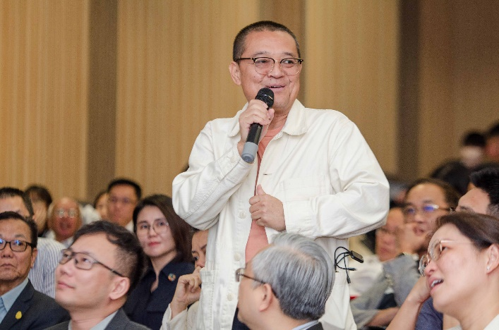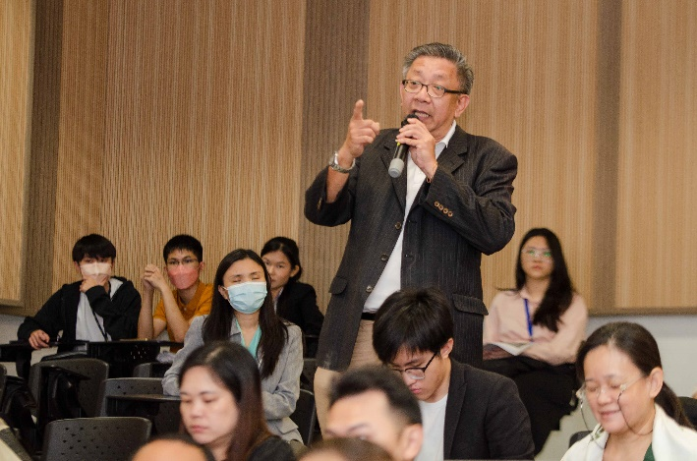

Q&A session