

**Visit by Shandong Federation of Returned Overseas Chinese**

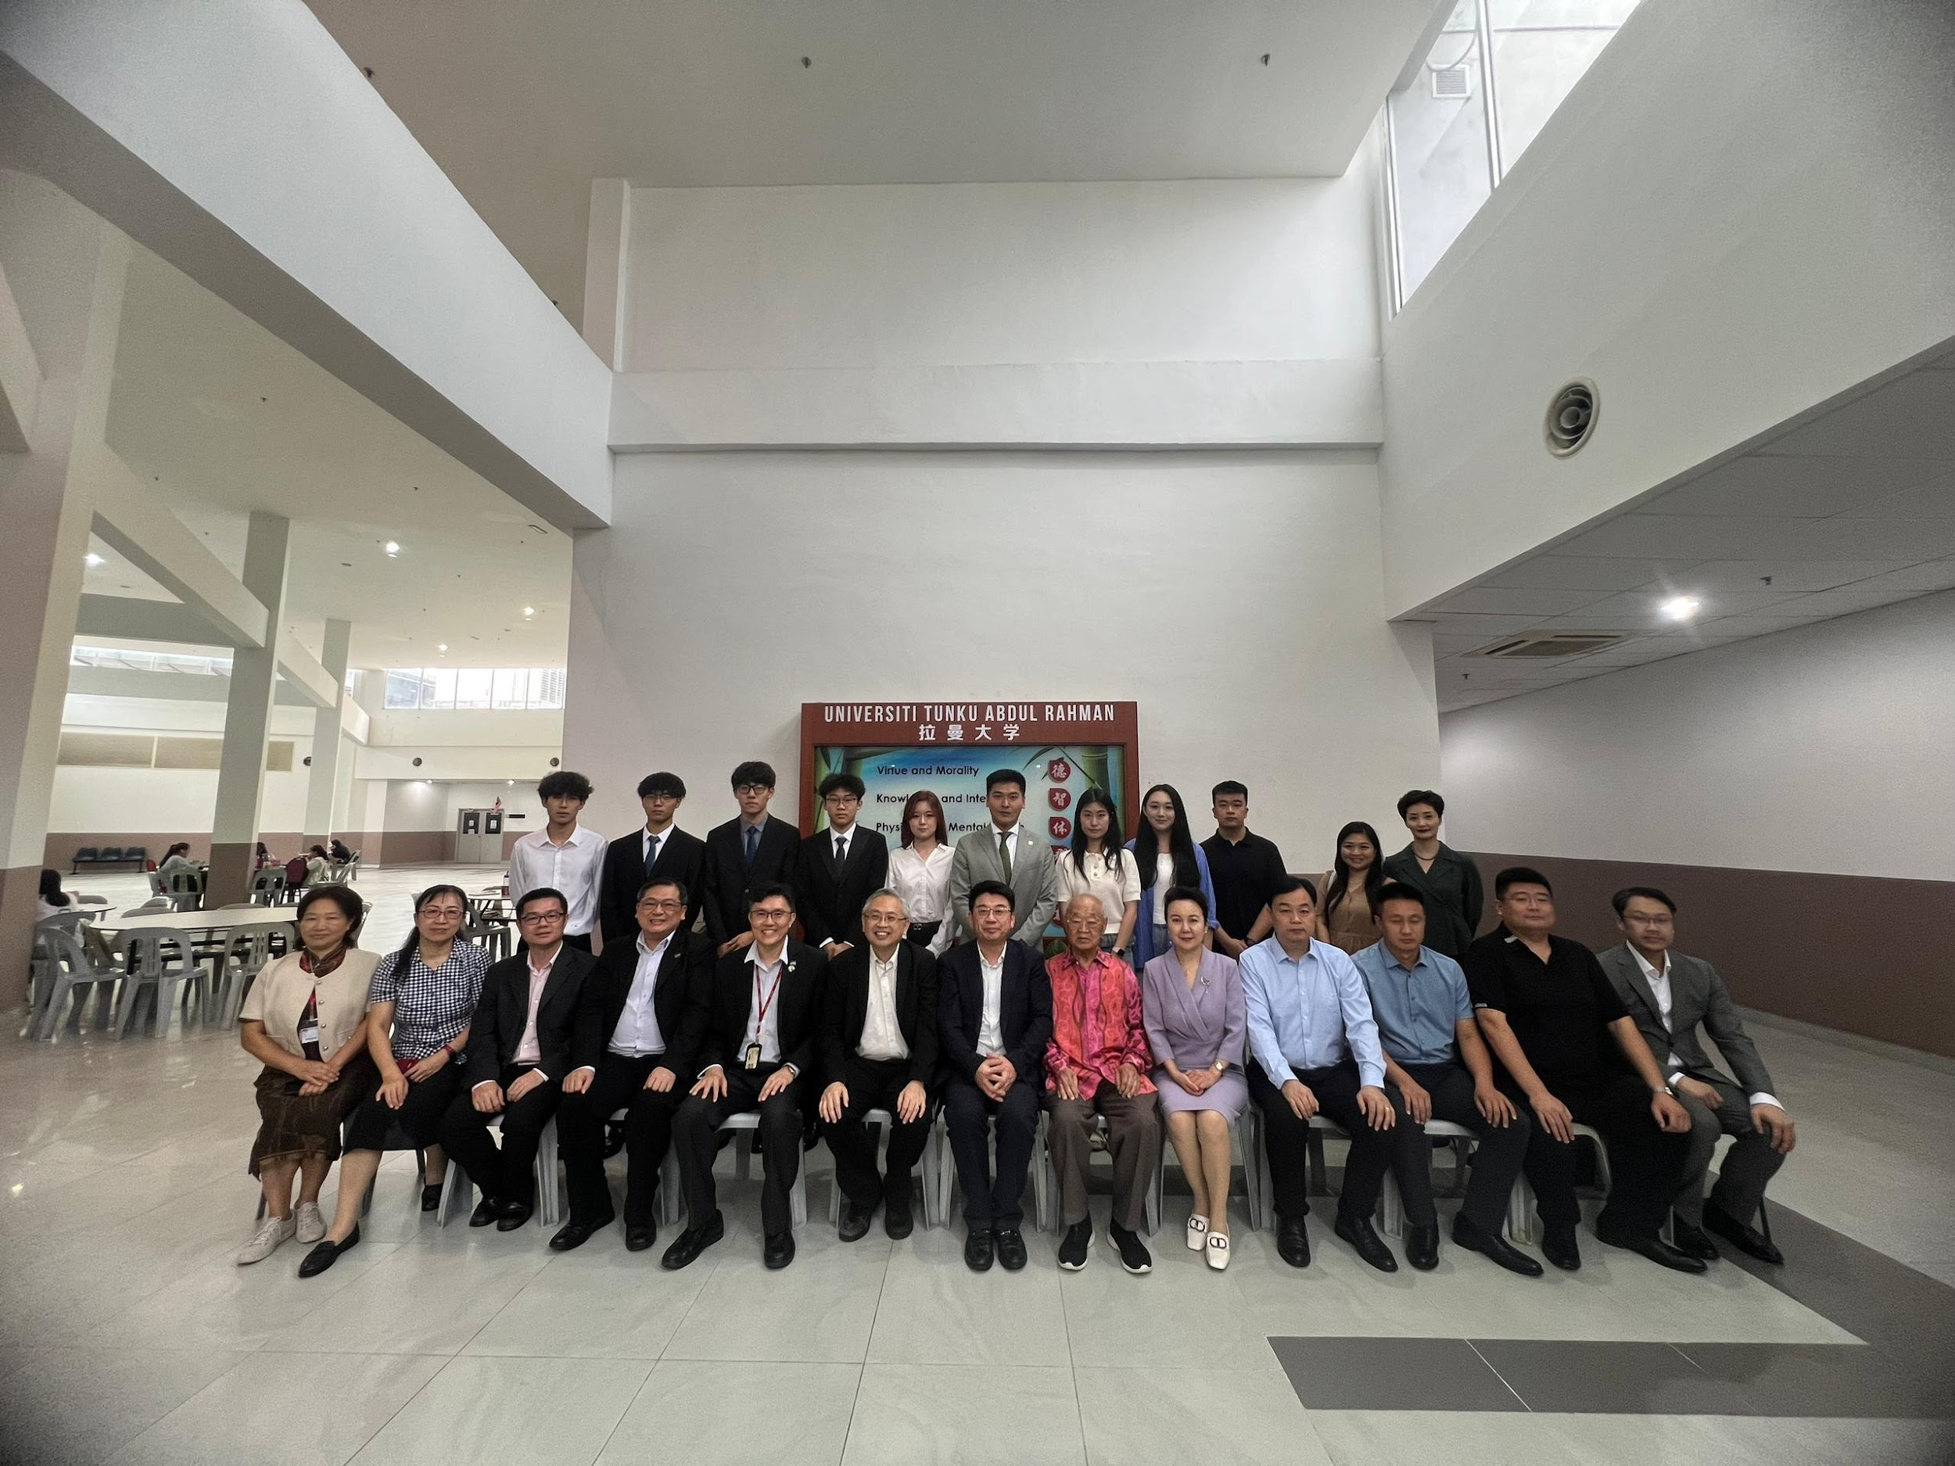

A group photo session marking the success of a fruitful visit

On 9 September 2024, UTAR welcomed a delegation from the Shandong Federation of Returned Overseas Chinese, China to its Sungai Long Campus. The visit aimed to explore opportunities for partnership and set the stage for future collaboration between the institutions.

The delegations were All-China Federation of Returned Overseas Chinese Vice Chairman and Shandong Province Returned Overseas Chinese Federation Chairman Mr Li Xingyu, China-ASEAN Business Association Chairman Tan Sri Lim Gait Tong, Shandong Province Returned Overseas Chinese Federation Secretary General Ms Lu Yazhen and Deputy Director Ms Mao Dongmei, Returned Overseas Chinese Federation of Rizhao City, Shandong Province Chairman Mr Song Qiang, Returned Overseas Chinese Federation of Heze City, Shandong Province Chairman Ms Guo Hui, Shandong Academy of Human Resource Industry in The Association of Southeast Asian Nations Director and Shandong Noble Education Technology Group Co., Ltd. Chairman and General Manager Mr Liu Yadong and Under Secretary General Mr Zhang Xu, Shandong Overseas Chinese Cross border E-commerce Group Co., Ltd CEO Mr Feng Pu Yuan, Shandong PuXuan Trading Co., Ltd CEO Ms Zhang Xuan, Linyi Zhongke Xinhua New Materials Technology Co., Ltd. CEO Mr Wang Xin Long and eight exchange students from Heze, China who studied in various local universities.

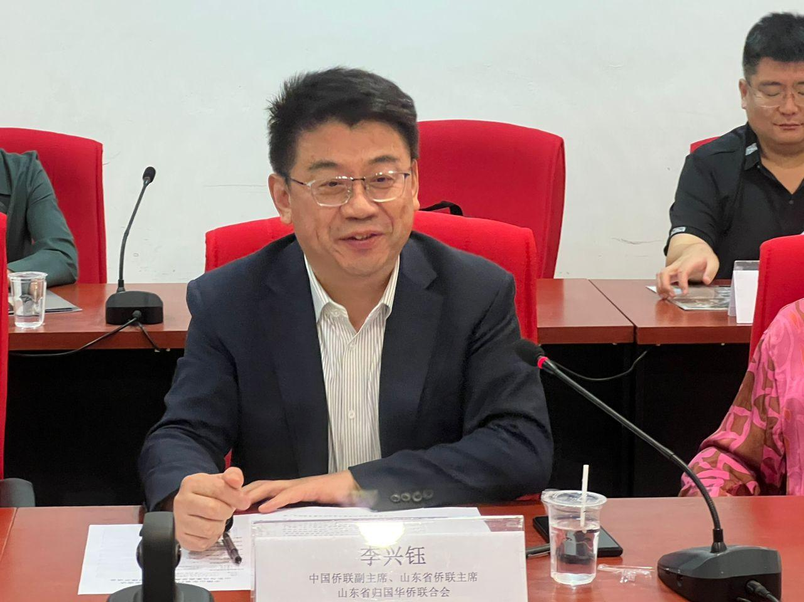

Mr Li

Welcoming them were UTAR President Ir Prof Dato’ Dr Ewe Hong Tat, Vice President for Internationalisation and Academic Development Ir Prof Dr Goi Bok Min, Institute of Chinese Studies Dean and UTAR Confucius Institute Director (Malaysia) Assoc Prof Dr Chong Siou Wei, UTAR Confucius Institute Director (China) Prof Ma Yingxin, Office of International Affairs (OIA) Director Assoc Prof Dr Lai Soon Onn and Assistant Manager Ms Wang Yiling.

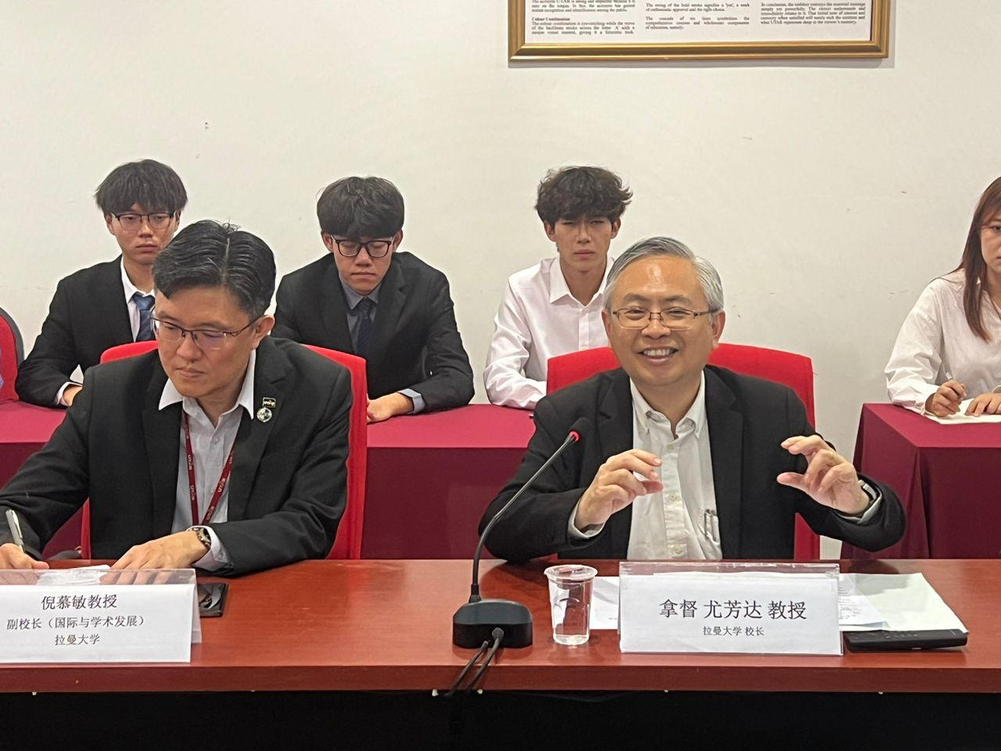

Front row: Prof Goi (left) and Prof Dato’ Ewe

A discussion was held, in which the parties briefly introduced their respective institutions and explored possibilities for future collaborations. Additionally, a memorandum of understanding (MoU) exchange ceremony took place between UTAR and Shandong Noble Education Technology Group Co., Ltd., China for the joint establishment of China-ASEAN International Exchange and Cooperation Centre for Outstanding Talents. The MoU was pre-signed by Prof Dato’ Ewe and Mr Liu on 6 May 2024.

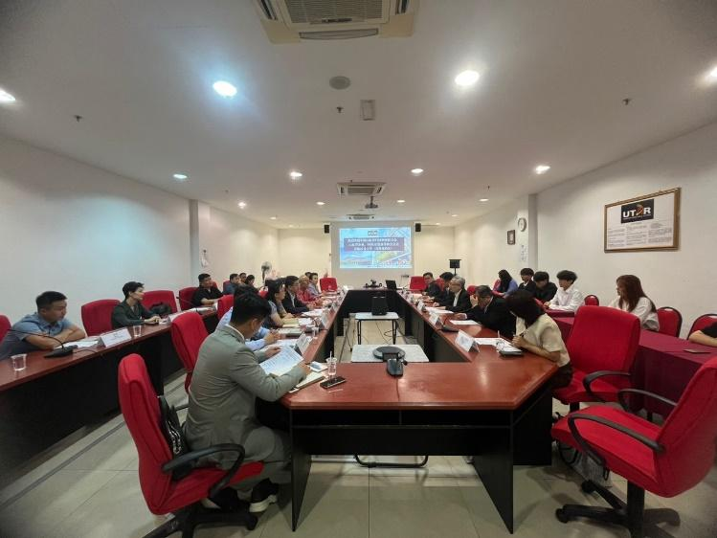

Ongoing discussion

The visit concluded with a souvenir exchange and a group photography session, bringing the successful and insightful day to a close.

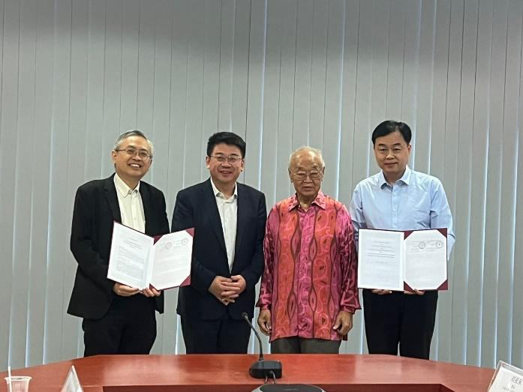

From left: Prof Dato’ Ewe, Mr Li, Tan Sri Lim and Mr Liu during the MoU exchange ceremony

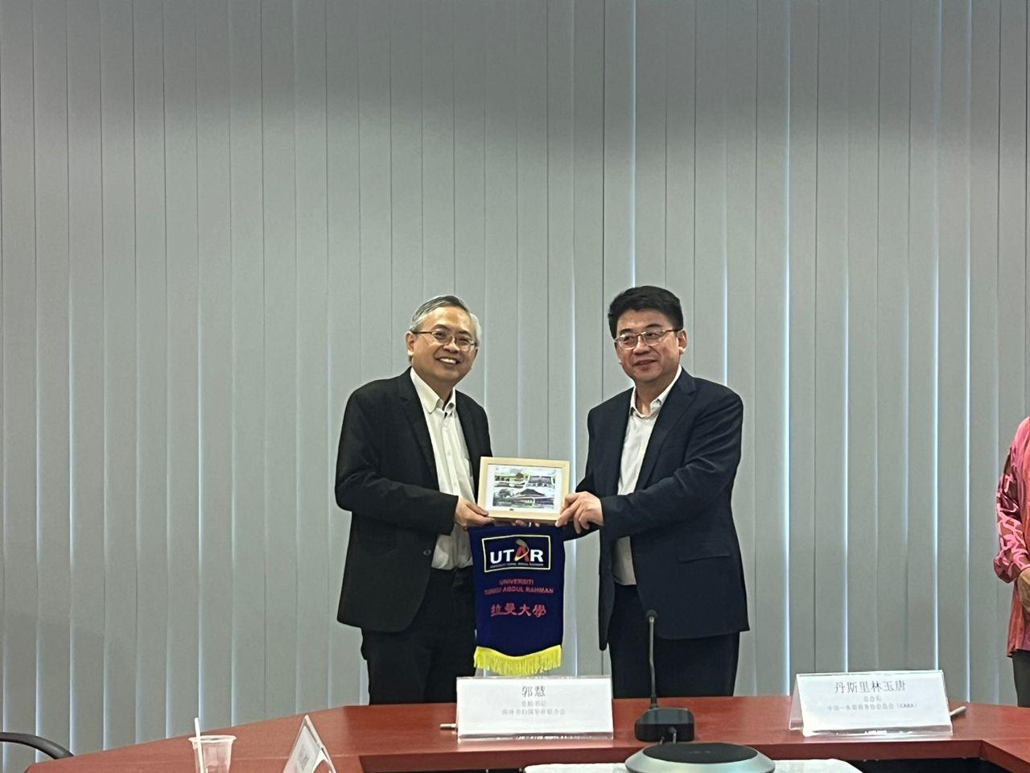 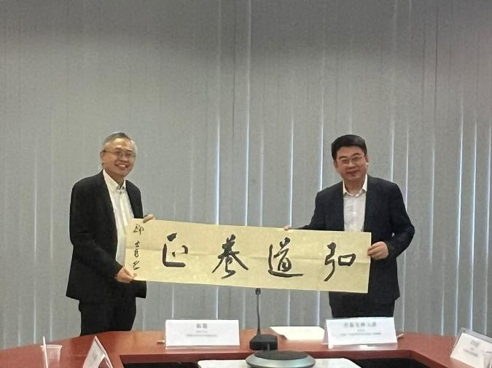

Prof Dato’ Ewe (left) and Mr Li exchanging tokens of appreciation