**Bargain Basement contributes to deserving beneficiaries**

With a heart for the community, Bargain Basement recently donated a total of RM20,000 from its proceeds to various deserving beneficiaries, channelled through Bargain Basement@UTAR at both campuses. The selected charitable organisations included Pertubuhan Kebajikan Orang Tua Wen Xin, Pertubuhan Kebajikan Orang Tua dan Kanak-kanak Cacat Shan Ai, Xiao Xin Serdang Old Folks Home, Beautiful Gate Foundation for the Disabled and Persatuan Pencinta Haiwan Jalanan Kampar. Part of the contribution was also donated to the UTAR Hospital Project, Student Welfare Fund and Student Activity Fund.

A simple presentation session took place in August 2024 at the respective charitable organisations and Bargain Basement@UTAR at the Kampar Campus outlet. Every Bargain Basement supporter—dedicated donors and customers—contributed to the Proceeds Giving, and their support has positively impacted many causes.

Bargain Basement is a community initiative founded by IOI Foundation Executive Director Datin Joanne Wong Su-Ching under the IOI Foundation, formerly known as Yayasan Tan Sri Lee Shin Cheng. It offers high-quality used or new items at affordable prices, with proceeds donated to deserving beneficiaries. Launched in 2016, the initiative continues to thrive.

UTAR has had the opportunity to collaborate with the IOI Foundation and participate in the Bargain Basement Project since 2022, promoting the United Nations’ Sustainable Development Goal 12, which aims to ensure sustainable consumption and production patterns. The collaboration also led to the opening of the third and fourth outlets at UTAR Kampar and Sungai Long Campuses, respectively. These outlets are currently operated by students from the Department of Student Affairs (DSA) of both campuses.

The Bargain Basement project at UTAR aims to allow students in the Young Entrepreneurs Society, Marketing Society, Logistics & International Shipping Society, and International Friendship Society to experience the practical side of managing business, and handling customers. It will also educate them on charity with proceeds channelled to UTAR Hospital Project and Kampar Charities. Additionally, it also teaches students to declutter their homes and contribute their used and unused items to benefit others.

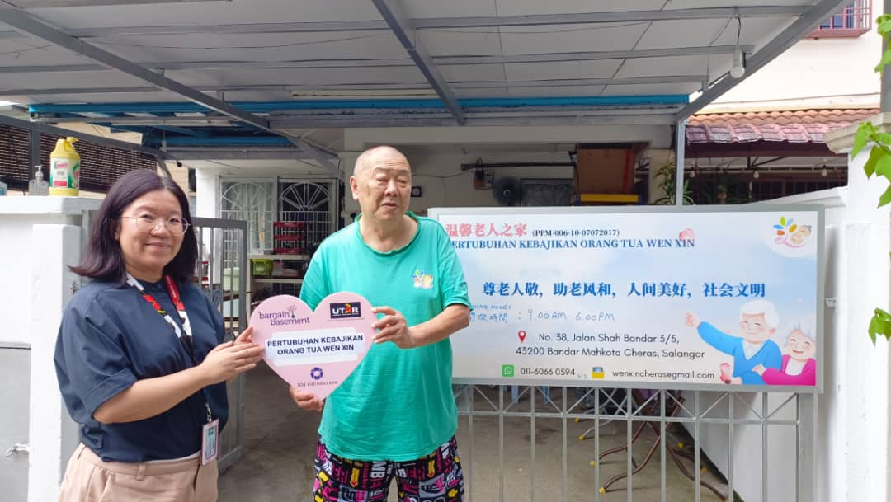

DSA Sungai Long Head Ms Loh Nyuk Leung (left) presenting the donation to the representative from Pertubuhan Kebajikan Orang Tua Wen Xin

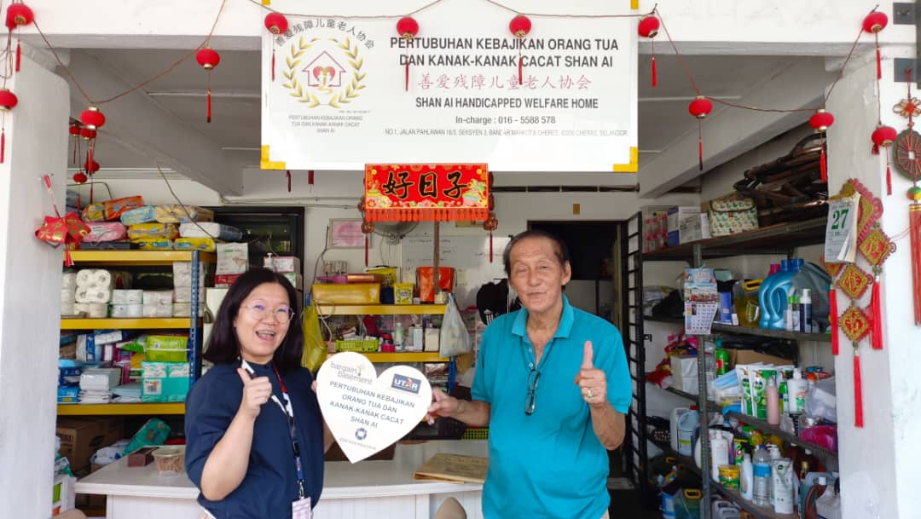

Ms Loh (left) presenting the donation to the representative from Pertubuhan Kebajikan Orang Tua dan Kanak-kanak Cacat Shan Ai

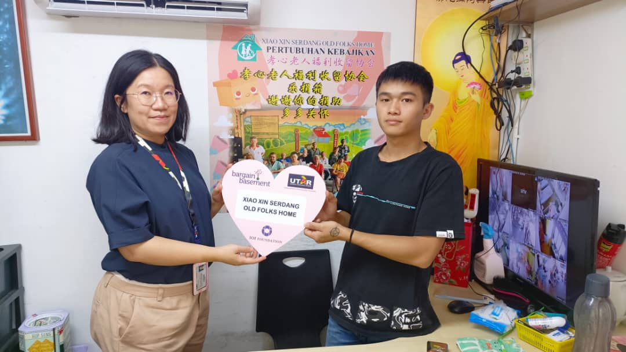

Ms Loh (left) presenting the donation to the representative from Xiao Xin Serdang Old Folks Home

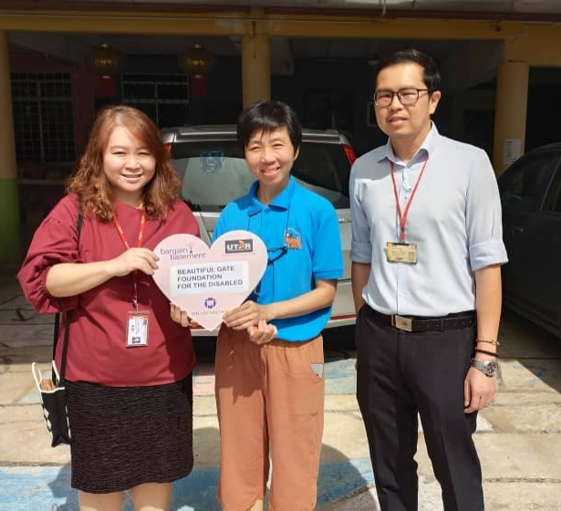

DSA Kampar Head Mr Chiang Jeng Fong (right) presenting the donation to the representative from Beautiful Gate Foundation for the Disabled, accompanied by DSA Kampar staff Ms Ma Foong Mei (left)

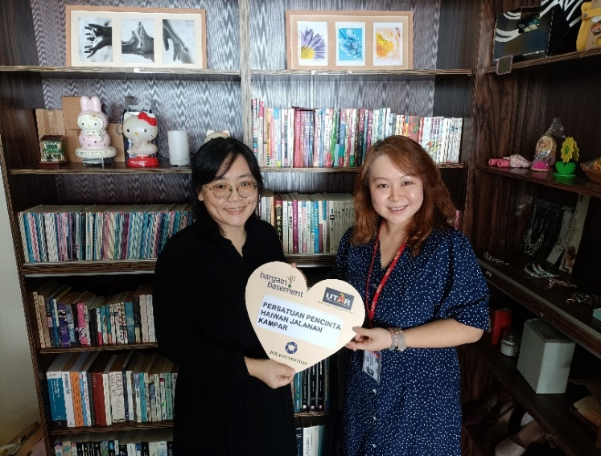

Ms Ma (right) presenting the donation to Persatuan Pencinta Haiwan Jalanan Kampar Chairperson Ms Yvonne Hoh (left)