Honouring long service and celebrating staff excellence at UTAR’s awards ceremony
UTAR celebrated the dedicated service and exceptional achievements of its staff at the UTAR Staff Awards Ceremony 2024, held at Kampar Campus on 4 September 2024. A total of 106 recipients gathered to mark this special occasion.
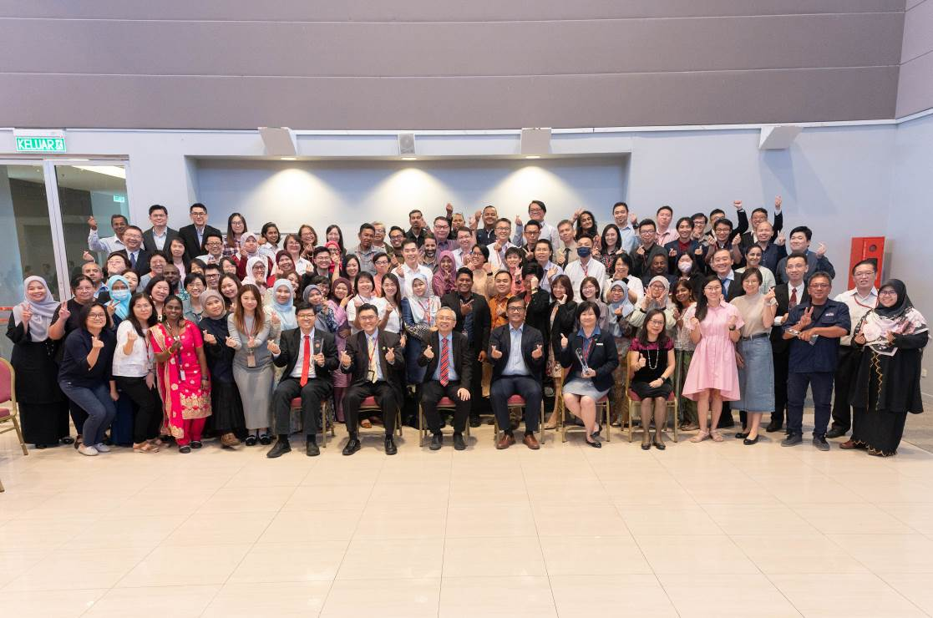
Seated from left: Prof Choong, Prof Goi, Prof Dato’ Ewe, Prof Faidz, Ms Loh and Ms Marchie Lim with recipients of Staff Long Service and Excellence Awards
This annual event was all about recognising the hard work of staff who have been with UTAR for at least ten years as well as honouring academics for their outstanding teaching and research efforts. The event also celebrated staff who have reached the impressive milestone of 20 years of good services.
Leading the event were UTAR President Ir Prof Dato’ Dr Ewe Hong Tat, along with Vice Presidents Ir Prof Dr Goi Bok Min, Prof Ts Dr Faidz bin Abd Rahman, and Prof Dr Choong Chee Keong. Also in attendance were Registrar Ms Loh Siaw Yien, Division of Human Resource Director Ms Marchie Lim Pin Sim, as well as faculty deans, directors, heads of departments, award recipients and staff.
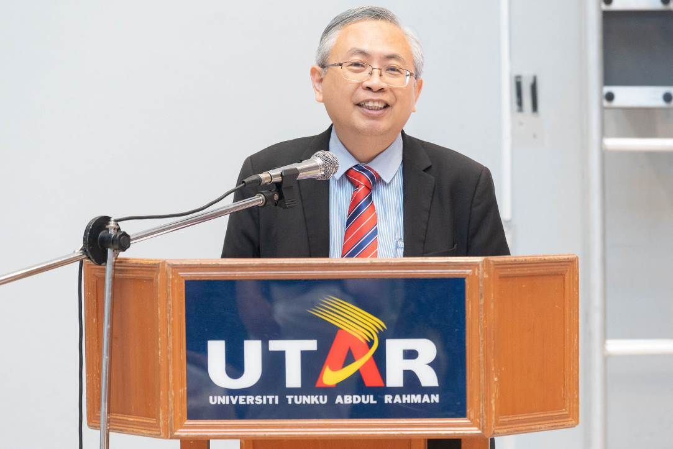
Prof Dato’ Ewe expressing gratitude to all recipients for their dedicated service and contributions to the University
Prof Dato’ Ewe expressed his heartfelt appreciation, and said, “Congratulations to all our award winners today. On behalf of the University, I want to express our heartfelt thanks for your dedication and hard work. Your commitment not only benefits our students but also sets a high standard for excellence in everything we do. As we celebrate your ten and twenty-year milestones, we hope you continue to inspire your colleagues and students to strive for the same level of excellence.”
He added, “Teamwork is crucial for our University’s progress. We must work together to advance our goals and maintain our high standards in teaching, learning, and research. We must all come together, pooling our talents and efforts to ensure the University moves forward towards excellence in teaching, learning, and research. As the proverb goes, ‘Alone, we can do so little; together, we can do so much.’ We must always remember to work in the University’s best interest and for the benefit of our students, who are under our care and guidance. I’m particularly proud to congratulate our Excellence Award winners in Innovation, Research, Teaching, E-Learning, and Staff Service. May your achievements inspire others to reach new heights and foster even greater successes.”
The ceremony’s highlight was the presentation of Long Service Awards to staff from both Kampar and Sungai Long Campuses. Each recipient was honoured with a beautiful crystal trophy, a token of their valued contributions.
Ms Christina John, a recipient of the Ten Years Long Service Award and Senior Lecturer at the Centre for Foundation Studies, Sungai Long Campus, said, “Witnessing students grow and succeed has been the most rewarding part of my decade at UTAR. Watching them evolve into successful professionals is incredibly fulfilling and has made my work feel more meaningful and connected to a larger purpose. Additionally, building relationships with colleagues and contributing to the University’s development has been deeply satisfying. My decade at UTAR has fostered a profound sense of community and accomplishment, leading to significant professional and personal growth.”
Another recipient of the Ten Years Long Service Award, Assoc Prof Dr Olanrewaju Abdullateef Ashola from the Faculty of Engineering and Green Technology (FEGT), said, “The most rewarding aspect of my time at UTAR has been engaging in meaningful research that benefits both the academic community and beyond. Securing government-sponsored grants has allowed me to tackle important issues and collaborate with colleagues and students locally and internationally. UTAR’s supportive environment has fostered my growth as an educator and researcher, deepening my passion for academia. Watching students receive their scrolls on graduation day and working with leading publishers has been incredibly fulfilling. The chance to make a significant impact through research and to see the University achieve recognition both locally and globally has been truly inspiring. Thank you, UTAR, for this opportunity.”
This year, more than 20 UTAR staff members received the Twenty Years Long Service Award. Among those honoured were Prof Dr Choong Chee Keong, Ms Loh Siaw Yen, Prof Ts Dr Liew Soung Yue, Ms Yeoh Meng Chin, Ms Loh Nyuk Leung, Mr Tiong Chiong Hieng, Mr Zakaria bin Alias, and several others.
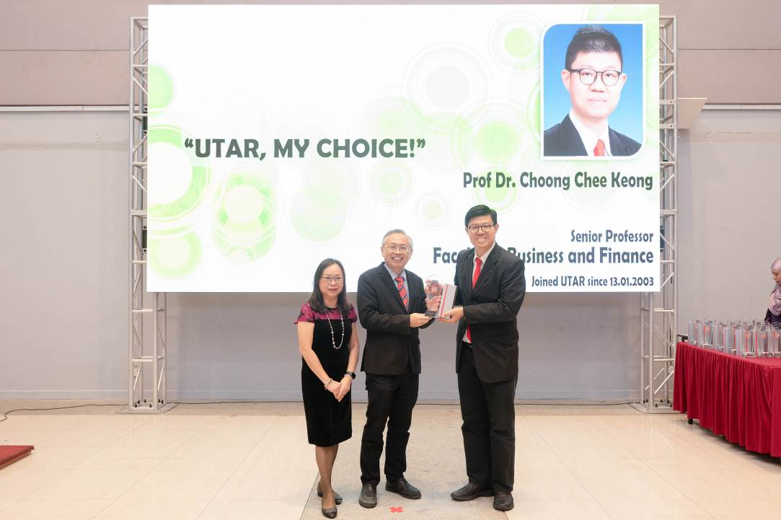
Prof Choong (right) receiving his award from Prof Dato’ Ewe (centre) and Ms Marchie Lim
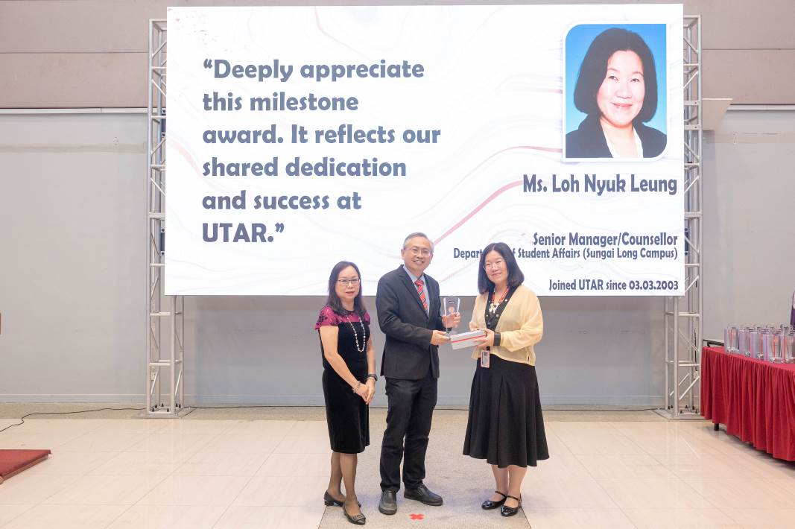
Ms Loh Nyuk Leung (right) receiving her award from Prof Dato’ Ewe (centre) and Ms Marchie Lim
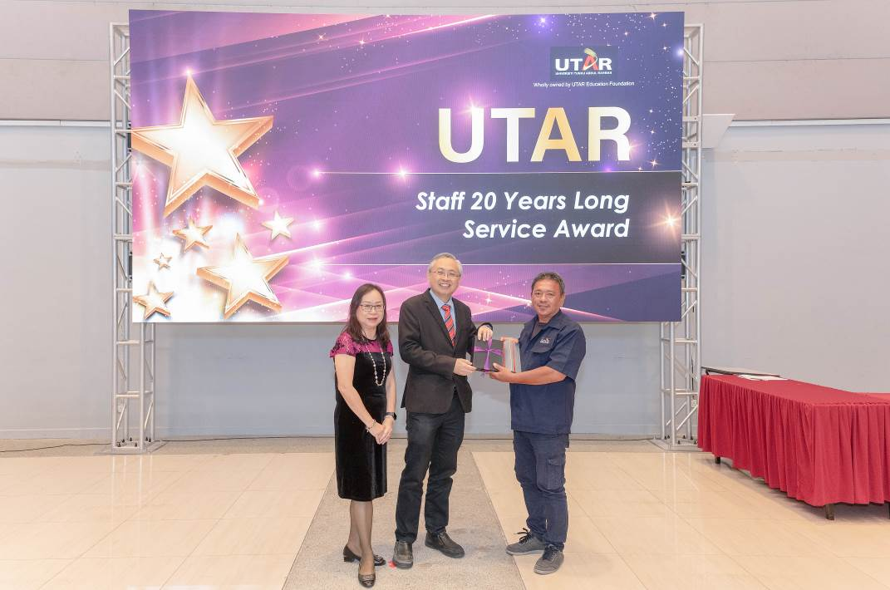
Mr Zakaria (right) receiving his award from Prof Dato’ Ewe (centre) and Ms Marchie Lim
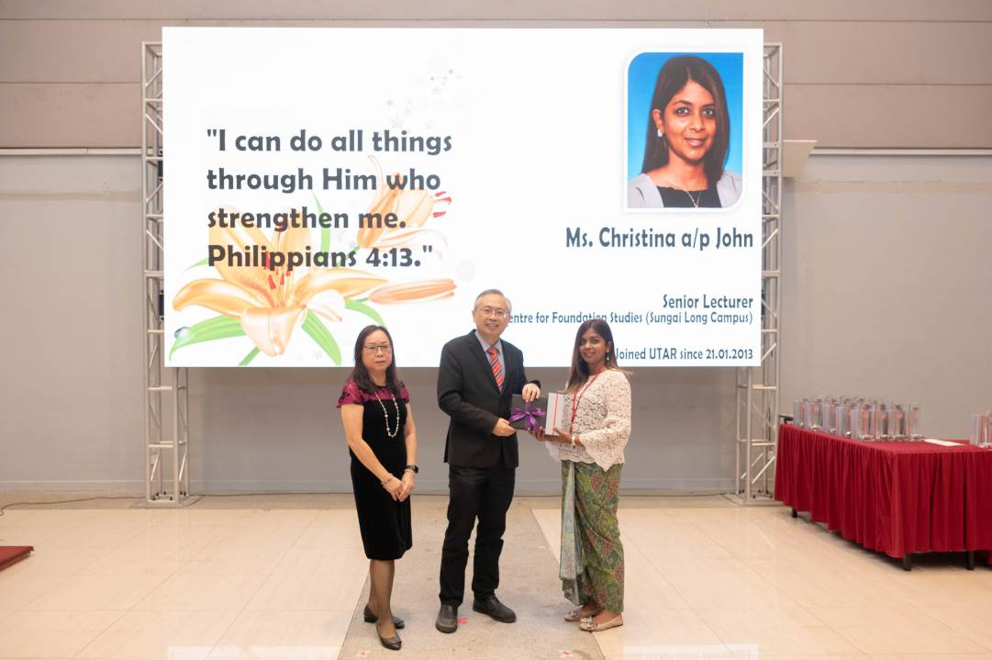
Ms Christina (right) receiving her award from Prof Dato’ Ewe (centre) and Ms Marchie Lim
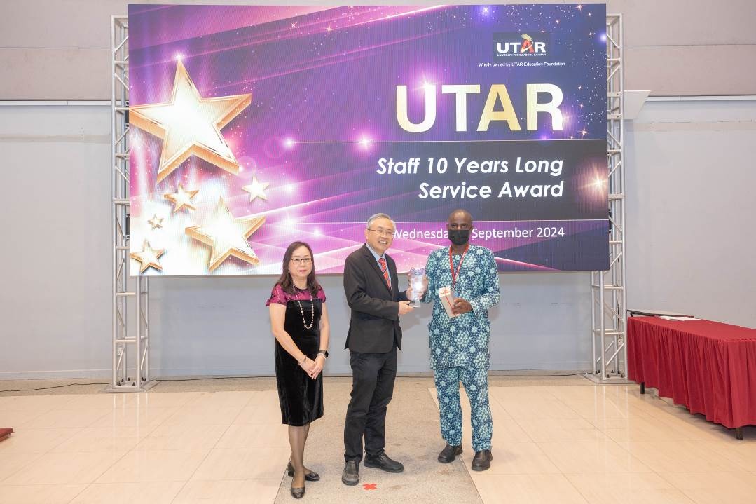
Dr Olanrewaju (right) receiving his award from Prof Dato’ Ewe (centre) and Ms Marchie Lim
Next up was the highlight of the morning, the Excellence Awards presentation. Recipients of the E-Learning Excellence Award, Innovation Excellence Award, Teaching Excellence Award, Staff Service Excellence Award, and Research Excellence Award, each received RM1,000 in cash, a certificate, and a trophy.
Meanwhile, the research centres honoured with the UTAR Research Centre Excellence Awards were granted a total of RM60,000. The Dr Wu Lien-Teh Centre for Research in Communicable Diseases, led by Chairperson Dr Ng Hien Fuh, received RM50,000 and a certificate. Following this, the Centre for Applied Psychology, under the leadership of Chairperson Dr Nurul Iman binti Abdul Jalil, was awarded RM10,000 and a certificate.
In addition, this year’s special award, the UTAR Top Researcher Award 2023, was presented to Prof Ts Dr Lim Eng Hock from the Lee Kong Chian Faculty of Engineering and Science. Prof Lim received a cash prize of RM 3,000, along with a certificate and a trophy.
The list of Excellence Awards winners is as follows:
UTAR E-learning Excellence Award (in no particular order)
1. Ir Dr Chee Pei Song, Lee Kong Chian Faculty of Engineering and Science – Category of Science, Engineering, and Technology
2. Ms Lee Cin Dee, Centre for Foundation Studies – Category of Science, Engineering, and Technology
3. Dr Azeyan binti Awee, Faculty of Business and Finance – Category of Management, Accountancy, Business, and Finance
4. Prof Dr N. Veera Sekaran a/l V. Nadarajan, M. Kandiah Faculty of Medicine and Health Sciences – Category of Health Sciences and Medicine
5. Puan Nurzanatul Amira binti Azizan, Department of Soft Skills Competency – Category of Social Science, Arts and Humanity
UTAR Teaching Excellence Award (in no particular order)
Category of Pure Sciences
1. Gs Ts Amelia Chiang Kar Mun, Centre for Foundation Studies (Sungai Long Campus)
2. Ms Chia Phee Phee, Centre for Foundation Studies (Kampar Campus)
Category of Applied Sciences and Technology
3. Ts Dr Lee Chen Kang, Lee Kong Chian Faculty of Engineering and Science
4. Ms Tan Lyk Yin, Faculty of Information and Communication Technology
Category of Engineering
5. Ts Dr Lee Jer Vui, Lee Kong Chian Faculty of Engineering and Science
6. Dr Leong Sim Siong, Faculty of Engineering and Green Technology
Category of Medicine and Health Sciences
7. Dr Avneet Kaur, M. Kandiah Faculty of Medicine and Health Sciences
Category of Communication, Business and Management
8. Dr Tee Peck Ling, Faculty of Accountancy and Management
9. Ms Foo Pik Yin, Faculty of Business and Finance
Category of Arts & Creativity
10. Ts Ng Perng Jeu, Faculty of Creative Industries
11. Puan Suriati binti Mohd Jaafar, Centre for Foundation Studies (Sungai Long Campus)
Category of Arts and Social Science
12. Dr Lew Hoi Len, Institute of Chinese Studies

UTAR Innovation Excellence Award (in no particular order)
1. Ir Ts Dr Yew Ming Kun, Lee Kong Chian Faculty of Engineering and Science

UTAR Staff Service Excellence Award (in no particular order)
1. Puan Nur Amirah binti Mohamad Nor, Centre for Multimedia Production and Services
2. Ms Chin Mei Jun, Registrar’s Office

UTAR Research Excellence Award (in no particular order)
1. Dr Steven Lim, Lee Kong Chian Faculty of Engineering and Science – Category of Science, Engineering, Technology and Medicine

UTAR Research Centre Excellence Award (in no particular order)
1. Dr Wu Lien-Teh Centre for Research in Communicable Diseases - Dr Ng Hien Fuh, Chairperson
2. Centre for Applied Psychology - Dr Nurul Iman binti Abdul Jalil, Chairperson

UTAR Top Researcher Award 2023
1. Prof Ts Dr Lim Eng Hock, Lee Kong Chian Faculty of Engineering and Science

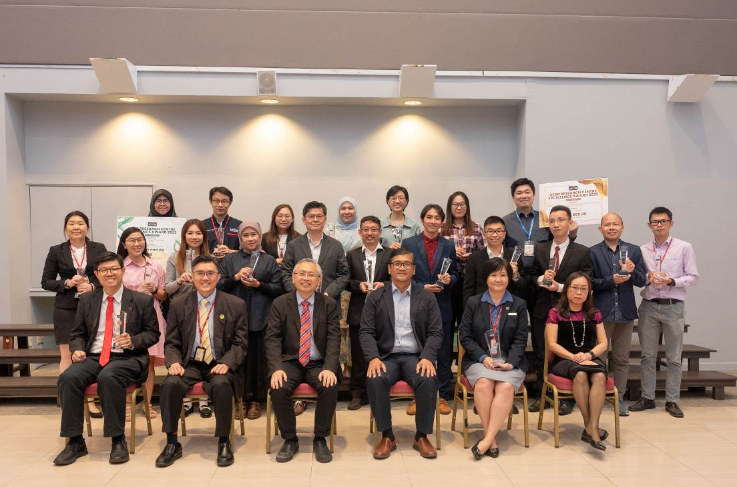
Seated from left: Prof Choong, Prof Goi, Prof Dato’ Ewe, Prof Faidz, Ms Loh and Ms Marchie Lim with the recipients of the Excellence Award
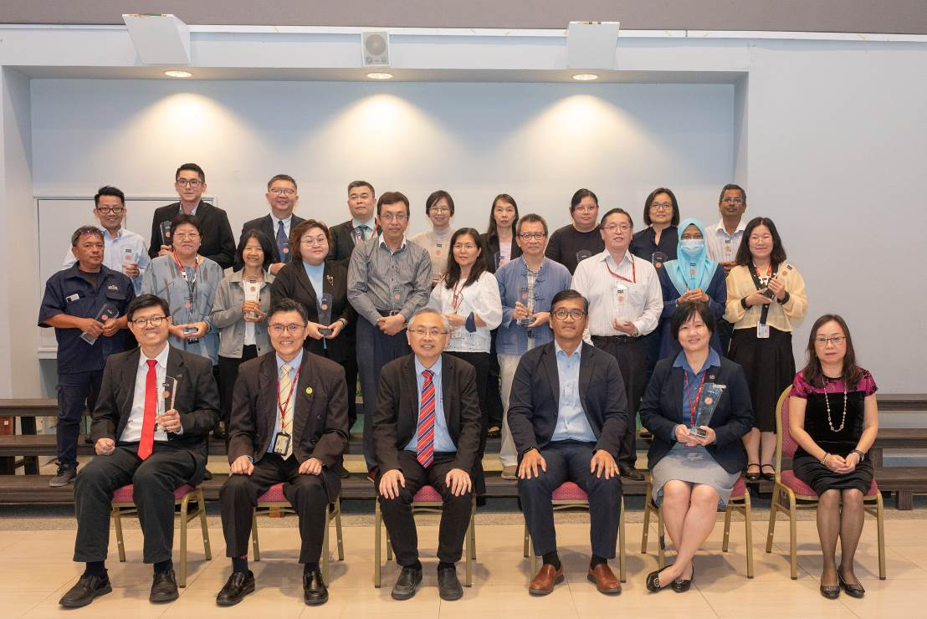
Seated from left: Prof Choong, Prof Goi, Prof Dato’ Ewe, Prof Faidz, Ms Loh and Ms Marchie Lim with recipients of the Twenty Years Staff Long Service Award
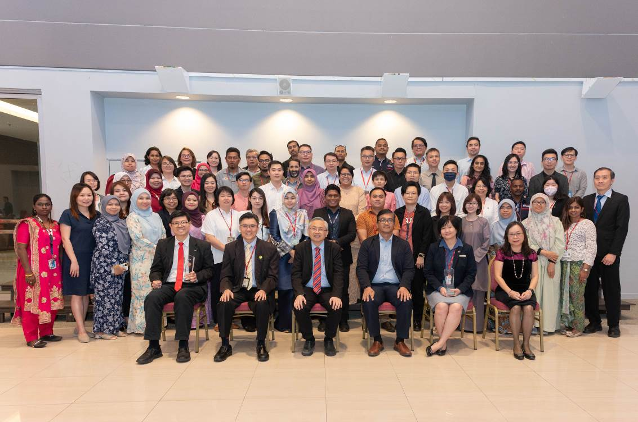
Seated from left: Prof Choong, Prof Goi, Prof Dato’ Ewe, Prof Faidz, Ms Loh and Ms Marchie Lim with the recipients of the Ten Years Staff Long Service Award

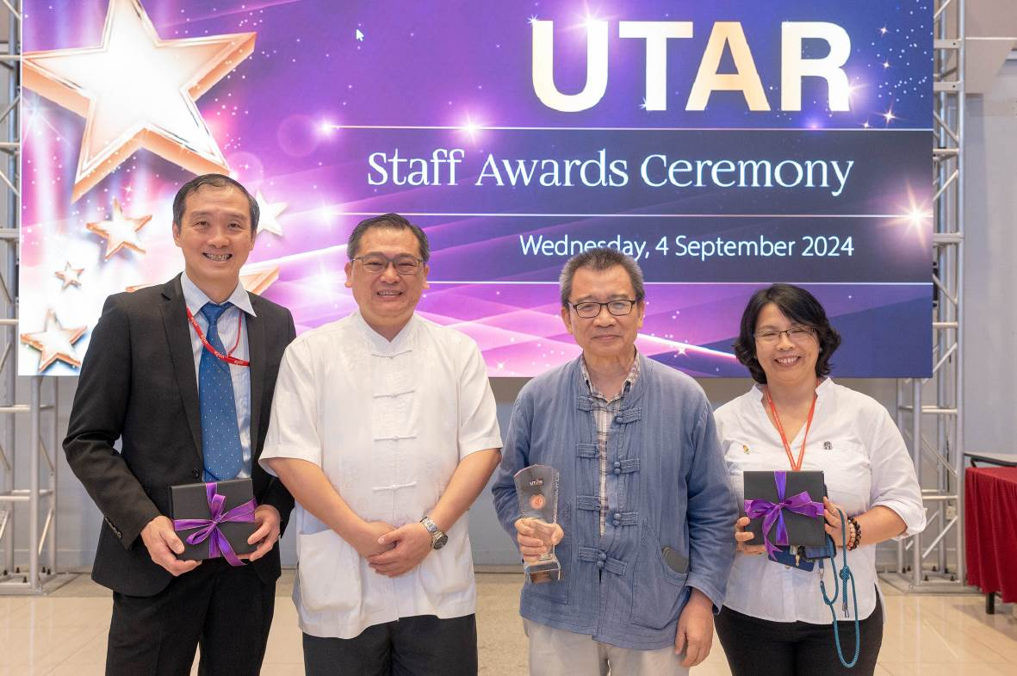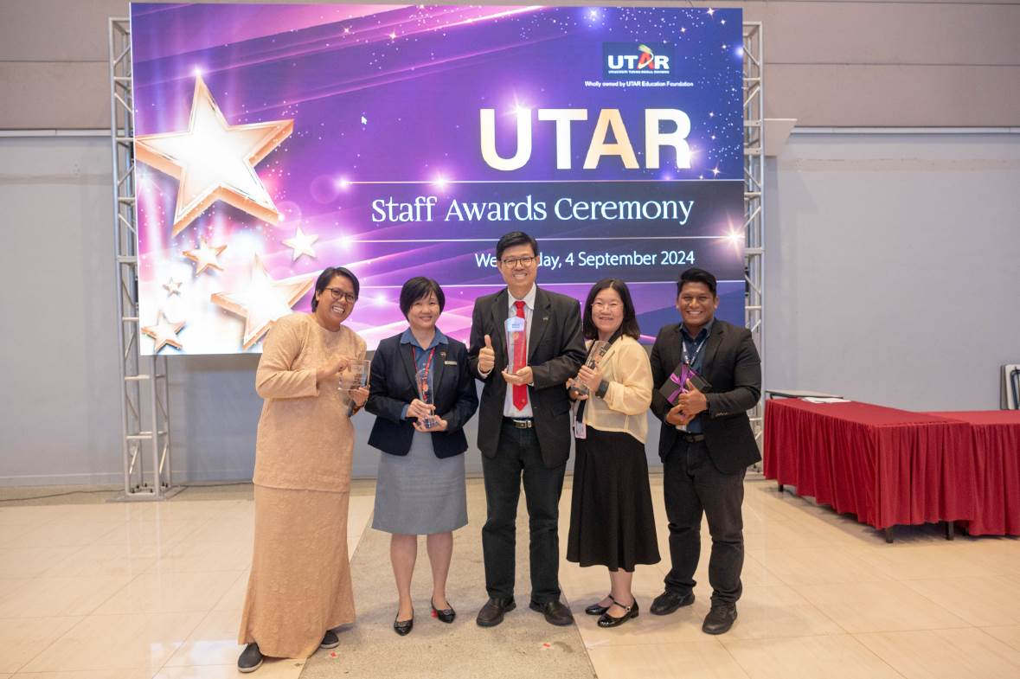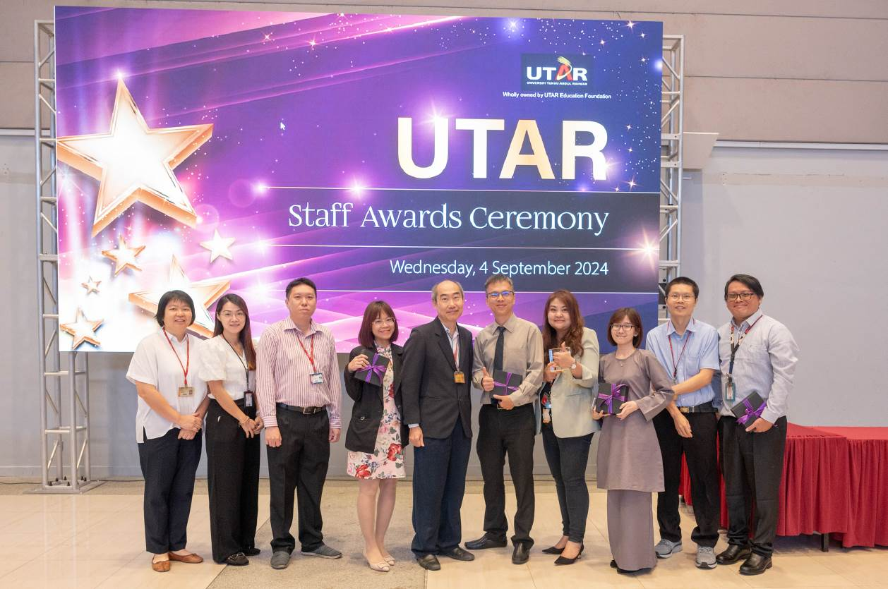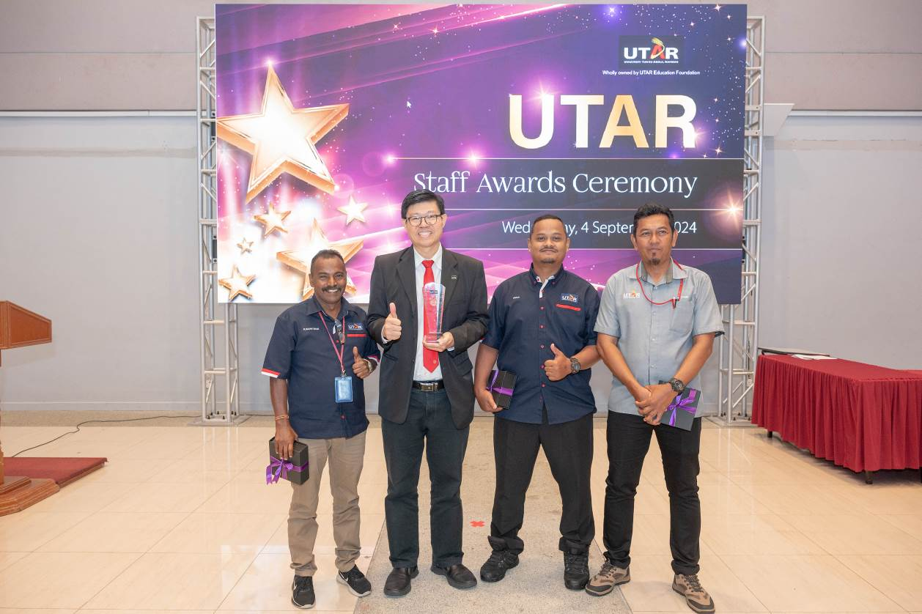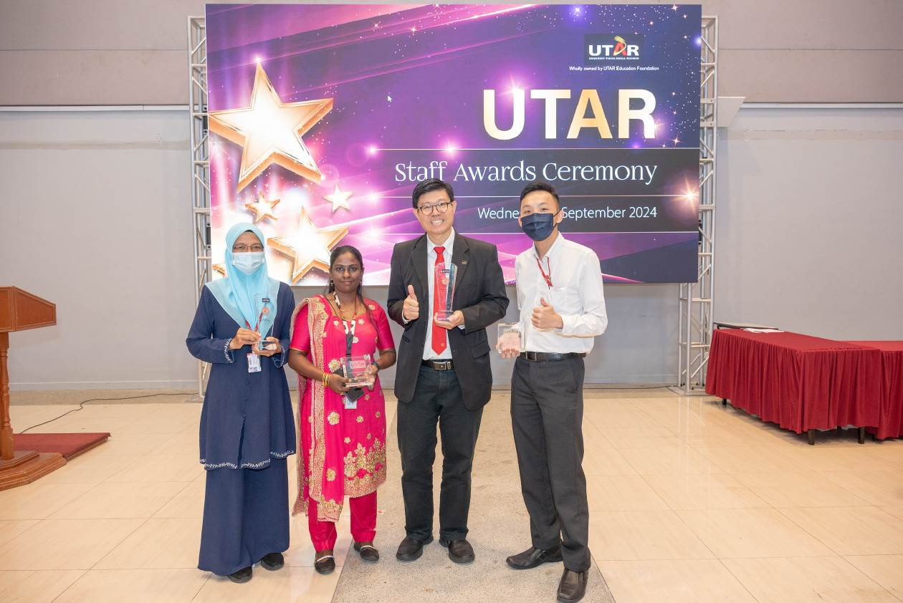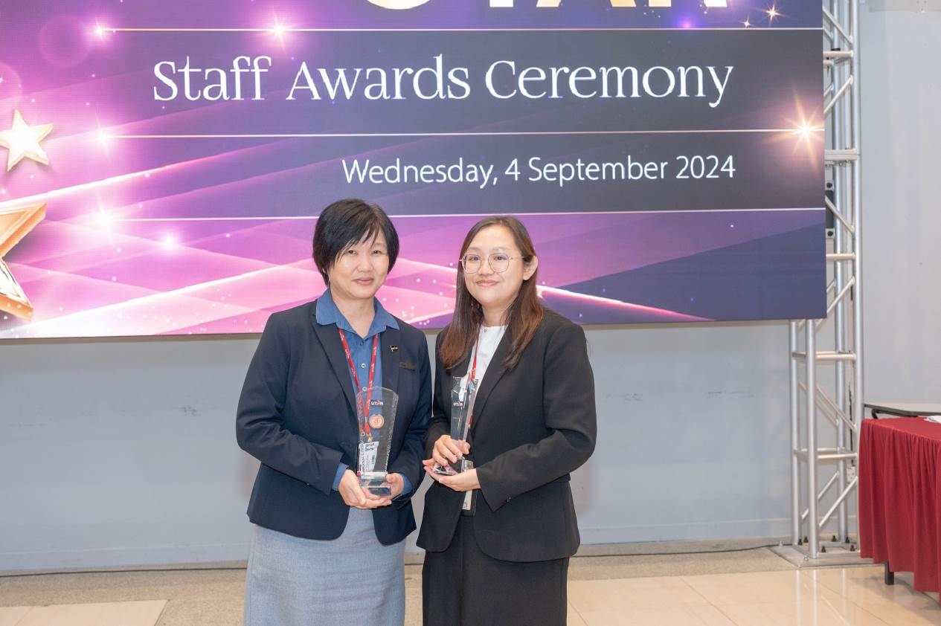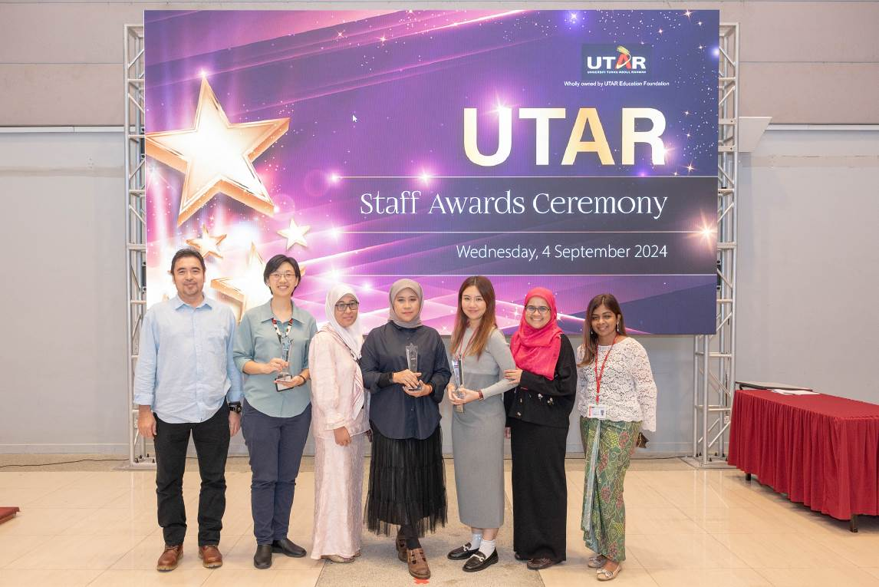
Some happy glimpses of award recipients at the Staff Awards Ceremony
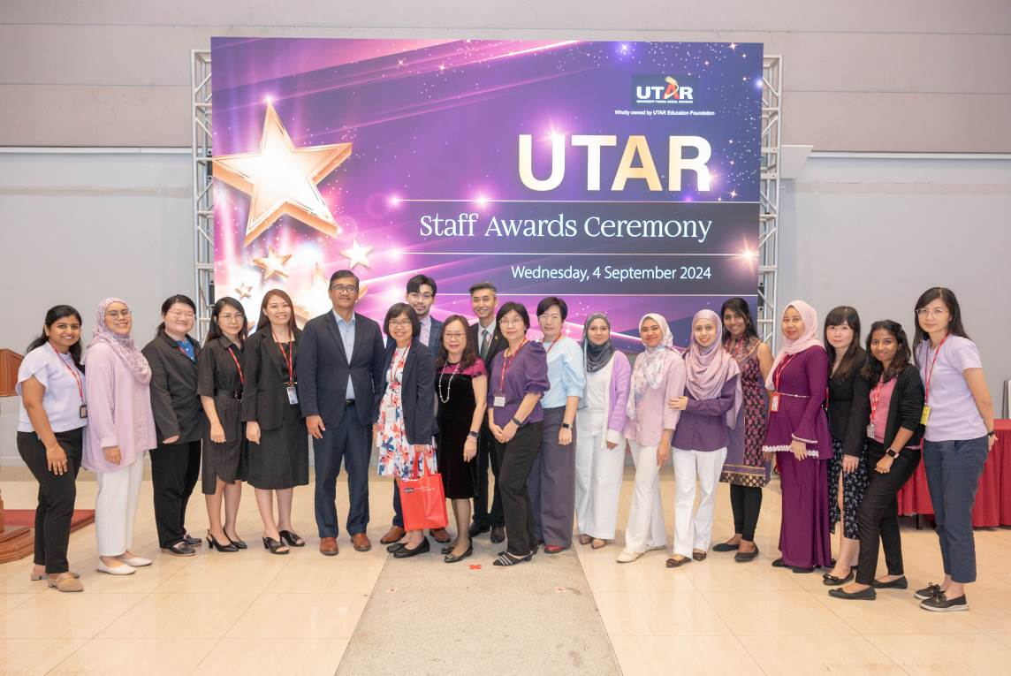
Thank you to the Division of Human Resources and the University Event Committee for organising a memorable Staff Awards Ceremony for UTAR staff
Click here (hyperlink) to see all the photos –(will be done by DCCPR)

