**UTAR hosts MoU signing ceremony between AAET and CAE, and joint seminar on Chinese Medicine**

UTAR hosted a momentous visit from the Chinese Academy of Engineering (CAE) on 7 September 2024 at its Kampar Campus. The delegation was warmly welcomed by the President of the ASEAN Academy of Engineering and Technology (AAET) and the President of UTAR, Ir Prof Dato’ Dr Ewe Hong Tat. A key feature of the event was the signing of a memorandum of understanding (MoU) between AAET and CAE, which aimed at fostering closer academic and technological collaborations.

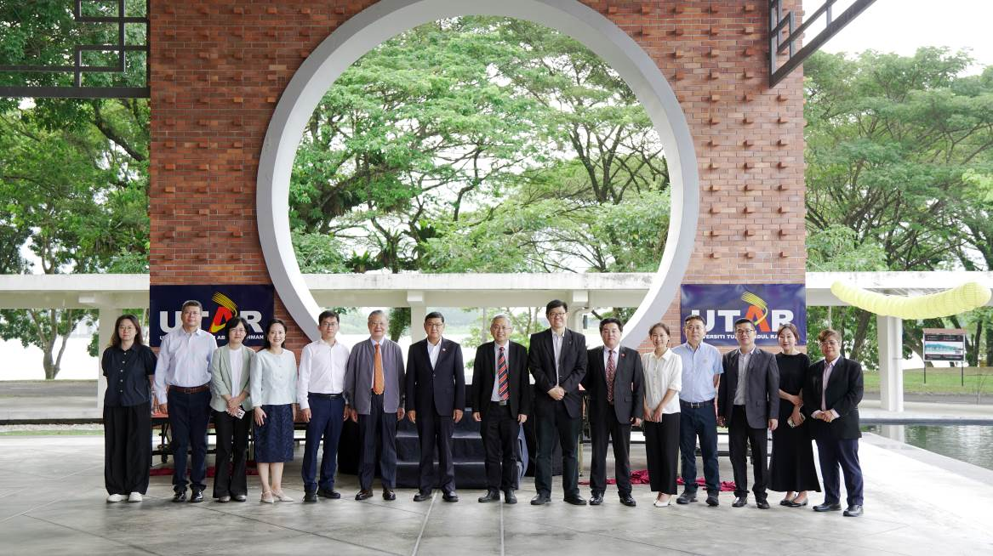

From left: Dr Liang Xue, Prof Cui, Prof Wang Ji, Prof Dr Yang Hui Ying, Dr Jiang Shukai, Prof Wang Qi, Prof Li, Prof Dato’ Ewe, Prof Choong, Mr Tian Qi, Dr Liu Chang, Dr Yang Zheng, Dr Lai, Dr Chen and Dr Fok

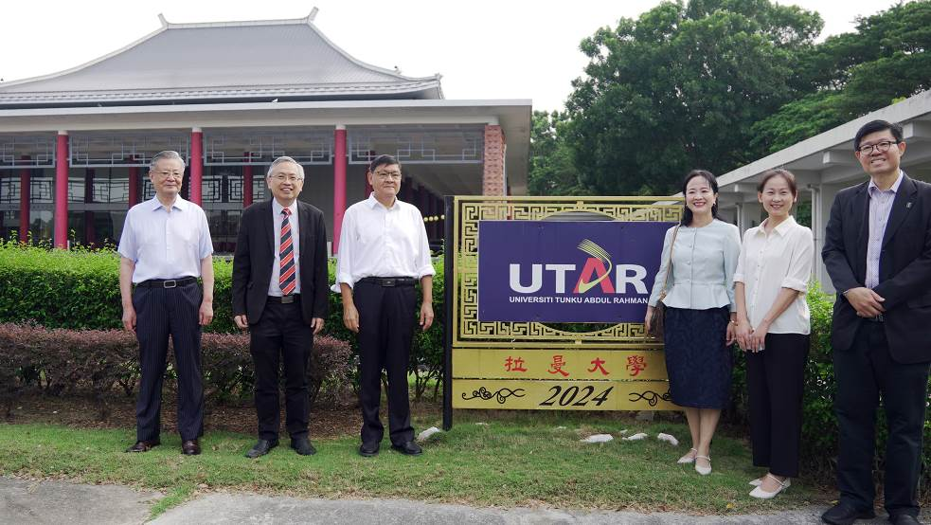

From left: Prof Wang Qi, Prof Dato’ Ewe, Prof Li, Prof Dr Yang Hui Ying, Dr Liu Chang and Prof Choong at Dewan Tun Dr Ling Liong Sik, UTAR Kampar Campus

The CAE delegation, one of China’s most prestigious institutions in engineering and technology, was led by CAE President Prof Li Xiaohong and included Director-General of the International Cooperation Department Mr Tian Qi, Director of the General Affairs Office Dr Jiang Shukai, Division Director of International Cooperation Department Dr Liu Chang, and CAE Member and Tenured Professor at the Beijing University of Chinese Medicine Prof Wang Qi. They were joined by a delegation from the Beijing University of Chinese Medicine, consisting of the Dean of the National Institute of TCM Constitution and Preventive Medicine Prof Wang Ji, Director of the Respiratory Department and Chief Physician at the Third Affiliate Hospital of Beijing University of Chinese Medicine Prof Cui Hongsheng, Assistant Researcher Dr Liang Xue, and lecturer Dr Yang Zheng.

The delegation was cordially received by Prof Dato’ Ewe, accompanied by AAET Council Member and Fellow Prof Dr Yang Hui Ying, UTAR Council Member Mr Hew Fen Yee, UTAR Vice President and AAET Fellow Prof Ts Dr Faidz bin Abd Rahman, UTAR Vice President Prof Dr Choong Chee Keong, along with UTAR academics who are AAET Fellows and Associate Fellows, including Dr Fok Kuk Fai, Ir Prof Dr Ng Choon Aun, Prof Ts Dr Liew Soung Yue, Assoc Prof Dr Yamuna Munusamy, Assoc Prof Dr Ng Hui Fuang, Dr Choo Peng Yin, Assoc Prof ChM Ts Dr Lam Sze Mun, Assoc Prof ChM Ts Dr Sin Jin Chung and Assoc Prof Ts Dr Ooi Boon Yaik.

Also present were Director of UTAR Hospital’s T&CM Centre Assoc Prof Dr Te Kian Keong, Director of UTAR’s Office of International Affairs Assoc Prof Dr Lai Soon Onn, Deputy Director of UTAR’s Office of International Affairs Dr Chen I-Chi, as well as UTAR staff and students.

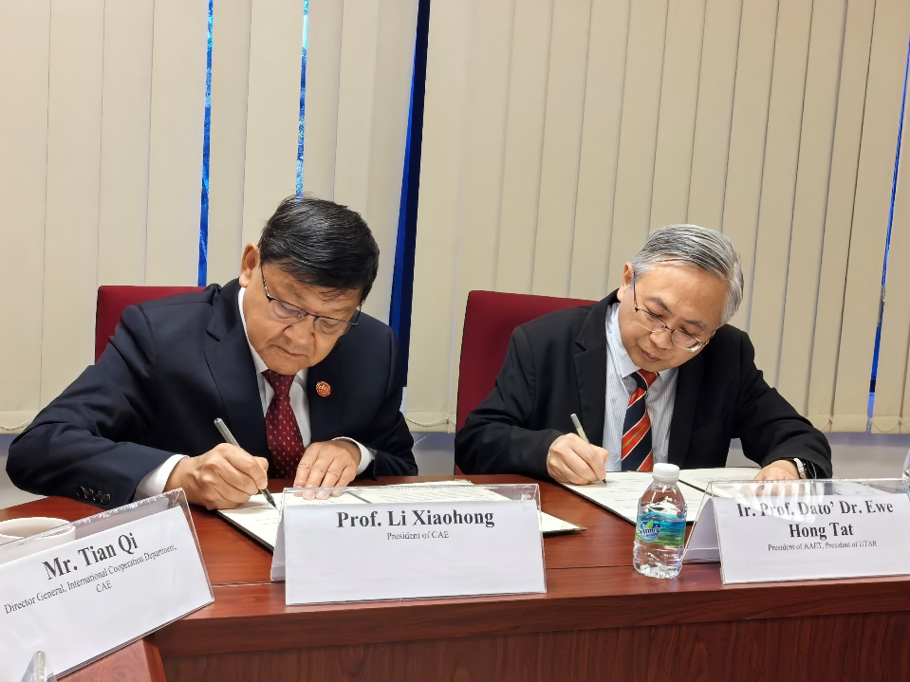

Prof Li (left) and Prof Dato’ Ewe (right) signing the MoU documents

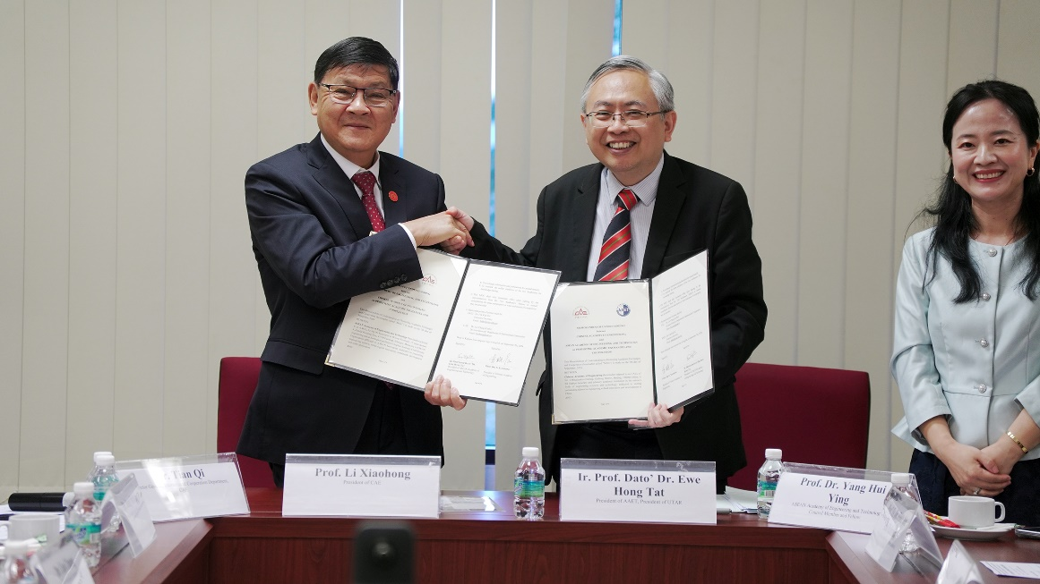

Prof Li (left) and Prof Dato’ Ewe (right) exchanging the signed MoU documents

The MoU signing ceremony was virtually attended by AAET Vice Presidents, Engr Romulo Agatep from the Philippines and Dr Aung Kyaw Myat from Myanmar, along with AAET Council Member from Singapore Prof Chew Yong Tian. The MoU between AAET and CAE, signed by Prof Dato’ Ewe and Prof Li in the presence of representatives from both academies, represents a significant step towards enhancing scientific and technological exchanges between ASEAN and China. It outlines key objectives, such as promoting engineering and technology education, facilitating joint research and workshops, and fostering innovation, particularly among young people in both regions. Additionally, the MoU lays the foundation for future collaborations through seminars, conferences, and the sharing of publications and information between the two institutions.

In his speech, Prof Dato’ Ewe said, “The partnership between AAET and CAE reflects our shared commitment to advancing engineering and technology education, research, and industrial collaboration between ASEAN and China. By joining forces, we generate a synergy that will drive progress and contribute to the development of our regions. I am glad that under the MoU, both parties will work together to promote skills and workforce development in the management, innovation, and development of engineering, science, and technology. This will not only enhance the capabilities of our professionals but also equip the next generation with the tools and knowledge they need to excel in a rapidly evolving global landscape.”

Meanwhile, Prof Li expressed his pleasure in signing the MoU with AAET and thanked Prof Dato’ Ewe and UTAR for their hospitality. He assured that the ties would lead to more fruitful collaborations between the two institutions in the future.

Following the signing, the delegation participated in a dialogue session, where AAET and CAE leaders exchanged ideas and explored potential areas for collaboration. The day’s programme continued with a tour of UTAR Hospital’s Traditional and Complementary Medicine (T&CM) Centre, showcasing UTAR’s commitment to holistic healthcare education.

In the afternoon, UTAR hosted the third joint seminar between AAET and CAE on Chinese Medicine. The seminar began with a welcome address, emphasising the significance of Traditional Chinese Medicine (TCM) as a cultural treasure of China. The joint seminar highlighted TCM’s global recognition for its unique theoretical framework and treatment methods, providing a platform for experts from various regions to share their research and discuss future developments.

A highlight of the seminar was the sharing and presentations of six leading TCM experts from China and Malaysia, namely National Great TCM Master of China Prof Wang Qi, Director of Traditional and Complementary Medicine Division, Kementerian Kesihatan Malaysia Dr Goh Cheng Soon, Prof Wang Ji, Assoc Prof Dr Te, Prof Cui Hongsheng and UTAR M. Kandiah Faculty of Medicine and Health Sciences (MK FMHS) Assoc Prof Dr Yang Zao, who were recognised for their contributions to the field. Their presentations provided in-depth insights and cutting-edge research, elevating the academic rigour of the seminar and contributing to the internationalisation of TCM. The event emphasised the importance of cross-border collaboration in promoting the global growth of TCM.

After the joint forum, Prof Dato’ Ewe, Prof Li, and the delegation also held a discussion with the Malaysian Minister of Science, Technology and Innovation, YB Tuan Chang Lih Kang, where they reaffirmed their dedication to advancing science and technology.

The visit also marked the celebration of 50 years of the Malaysia-China diplomatic relationship, further reflecting the strong bond between the two economies.

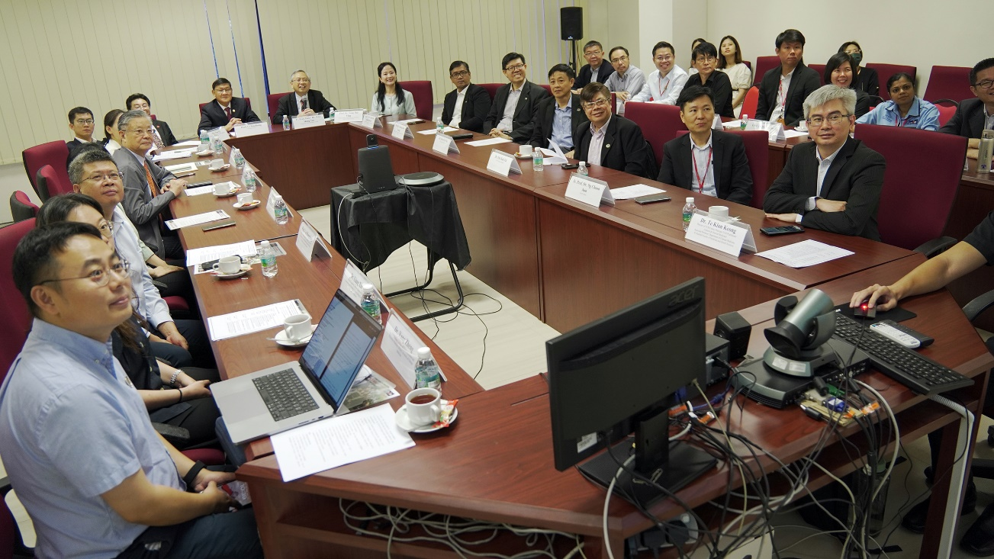

The arrival of delegates from AAET, CAE and UTAR for the MoU signing ceremony

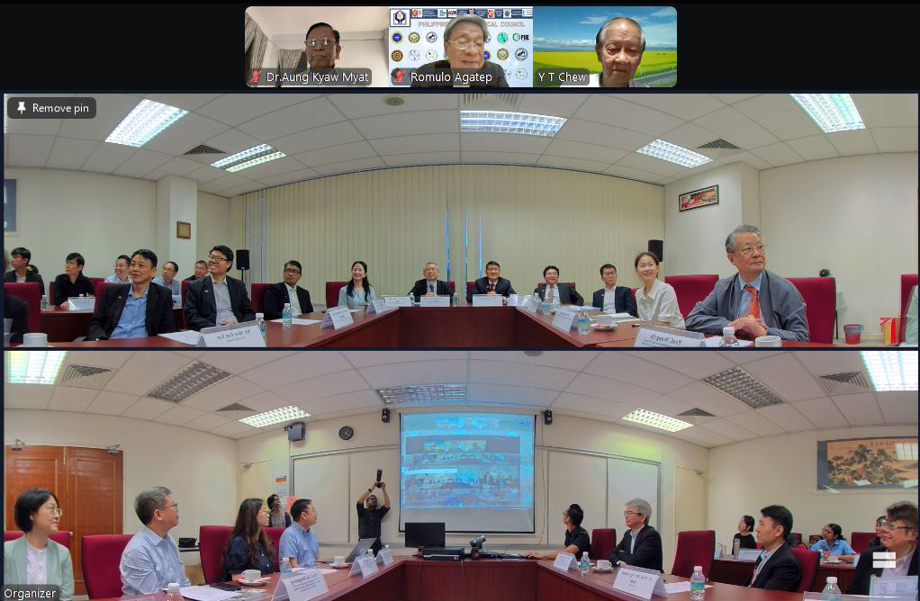

A group photo with the distinguished AAET guests who joined the MoU signing ceremony on virtual platform

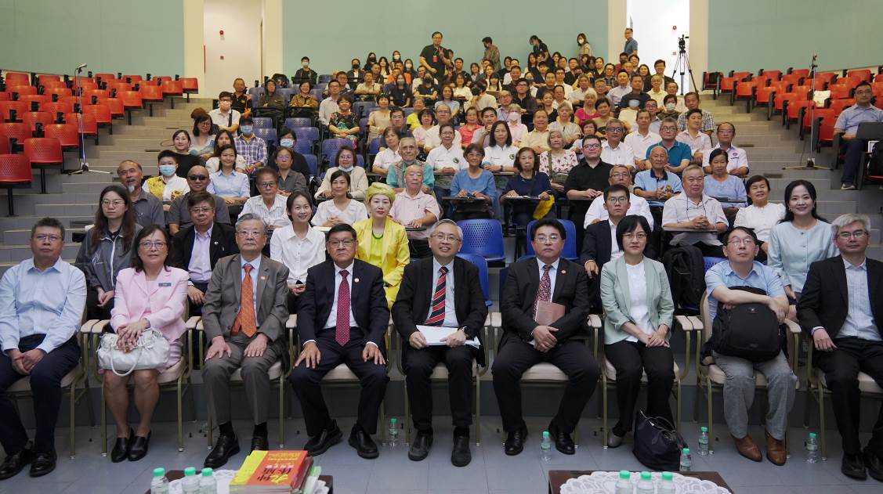

Seated, front row (from left): Prof Cui, Dr Goh, Prof Wang Qi, Prof Li, Prof Dato’ Ewe, Mr Tian Qi, Prof Wang Ji, Dr Yang Zao and Dr Te

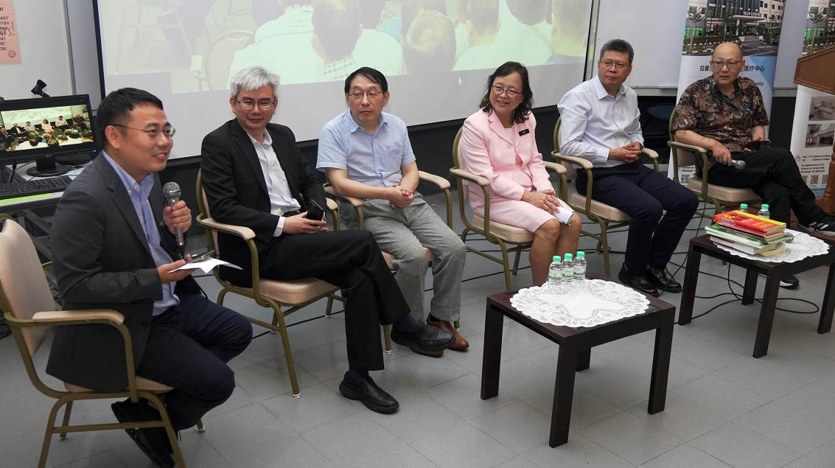

TCM experts (from left): Dr Yang Zheng, Dr Te, Dr Yang Zao, Dr Goh, Prof Cui and Mr Wang

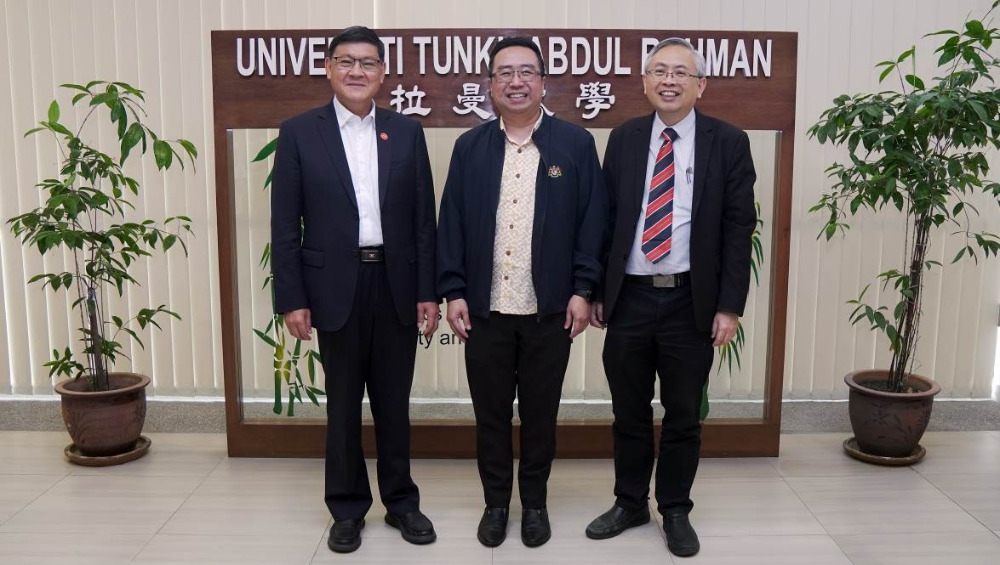

From left: Prof Li, Tuan Chang and Prof Dato’ Ewe