UTAR inbound study tours enrich university life
Beyond lessons in the four-walled classroom, students engage in extracurricular activities to enrich their university experience. Unconfined, they also seek out other programmes that offer opportunities to expand their horizons and gain new experiences. One such programme is the inbound study tours.
UTAR’s inbound study tours are designed to foster academic learning, cultural immersion, and community engagement, offering participants a comprehensive understanding of Malaysia’s rich heritage, dynamic communities, and diverse cultures. Each study tour is carefully curated to ensure that participants leave with not only enhanced academic knowledge but also meaningful connections and lifelong memories.
One of the most compelling aspects of UTAR’s inbound study tours is the wide variety of activities that participants engage in. These activities are designed not only to educate but also to immerse students and faculty members in Malaysia’s unique cultural and historical landscape. For instance, the participation of Singapore University of Social Sciences (SUSS) students in the traditional art of Labu Sayong designing. This hands-on activity involved learning the intricate process of crafting Perak’s iconic clay water vessels, providing participants with a tangible connection to Malaysia’s cultural heritage. Engaging in such traditional arts allowed participants to appreciate the craftsmanship and cultural significance behind these practices, which were essential to preserving Malaysia’s rich cultural tapestry in the face of modernisation and globalisation.
The UTAR student buddy system incorporated into the programme also makes cultural exchange another defining feature of the study tours. Participants’ meaningful interactions with the local communities and UTAR student buddies foster mutual understanding and long-lasting relationships. These exchanges deepen participants’ appreciation of Malaysia’s diverse cultural landscape, providing a broader perspective on the country’s many communities.
In addition to cultural activities, the study tours include visits to historical sites that offer participants a deep and nuanced understanding of Malaysia’s past. A highlight for many participants was the visit to Kellie’s Castle, an architectural marvel that stands as a testament to Malaysia’s colonial history. The castle, with its intriguing backstory and unfinished construction, provided a unique lens to explore the country’s complex history and the enduring legacy of its colonial period. These site visits are not just about viewing historical landmarks; they are about engaging with history in a way that brings the past to life, offering participants a deeper understanding of the historical forces that have shaped Malaysia.
Notably, these activities have not only benefitted students from Singapore, but also UTAR which was given the privilege of hosting a wide range of esteemed universities from across the globe. Among them were National Pingtung University; UIN Iman Bonjol Padang; Yuan Ze University; Lanzhou Jiaotong University; Southwest Medical University; and Hungkuang University. These universities represented a diverse array of academic traditions and cultural backgrounds, making their participation in UTAR’s inbound study tours a truly global exchange of ideas and experiences.
In 2024, UTAR’s inbound study tours hosted several universities:
• National Pingtung University: 8–18 June and 20 June–2 July
• National Sun Yat-sen University: 27 June–2 July
• UIN Imam Bonjol Padang: 1–14 July
• Yuan Ze University: 10 July
• Singapore University of Social Sciences: 14–20 July
• Lanzhou Jiaotong University: 21–30 July
• Southwest Medical University: 11–20 August
• Hungkuang University: 19–26 August
Many of these institutions have returned for subsequent visits, a testament to the high-quality experiences and deep connections fostered through these tours. Feedback from these tours has also been overwhelmingly positive. National Pingtung University commended the programme for its ability to benefit rural children by providing better learning opportunities, with hopes to participate in teaching in the future. Similarly, Southwest Medical University praised the warmth and dedication of UTAR Buddy and the academic team, emphasising how deeply impressed they were. Hungkuang University expressed interest in more practical courses related to their field of study, suggesting ways to enhance the programme further.
Another integral component of UTAR’s inbound study tours is the focus on understanding local economies, particularly through visits to small and medium enterprises (SMEs) in new villages. These visits offer participants the opportunity to witness first-hand the entrepreneurial spirit and innovation that drive these local businesses. For example, participants visited a charcoal factory in Kuala Sepetang and a mosquito coil factory, where they learned about the production processes and the creative use of local resources. These experiences provide valuable insights into ways small enterprises contribute to local economies and preserve cultural identities, while also adapting to modern challenges. Participants often leave with a deeper appreciation for the resilience and creativity of these businesses, which play a crucial role in sustaining local communities.
Community service is another key feature that sets UTAR’s inbound study tours apart from other academic programmes. These projects are designed to provide participants with hands-on experience in contributing to local communities, often in collaboration with UTAR students and faculty. For instance, students from Southwest Medical University, together with UTAR students and faculty, conducted an English Fun Learning session at Kampung Orang Asli Batu Berangkai in Kampar. Despite the challenges faced, the session was a success, demonstrating the power of teamwork, adaptability, and social responsibility. The project not only benefited the Orang Asli community but also offered participants a first-hand look at the importance of societal responsibility and the impact of education on underrepresented communities. In some tours, participants have worked in new villages to develop community service projects, while in others, they have engaged with Malay, Indian, or Orang Asli communities. These interactions gave participants a broader perspective on Malaysia’s diverse cultural landscape, deepening their understanding of the different communities that make up the country.
Moreover, UTAR’s inbound study tours are characterised by a strong emphasis on cultural exchange. Participants have the opportunity to engage in meaningful interactions with local communities and UTAR student buddies, fostering mutual understanding and respect. These exchanges are not merely about learning from one another but about building lasting relationships that transcend cultural and national boundaries. Through these interactions, participants gain valuable insights into the daily lives, traditions, and perspectives of Malaysians, creating a sense of connection and shared experience that enriches their overall educational journey.
The collaborative efforts of UTAR’s Faculties and the Department of Soft Skills Competency at Kampar Campus ensure that each study tour is meticulously planned and executed, offering a well-rounded experience that combines academic learning with cultural and social engagement. Whether it’s a participant’s first time in Malaysia or a return visit, each study tour is crafted to highlight the best of what the country has to offer, from its vibrant cities to its serene countryside, from its historical landmarks to its thriving local businesses.
Conclusively, UTAR’s inbound study tours are not just academic excursions; they are transformative experiences that equip participants with the knowledge, empathy, and cultural awareness needed to thrive in an increasingly interconnected world. By combining academic learning with cultural immersion and community engagement, these tours offer a unique and enriching experience that leaves a lasting impact on all who participate. We invite universities from around the world to join us in this journey of cultural exchange and academic excellence, and to discover the unique opportunities that UTAR’s inbound study tours have to offer. Together, we can create experiences that inspire and empower the leaders of tomorrow, making UTAR a hub for international collaboration and cultural understanding.
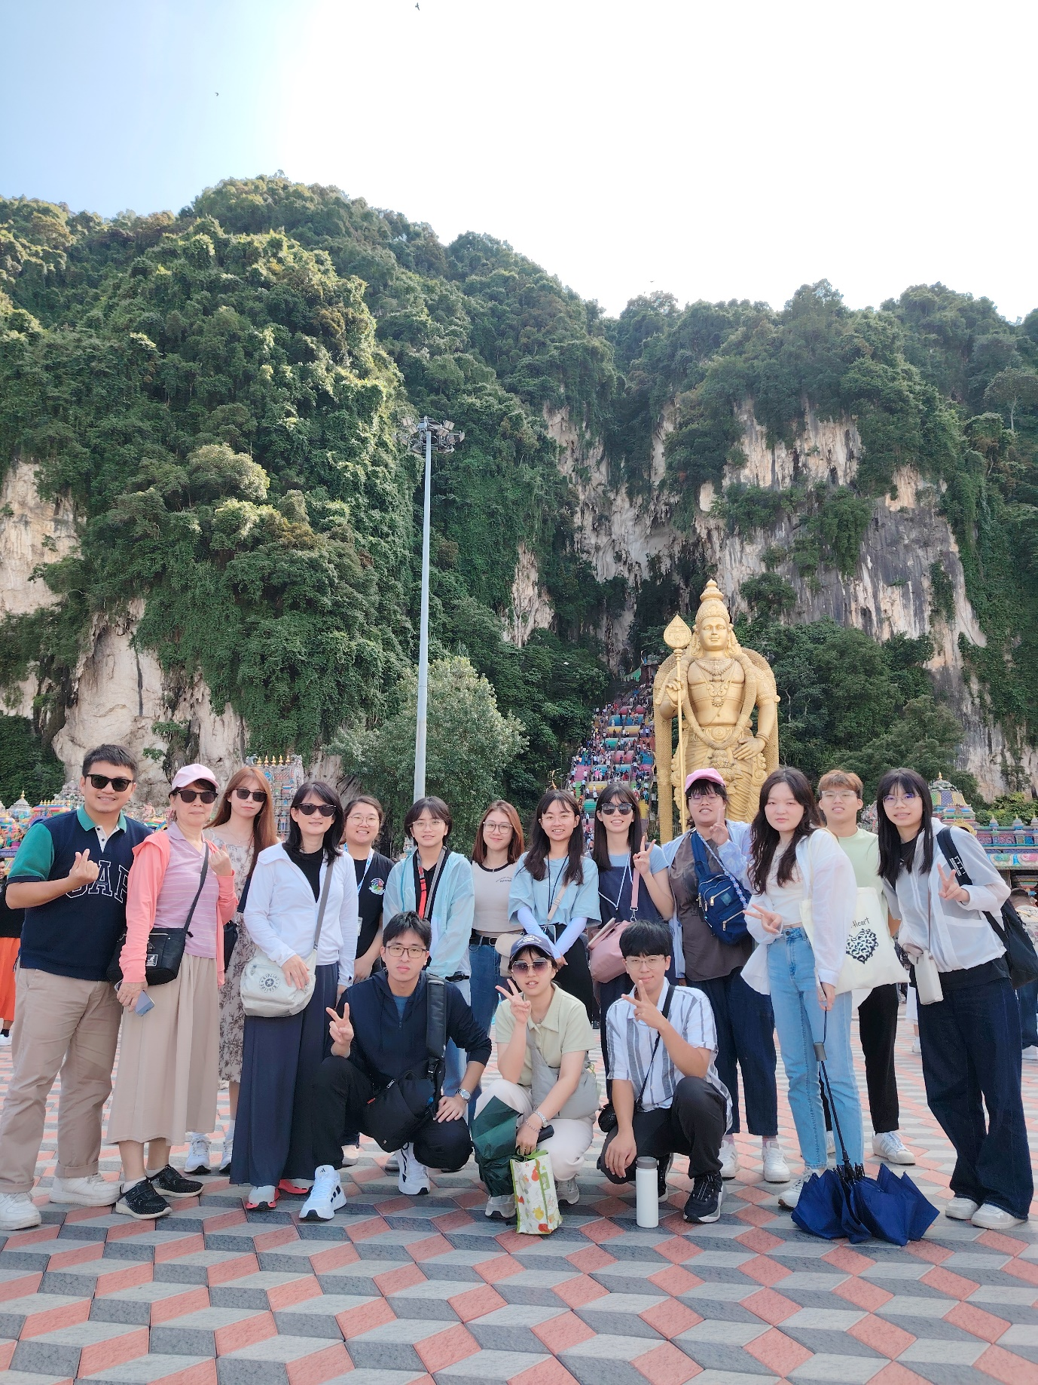
A visit to Batu Caves by National Pingtung University students
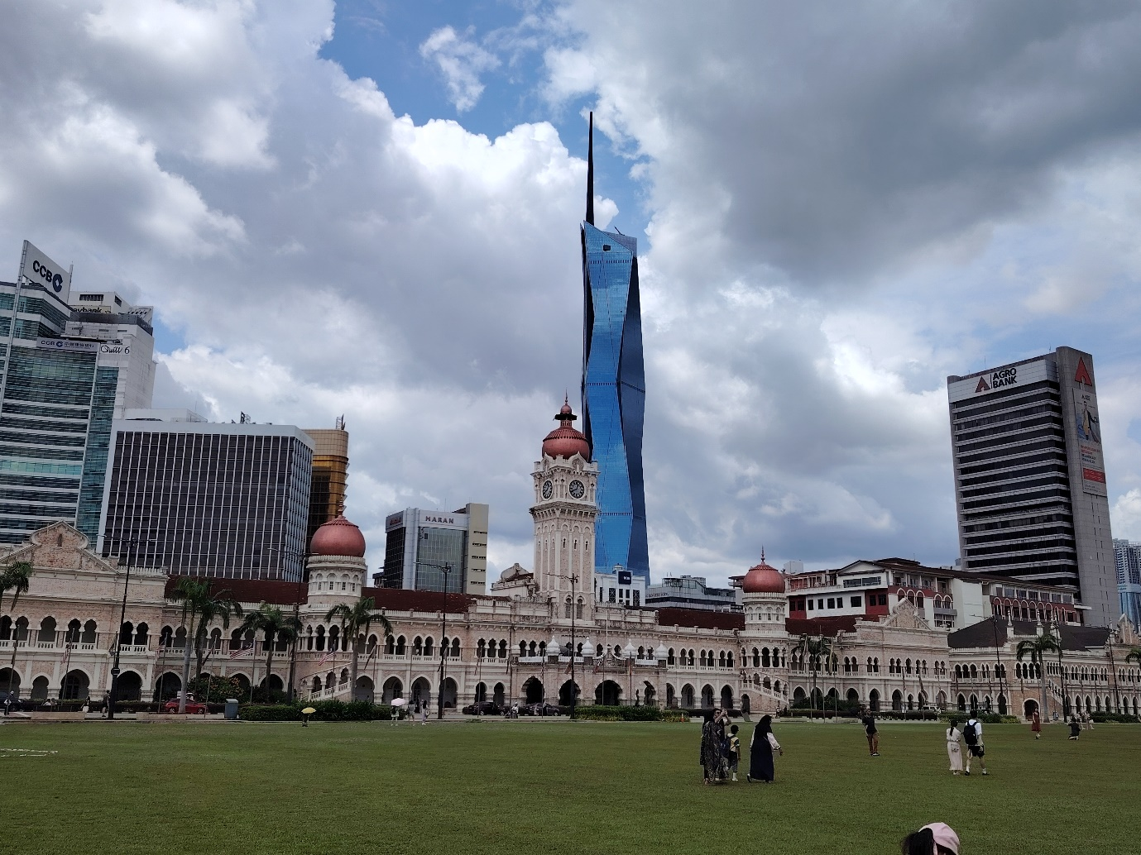
A visit to a historical site, Independence Square (Dataran Merdeka) by National Pingtung University students
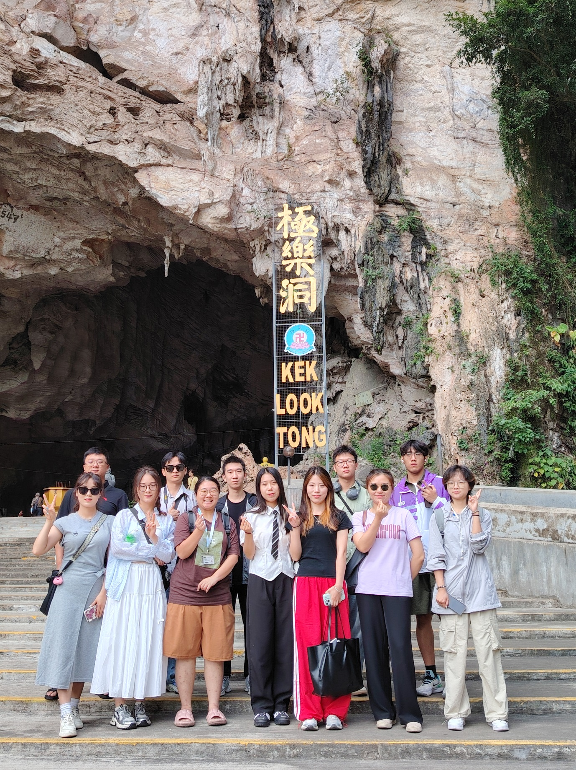
Lanzhou Jiaotong University students appreciating Mother Nature at Kek Look Tong Cave Temple and Zen Gardens
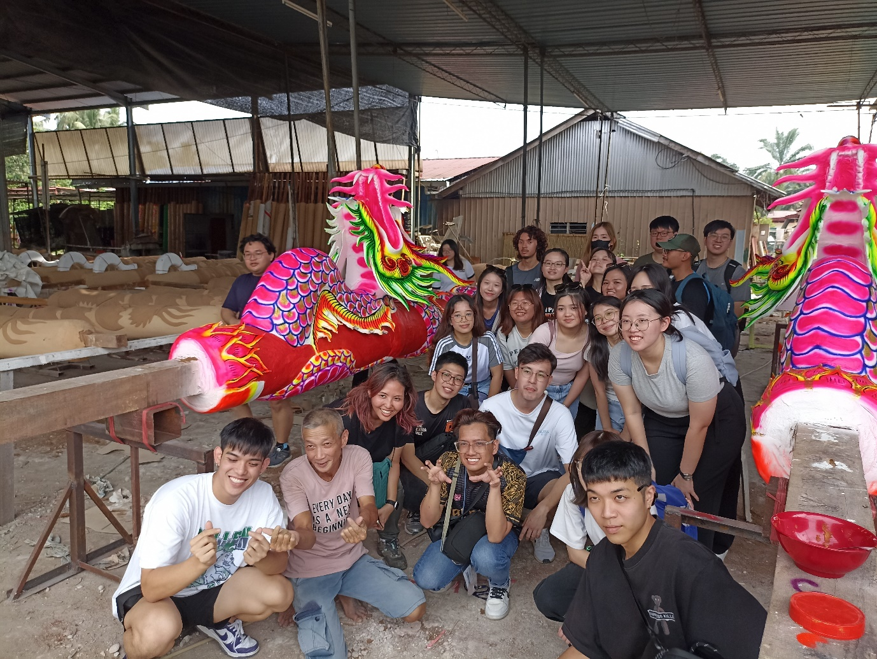
Singapore University of Social Sciences students learning the process of making Dragon joss stick for Chinese prayer
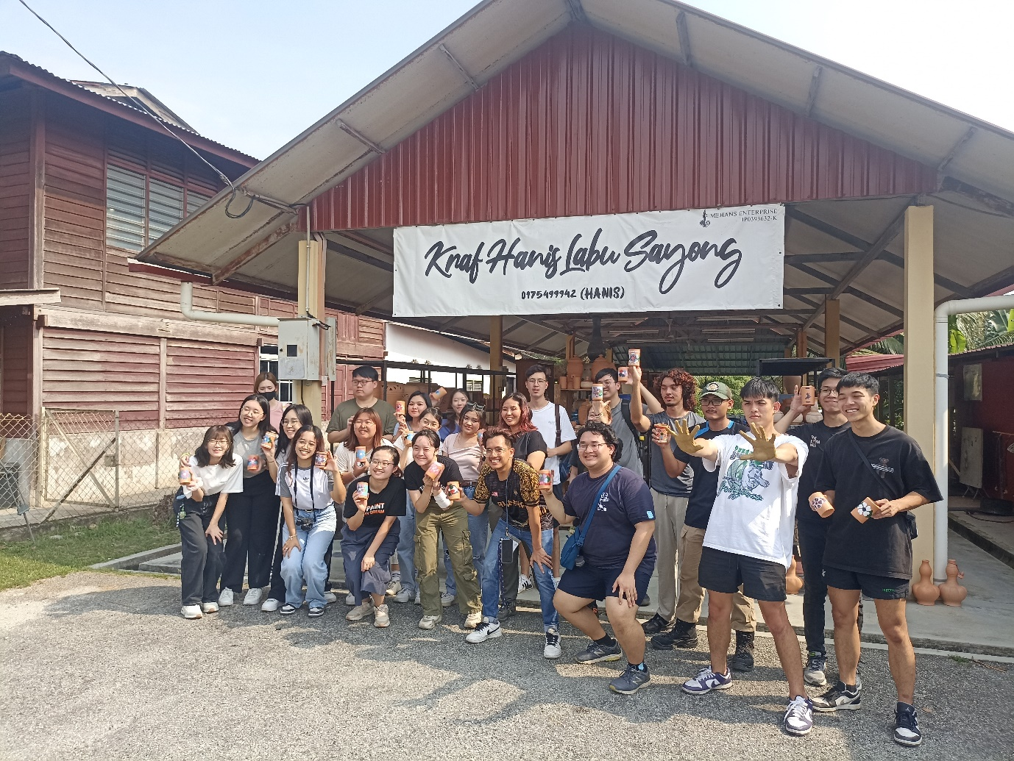
Singapore University of Social Sciences students appreciating local handicraft art—Labu Sayong
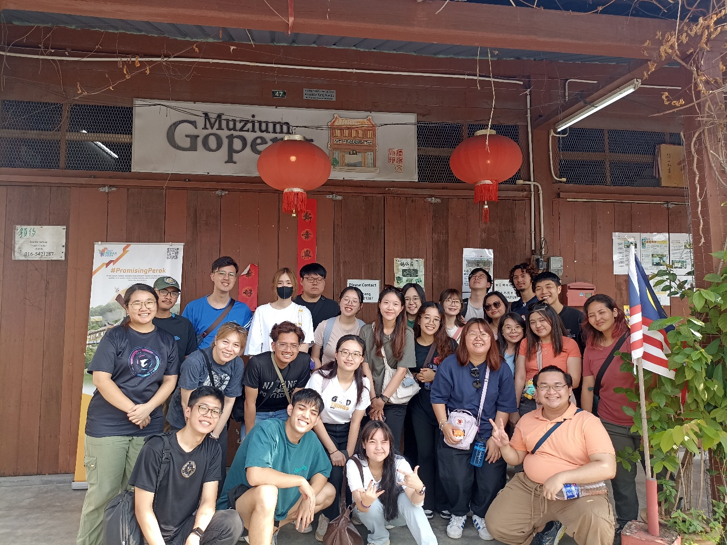
Singapore University of Social Sciences students learning about Gopeng’s glorious days at the Muzium Gopeng
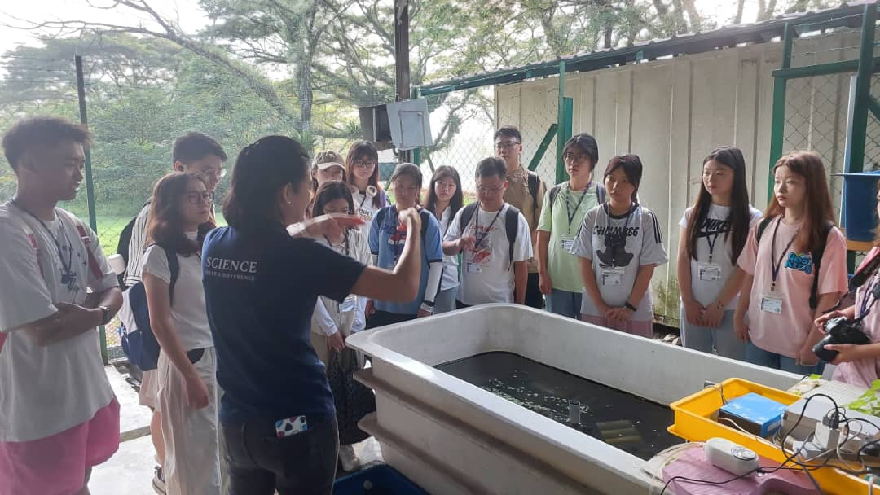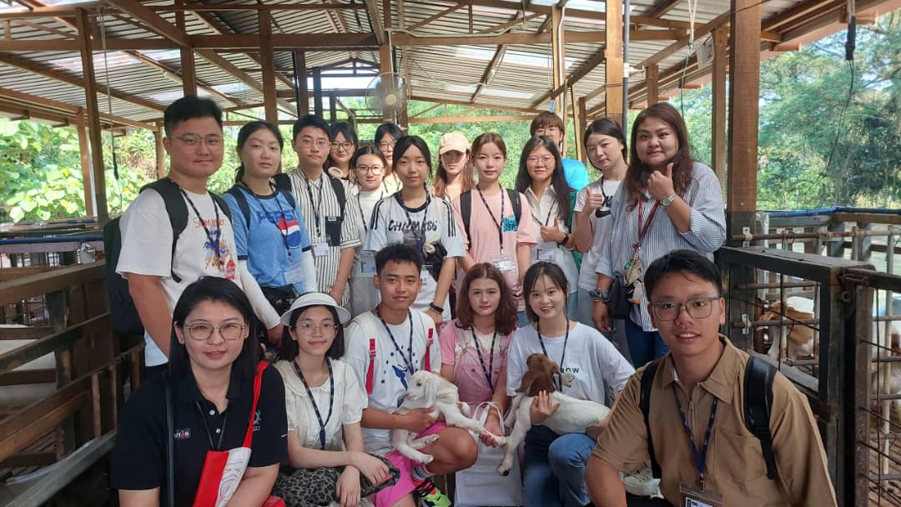
Lessons on biodiversity at UTAR’s Agricultural Park for Southwest Medical University students
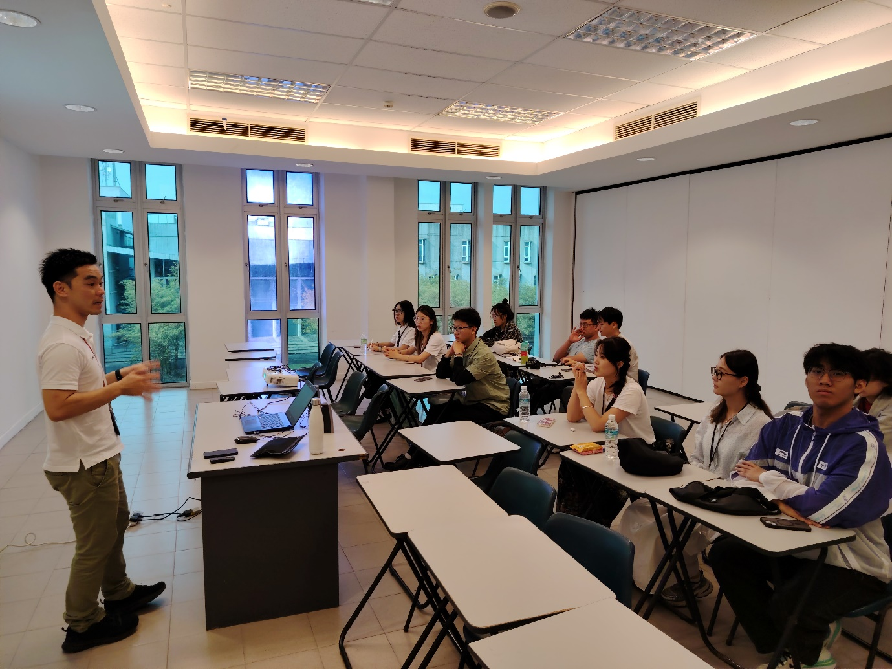
Participants from Lanzhou Jiaotong University gaining insights at the Sustainability in Malaysia Transportation Workshop
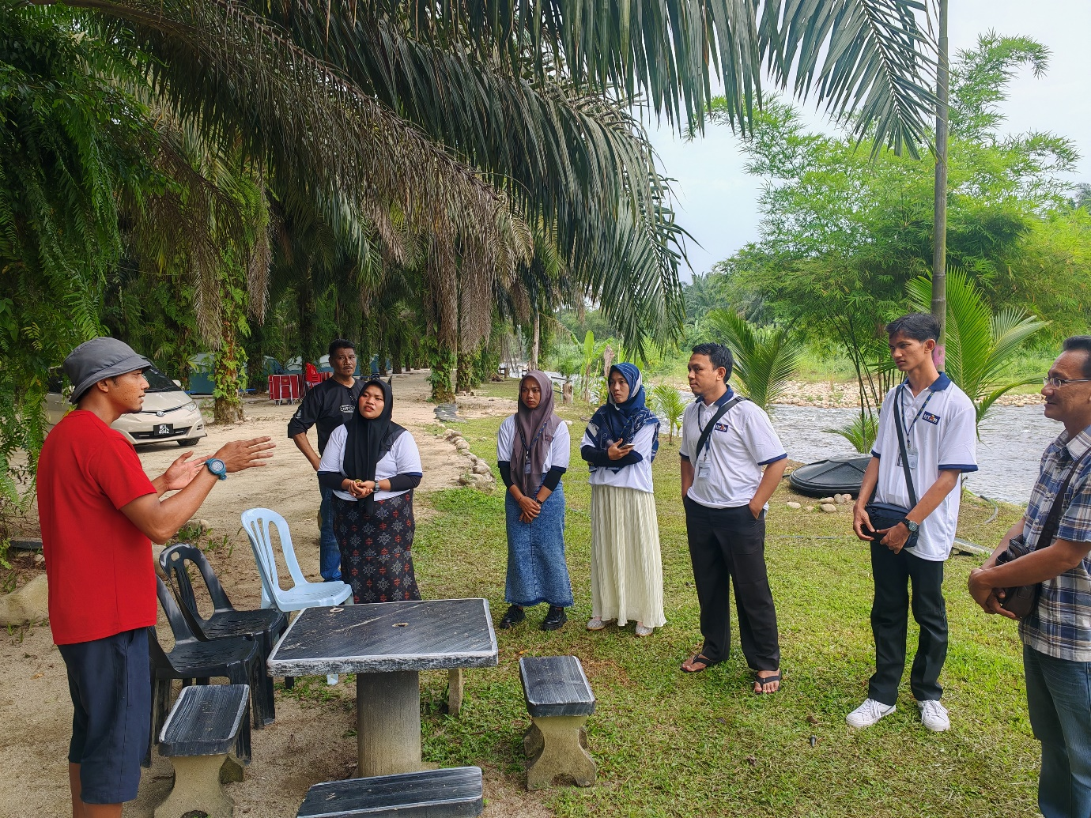
UIN Imam Bonjol Padang students visiting Gopeng Water Rafting tourism spot
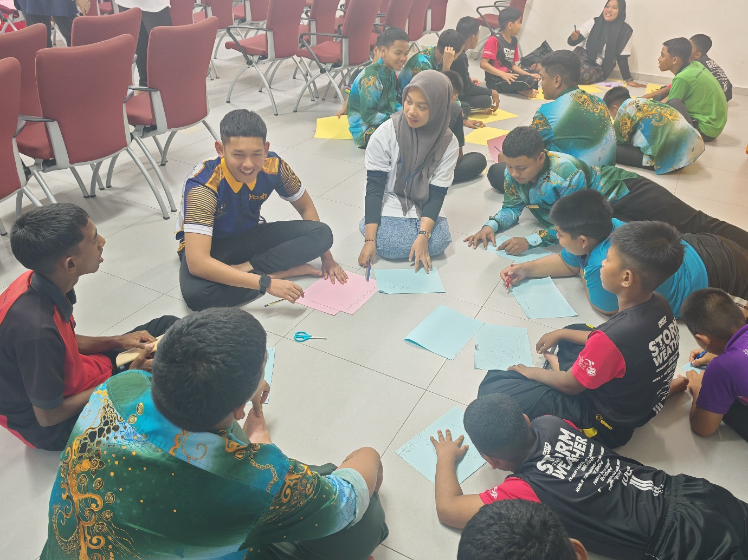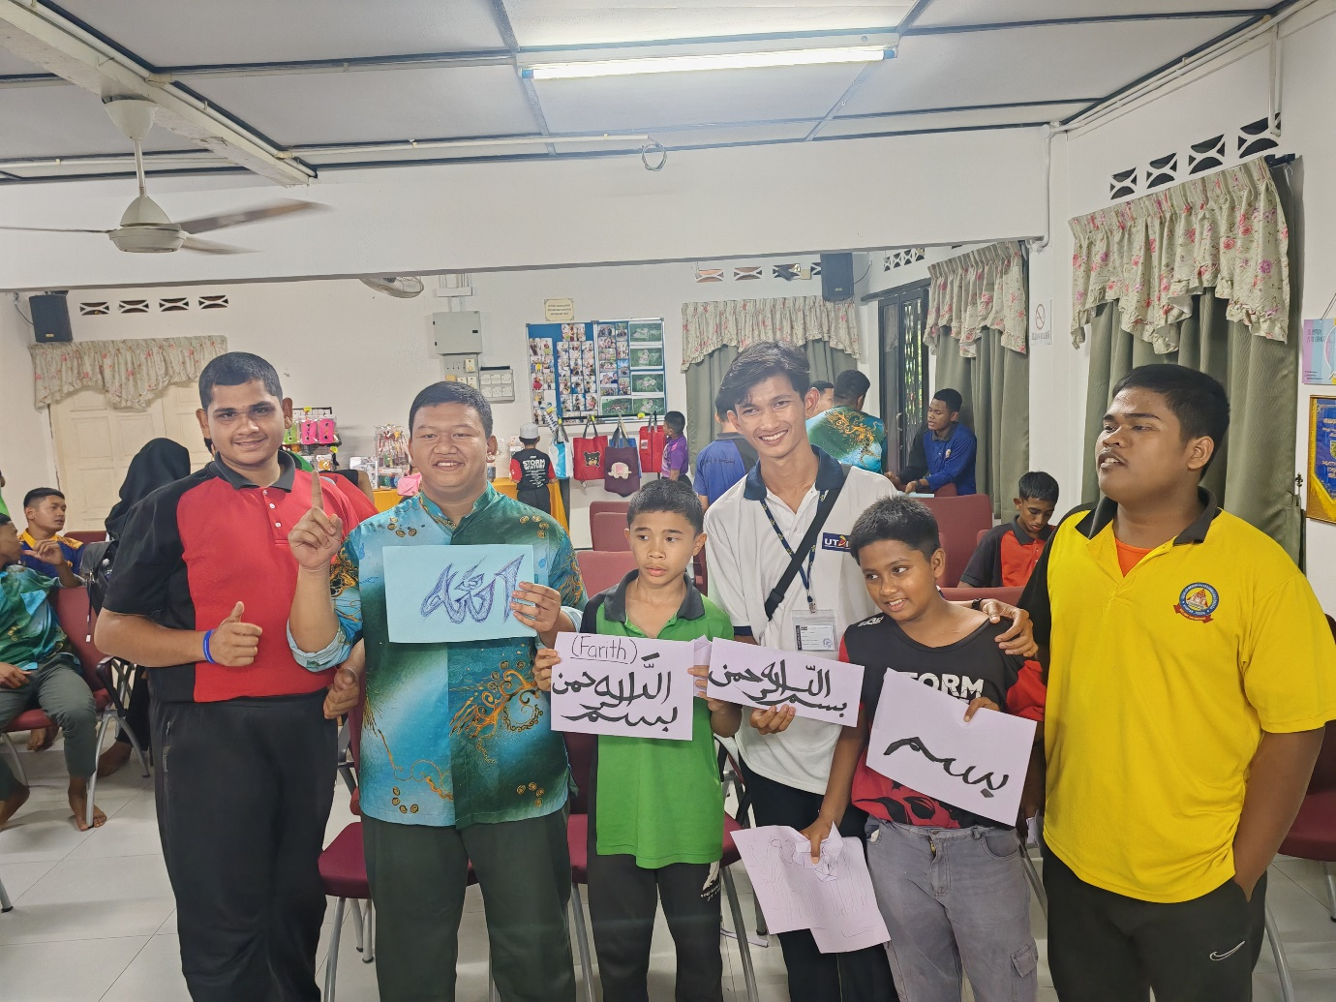
UIN Imam Bonjol Padang students conducting community service at Darul Hikmah Gopeng
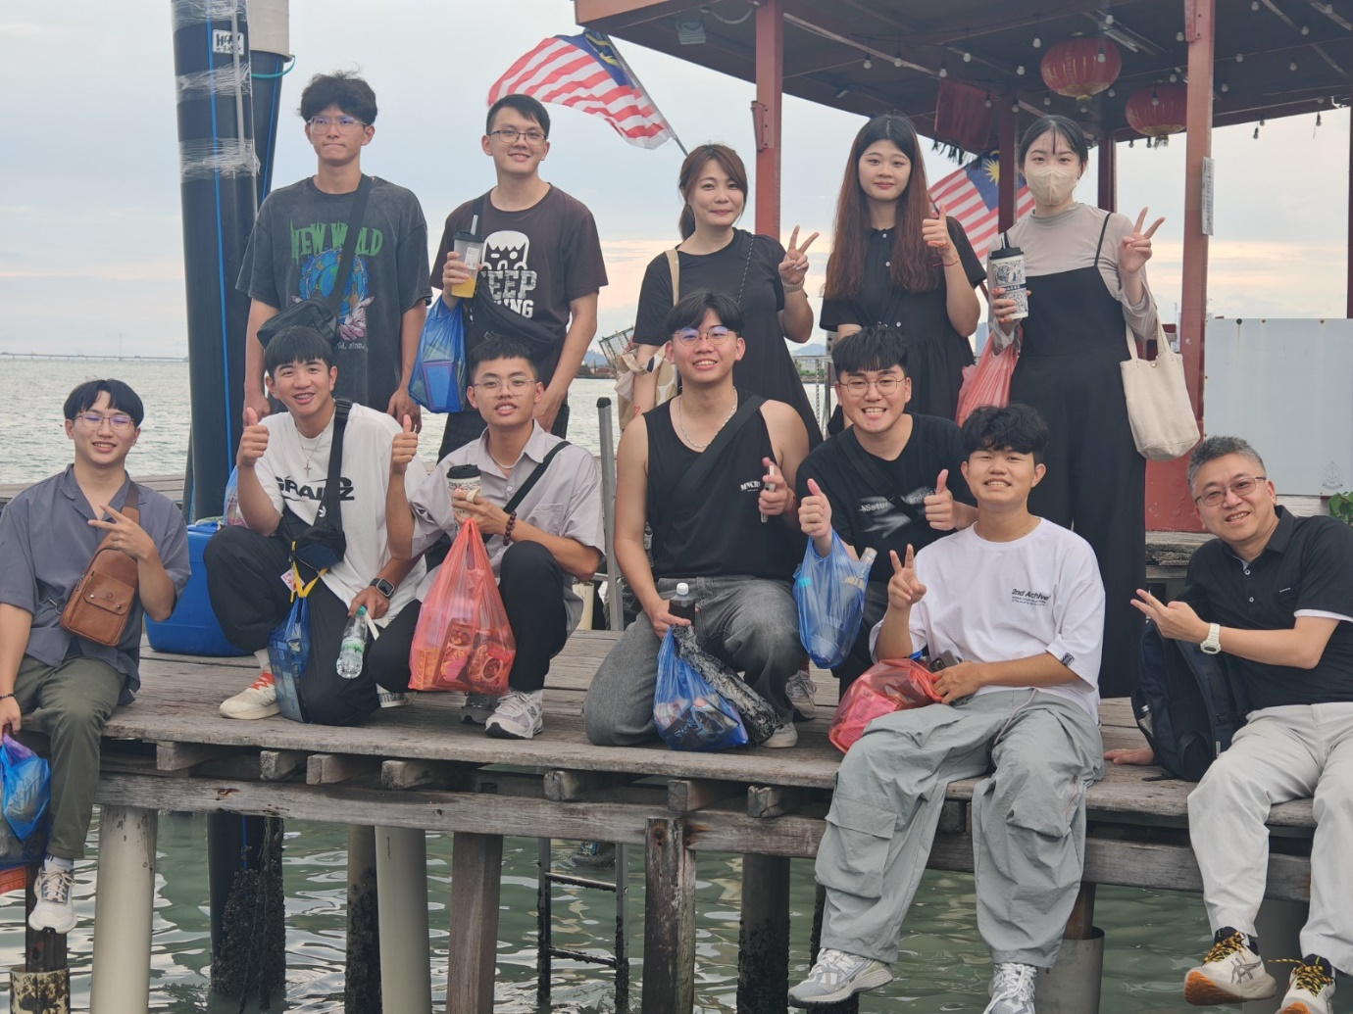
HungKuang University students making a quick stop at Jetty Chew, Penang
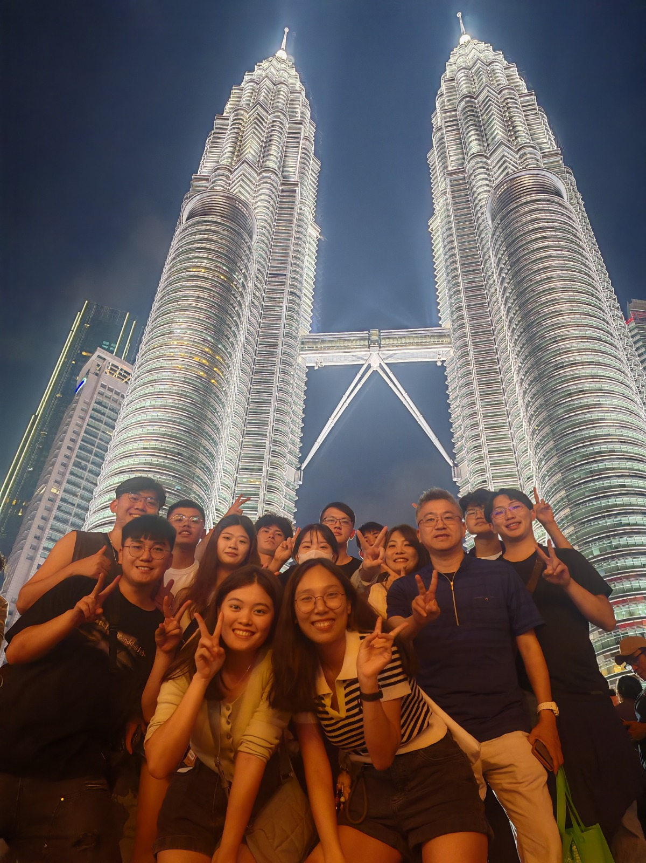
HungKuang University students’ visit to KLCC Twin Tower

