**UTAR and SNUCM deepen TCM collaboration through international academic colloquium**

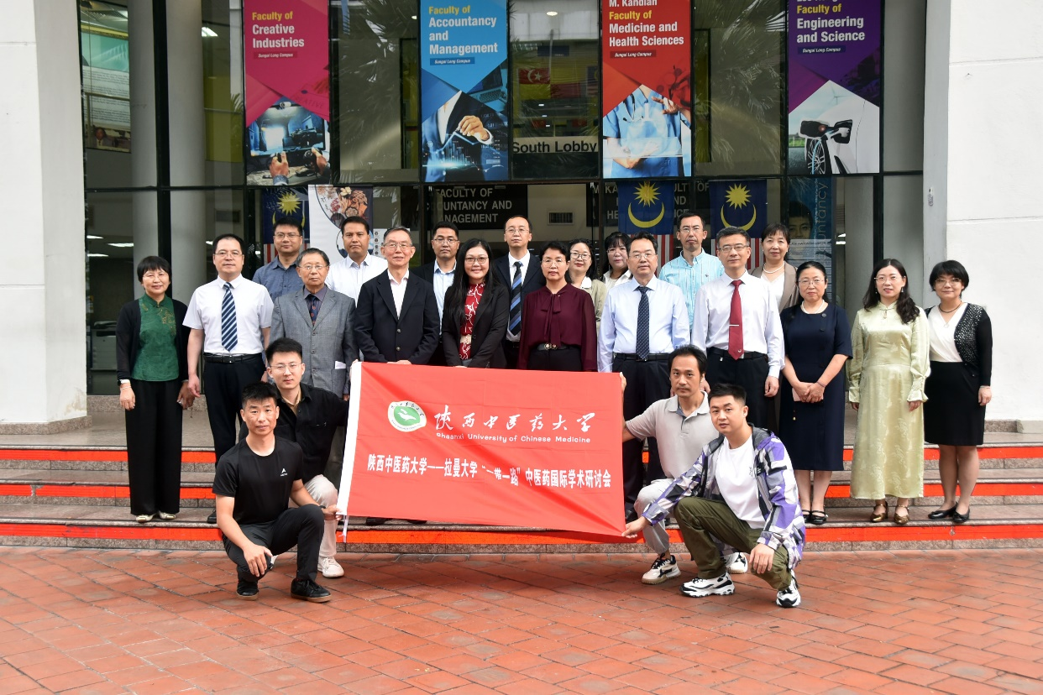

Second row, fourth from left: Dr Leu, Prof Chen and Prof Lim with academics and students of SNUCM and UTAR

UTAR, in collaboration with Shaanxi University of Chinese Medicine (SNUCM), hosted the “Belt and Road” International Academic Colloquium of Cultivating Excellence in Traditional Chinese Medicine (TCM). The two-day event, held from 18 to 19 September 2024, saw over 30 distinguished speakers and experts from both universities gather to discuss innovations and advancements in TCM research, clinical practice, and international cooperation.

The colloquium, part of the Belt and Road Initiative, aimed to strengthen international collaboration, promote cutting-edge TCM research and deepen academic exchanges between Malaysia and China. Since the signing of the memorandum of understanding (MoU) in 2019, UTAR and SNUCM have built a strong partnership, contributing significantly to talent development and research advancements in TCM.

The event commenced with welcome remarks from UTAR M. Kandiah Faculty of Medicine and Health Sciences (MK FMHS) Department of Chinese Medicine Head Dr Leu Kim Fey. He expressed his gratitude, saying, “Since signing the MoU in May 2019, UTAR and SNUCM have maintained close collaboration and established a strong friendship. This colloquium will further deepen our cooperation, foster academic exchange, and enhance talent development programmes between the two universities.”

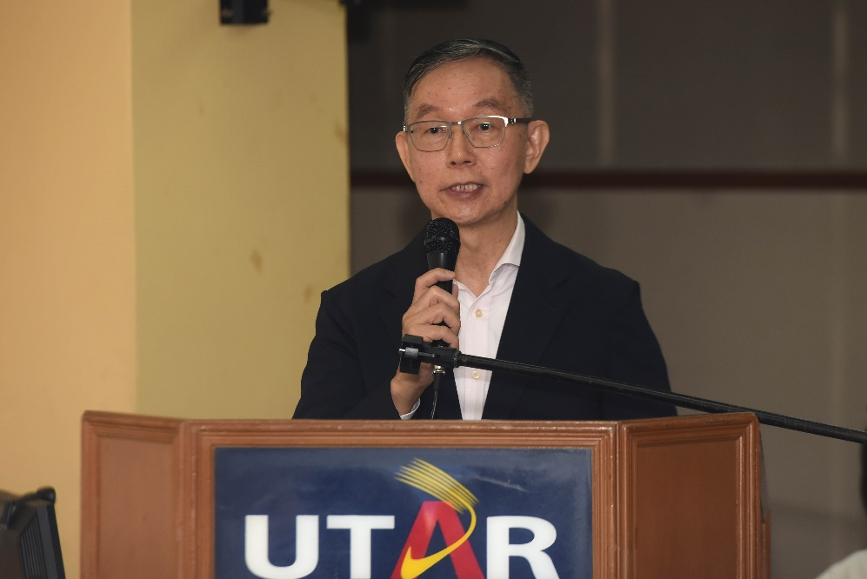

Dr Leu delivering his welcome remarks

It was followed by an opening address from UTAR Institute of Postgraduate Studies & Research (IPSR) Director Prof Ts Dr Lim Yang Mooi. She said, “What we are doing here today is an important first step for researchers to advance in their fields and push forward with more research in TCM. I strongly believe that this colloquium will yield significant outcomes in the years to come, with its impact being far-reaching. Our goal is not only to produce high-impact publications through our collaborations with India and China but also to ensure the quality of the research. We are focused on producing sound and robust research through the R&D efforts of both parties, and we will continue to pursue these endeavours.”

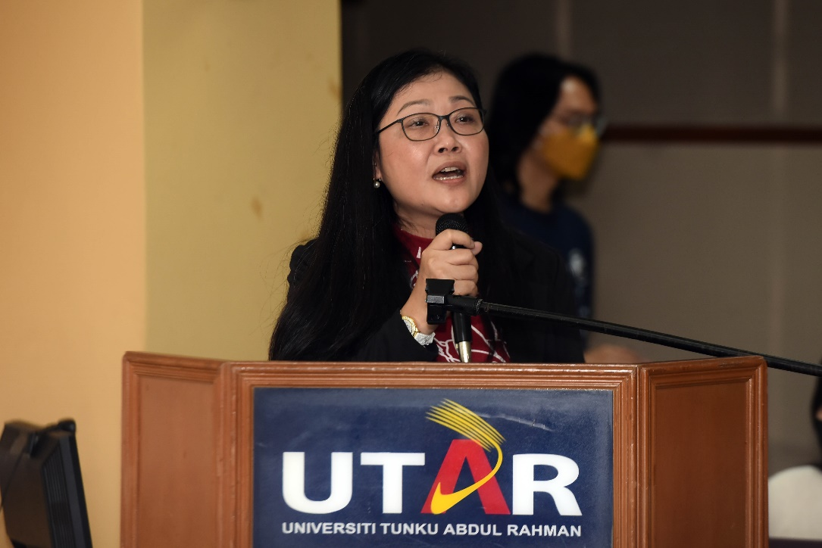

Prof Lim emphasising the importance of this academic colloquium

SNUCM Office of International Affairs Director Prof Chen Zhenlin highlighted the fruitful collaboration between the two institutions. She announced that both universities had been selected for the inaugural “China-ASEAN Thousand Schools Collaboration Programme”, further elevating their partnership to a national level. Prof Chen expressed her enthusiasm for future collaborations, inviting guests to visit SNUCM and envisioning the colloquium as a key platform for fostering international exchanges in TCM.

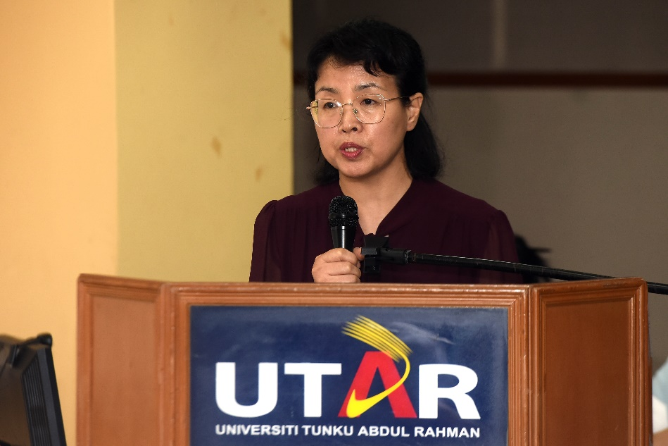

Prof Chen inviting UTAR staff and students to visit SNUCM

The colloquium featured a wide array of presentations on clinical applications, pharmaceutical research, cultural dissemination, technological innovation, and health management. Key topics on the first day included the treatment of membranous nephropathy using six combined methods; the anti-cancer properties of the Malaysian folk herb bitter leaf; the harmony between man and nature based on the five movements and six qi theory; and the management of blood pressure with traditional compounds like Epigallocatechin-3-Gallate (EGCG). Health concerns such as senile dementia, oxidative stress-induced ageing, and atherosclerosis were also explored, alongside acupuncture techniques for beauty and anti-ageing. Presentations were delivered by 15 academics from SNUCM and six academics from UTAR MK FMHS.

On the second day, presentations by UTAR TCM students focused on specific health issues and management programmes, such as TCM treatments for dengue fever, health management for polycystic ovary syndrome, and fertility and health management during perimenopause. These discussions integrated both traditional and modern approaches, highlighting TCM’s relevance in contemporary healthcare. In addition, sessions on research methodologies, thesis writing, and postgraduate strategies provided support to the next generation of TCM researchers.

The colloquium reflected the ongoing partnership between UTAR and SNUCM, which began in 2019. The event aligned with the goals of the Belt and Road Initiative, emphasising regional collaboration in healthcare, research, and education.

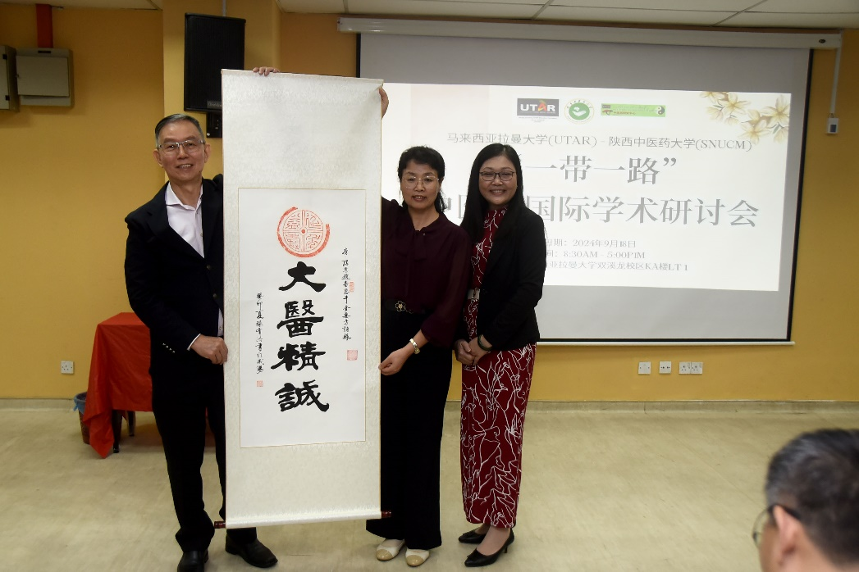

From left: Dr Leu, Prof Chen and Prof Lim

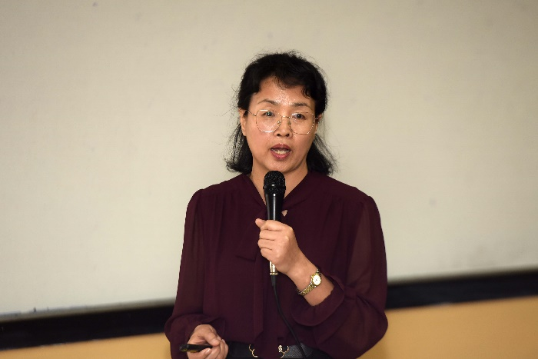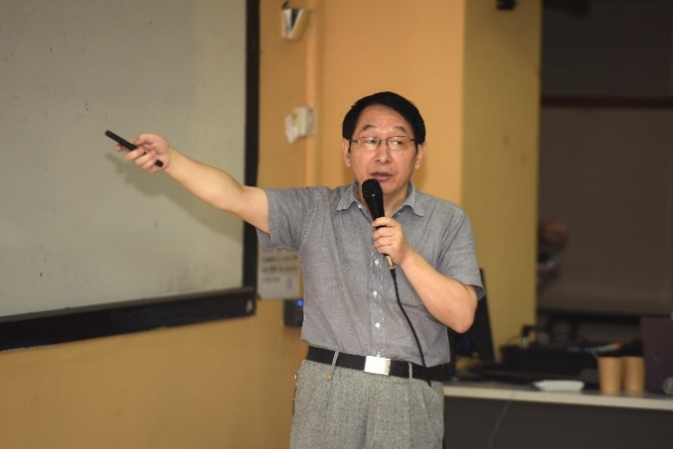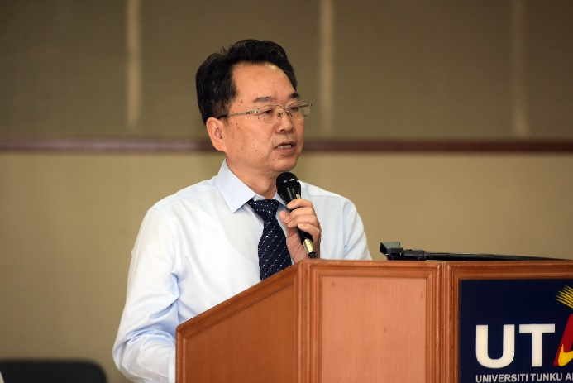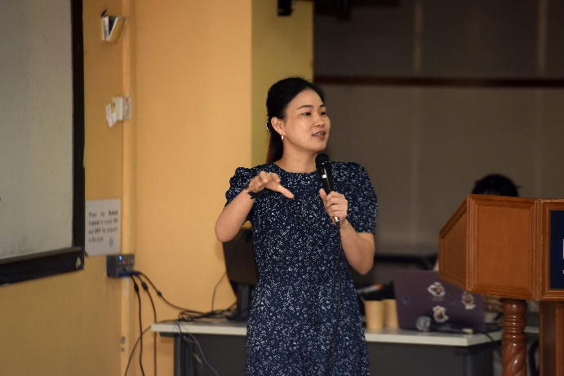

SNUCM and UTAR academics presenting their research outcomes (clockwise from top left): Prof Chen, MK FMHS academic Assoc Prof Dr Yang Zao, Centre for Research on Non-Communicable Diseases Chairperson Assoc Prof Ts Dr Lee Siew Keah and SNUCM academic Prof Lei Genping

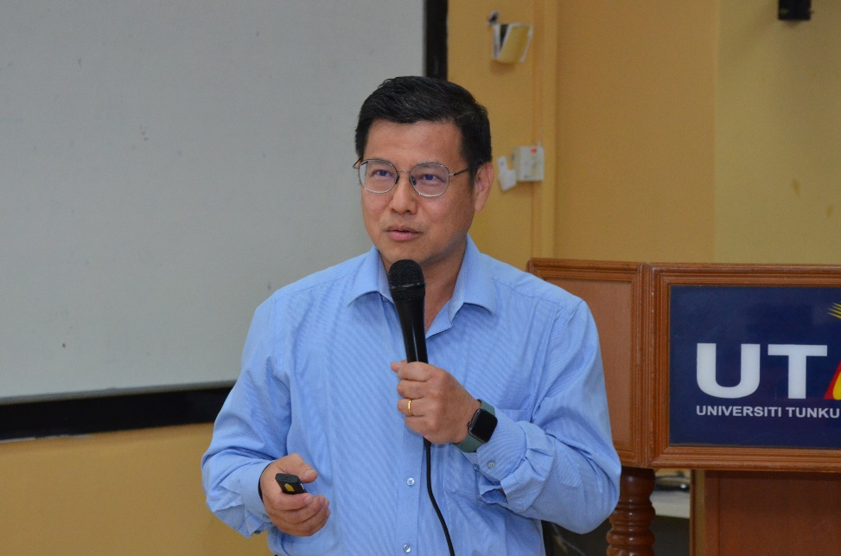

MK FMHS Deputy Dean for R&D and Postgraduate Programmes Prof Dr Alan Ong Han Kiat sharing his experience on cultivation

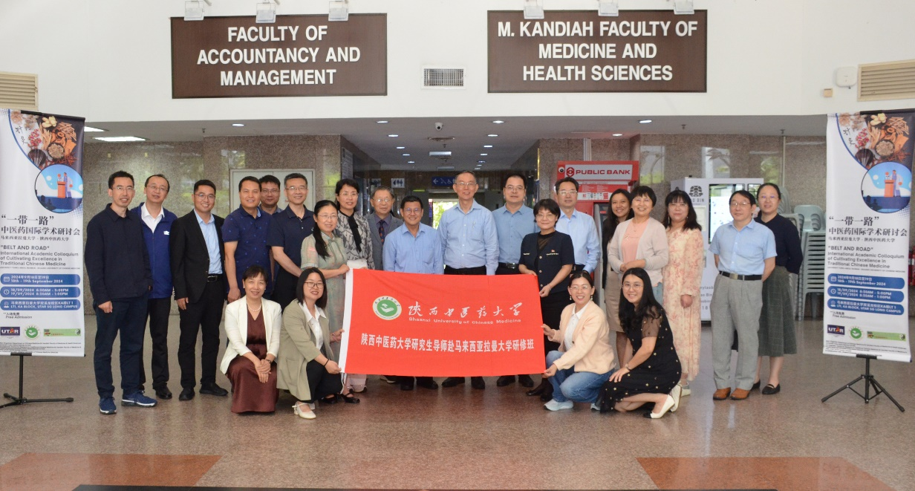

Group photo after the event